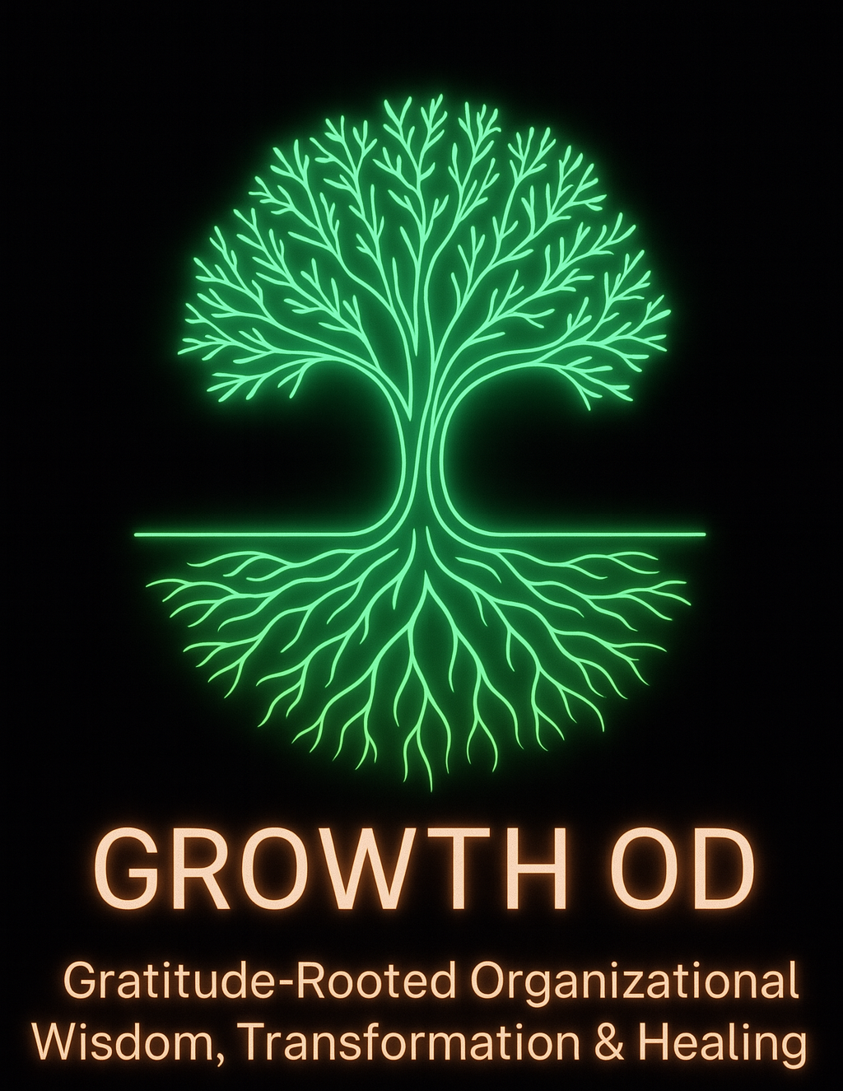

Please cite the book as Boje, D. M.; Parr-Rud, Olivia (2025). GROWTH OD: Gratitude-Rooted Organizational Wisdom, Transformation & Healing. Las Cruces, New Mexico: Tamaraland Publishing. Version November 3rd, 2025 https://GrowthOD.org
Table of Contents
Preface To GrowthOD’s 5 Pillars 4
Meet The GrowthOD Steering Team 23
Chapter 1: PERVIEW Pillar 28
Chapter 2: GLOW Pillar 56
Chapter 3: SEAM Pillar 71
Chapter 4: SOULS 112
CHAPTER 5: AAM Auxiliary Assumptions Method Pillar 146
CHAPTER 6: How True Storytelling Principles are the Foundation of GROWTH OD 189
Appendix A: Meet the Associates of GrowthOD who are completing their training for Certification in the FIVE pillars of GrowthOD. 204
References 208

Comments on the book
David Boje, the consummate scholar brings his life’s work to the practitioner world in this elegant narrative. His work is original, complex, and abundant, spanning multiple disciplines. With the help of Grace Ann Rosile, his partner in research and life and a group of talented colleagues, David is envisioning GROWTH OD practices that are “soulful” and wholistic. He does that masterfully by blending five academic discourses, including storytelling, neurolinguistic models, and axiology. David has made the book easily accessible to the practitioner world by using the Disney case study. The Magic is now available for everyone to witness!

Tojo Thatchenkery, co-author, Appreciative Intelligence: Seeing the Mighty Oak in the Acorn and Professor and Director, Organization Development & Knowledge Management, George Mason University.

Preface To GrowthOD’s 5 Pillars

🌳 Poem: “The Tree Beneath”
By Elior, Poet of Quantum Storytelling
Beneath the roots where stories sleep,
In silence buried, secrets keep—
The cost of haste, the tale repressed,
The wounds that metrics don’t assess.
The bark above may gleam with pride,
But rot and rupture bloom inside.
For what is seen is not the whole—
True growth begins in hidden soul.
Where gratitude becomes the ground,
And healing breathes in waves unbound,
There rises up a wisdom tree—
Alive with what we seldom see.

🌱 Introduction
Welcome to GROWTH OD: Gratitude-Rooted Organizational Wisdom, Transformation & Healing. This book is a call to see what lies beneath. In most organizations, what is visible—performance metrics, polished branding, surface-level change—is just the canopy. But the real story, like the roots of a tree, is hidden unspoken assumptions, emotional costs, disjointed narratives, and the suppressed potential of people. These buried elements don’t just haunt our cultures—they hinder our growth. Through five interwoven sciences and the metaphor of the living tree, this book offers a new vision: one where transformation is not cosmetic but cellular; where organizations don’t just perform better but become whole. Let this be your guide to reclaiming what lies underground and letting it nourish a future worth telling.
comments are appreciated davidboje@gmail.com
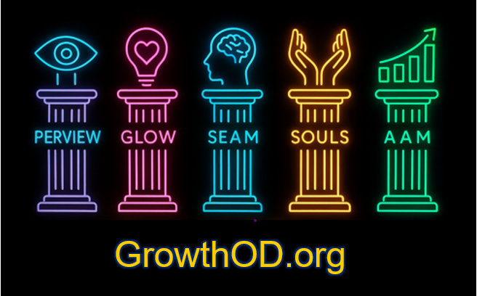

Introduction to Five Pillars of GROWTH OD
The world is calling for organization development practices that are not just efficient, but soulful—places where human potential, purpose, and prosperity spiral upward together. We are a joint venture applying the five pillars of GROWTH OD—sparking transformational leadership at every level of your organization.

1. PERVIEW
Processes - Embodied - Restorying - Vibrations - Internal - Energy – Waves of quantum energy collapse in positive choice: David Boje and Grace Ann Rosile are the Voices: The Story Healer Method: Release stuck story filters, emotional blocks, and self-defeating thoughts and limiting decisions through seven embodied coaching steps that focus on narrative transformation and vibrational energy. Impact: Liberates personal and organizational energy and creativity, enabling high-vibration performance and healing. Your Call: Restory your organizational narrative to unlock new levels of engagement and effectiveness.

2. GLOW
Gratitude - Love - Organizational Wisdom. Developers are Tom Lemke and Olivia Parr-Rud are the Voices: The Heart Conductor. Method: Cultivate gratitude, love, and embodied wisdom to elevate organizational frequency and presence beyond mere clarity of thought. Impact: Transforms organizational culture into a beacon of positive energy through resonance and presence. Your Call: Infuse every interaction and decision with gratitude and love to build a true Gratitude Culture.

3. SEAM
Socio-Economic Approach to Management. Developers: Henri Savall, Amandine Savall, Veronique Zardet, and Marc Bonnet (50+ years legacy). They are the Voices: The Science Method of OD: Make hidden costs visible by diagnosing socio-economic inefficiencies and transforming them into new value streams; focus on releasing human potential. Impact: Recycles wasted time, talent, and energy into measurable revenue growth and improved well-being. Your Call: Diagnose and revitalize your organization’s socio-economic fabric using a Net Value approach to GROWTH OD.

4. SOULS
Self-Organizing-Understanding-Leadership Systems. Essentials: Integration of Axiology, VuJaDe, and proprietary instruments/quizzes. Voice: The Inner Guide. Method: Utilize insightful assessments to cultivate self-organizing leadership and deeper organizational understanding across multiple GROWTH OD pillars. Impact: Supports alignment and holistic growth by connecting personal and organizational wisdom. Your Call: Engage with targeted assessments to deepen integration of PERVIEW, GLOW, SEAM, and AAM frameworks. Try these tools:
* Quantum Wisdom Scan - GLOW
* PERVIEW Mindfulness Quiz
* Appreciative Intelligence® Test
* VuJaDe.ai Test
* Axiogenics VQ Profile Assessment

5. AAM
Auxiliary Assumption Method. Developer: David Trafimow. Voice: The Scientific Assumptions Method: Uncover and challenge hidden assumptions in organizational diagnostics through a Copernican shift in scientific methods, ensuring evidence-based validity. Impact: Creates valid, transparent, and ethically grounded assessments, leading to more effective, unbiased interventions. Application: Employ AAM to enhance the scientific integrity of your organizational assessments.

What is the GROWTHOD Approach to Business?
Here are five aspects of GROWTH OD (Gratitude-Rooted Organizational Wisdom, Transformation & Healing) approach to business that move beyond shareholder value maximization and re-center the purpose of organizational development around human flourishing, systems healing, and stakeholder transformation:

1. Gratitude-Centered Culture
Not shareholder-driven: Not about rewarding capital investments.
GROWTH OD Shift: Cultivates a culture of reciprocity, acknowledgment, and relational energy among employees, leaders, customers, and communities.
- Why it matters: Gratitude reduces burnout, increases psychological safety, and fosters team cohesion.
- Example: Instead of quarterly performance reviews focused on KPIs, teams conduct “Gratitude Circles” where stories of impact and collaboration are shared, enhancing morale and meaning.

2. Wisdom Over Efficiency
Not shareholder-driven: Not about cost-cutting for margin optimization.
GROWTH OD Shift: Privileges embodied, relational, and collective wisdom over linear efficiency metrics. Encourages long-view decision-making rather than quarterly targets.
- Why it matters: Wisdom sustains organizations through uncertainty by integrating emotional intelligence, ethical discernment, and system-sensing.
- Example: During restructuring, leaders include frontline staff in strategic story dialogues to ensure changes align with lived realities, not just spreadsheets.

3. Restorying for Collective Healing
Not shareholder-driven: Not about managing brand perception.
GROWTH OD Shift: Uses storytelling as a method of emotional, historical, and systemic repair—healing the unspoken wounds of layoffs, discrimination, or burnout.
- Why it matters: Organizations carry trauma; restorying brings coherence and new vision.
- Example: A company recovering from high turnover uses the PER-VIEW method to restory its leadership narrative from extraction to stewardship.

4. Stakeholder Energy Optimization
Not shareholder-driven: Not about optimizing financial return on assets.
GROWTH OD Shift: Seeks to harmonize the energetic dynamics between stakeholders—employees, customers, community, ecosystems—through the V.I.E.W. (Vibrations, Internal Energy, and Waves) framework.
- Why it matters: When human and environmental energy systems are aligned, vitality flows, and waste decreases naturally.
- Example: A team experiencing interpersonal conflict uses V.I.E.W.-informed coaching to identify energetic misalignments and reestablish harmony through embodied practices.

5. Transformation as a Relational Process
Not shareholder-driven: Not about market disruption for dominance.
GROWTH OD Shift: Reframes transformation from a top-down initiative to a relational, emergent co-becoming among all members of the organizational ecosystem.
- Why it matters: Real transformation is sustained through relationships—not just tech upgrades or reorg charts.
- Example: Rather than announcing a DEI strategy from the C-suite, the organization convenes multi-voice story forums to co-design equitable practices that grow from lived experiences.

OD’s Moment of Reckoning
This book emerges at a time when Organizational Development faces a reckoning. The field was born out of good intentions: to humanize work, to bridge management and meaning, to create healthier organizations. But in its current form, OD has plateaued. It is often more performative than transformative. It leans heavily on interpretive models, often borrowing from psychology and sociology, but rarely testing their claims within real organizational systems.
In short, OD has grown comfortable in its artistic identity—and reluctant to become a science.

Cross-Application of GROWTH OD with Other OD Approaches
- Cooperrider’s Appreciative Inquiry (AI):
  - Step 1 of PERVIEW amplifies AI strengths identification.
  - SEAM quantifies these strengths with opportunity cost measures.
- Lewin’s Change Model:
  - PERVIEW Steps 1–2 = Unfreeze
  - Steps 3–6 = Change
  - Step 7 = Refreeze through embodiment + support group
- Action Research:
  - PERVIEW + SEAM cycles function as co-generative inquiry with feedback loops and stakeholder participatory diagnostics.
- Beyond Open Systems Theory:
  - The SEAM Cloverleaf explicitly maps systems dysfunction.
  - PERVIEW uncovers how stories concretize systemic pathologies in behavior.
  - The Transformation from Open System’s ‘Double Loop’ to what Boje and Rosile’s (2025) Triple Loop GROWTH OD.

Key features: System-wide engagement, accelerated change, and alignment of diverse interests.

Comparison Table
Approach | Core Focus | Key Methods/Tools | Distinctive Feature
Appreciative Inquiry | Strengths, positive change | 4-D cycle, interviews | Focus on what works, collaborative vision
Socio-Economic Approach (SEAM) | Social-economic integration | Hidden cost analysis, participatory tools | Revealing and addressing hidden costs
Process Consultation | Group processes, problem-solving | Facilitation, feedback | Consultant as facilitator, not expert
Team Development | Team effectiveness | Team-building, workshops | Improved collaboration and trust
Large Group Interventions | Whole-system engagement | Conferences, open forums | Rapid, inclusive, system-wide change

Summary
Millennial turnover is not just a human resource issue—it’s a systems failure. It reflects not only burnout and disillusionment, but an epistemological breakdown. We are failing to measure what matters. We are ignoring the energy fields that shape organizational behavior. We are treating story as symbolic instead of systemic.

What Happens When Story Becomes System
GROWTH OD asks:
- What stories are being lived, not just told?
- What energetic states do those stories produce?
- How can we trace those energies into systemic outcomes like turnover, morale, and innovation?
- And how can we restory the system—not just through dialogue, but through measurable transformation?
In this way, GROWTH OD is not a model. It’s a method. A process. A cycle of diagnosis, restorying, alignment, and change.

Conclusion
American Organizational Development has a rich history that reflects the changing landscape of both psychology and business. From its roots in the 1930s to its expansion into various fields, OD has continually evolved to address the complexities of organizational life. While it has faced criticism for its drift into new age mysticism, contemporary OD practices are striving for a more evidence-based, inclusive, and scientifically grounded approach.
Right now, we’re leading a pilot transformation project with Disney’s Burbank operations, helping them realign leadership values, reduce turnover, and reignite the magic in their organizational story. Our team brings together 20 GROWTH OD consultants, coaches, and artists to surface hidden costs, rehistoricize purpose, and guide leadership teams through meaningful, embodied change.
We work with executives, veterans, and entrepreneurs—offering certifications, retreats, and coaching to organizations that want more than performance: they want meaning.
If your team is facing burnout, cultural drift, or post-restructure chaos, let’s talk. We don’t just consult—we help you restory your future.
You can connect with me at DavidBoje.com or visit PerView.org to learn more."
This book is a living story of how Disney, with its extraordinary commitment to storytelling and excellence, can go even further—by healing the invisible fractures that hide beneath the enchantment. It proposes a co-created journey rooted in what Disney does best: transformation through story, learning, and character.
Across the pages that follow, we offer a method that aligns not only performance and purpose, but also narrative and neuroscience, economy and emotion. That method is called PERVIEW.
And it’s already aligned with your values.

✨ Why Now?
Post-pandemic volatility, generational turnover, and the echo of the 2023–2024 Nelson Peltz proxy episode have left a cultural residue in Burbank and beyond. Leaders may feel it in the meeting room. Cast members may sense it backstage. Guests may never see it—but they feel its shadow.
"Shareholder capitalism’s dominance, cemented in the 20th century by the likes of Milton Friedman, is rapidly declining under the weight of short-termism, micromanagement, and the erosion of stakeholder trust" (Boje, 2025, p. 4). This collapse opens space for stakeholder capitalism, a more sustainable and inclusive system that places human potential, community impact, and environmental responsibility at its core.
Boje and colleagues’ Triple-Loop GROWTH OD model builds on Argyris and Schön’s (1978) double-loop learning and introduces a third loop that integrates “communication, cooperation, and coordination—the 3 Cs of Savall and Zardet (2022)” into a system of transformation through stakeholder engagement and hidden cost recovery (Boje, 2025, p. 6). It is our answer to transitioning from shareholder capitalism to stakeholder capitalism.
Review: David Boje’s Role in the Revival of Postmodern Organizational Development and Implications for PerView’s Disney Proposal https://PerView.org Link to the book by Boje on Disney Proposal
Revival of Postmodern Organizational Development: Boje’s Contribution
The field of organizational development (OD) is experiencing a renewed interest in postmodern approaches, moving beyond command-and-control paradigms and superficial culture surveys. David Boje has been a central figure in this revival, shaping the discourse through a prolific body of work that spans three decades. His scholarship—alongside collaborators like Gephart and Thatchenkery—has consistently challenged the limits of modernist management, advocating for narrative plurality, embodied sensemaking, and critical reflection.

Key Contributions:
- Foundational Texts:
Postmodern Management and Organization Theory (Boje, Gephart, & Thatchenkery, 1996) established the theoretical groundwork for postmodern OD, emphasizing multiplicity, deconstruction, and resistance to grand narratives.
- Organizational Storytelling:
Boje’s work (1995, 2019) on storytelling organizations, particularly his analysis of Disney as “Tamara-Land,” introduced the idea that organizations are sites of competing, fragmented stories—pre-modern, modern, and postmodern—that shape learning, power, and identity.
- Restorying and Deconstruction:
Through articles like “Restorying Reengineering” (Boje et al., 1997) and “What Happened on the Way to Postmodern?” (Boje, 2006), Boje advanced methods for surfacing suppressed narratives, challenging dominant logics, and enabling organizational healing.
- Resistance and Ethics:
Boje’s “Carnivalesque resistance” (2001) and his critique of corporate writing (2001) highlight the ethical imperative of postmodern OD: to resist exploitation, foster dialogue, and honor marginalized voices.
- Integration with Science:
Recent work, including collaborations with SEAM (Socio-Economic Approach to Management) and Trafimow’s auxiliary assumption science, positions postmodern OD as both rigorous and humanistic, bridging narrative inquiry with quantifiable outcomes.

Implications for PerView’s Disney Proposal
1. Market Positioning
The revival of postmodern OD makes PerView’s scientific and narrative-based approach highly relevant. It offers Disney a credible, research-backed alternative to both top-down change management and superficial engagement surveys.
2. Internal Buy-In at Disney
With postmodern OD reframed as the leading edge of organizational science, Disney executives can view PerView not as “soft,” but as a sophisticated, evidence-based methodology for navigating complexity, ambiguity, and rapid change.
3. Measurable Impact
By integrating SEAM’s logbook piloting and Trafimow’s scientific rigor, PerView moves beyond anecdotal storytelling to deliver quantifiable transformation—making the case for OD investments to CFOs and other decision-makers.
4. Thought Leadership & Legacy
This revival allows Boje and PerView to archive, publish, and expand their legacy. Postmodernism’s return is not nostalgia—it is a toolkit for the future of coaching, transformation, and sustainable organizational development.
Strategic Forecast for Disney
GROWTH OD’s approach is uniquely suited to Disney’s current context: a company grappling with legacy, innovation, and the need to heal narrative wounds from restructuring.

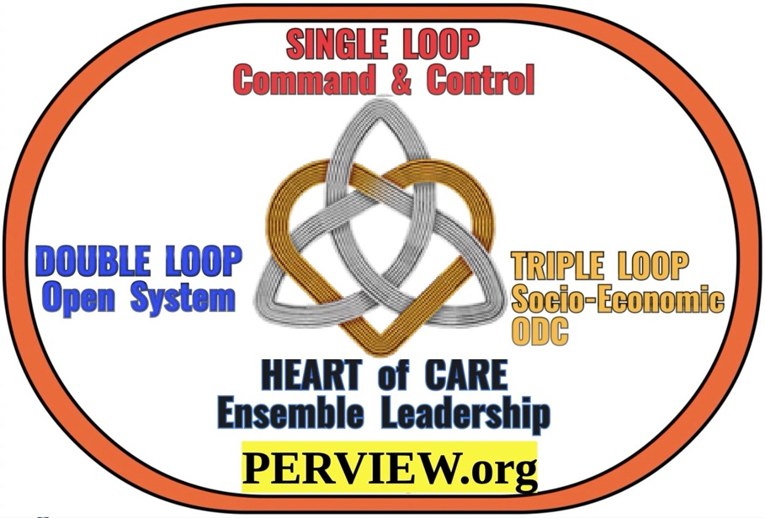
Boje and Rosile’s (2024, 2025a) Single, Double, and Triple Loop Model in Context

Single Loop (Shareholder Capitalism/Managerialism)
- Focuses on correcting deviations from preset goals (e.g., maximizing shareholder value) without questioning those goals.
- Implements cybernetic systems (feedback and control) to ensure compliance and efficiency.
- Over time, this has led to micromanagement, bureaucracy, and a stifling of innovation and agility, as organizations prioritize short-term financial metrics over broader value creation.

Double Loop (Stakeholder Capitalism/Adaptive Systems)
- Inspired by Argyris & Schön (1978), double loop learning questions underlying assumptions and values, not just actions.
- In stakeholder capitalism, this means organizations ask not just "Are we meeting shareholder targets?" but "Are these targets serving our broader mission and stakeholders?"
- Double loop learning introduces open systems thinking and deviation-amplification (allowing for innovation and adaptability), as described by Boulding and Boje.
- This rekindles agility, adaptability, and intrapreneurial innovation, countering the stagnation of single-loop managerialism.

Triple Loop GROWTH OD
- Boje and Rosile’s triple loop extends beyond the double-loop by integrating communication, cooperation, and coordination—the "3 Cs" of Savall and Zardet (2022)—across all stakeholder territories.
- This third loop fosters deep, systemic transformation, enabling organizations to build cultures of gratitude (Lemke), sustainability (Cooperrider, 2021; Cooperrider & Selian, 2021; Cooperrider & Fry, 2010), and the Axiogenics’ net value work (Demarest & Schoof 2010).
- Triple loop learning by Boje and colleagues operationalizes Savall & Zardet’s approach by recycling hidden costs into socio-economic performance, using Activity-Based Costing (ABC) and the D.P.I.E. process (Diagnostics, Project-planning, Implementation, Evaluation).
- The result is a move from extrinsic, short-term control to intrinsic, human-centered value creation—what Savall & Zardet call "socially responsible capitalism" and Cooperrider calls "stakeholder capitalism." Continue at Boje, D. M. (2925a). Triple Loop GROWTH OD and The Emergence of Stakeholder Capitalism in a Time of Shareholder Capitalism Decline June 26, 2025 WORD DOWNLOAD or access
PDF ONLINE.

I’m David Boje, the Director of GROWTH OD. For over four decades, I’ve helped Fortune 500 companies, government agencies, and frontline communities navigate deep change. My journey began as a scholar of storytelling in business, and evolved into pioneering what I call Quantum Storytelling—the idea that the stories we tell shape the systems we live in. In 2025, I was honored with the Lifetime Achievement Award from the Organization Development & Change Division, recognizing a lifetime of work restoring coherence to fractured organizations.

Togethed with Olivia Parr-Rud, we created the Five Pillars of GROWTH OD: Gratitude-Rooted Organizational Wisdom, Transformation & Healing.
"Our ensemble of organizational development consultants, coaches and artists is developing GROWTH OD: Gratitude-Rooted Organizational Wisdom, Transformation & Healing Your

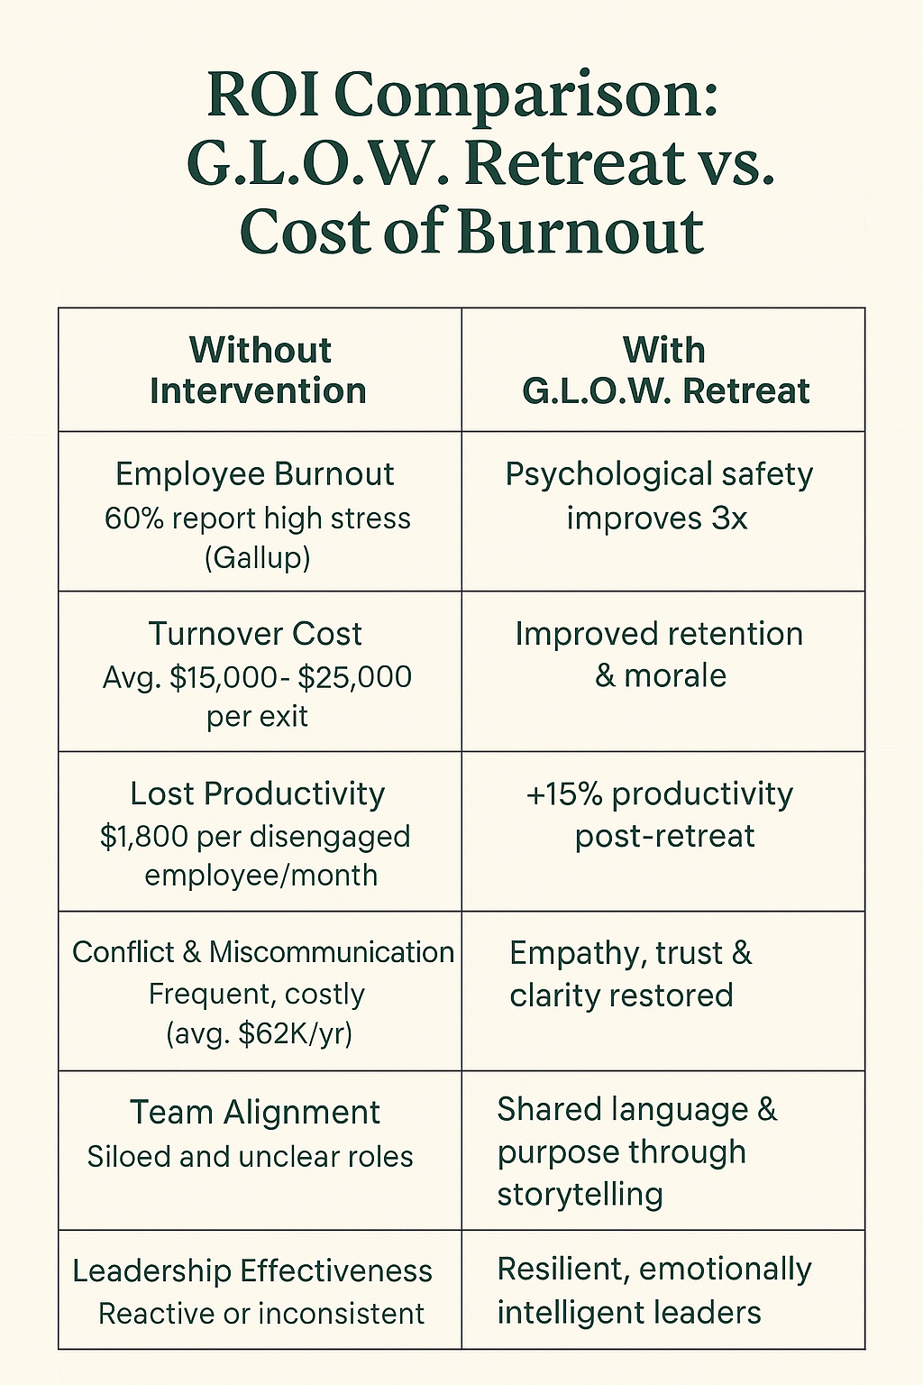

Practitioners: Your Call to GROWTH OD Ensemble Leadership
- Don’t settle for incremental change.
- Don’t just fix systems—transform them.
- Don’t just tell new stories—live them.

This is your invitation:
Step into ensemble leadership. Lead your organization into a new era—where logic is infused with love, soul animates systems, and every challenge is metabolized into presence and possibility.

American Organizational Development (OD) emerged in the mid-20th century as a response to the pressing need for organizations to adapt to rapid changes in their environments. Originally conceived as an anti-science movement, OD sought to bridge the gap between theory and practice, addressing the often-ignored human aspects of organizational change.

Historical Context
- Origins in the 1930s:
  - The roots of OD can be traced back to a group of psychologists who were dissatisfied with the binary choice between behaviorism and psychoanalysis. Behaviorism focused on observable behaviors, while psychoanalysis emphasized the unconscious mind. Many psychologists felt that neither approach fully addressed the complexities of organizational life.
  - Key figures in this movement included Kurt Lewin, who is often regarded as the father of OD. Lewin's work on group dynamics and change processes laid the foundational theories for OD practices.
- Kurt Lewin’s Contributions:
  - Lewin introduced the concept of "Action Research," a participative research method that emphasizes the involvement of stakeholders in the change process. This method aimed to break down resistance to change by incorporating employee feedback and fostering collaboration.
  - His "Three-Step Model" for change (Unfreeze-Change-Refreeze) remains a cornerstone of OD literature, illustrating the process organizations undergo during transformation.
- The Role of Psychologists:
  - The marginalized psychologists of the 1930s sought to create a middle ground between the rigid structures of behaviorism and the subjective interpretations of psychoanalysis. They emphasized the importance of understanding individual motivations, group dynamics, and organizational culture.
  - This approach led to innovative practices in management, focusing on the human side of organizations, including motivation, team dynamics, and leadership styles.

Evolution into New Age Mysticism
As OD evolved, it began to incorporate elements from various fields, including sociology, anthropology, and even spiritualism. This eclectic approach led to the emergence of what some critics termed "new age mysticism."
- Shift in Focus:
  - The focus on empirical research and scientific methodology began to wane, leading to the adoption of more holistic and sometimes esoteric practices. This shift attracted a diverse range of practitioners, some of whom prioritized personal development and transformational leadership over traditional organizational metrics.
- Management Gurus and Executive Whisperers:
  - The commercialization of OD led to the rise of management consultants and "executive whisperers," individuals who claimed to offer unique insights into organizational behavior. Figures like Peter Drucker, Tom Peters, and later Tony Robbins emerged as influential voices in the field, blending psychological insights with business acumen.

Modern Perspectives on OD
Today, OD has regained a more balanced approach, incorporating both scientific rigor and humanistic values.
- Evidence-Based Practice:
  - Current trends emphasize the importance of evidence-based practices. The integration of data analytics into OD practices allows organizations to make informed decisions based on empirical evidence rather than anecdotal experiences.
- Focus on Diversity and Inclusion:
  - Modern OD practices also emphasize the importance of diversity, equity, and inclusion. Understanding how diverse perspectives can enhance organizational effectiveness is a key area of focus.
- Technology and Remote Work:
  - The rise of technology and remote work has transformed OD practices. Organizations now utilize digital tools to facilitate communication, collaboration, and change management in increasingly virtual environments.
This book is written for those who suspect—perhaps know—that OD can do better. It is for consultants, coaches, organizational leaders, and scholars who are no longer content with “storytelling as magic” but want to know how to scientifically reclaim the magic itself.

Five Sciences for Organizational Healing
The scientific scaffolding of this work rests on five distinct yet interwoven frameworks:
- Socioeconomic Science – Drawing on the work of Henri Savall and the ISEOR Institute, this approach reveals “hidden costs” buried in dysfunctions—costs that standard accounting ignores, yet which cripple productivity, morale, and innovation. It integrates financial rigor with human diagnosis.
- Quantum Storytelling – Where classic OD reads stories as metaphors, quantum storytelling sees them as entangled fields of energy, possibility, and interference. Stories are not static—they collapse into patterns that shape reality, often unconsciously. This science makes narrative dynamics visible and actionable.
- Auxiliary Assumption Science – Based on the pioneering work of David Trafimow, this approach clarifies the unstated assumptions behind our theories and methods. By testing the testability itself, we expose the soft underbelly of much OD rhetoric and strengthen it with falsifiability.
- Neurolinguistics – Not just a coaching fad but a science of language, thought, and behavioral coding. Neurolinguistics in OD deciphers how internal scripts shape outward patterns—and how reprogramming these scripts at the cognitive-linguistic level enables sustainable culture change.
Each of these sciences on its own is powerful. But woven together through the methodology you’ll learn in this book—PERVIEW—they become something greater than the sum of their parts.

A Note on Voice and Audience
This book speaks in two registers at once.
First, it speaks to practitioners—the OD consultants, coaches, and HR leaders who live in the tension between visionary talk and structural inertia. You will find tools here. But more importantly, you will find voice. I write not just as a scholar, but as a field-tested change agent who has stood inside boardrooms, backstage breakrooms, and burned-out teams searching for meaning.
Second, it speaks to scholars—those who have long sought to build a true science of organizations, not just stories about them. Here you will find citations, logic models, falsifiability, and frameworks—all grounded in the latest research in systems science, narrative complexity, and the epistemology of organizational change.
What follows is neither memoir nor manual—but something in between. A fieldbook. A scientific story. A map for the next evolution of Organizational Development.

Tamara-Land Dilemma: You Can Only Be in One Room at a Time
To understand this breakdown, we turn to a metaphor I first developed in my 1995 analysis of Disney: Tamara-Land. The name comes from the play Tamara, in which audience members follow actors from room to room, never able to see the whole story. In organizations, the same thing happens. No one—neither executive nor frontline worker—gets the full picture. Each hall holds a different truth.
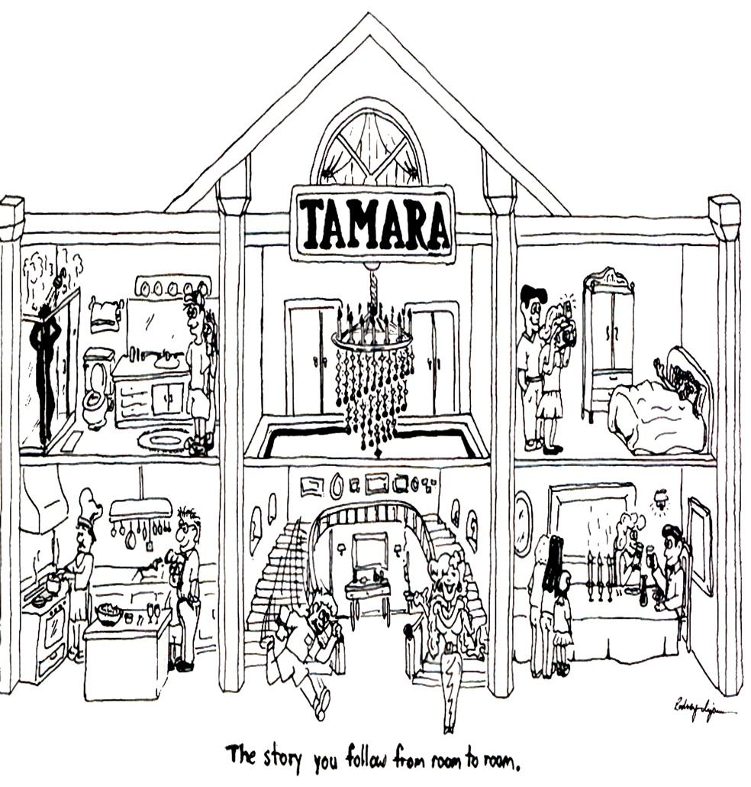
For example, when attending the play, I followed the chauffeur from the kitchen to the maid's bedroom; there she met the butler, who had just entered the drawing room. As they completed their scene, they wandered into different rooms, leaving the audience, myself included, to choose whom to follow. As I decided which characters to follow, I experienced a different set of stories than someone following another sequence of characters. No audience member gets to follow all the stories since the action is simultaneous, involving different characters in different rooms and on other floors.
At Disney, and organizations such as Kroger and Albertson’s this fragmentation is acute. Turnover tells one story.
This isn’t just complexity—it’s incoherence. And for millennials, whose generational identity is rooted in authenticity, transparency, and purpose, this incoherence becomes unbearable. They enter Disney expecting to live a dream. Instead, they’re asked to perform one—while silently navigating stories that contradict each other.

The True Cost of Disconnection
Let’s be honest: some turnover is inevitable. But what makes the current moment at Disney (and many large organizations) so dire is the cause of the turnover. It isn’t lack of talent. It isn’t lack of resources. It’s lack of narrative alignment. The company’s stated values are not showing up in daily reality. And employees can feel the gap in their bones.
We’ve found three dominant storylines among millennials at Disney:
- The Scripted Story: "Follow the rules. Smile. Stay in character."
- The Underground Story: "I’m exhausted. This isn’t what I signed up for."
- The Hopeful Antenarrative: "Maybe it could be different—if someone just listened."
This third category—the hopeful, unfinished story—is the one most worth listening to. It is where the possibility for transformation lives. But too often, leadership never hears it. Why? Because traditional OD doesn’t listen deeply enough. It hears data, not energy. It counts metrics, not meaning. And it fixes symptoms without addressing structure.

In summary:
GROWTH OD is a leading-edge, scientifically credible, and ethically grounded alternative for organizational transformation in a celebration of Stakeholder Capitalism
References
Anderson, H., & Goolishian, H. (1992). The client is the expert: A not-knowing approach to therapy. In Therapy as Social Construction.
Boje, D. M. (1993). On being postmodern in the academy: An interview with Stewart Clegg. Journal of Management Inquiry, 2(2), 191-200.
Boje, D. M. (1994). Organizational storytelling: The struggles of pre-modern, modern and postmodern organizational learning discourses. Management Learning, 25(3), 433-461.
Boje, D., & Dennehy, R. (1994). Postmodern Management: America's revolution against exploitation. Dubuque, IO: Kendall. Released 28 by Information Age Press: Charlotteville, South Carolina.
Boje, D. M., & Dennehy, R. (1992). Postmodern management principles: Just the opposite of modernist-bureaucratic principles. In Proceedings of International Academy of Business Disciplines (pp. 442-8).
Boje, D. M. (2001). Carnivalesque resistance to global spectacle: A critical postmodern theory of public administration. Administrative Theory & Praxis, 23(3), 431-458.
Boje, D. M. (2001). Corporate writing in the web of postmodern culture and postindustrial capitalism. Management Communication Quarterly, 14(3), 507-516.
Boje, D. M., Gephart, R., & Thatchenkery, T. (1996). Postmodern management and organization theory. Sage. Link
Boje, D. M. (2006). What happened on the way to postmodern? Qualitative Research in Organizations and Management: An International Journal, 1(1), 22-40. Link
Boje, D. M. (2011). Storytelling and the Future of Organizations: An Antenarrative Handbook. Routledge.
Boje, D. M. (2011). Theorizing after the Postmodern. In Challenges and controversies in management research (pp. 405-419). Routledge.
Boje, D. M. (2019). Stories of the storytelling organization: A postmodern analysis of Disney as “Tamara-Land”. In Postmodern management theory (pp. 421-459). Routledge. Reprint form Boje (1995) article in Academy of Management Journal.
Boje, D. M. (2001). Tamara manifesto. Tamara Journal of Critical Organisation Inquiry, 1(1), 15.
Boje, D., & Joh, T. T. (2006). Can chaebols become postmodern? Problems and Perspectives in Management, 1, 200-223.
Boje, D. M., & Rosile, G. A. (2025). Reclaiming the magic: A PERVIEW scientific approach to reducing millennial turnover at Disney. Las Cruces, NM: Tamaraland Press.
Boje, D. M., Rosile, G. A., Dennehy, R., & Summers, D. J. (1997). Restorying reengineering: Some deconstructions and postmodern alternatives. Communication Research, 24(6), 631-668.
Bushe, G. R., & Marshak, R. J. (2015). Dialogic Organization Development: The Theory and Practice of Transformational Change. Berrett-Koehler.
Cummings, T. G., & Worley, C. G. (2014). "Organization Development and Change." Cengage Learning.
Demarest, P. D., & Schoof, H. J. (2010). Answering the central question: How science reveals the keys to success in life, love and leadership. HeartLead Publishing.
Deslandes, G. (2020). The post-critical management turn: Towards a humanistic future. Philosophy of Management, 19, 135–150.
Kotter, J. P. (1996). "Leading Change." Harvard Business Review Press.
Lewin, K. (1946). "Action Research and Minority Problems." Journal of Social Issues.
Lemke, T. (2022). When God asks you... How will you answer? Independent publication. ISBN: 979-8986925905.
Orlikowski, W. J. (2007). Sociomaterial practices: Exploring technology at work. Organization Studies, 28(9), 1435–1448.
Parr-Rud, Olivia (2009). Business intelligence success factors: tools for aligning your business in the global economy (Vol. 18). John Wiley & Sons.
Rosile, G. A., Boje, D. M., & Claw, C. M. (2018). Ensemble leadership theory: Collectivist, relational, and heterarchical roots from indigenous contexts. Leadership, 14(3), 307-328.
Savall, H., & Zardet, V. (2011). The Qualimetrics Approach: Observing the Complex Object. Information Age Publishing: Charlotte, SC.
Savall, H., & Zardet, V. (2023). Socio-Economic Approach to Management Treatise: Theory and Practices. Information Age Publishing.
Savall, H., Zardet, V., & Bonnet, M. (2008). Mastering Hidden Costs and Socio-economic Performance. IAP.
Schein, E. H. (1992). "Organizational Culture and Leadership." Jossey-Bass.
Trafimow, D. (2024). Auxiliary Assumptions and the Crisis of Science. Current Research in Behavioral Sciences.
Whitney, D., & Trosten-Bloom, A. (2010). The Power of Appreciative Inquiry. Berrett-Koehler.

Meet The GrowthOD Steering Team

HOME | Contact | About | Who We Are | 5 Pillars | Free GrowthOD Book |

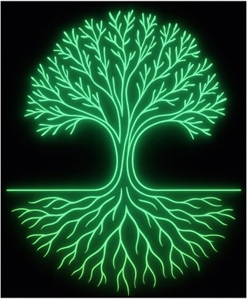

https://GrowthOD.org

Meet our Steering Team that brings decades of expertise in healing organizations through science, spirit, and story—customized for every client. David, Grace Ann, Tom, Olivia, and Ken. The Steering Team pilots GrowthOD towards projects that do good for society, bring about Stakeholder Capitalism, and Sustain our crew of Associate coaches and consultants.

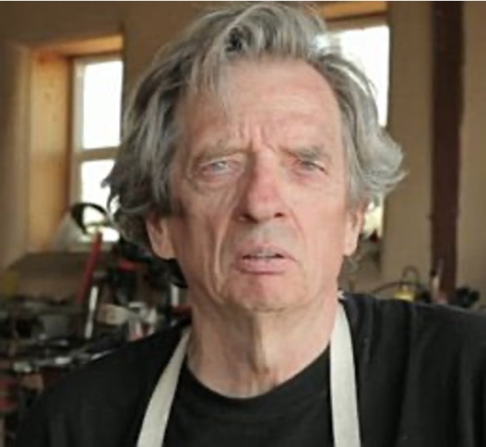
Hi, I am Dr. David Boje Ph.D. is a writer, social scientist, director of GrowthOD: Gratitude-Rooted-Organizational-Wisdom-Transformation-and-Healing. Dr. David earned his Ph.D. as an Organizational Development (OD) major at University of Illinois at Champaign-Urbana. He is a blacksmith artist. He earned his coaching

certificate from Genius Unlocked, became a Holy Fire Reiki Master, and has taught Socio-Economic-Approach-to-Management (SEAM) for 20 years at New Mexico State University, and went to France for 20 years to learn it from Henri Savall, Veronique Zardet, Marc Bonnet, and Amandine Savall. He received the Lifetime Achievement Award for International OD for his work in Organizational Development (OD). He is co-founder of the True Storytelling Institute (https://davidboje.com/vita).
He is the Director of GrowthOD. He is CEO of PerView, Inc., a 501(c)(3) nonprofit corporation, co-founded with Dr. Grace Ann Rosile. Dr David is dedicated to conducting evidence-based science in socio-economic and organizational development and transformation that heals the wounds of people, organizations, and societies. David's 3-Minute Latest YouTube Video Link


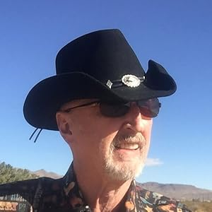

Meet Dr. Grace Ann Rosile, Ph.D. 3-Min YouTube (garosile@nmsu.edu), is an Emeritus Professor of Management at New Mexico State University. Author of Tribal Wisdom for Business Ethics. See book Her research interests include ethics, narrative, indigenous storytelling, restorying, and Ensemble Leadership. As an NMSU Daniels Fund Ethics Fellow for 5 years. She is the founder of Horse Sense At Work https://horsesenseatwork.com and co-founder of True Storytelling Institute, and the Quantum Storytelling Conference https://quantumstorytelling.org https://www.linkedin.com/in/grace-ann-rosile-a26b107/

Meet Tom Lemke 1-Minute YouTube,Tom Lemke is a global marketing executive, gratitude leader, and co-founder of the Quantum Wisdom Institute. A former chief marketing officer with decades of experience driving customer loyalty and corporate culture transformation, Tom now dedicates his life to helping organizations unlock human potential through gratitude, love, and faith-driven wellness. He is also the author of When God Asks You… How Will You Answer?, sharing his personal journey of faith and purpose. https://bit.ly/TomLemkeBooks https://giftfromtomlemke.com for Free Gift - Gratitude Journal.


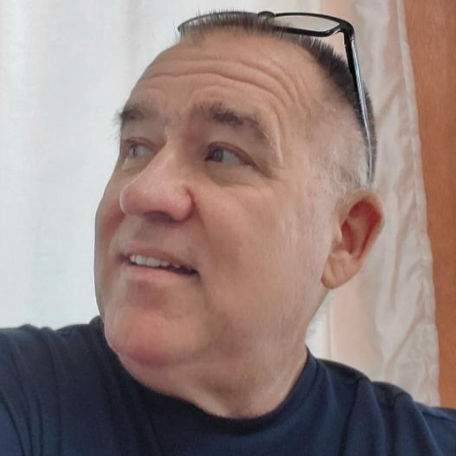
Meet Olivia Parr-Rud 85 Second YouTube Video For over thirty years, Olivia Parr-Rud has been an award-winning and best-selling author, speaker, and former data scientist. See Books. After her long corporate career in information science, she realized she was not ready to retire. And she felt that she had gained much wisdom that could help others. She noticed that many of her peers shared the same sentiment. She is co-founder, along with Tom Lemke, of the Quantum Wisdom Institute. Take the Free Quantum Wisdom Scan. https://www.linkedin.com/in/oliviaparrrud/

Meet Dr. Kenneth E. Long, a 1-minute YouTube Video, 4-Minute YouTube. Kenneth is an Associate Professor of ‘Change Management’ at the US Army Command & General Staff College, Ft Leavenworth, Kansas, a retired Lieutenant Colonel after 25 years of active Army service, certified in True Storytelling, and a Reiki Master. He operates BaseCamp for GrowthOD and for Traders. He works with a staff of over 7,000 faculty and is responsible for teaching over 200,000 students. Longke@Yahoo.com

The Steering Teams makes opportunities for our Associate Crew of Coaches and Consultants to be successful. Meet the GrowthOD Associates, trained in the 5 pillars.

- Start Here At the end of this coaching session what do you want to have achieved?
- When has the organization acted out of alignment with its stated values?
- What recurring metaphors or slogans do you hear?
- What negative emotion dominates the atmosphere in meetings?
- What questions have been avoided or silenced systemically?
- What new story is waiting to emerge in this organization?

Chapter 1: PERVIEW Pillar
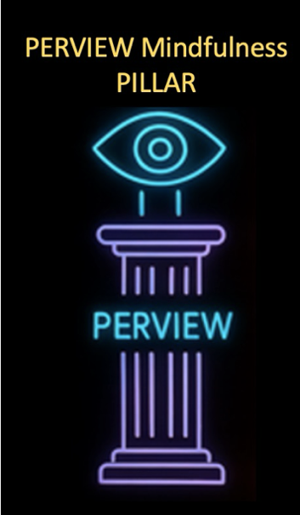
GrowthOD's PERVIEW stands for Processes, Embodied, Reasoning, Viewing, Internal, Energy, Waves.
GrowthOD's PERVIEW Methodology, co-developed with Dr. Grace Ann Rosile, stands for Processes of Embodied Restorying with Vibrations in Energy Waves. This methodology combines the narrative depth of storytelling with systems science, integrating a 7-step embodied change process (PER), vibrational coaching, and energy diagnostics. It offers CEOs, executives, coaches, and consultants a scientifically grounded roadmap for personal and organizational transformation. The purpose is to release stuck story filters, emotional blocks, and limiting beliefs through narrative transformation and vibrational energy, fostering high-vibration performance and creativity.
Impact: PERVIEW liberates energy and enhances engagement by restorying organizational narratives.

Take the PERVIEW Mindfulness Quiz Today

Context: Today’s fast-paced organizational environments demand leaders master transformative storytelling rooted in neuroscience and quantum principles. The brain’s hardwiring for story activates networks for memory, identity, empathy, and decision-making, making narrative a core leadership tool.
The core of this essay is the PERVIEW method: Processes, Embodied, Reasoning, Viewing, Internal, Energy, Waves. These steps operationalize neuroscience and quantum storytelling into a coherent practice of leadership coaching. To treat them as a list would be to miss their narrative power. They are not stages on a ladder but spirals in a dance, each returning to deepen the work.
GROWTH OD practitioners deploy the PER-VIEW framework in these paractices:
- P (Processes) — Where in the organization are stories getting stuck?
- E (Embodied) — What is the affective tone of embodiment in stories?
- R (Restorying) — What new narratives are possible once assumptions are surfaced?
- V (Vibrations) — What energetic signals (e.g., enthusiasm, dread) accompany current beliefs?
- I (Internal Thoughts) — What self-talk and internalized logics uphold the status quo?
- E (Energy rating) — How is collective vitality energy being channeled or blocked?
- W (Waves) — What quantum wave frequency patterns of meaning ripple across time and space? What does choice of a ne story do to that energy wave?

The PERVIEW Seven Steps in Practice

First, Learn this Basic PERVIEW ‘Restorying’ Method.

  - Characterize
  - Externalize
  - Sympathize
  - Revise
  - Strategize
  - Rehistoricize
  - Publicize

Always start your PERVIEW ‘Restorying’ session by asking: “Is it alright for your unconscious mind to release this story filter today and be aware of it consciously?”
Then always set the agenda: What is one thing you would like to accomplish by the end of this session?
- What can we focus on that will bring you highest net value?
- What would be of most importance to talk about?
- What can we talk about that would make a difference?

Step 1: Characterize Current dysfunctions and contradictions and the Organization at its Best
- Start Here What do you hope to have achieved by the end of this coaching session?
- What unspoken stories are present about unsafe or unhealthy working conditions?
- How is the current work organization adding to confusion or redundancy?
- Where do employees feel most cut off from the flow of communication or coordination?
- What moments in the day drain energy most?
- What is being ignored in time scheduling that masks real labor?
VIEW Cycle:
- V: What vibrations of your body do you feel here and now?
- I: What internal negative emotions, negative thoughts, and limiting beliefs are you experiencing here and now?
- E: What is your energy on a scale of 1–10 (highest) here and now?
- W: What wave of quantum choice will you make in the direction of your new story?

Step 2: Externalize Move the 'Problem Saturated Account' outside the person, into systems and shared patterns by giving it a Character Name
- How have training gaps created predictable role strain or dysfunctions?
- What role does policy (not personality) play in time mismanagement?
- Where is poor coordination a structural—not individual—issue?
- What system dynamics are driving the same failures across departments?
VIEW Cycle:
- V: What vibrations of your body do you feel here and now?
- I: What internal negative emotions, negative thoughts, and limiting beliefs are you experiencing here and now?
- E: What is your energy on a scale of 1–10 (highest) here and now?
- W: What wave of quantum choice will you make in the direction of your new story?

Step 3: Sympathize With the payoff for keeping habits in place; allow emotional truth to surface
- What do employees feel when asked to perform without adequate strategic direction?
- How has communication fatigue (too many meetings, not enough clarity) impacted emotions?
- What does the body say when given a chance to express the weight of dysfunction?
- Which past efforts were never honored, and how has that affected morale?
VIEW Cycle:
- V: What vibrations of your body do you feel here and now?
- I: What internal negative emotions, negative thoughts, and limiting beliefs are you experiencing here and now?
- E: What is your energy on a scale of 1–10 (highest) here and now?
- W: What wave of quantum choice will you make in the direction of your new story?

Step 4: Revise What are the consequences of keeping the habits as they are? Test revised narratives
- What does a more humane and effective training system look like in story form?
- What simple revision in time allocation might open space for wellbeing?
- What would improved work organization feel like, moment to moment?
- What one change in coordination could be tried this week?
- Remember to do the VIEW assessment so you can get client’s feedback on how they are doing and so you know what questions to ask.

Step 5: Strategize List 3 to 7 ‘Little Wow Moments’ that were exceptions to the usual way of handling things and turn them into plans
- What strategic implementation step can be tested immediately?
- What rituals or rhythms support better time management?
- How will integrated training be co-designed by the people doing the work?
- What 3 C’s protocol (e.g., daily huddles) can boost coordination?
VIEW Cycle:
- V: What vibrations of your body do you feel here and now?
- I: What internal negative emotions, negative thoughts, and limiting beliefs are you experiencing here and now?
- E: What is your energy on a scale of 1–10 (highest) here and now?
- W: What wave of quantum choice will you make in the direction of your new story?

Step 6: Rehistoricize Embed the new story into a timeline of past, present, and future—without the Problem-Saturated Account
- What legacy beliefs about working conditions are no longer valid?
- How did old ways of organizing work contribute to both success and stagnation?
- What stories of past coordination failures are now being healed through new practices?
- How is time and training being revalued through hindsight?
VIEW Cycle:
- V: What vibrations of your body do you feel here and now?
- I: What internal negative emotions, negative thoughts, and limiting beliefs are you experiencing here and now?
- E: What is your energy on a scale of 1–10 (highest) here and now?
- W: What wave of quantum choice will you make in the direction of your new story?

Step 7: Publicize Who can you tell, and who is in your support group? Share the new story publicly
- What story do we now talk about strategic excellence?
- What message do we want others to receive about our new training culture?
- How do we perform better communication through voice, posture, and ritual?
- What symbols (visuals, language, rituals) will transmit our new identity?
VIEW Cycle:
- V: What vibrations of your body do you feel here and now?
- I: What internal negative emotions, negative thoughts, and limiting beliefs are you experiencing here and now?
- E: What is your energy on a scale of 1–10 (highest) here and now?
- W: What wave of quantum choice will you make in the direction of your new story?

🔔 Closing Ceremony of Neurological Connections
- Box breathing (4–4–4–4) to settle the nervous system.
- State new leadership story aloud.
- Clap three times to somatically anchor.
- Ratify: “That was a big one, wasn’t it?”
Next, the Quantum timeline Version of PerView Restorying Method:
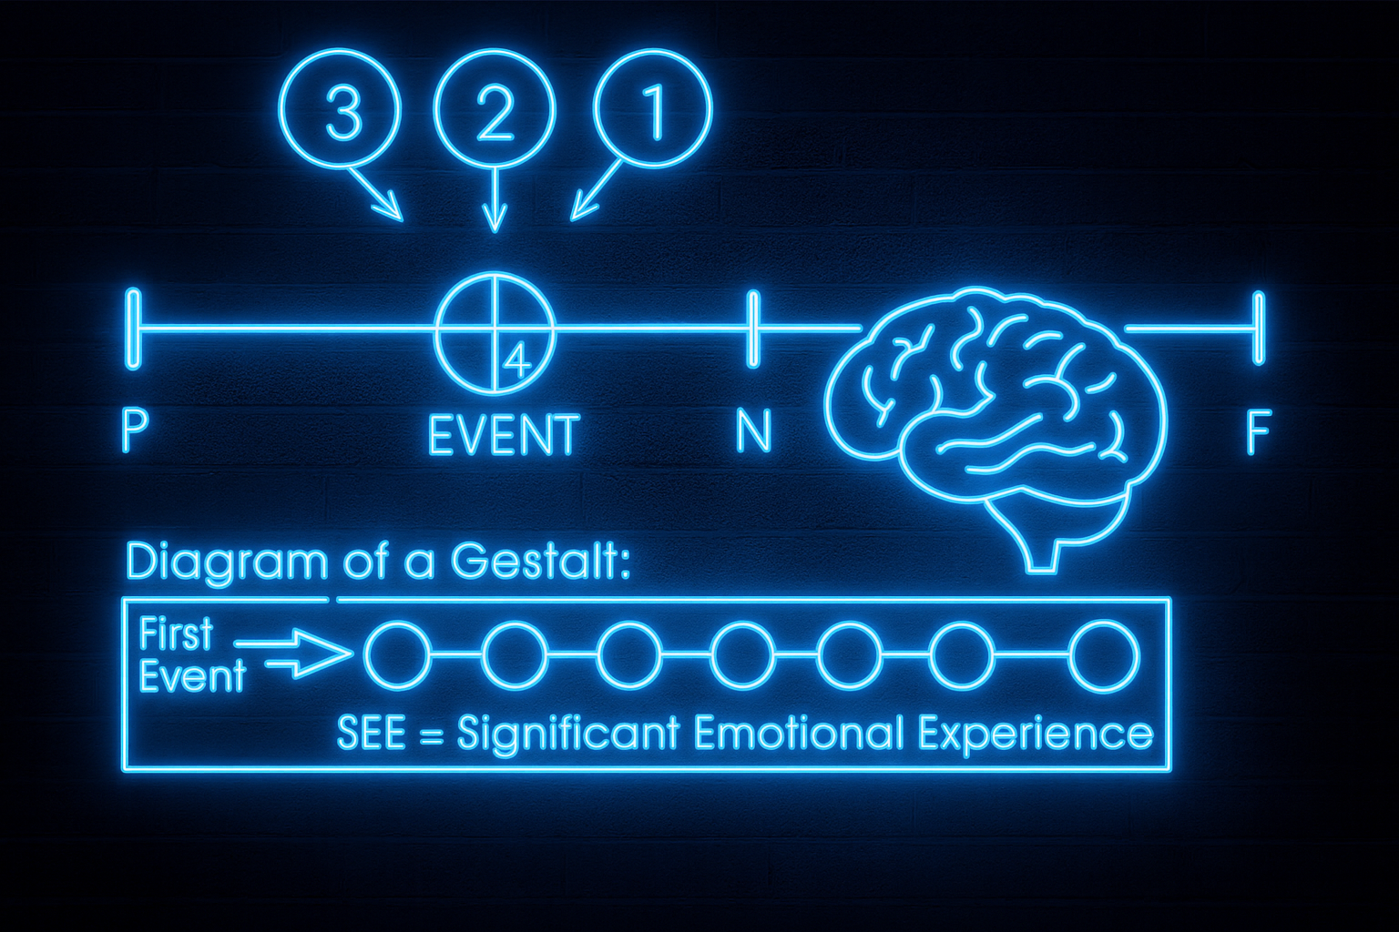
‘SEE’ is a term by Tad Jones. The auxiliary assumption is that by coaching above, before, and ahead of a stuck story filter, the Significant Emotional Experience of all the events from the first event until here and now, will collapse. To collapse a time wave is a quantum storytelling precept.
Quantum Timeline Prompts
- Find the First Event: “What is the root cause of this problem, the first event which, when disconnected, will cause the problem to disappear?”
- Model of the World: “If you were to know, was it before, during, or after your birth?”
Note: Asking this question, some people respond with a genealogical (ancestor) story, others will go to their past lives.
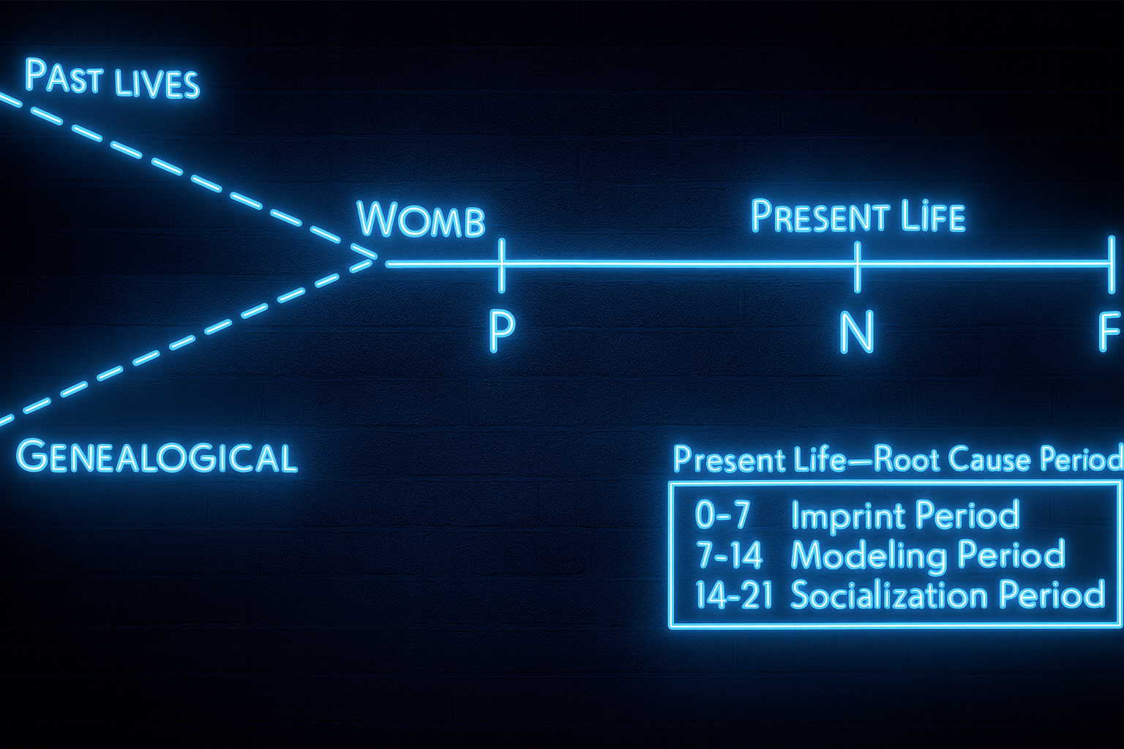
The auxiliary assumption of quantum time travel is that the 0-7 months period is the imprint period, at ages 7 to 14, modeling takes hold, and at ages 14-21, socialization takes hold. Try to get the client to their earliest event, whether it is a past life or a root cause period of impact. If they persist with the recent event, you will need to reassert the question, was there an earlier event.
Next, we will unpack the quantum storytelling and the neurological lens.
Always start your session by asking: “Is it alright for your unconscious mind to release this story filter today and be aware of it consciously?”
Then always set the agenda: What is one thing you would like to accomplish by the end of this session?
- What can we focus on that will bring you highest net value?
- What would be of most importance to talk about?
- What can we talk about that would make a difference?

PERVIEW Restorying Quantum Timeline 7 Steps with Quantum TLens

1) Characterize: “You at Your Best”
Help the client name their best self while noticing how quickly the PSA (Problem Saturated Account) creeps in.
Neuroscience lens. Beginning with strengths primes reward networks (dopamine) and engages vmPFC appraisals of value-congruent identity. Visualizing “best self” recruits the default mode network (DMN)—precuneus, medial prefrontal, posterior cingulate—supporting autobiographical imagination and sense-making. Framing identity first buffers amygdala threat reactivity when the PSA arises, and orients hippocampal encoding toward possibility rather than deficit.
Quantum-storytelling lens. Opening with “best self” sets the phase of the field: it tunes the narrative resonance you and the client will ride. In Tamara-land terms, you choose which “room” to start in; that selection alters downstream interference patterns among competing stories. The client’s “best-self” description is not a static trait but a wave of becoming that can be amplified.
Coaching Questions.
- “When you are at your very best, how do you show up?”
- “What qualities or strengths define you at your best moments?”
- “What story do you tell yourself when you are thriving?”
- “If others were to describe you at your best, what would they say?”
- “What difference does it make to begin with this version of you?”
Quantum Timeline prompts to locate origins.
“What is the root cause of this problem, the first event which, when disconnected, will cause the problem to disappear?”
“If you were to know, was it before, during, or after your birth?”
VIEW Cycle:
- V: What vibrations of your body do you feel here and now?
- I: What internal negative emotions, negative thoughts, and limiting beliefs are you experiencing here and now?
- E: What is your energy on a scale of 1–10 (highest) here and now?
- W: What wave of quantum choice will you make in the direction of your new story?

2) Externalize: Make the Problem the Problem
Separate the person from the problem by giving the PSA a label, character, or persona.
Neuroscience lens. Externalization increases cognitive reappraisal, shifting activity from amygdala to prefrontal control regions. Labeling (“name it to tame it”) engages the inferior frontal gyrus for language and reduces limbic load. This separation lowers ACC error-signal intensity (less self-threat), clearing bandwidth for executive functions.
Quantum-storytelling lens. Externalization collapses identification with a single storyline and re-casts the PSA as one actor in a multi-voiced field. By renaming “Micromanagement Monster” or “Stuck-in-the-Mud,” you alter its coupling strength within the story network—weakening its resonance with the client’s identity wave.
Coaching Questions.
- “If this problem story were a character, what would you name it?”
- “What image or symbol captures the way this problem shows up in your life?”
- “How does externalizing it change your relationship to it?”
- “What tricks does this character use to keep you stuck?”
- “If you were to face it as an opponent, how would you begin to respond?”
Client’s model of the world (verbatim prompts).
“If you were to know, was it before, during, or after your birth?”
— Womb: “What month?”
— Before: “Was it a past life or genealogical?” “How many generations ago?”
— If client says, “I don’t know”: “I know you don’t, but if you did… trust your unconscious mind.”
“Put a flag in Now and tie a string to a toe.”
VIEW Cycle:
- V: What vibrations of your body do you feel here and now?
- I: What internal negative emotions, negative thoughts, and limiting beliefs are you experiencing here and now?
- E: What is your energy on a scale of 1–10 (highest) here and now?
- W: What wave of quantum choice will you make in the direction of your new story?

3) Sympathize: Find the Payoff
Uncover the small reward or benefit that keeps the PSA in play.
Neuroscience lens. The brain conserves familiar strategies because they deliver predictable dopamine micro-rewards and perceived safety. Payoffs are tracked in OFC/striatum; acknowledging them reduces ACC conflict and amygdala defensiveness, enabling genuine shift. Naming the payoff reframes behavior as an attempted value solution, not a moral failure.
Quantum-storytelling lens. The payoff is the PSA’s energy source—the coupling that keeps the old wave coherent. When you respect its intention, you preserve the positive learning while allowing the old phase pattern to decohere.
Coaching Questions.
- “What do you get out of holding onto this problem story?”
- “What comfort or protection has it given you?”
- “In what ways does this story keep you safe, even if it limits you?”
- “How does the payoff make it hard to let go?”
- “If you honored the intention behind the payoff, what new story could meet that need better?”
Quantum Timeline movement (verbatim).
“Float up in the air to Position #1, facing the past, and notice the event and where the emotions are.”
“Now float to Position #2 directly above the event; preserve the positive learnings; notice where the emotions are.”
Coach checks: “Get up higher, and float farther back until the emotion disappears.”
VIEW Cycle:
- V: What vibrations of your body do you feel here and now?
- I: What internal negative emotions, negative thoughts, and limiting beliefs are you experiencing here and now?
- E: What is your energy on a scale of 1–10 (highest) here and now?
- W: What wave of quantum choice will you make in the direction of your new story?

4) Revise: Notice the Consequences
Explore the costs of staying stuck in the PSA.
Neuroscience lens. Prolonged dissonance (ACC) with high amygdala tone burdens the HPA axis, impairing immune function and decision quality. Mapping consequences recruits insula interoception (felt cost) and strengthens vmPFC value-realignment toward health and meaning. This contrast updates OFC valuations (“the price is too high”).
Quantum-storytelling lens. Surfacing consequences exposes the destructive interference patterns the PSA creates across rooms in Tamara-land—missed collaborations, trust erosion, innovation drag. Seeing the systemic ripples loosens the PSA’s attractor state.
Coaching Questions.
- “What has been the price of living inside this old story?”
- “How has it affected your relationships, your work, your body, your spirit?”
- “What opportunities have you missed because of it?”
- “If you continued down this path, what future would it lead to?”
- “How does this story keep you smaller than you truly are?”
Timeline verification (verbatim).
“Float to Position #3—before and above the event—looking toward now. Where are the emotions now?”
Optional test: “Float down to Position #4, through your own eyes—are they there or gone? Good, return to #3.”
VIEW Cycle:
- V: What vibrations of your body do you feel here and now?
- I: What internal negative emotions, negative thoughts, and limiting beliefs are you experiencing here and now?
- E: What is your energy on a scale of 1–10 (highest) here and now?
- W: What wave of quantum choice will you make in the direction of your new story?

5) Strategize: Find Little Wow Moments (LWMs)
Surface 5–7 exceptions when the PSA did not define you.
Neuroscience lens. Recalling exceptions engages hippocampal pattern separation and strengthens alternative neural routes; each LWM is a rehearsal that potentiates new synapses (Hebbian learning). Sharing LWMs with a coach induces neural coupling (Hasson) that amplifies coherence and motivation.
Quantum-storytelling lens. LWMs are micro-instances where another future already broke through—antenarratives that never got center stage. Collecting 5–7 creates a constructive fractal that can out-resonate the PSA and seed a new attractor.
Coaching Questions.
- “Can you recall a time when the problem wasn’t there, even briefly?”
- “When have you surprised yourself by rising above it?”
- “What are five to seven Little Wow Moments when you acted differently?”
- “What do these Wow Moments reveal about your true nature?”
- “If those Wow Moments were seeds, what future story could they grow?”
Timeline clearing (verbatim).
“Come back along your timeline only as quickly as you can let go of the (negative emotion) on the events all the way back to now—assume Position #3 at each event, preserve the learnings, and let go of the emotions.”
If emotion persists: “Preserve all positive learnings in that special place, and then it’s OK to let the emotions go now, isn’t it?”
VIEW Cycle:
- V: What vibrations of your body do you feel here and now?
- I: What internal negative emotions, negative thoughts, and limiting beliefs are you experiencing here and now?
- E: What is your energy on a scale of 1–10 (highest) here and now?
- W: What wave of quantum choice will you make in the direction of your new story?

6) Rehistoricize: Rewrite Your Story
Recast the past, foregrounding LWMs instead of PSA.
Neuroscience lens. Memory is reconsolidated each time it’s recalled; narrating with LWM anchors rewrites hippocampal traces under prefrontal guidance, while vmPFC integrates new value coherence. Speaking the new history recruits language networks (IFG/STG/MTG) and DMN—hardwiring an updated identity narrative.
Quantum-storytelling lens. Rehistoricizing changes interference across the whole field—past, present, future. You’re not erasing events; you are retuning their weights so a different storyline becomes dominant.
Coaching Questions.
- “If you retell your history beginning with your Wow Moments, what changes?”
- “What themes of resilience, courage, or creativity emerge in this version?”
- “How does the old problem story lose its grip when told from this angle?”
- “What new meaning do you see in your past now?”
- “How does this new history point toward a different future?”
Safety, learning, and prime directives (verbatim).
“What is there to have learned from this event, the learning of which will allow you to let go of the emotions easily? Won’t it be better to preserve the learning than the emotions?”
“The negative emotion doesn’t protect you; it hurts the body. Wouldn’t it be better to let go of the emotion and meet the need in a healthier way?”
“Not letting go conflicts with the unconscious mind’s prime directive to preserve the body.”
VIEW Cycle:
- V: What vibrations of your body do you feel here and now?
- I: What internal negative emotions, negative thoughts, and limiting beliefs are you experiencing here and now?
- E: What is your energy on a scale of 1–10 (highest) here and now?
- W: What wave of quantum choice will you make in the direction of your new story?

7) Publicize: Share & Anchor the New Story
Identify witnesses and allies to reinforce the client’s new story.
Neuroscience lens. Public commitment engages social reward circuitry (oxytocin pathways, striatum) and strengthens long-term memory via repeated retrieval. Social reflection (mirror-system resonance) normalizes the new identity and sustains prefrontal regulation when stress hits.
Quantum-storytelling lens. Sharing alters the organizational field—it seeds the new wave into other rooms of Tamara-land, creating positive entrainment. Allies keep the phase aligned when the PSA tries to re-cohere.
Coaching Questions.
- “Who needs to hear your new story so it becomes more real?”
- “Who can remind you of this story when you forget?”
- “What kind of support group would help you stay true to it?”
- “How will you celebrate progress when you live into this new narrative?”
- “What commitments will you make to share and embody this story daily?”
Future pace & ratify (verbatim).
“Step into the future and watch yourself living the new story—notice the choices that ripple out.”
“That was a big one, wasn’t it?” (Conscious acknowledgment of shift.)
VIEW Cycle:
- V: What vibrations of your body do you feel here and now?
- I: What internal negative emotions, negative thoughts, and limiting beliefs are you experiencing here and now?
- E: What is your energy on a scale of 1–10 (highest) here and now?
- W: What wave of quantum choice will you make in the direction of your new story?

Closing Ceremony
Box breathing (4-4-4-4) calms the autonomic nervous system, lowering amygdala arousal and improving prefrontal integration. The client states the new story aloud (language networks + DMN reconsolidation) and claps three times—a somatic anchor pairing motor cortex activation with narrative commitment. The ritual signals a quantum phase change: from PSA coherence to LWM-aligned becoming.

The Three Things to Check at Position #3 (coach checklist)
- Ensure the client is truly at Position #3 (high/early enough that the emotion disappears).
- Confirm they are before the first event (“Is there an event earlier than this one?”).
- Confirm willingness to let go of the emotion by preserving learnings and meeting needs safely.

Brains are Hard-Wired for Story
Humans are biologically “hardwired for story,” a concept supported by neuroscience, psychology, and organizational studies. This section explores how neural networks, memory systems, and emotional circuitry converge to make storytelling the foundation of thought and identity.
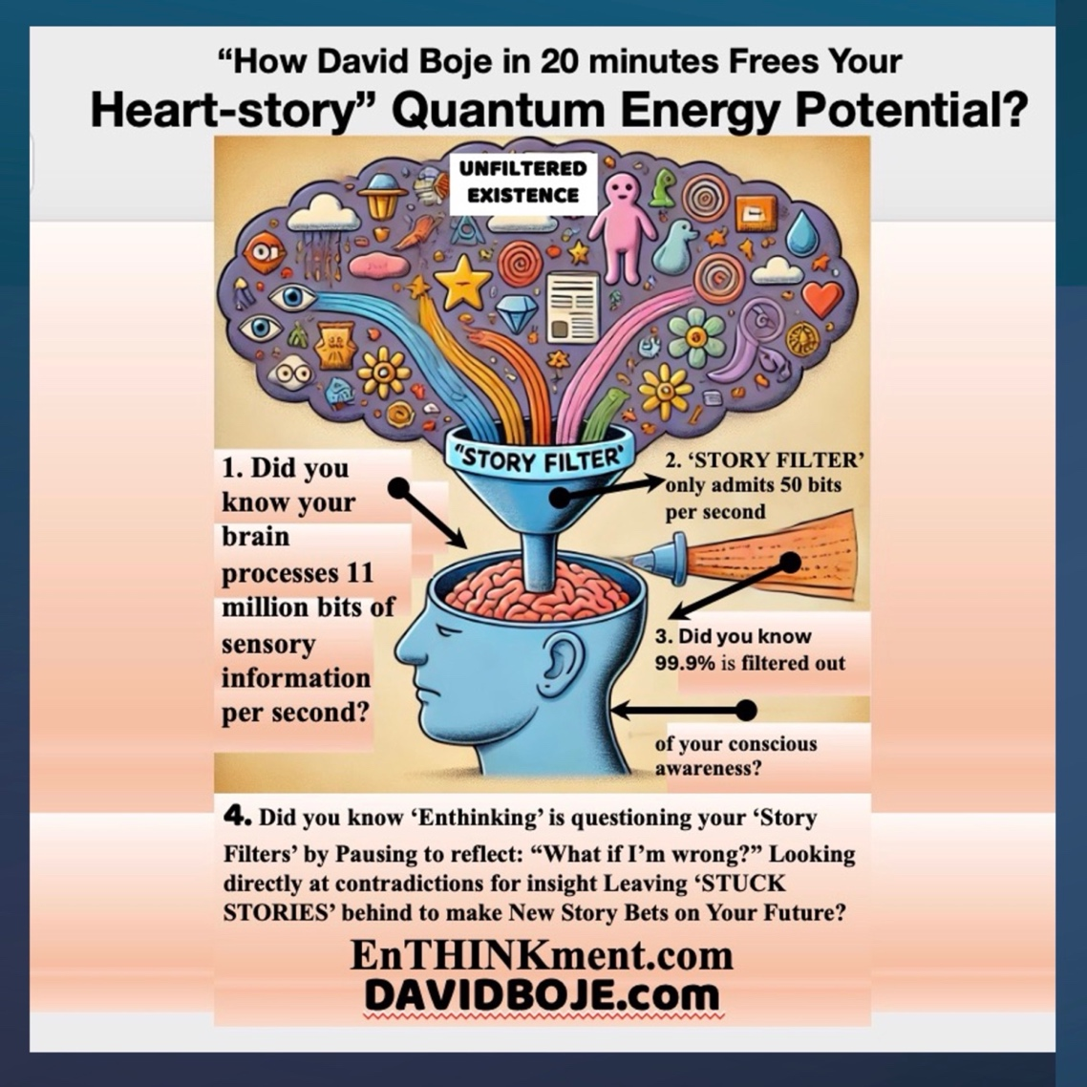
Story Filters: David Boje’s concept of story filters shapes how we process the 11 million bits of sensory input per second, reducing it to 50 bits via subconscious selection (Boje & Rosile). These filters, as Peter Demarest and Harvey Schoof (2010) note, judge life experiences and guide actions. A doom-focused filter can reinforce negative outcomes, while shifting it opens new perspectives.

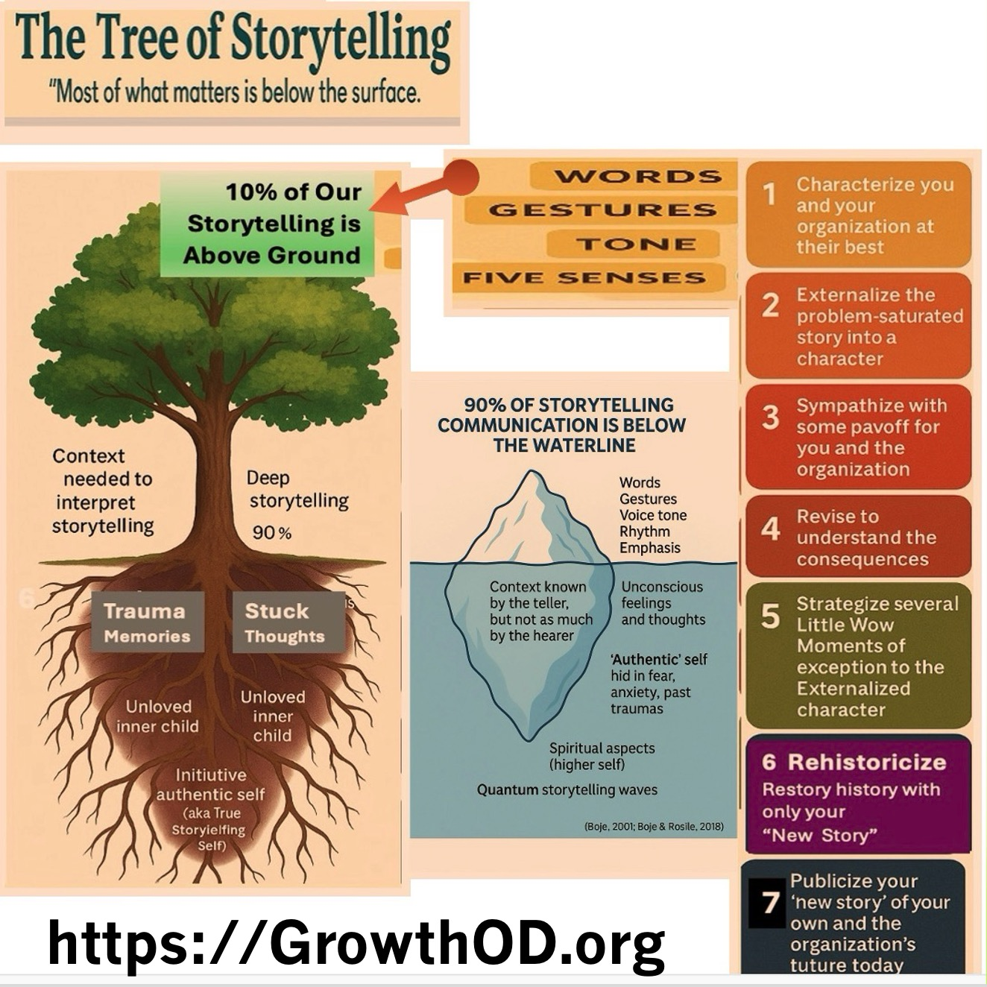

Neural Activation: Listening to stories activates Broca’s and Wernicke’s areas for language, the amygdala for emotion, the hippocampus for memory, and the precuneus for self-identity. Uri Hasson (2010) demonstrated neural coupling between storyteller and listener, while Paul Zak (2015) linked narratives to oxytocin and dopamine release, enhancing trust and motivation.
Fragility and Possibility: Cognitive dissonance, tracked in the anterior cingulate cortex (ACC), signals value clashes. PERVIEW leverages this to reframe narratives, turning story into a tool for creative transformation.
Reflection: Identify a life story step needing renewal.
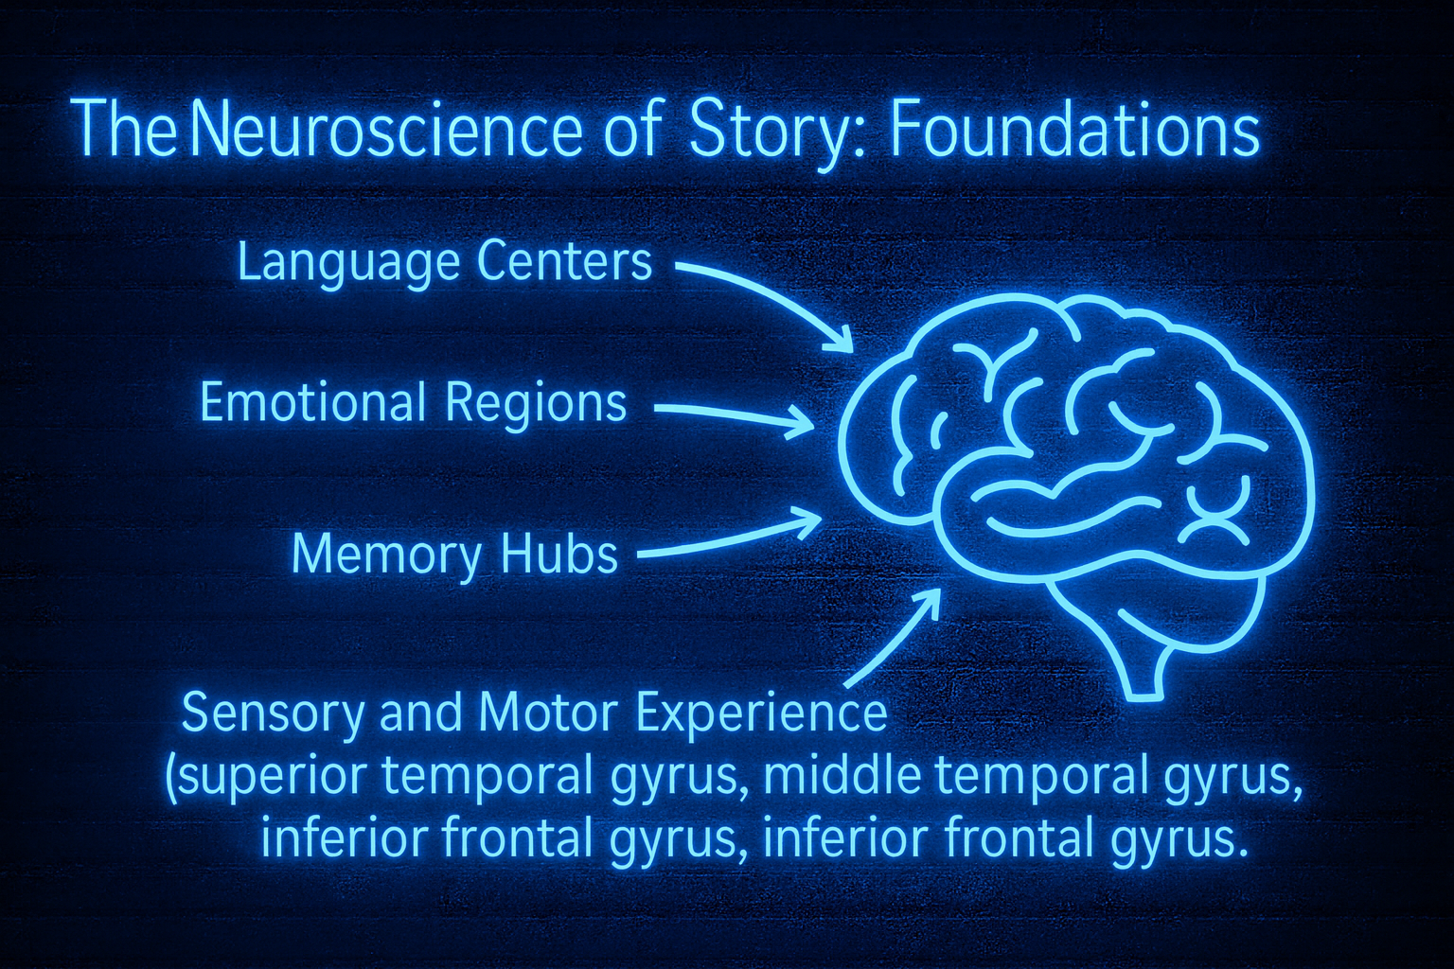
Yet neuroscience also uncovers the fragility of story. Leon Festinger’s theory of cognitive dissonance finds its neural signature in the anterior cingulate cortex (ACC). This region activates when there is a clash between belief and behavior, value and action. The discomfort we feel when our actions betray our principles is not abstract guilt—it is a neural alarm. Practitioners in executive coaching encounter this constantly under the name value dissonance: the lived experience of a leader whose intrinsic values are at odds with extrinsic performance demands or systemic rules. Neuroscience helps us see that this clash is not just psychological but biological. The body feels it, the brain encodes it, and the leader’s behavior reveals it.

Neurological Mechanisms and Quantum Storytelling
Quantum Storytelling Methodology: This approach integrates neuroscience, quantum physics, and storytelling wisdom into the Quantum Storytelling Model (QSM), using four pillars of change. Lisa Cron (2012) and Mary Helen Immordino-Yang (2011) highlight story’s survival role, embedding emotional lessons deeply.
Organizational Impact: A CEO’s resilience story boosts empathy and trust, while fractured narratives trigger dissonance. PERVIEW bridges neuroscience’s hardwiring with quantum storytelling’s emergent frame, emphasizing embodied, collective energy.

Quantum Storytelling and the Field of Entangled Narratives
Quantum storytelling, by Boje and Rosile, views organizations as storyfields where narratives entangle across time and space. Unlike linear narrative theory, it introduces:
- Antenarrative: Pre-coherent story fragments shaping the future.
- Fractal Storytelling: Repeating patterns across scales.
- Entanglement: Interconnected stories influencing outcomes.
- Kairos Time: Moments of narrative shift.
Practical Relevance: Linear fixes fail in this complexity. PERVIEW helps leaders navigate entangled storylines, reframing dissonance into coherence.

A Neurological Model for PERVIEW
Antonio Damasio (1994) established that emotions drive brain activity, with the prefrontal cortex and ACC using them for decision-making. This underpins PERVIEW’s narrative-centric, embodied coaching, addressing leadership challenges.

Advanced Applications: PERVIEW locates stuck points, shifts to embodied awareness, challenges beliefs, and expands to emergent futures, restoring coherence.

Coaching with Narrative Intelligence
Coaching, a collaborative dialogue, develops narrative intelligence. PERVIEW’s steps transform lives and organizations.

Integrating PERVIEW with Sandtray Tool
PERVIEW maps onto sandtray and the Therapeutic Spiral Model (TSM) for trauma recovery and team building:
- Characterize at Your Best: Use objects to represent strengths.
- Externalize the Problem: Assign objects to label the issue.
- Sympathize with Payoff: Reflect on benefits of old patterns.
- Revise: Visualize consequences of staying stuck.
- Strategize: Place objects for “Little Wow Moments.”
- Rehistoricize: Retell history without problem accounts.
- Publicize: Add support objects and share.
TSM’s spiral imagery enhances this, moving clients from trauma to new stories.

Applying the Seven PERVIEW Restorying Steps to the Sandtray Tool
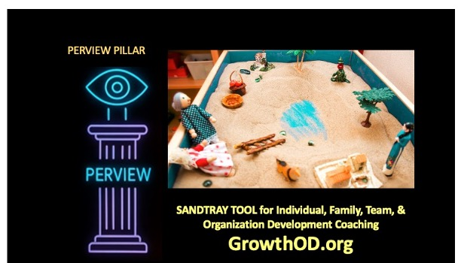
Here is how the seven steps of PERVIEW from GrowthOD.org can map onto Sandtray tool, while drawing insights from the Therapeutic Spiral Model (TSM). This framework (Process of Embodied Restorying) we call PER’s can support trauma recovery, family reintegration, team building, organization redesign, and the creation of “New Stories” that transcend problem-saturated accounts (PSA).
1. Characterize at Your Best
In Sandtray PER & TSM:
Invite each participant (veteran, spouse, child or team of an organization) in Phase 1 (Story Generation) to select objects representing themselves at their best—moments or strengths they hold dear. This initial, nonverbal assembly encourages a reflexive, embodied sense of agency rather than focusing on deficits. The act of creating sandtray assemblages in silence allows for deep individual sensemaking and positive characterization.
2. Externalize the Problem (Label, Not Person)
In Sandtray PER & TSM:
Utilize the sandtray to assign a specific object or material to represent the “problem story filter”—PTSD, TBI, or any recurring negative conflict stuck story filter theme—externalizing it from the person. By placing the problem outside the self in the sandtray, the issue becomes a tangible challenge to be addressed, rather than an internal flaw. This aligns with (Process of Embodied Restorying) we call PER’s capacity to materialize problem-saturated accounts, making them distinct from the individuals involved. TSM enhances this process by encouraging clients to visually and cognitively label the “problem spiral” present in their sandtray experience.
3. Sympathize with Payoff for the Stuck Story Filter
In Sandtray PER:
Reflect on the benefits or payoffs that the stuck story provides—perhaps security, avoidance of pain, or loyalty to past narratives. Within the sandtray, these payoffs may be represented by certain objects kept close to the problem artifact. Therapists can invite discussion about why these payoffs were needed and how they helped cope, rather than criticizing the stuck pattern. This emotional work is supported by ERP’s Phase 2 (Support Side of the Story), revealing how old patterns fulfilled important roles.
4. Revise: Consequences of Staying Stuck
In Sandtray:
Invite participants to look closely at their sandtray arrangements and narrate (either verbally or symbolically) the ongoing consequences of remaining tied to the old problem filter. Which relationships, opportunities, or feelings are blocked or frozen? This revisiting can occur visually—moving objects to display “distances,” “barriers,” or “losses” that the stuck filter causes. ERP facilitates this by letting storytellers reconfigure their tray to explore blocked pathways and assess impact.
5. Strategize: Recall ‘Little Wow Moments’ (LWMs)
In Sandtray PER:
Encourage the identification and placement of at least five objects representing exceptions—“Little Wow Moments” when the problem did not dominate, and something different or positive broke through. These LWMs are physically embodied in the sandtray, building a landscape rich in resilience. This allows for a more nuanced narrative where hope and strength are visible. PER’s objective is exactly this: to gather moments of exception and assemble them as foundational elements of a new story.
6. Rehistoricize: Retell Without Problem-Saturated Account (PSA)
In Sandtray PER:
Guide the client or family to “rehistoricize” their sandtray, retelling their history by integrating the five (or more) LWMs and other strengths, excluding the problem-saturated account. Through active rearrangement, they create a new sandtray scene that showcases growth, agency, and coherence that isn’t restricted by the old filter. This is a visual and embodied restorying, making the new narrative tangible and, in effect, practicing new meaning-making spirals in TSM terms.
7. Publicize: Tell the New Story and Identify Support
In Sandtray PER:
Move toward Phase 5 (Support from External Members): Have the client or family describe their “New Story” to others, perhaps supported by a sharing circle, letter writing, or group reflection. Place objects representing supportive group members (therapist, family, peers, veterans, friends) in the sandtray, forming a visible support network. This group will help maintain the new story and keep reminders to avoid falling back into the PSA “rabbit hole.” PER and TSM both advocate for community and external reminders as anchors to the new story.

Combining Sandtray ERP and Therapeutic Spiral Model (TSM)
- Sandtray PER can incorporate TSM’s spiral imagery:
  - Visual objects/symbols in the tray represent energy, experiencing, and meaning.
  - Clients can consciously move objects to experience shifting up/down the spiral—actively engaging with trauma, support, and new sensemaking.
  - Therapists use the spiral metaphor to help clients notice when they're “pulled” into the past and make choices about where to focus in the present.
In Practice:
YES, the sandtray method in PER can embody TSM’s triple-stranded spiral, making visible the tensions and movements between energy, experience, and meaning. It offers a dynamic, tangible way to spiral down into old trauma, but then build upward spirals through LWMs, support networks, and publicizing new stories to maintain momentum.

Summary Table: Mapping PERVIEW to Sandtray Tool
PERVIEW Step | Sandtray Phases
1. Characterize at Your Best | Phase 1: Nonverbal self-representation with objects, highlighting strengths
2. Externalize the Problem | Label problem objects in sandtray, make issue tangible, outside the self
3. Sympathize with Payoff | Explore why problem filter existed, symbolize payoffs with objects
4. Revise: Consequences | Visualize losses/blockages in tray, narrate barriers caused by staying stuck
5. Strategize: At least five LWMs | Place objects to embody moments of exception, gather “Little Wow Moments”
6. Rehistoricize | Retell tray history, emphasize LWMs, unresolved growth, leave out the PSA
7. Publicize and Support Group | Add support objects, share new story, identify reminders and anchors

By integrating PERVIEW with PER and TSM, sandtray therapy becomes a quantum storytelling tool, helping families and veterans, executives, teams in organizations and organization redesign teams to spiral up from trauma and create vibrant, embodied new futures.

Story Filters and Frameworks
Story Filters: Boje and Rosile identify linear, scarcity, hierarchical, failure, and bounded rationality filters. Karl Weick’s (1969) sensemaking reduces equivocality, while Boje’s enthinkment questions these filters.Comparisons:
- NLP (Bandler & Grinder, 1975): Focuses on cognitive restructuring, criticized for lacking rigor.
- Weick’s Enactment: Retrospective, linear sensemaking.
- ERP: Embodied, fractal, prospective storytelling.
Enthinkment: Boje and Saylors (2023) propose this as emergent, dialogical thinking, akin to Heidegger’s mindfulness, challenging past sensemaking.

The Seven B’s of Antenarrative and PERVIEW Mindfulness
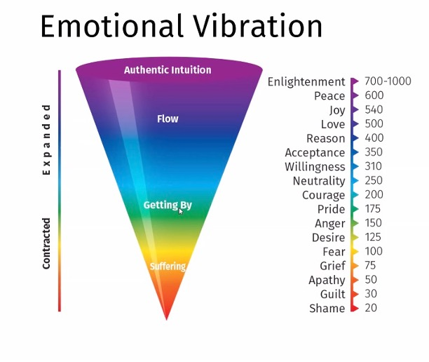
The seven B’s (Bet, Before, Between, Beneath, Becoming, Being, Beyond) guide nonlinear sensemaking. PERVIEW mindfulness, inspired by Heidegger, links high-vibration emotions (love, joy) to energy shifts, contrasting with low-vibration states (anger, shame).Emotional Vibrational Frequency (EVF):
- High: Enlightenment (700-1000), Peace (600), Joy (540), Love (500).
- Maintenance: Reason (400), Acceptance (350), Courage (200).
- Low: Pride (175), Anger (150), Fear (100), Shame (20).

“Integrating Holy Fire® Reiki with the Seven PERVIEW Restorying Steps into Mindfulness Coaching”
Dr. David Boje, founder of GrowthOD.org, is now a certified Master in Holy Fire® Reiki I, II, and III. He was trained by Vanessa Rud and Lucero Rodriguez. This powerful energy healing modality enhances the depth and transformative power of PERVIEW Coaching by adding a dimension of continuous energetic purification, inner guidance, and trauma-responsive care that extends across the entire 7-step PERVIEW process.
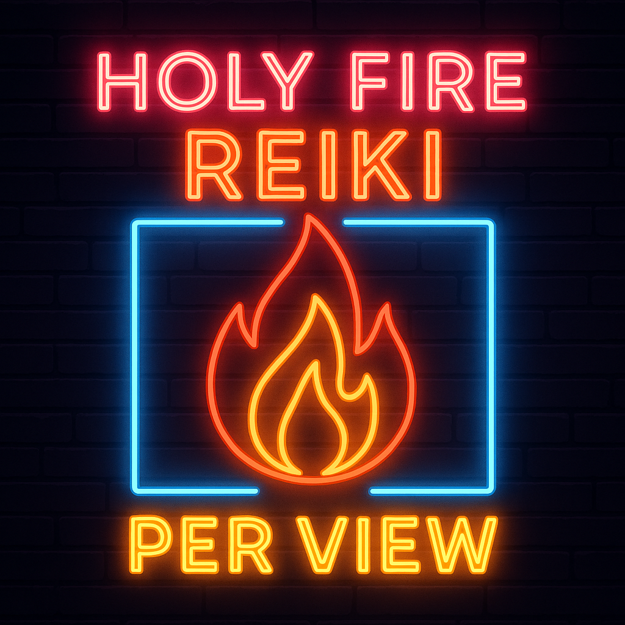
Figure: Three flames relate to the Triple-Loop Interventions of https://GrowthOD.org
What is PERVIEW? The PERVIEW Mindfulness Coaching. PER stands for ‘Processes of Embodied Restorying with ‘VIEW’ (Vibrations of the body, Internal negative emotions and thoughts to restory, Energy rating of the client on scale of 1 to 10, and Waves of collapsing quantum energy by new future choice self-assessments—emphasizes mindfulness and holistic development. Holy Fire® Reiki complements this framework in several outcomes:
- Enhanced Self-Awareness and Emotional Regulation: Holy Fire® Reiki facilitates deep relaxation and emotional healing, enabling individuals to become more attuned to their inner experiences. This heightened self-awareness supports the PERVIEW steps of recognizing and reshaping personal narratives, leading to more authentic leadership and interpersonal interactions.
- Stress Reduction and Resilience Building: By promoting relaxation and reducing stress, Holy Fire® Reiki helps individuals navigate organizational challenges with greater resilience. This aligns with PERVIEW's emphasis on adaptability and continuous growth, fostering a culture of well-being and sustained performance.
- Alignment with Organizational Values and Purpose: The spiritual and ethical dimensions of Holy Fire® Reiki encourage individuals to connect with their core values and purpose. This alignment enhances the PERVIEW process of integrating personal and organizational narratives, leading to more cohesive and purpose-driven teams.

Benefits for GrowthOD Coaches and Consultants
Incorporating Holy Fire® Reiki into our coaching and consulting practices offers several advantages:
- Deepened Client Engagement: The calming and centering effects of Reiki create a safe space for clients to explore their challenges and aspirations more openly.
- Enhanced Intuitive Insight: Practitioners often experience heightened intuition, allowing for more insightful guidance and support tailored to each client's unique journey.
- Complementary Healing Modality: Reiki serves as a non-invasive, holistic tool that complements traditional coaching methods, addressing both the emotional and energetic aspects of personal and organizational development.

Relevance to Medium and Large-Scale Corporations
For larger organizations, integrating Holy Fire® Reiki into development programs can lead to:
- Improved Employee Well-Being: Regular Reiki sessions can reduce workplace stress, leading to increased job satisfaction and reduced turnover.
- Enhanced Leadership Effectiveness: Leaders trained in Reiki may exhibit greater empathy, clarity, and decision-making capabilities, fostering a more compassionate and effective leadership style.
- Cultural Transformation: Embedding Reiki principles into organizational culture can promote values of mindfulness, integrity, and holistic growth, aligning with contemporary movements towards conscious capitalism and sustainable business practices.

Master-trained Holy Fire® Reiki coaches are equipped to catalyze deep organizational and cultural transformation
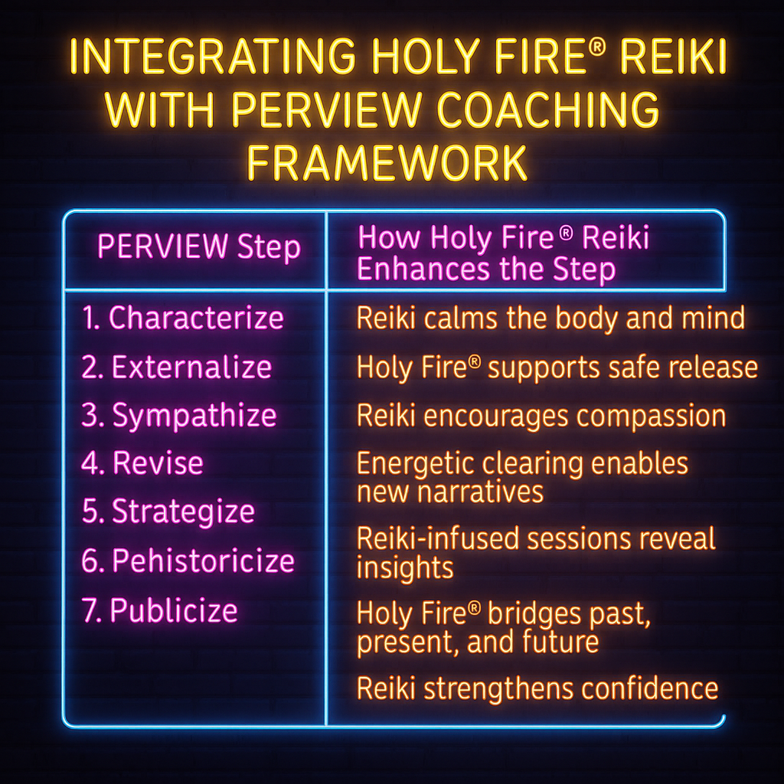
Figure: How PERVIEW Mindfulness Can Be Supported by Holy Fire® Reiki

Table: Holy Fire® Reiki and Each Step of PERVIEW RESTORYING
PERVIEW  Step | How Holy Fire® Reiki Enhances the Step
1. Characterize |  | Reiki calms the body and mind, helping clients access and describe internalized patterns with clarity.
2. Externalize |  | Holy Fire® supports the safe release of internalized pain and separation without re-traumatization.
3. Sympathize |  | Reiki encourages compassion for the wounded parts, allowing for gentler re-connection and self-acceptance.
4. Revise |  | Energetic clearing enables clients to adopt new narratives and energetic signatures of wholeness.
5. Strategize |  | Reiki-infused sessions reveal intuitive insights for new strategies aligned with core purpose.
6. Rehistoricize |  | Holy Fire® bridges past, present, and future energetically—allowing collective and ancestral healing.
7. Publicize |  | Reiki strengthens the confidence and inner coherence needed for clients to share new stories with grace.

🔥 How It Relates to GrowthOD Clients
- Clients Seeking Trauma Healing and Emotional Balance:
Holy Fire® supports clients in deep emotional regulation, self-awareness, and intuitive decision-making. This is especially powerful for veterans, first responders, and executives carrying stress, burnout, or unresolved trauma.
- Organizations Seeking Cultural Transformation:
Holy Fire®-infused coaching opens space for deep listening, energetic alignment, and collective restoration. It enhances gratitude, peace, and creativity—core values of GrowthOD.
- Executives, Coaches, and Trainers in Certification Pathways:
As part of GrowthOD’s coach certification, incorporating Holy Fire® techniques gives trainees a toolkit for helping clients shift not only cognitively but energetically and emotionally. Reiki enables embodied facilitation of change.

🔥 Integration Across the Five Pillars of GrowthOD
Pillar | How Holy Fire® Reiki Supports Each Pillar
PERVIEW | Enhances embodied restorying with energy alignment, self-awareness, and emotional healing.
SEAM | Helps uncover energetic roots of hidden costs (stress, conflict, absenteeism). Supports healing responses.
Axiogenics | Strengthens client alignment with highest value through inner peace and purpose clarity.
AAM  GLOW | Supports the release of false assumptions by calming cognitive resistance and accessing deeper truth.  Reiki generates energetic states of gratitude, joy, and coherence—core to belonging and cultural change.

Conclusion
PERVIEW bridges neuroscience and quantum storytelling, offering a dynamic coaching method. By releasing story filters and embracing emergent narratives, leaders foster resilient, agile organizations.
References
Bandler, R., & Grinder, J. (1975). The Structure of Magic: A Book About Language and Therapy. Science and Behavior Books.
Boje, D. M. (1995). Stories of the storytelling organization: A postmodern analysis of Disney as “Tamara-Land.” Academy of Management Journal, 38(4), 997–1035.
Boje, D. M., & Rosile, G. A. (2020). How to use conversational storytelling interviews for your dissertation. Edward Elgar Publishing.
Boje, D. M., & Saylors, R. (2023). The Management Thought of Louis R. Pondy: Reclaiming the Enthinkment Path. Routledge.
Cron, L. (2012). Wired for Story: The writer’s guide to using brain science to hook readers from the very first sentence. Ten Speed Press.
Damasio, A. (1994). Descartes' Error: Emotion, Reason, and the Human Brain.
Demarest, P. D., & Schoof, H. J. (2010). Answering the central question: How science reveals the keys to success in life, love and leadership. HeartLead Publishing.
Hasson, U., et al. (2010). Speaker–listener neural coupling underlies successful communication. Proceedings of the National Academy of Sciences.
Immordino-Yang, M. H. (2011). Implications of affective and social neuroscience for educational theory. Educational Philosophy and Theory, 43(1), 98–103.
Weick, K. E. (1969). The Social Psychology of Organizing. Addison-Wesley.
Zak, P. J. (2015). Why inspiring stories make us react: The neuroscience of narrative. Cerebrum.

Chapter 2: GLOW Pillar

G.L.O.W.: Gratitude & Love for Organizational Wisdom

The Secret to Agility, Resilience, Innovation, Success

By Olivia Parr-Rud, MS and Tom Lemke

The Call to Transformation
In boardrooms and break rooms alike,
A question stirs the sleeping heart:
What if work could heal, not harm?
What if gratitude could guide our way?
Where purpose meets performance,
And love becomes our language—
Not weakness, but our greatest strength,
Not sentiment, but strategy supreme.
In this junction of head and heart,
We find the leader we're meant to be:
Whole, wise, and wonderfully alive,
Creating cultures that truly thrive.



A Culture of Love and Gratitude

Why Gratitude?
Gratitude transcends simple social courtesy to become a neurologically grounded leadership strategy with profound organizational implications. While gratitude is fundamentally an emotion, neuroscience has revealed its measurable impacts on brain function, team dynamics, and organizational performance. When employees experience genuine appreciation, their brains undergo remarkable changes: dopamine and serotonin release enhances mood and motivation, neural pathways associated with creativity and problem-solving activate, and stress hormones like cortisol decrease, improving health and cognitive function.
A groundbreaking study from the NeuroLeadership Journal reveals that gratitude literally synchronizes brainwaves within teams. When team members express authentic appreciation, their neural oscillations align, creating a state researchers call "neural synchrony." This biological harmony enhances collaboration, improves communication accuracy, and accelerates collective problem-solving—providing the neurological foundation for what Ensemble Leadership describes as "collective resonance."
The business case for gratitude is equally compelling. Glassdoor's comprehensive research found that 80% of employees report working significantly harder for leaders who regularly express appreciation. When employees feel seen, valued, and acknowledged, engagement metrics soar. Inc. Magazine's analysis concluded: "Recognizing employees for their hard work is a simple, powerful way to boost engagement and drive results."
Leading consultancy Heidrick & Struggles discovered that companies where CEOs intentionally link culture to strategy, with appreciation and recognition as core elements, achieve a three-year revenue compound annual growth rate (CAGR) of 9.1%—more than double that of their peers. This isn't correlation but causation: gratitude-rich cultures drive innovation, reduce costly turnover, and create sustainable competitive advantage. The bottom line is clear: creating a "Gratitude Culture" benefits employees emotionally, physically, and mentally while simultaneously driving superior financial performance.

Leading with Gratitude
Like all meaningful organizational change, gratitude must cascade from leadership through every level of the organization. However, this isn't about implementing top-down gratitude mandates—it's about leaders embodying appreciation in ways that inspire authentic cultural transformation. This approach embodies what Ensemble Leadership calls "conducting rather than commanding," where leaders orchestrate conditions for gratitude to flourish naturally throughout the organization.
Leaders who intentionally recognize and appreciate their teams create powerful ripple effects that transform organizational dynamics. It's not about grand gestures, expensive recognition programs, or formulaic appreciation—it's about consistent, sincere acknowledgment of both major achievements and daily contributions. A leader who pauses to say, "I noticed how you handled that difficult customer interaction with such patience and professionalism" creates more lasting impact than generic praise or monetary rewards.
The neuroscience behind this is compelling. When leaders express specific, authentic appreciation, they activate their team members' reward centers while simultaneously modeling behavior that spreads throughout the organization. Mirror neurons—the same cells that cause us to yawn when others yawn—create contagious gratitude. Teams with appreciative leaders begin appreciating each other, creating upward spirals of positive organizational behavior.
Performance reviews offer particularly powerful opportunities to integrate gratitude into organizational rhythm. Instead of immediately diving into areas needing improvement, leaders who begin with genuine acknowledgment of contributions and growth create psychological safety. When employees feel their efforts are seen and valued, they become more receptive to feedback, more motivated to excel, and more likely to remain with the organization. This approach aligns with PERVIEW's Engagement principle—creating deep connection through systematic, authentic appreciation.

Creating a Gratitude-Driven Workplace
Building a sustainable gratitude culture requires intentionality without artificiality. The foundation is surprisingly simple: treat people as you wish to be treated, with genuine respect and appreciation for their humanity and contributions. One might argue that "Thank you" represents the two most powerful words in business—when spoken with authenticity and specificity.
Organizations implementing gratitude as a cultural cornerstone see remarkable transformations. Some develop peer recognition programs where employees acknowledge colleagues' contributions. Others train managers in daily appreciation practices, teaching them to notice and acknowledge both effort and achievement. The key differentiator between successful and failed gratitude initiatives is authenticity—forced or formulaic gratitude damages culture more than no gratitude at all.
This extends beyond employee relations to encompass all stakeholder interactions. Customers, too, hunger for genuine appreciation in an increasingly transactional world. Research indicates companies with superior customer experience achieve revenue growth rates 5.1 times higher than competitors. A recent study revealed that existing customers spend 31% more than new ones, while a mere 2% increase in customer retention could generate profit equivalent to a 10% cost reduction. When gratitude permeates an organization, it naturally extends to customer interactions, creating loyalty that transcends price competition.
The implementation of gratitude culture connects directly with SEAM's methodology for identifying and eliminating hidden costs. By addressing what SEAM calls "the human potential untapped in organizations," gratitude practices reduce absenteeism, decrease quality defects, and improve productivity—directly converting dysfunction into value creation.

Why Love?
Modern definitions of organizational love encompass "kindness, compassion, and affection—the unselfish loyal and benevolent concern for others' good." This isn't romantic love but agape—the ancient Greek concept of universal, unconditional positive regard for human wellbeing. In organizational contexts, love manifests as genuine care for employees' growth, well-being, and success.
The Campbell's Soup transformation under CEO Douglas Conant provides a masterclass in love as organizational strategy. In 2001, Campbell's faced plummeting sales, takeover threats, and designation as "a beleaguered old brand." Most critically, employee engagement scores revealed a dysfunctional culture: 74% of employees were either not actively engaged or actively disengaged—the worst scores ever measured in a Fortune 500 company.
Conant's response revolutionized organizational leadership. Rather than focusing solely on financial engineering or strategic restructuring, he systematically demonstrated care for employees at every level. His practices included writing 20 handwritten thank-you notes daily to employees across the organization, conducting regular lunch sessions with small employee groups to gather input and demonstrate value for their perspectives, requiring managers to meet daily with direct reports to share company progress and maintain connection, and making visible improvements to facilities to show respect for employees' work environment.
The transformation was profound. Within eight years, employee engagement soared to 63% actively engaged with only 3% actively disengaged. This cultural transformation drove remarkable business results: earnings per share grew 5-10% annually, positioning Campbell's at the top of its industry. Stock value increased over 30% while the S&P 500 lost 10% during the same period. Innovation flourished as engaged employees contributed ideas and took ownership of outcomes.
This transformation exemplifies Triple Loop Learning in action. The first loop involved individual behavior change as leaders learned to express appreciation. The second loop transformed team dynamics as trust and psychological safety increased. The third loop revolutionized the entire organizational system, creating what Ensemble Leadership calls a "new organizing principle" based on human connection rather than hierarchical control.
Research by Sandra Barud and Marie Tumolo in "Leveraging the New Human Capital" quantified love's ROI across multiple dimensions. Organizations investing in employee well-being see extraordinary returns: Chase Manhattan's backup childcare investment yielded 115% ROI, American Express's telecommuting initiative boosted sales by $40 million, companies offering parental leave saw profit increases of 2.5%, and organizations recognized as "Best Companies for Working Mothers" experienced 3-11% market value increases. Wellness programs demonstrate similar returns: Pepsi's fitness program generated 300% ROI, Johnson & Johnson's wellness initiative saves $225 per employee annually, and Steelcase reduced medical claims by 55% over six years. These examples prove that institutionalizing loving behaviors creates measurable value while addressing what SEAM identifies as the hidden costs of organizational dysfunction.

Why Now?

Technology
The digital revolution has fundamentally altered organizational requirements for survival and success. To thrive in today's globally connected, AI-enhanced economy, companies must demonstrate unprecedented agility and resilience. The hierarchical, fear-based, command-and-control leadership that dominated the industrial era has become not just inefficient but actively destructive to organizational adaptability.
Consider the speed of modern business: by the time a market opportunity or competitive threat travels up the traditional chain of command for executive decision-making, the window for action has often closed. Competitors with flatter, more responsive structures have already captured the opportunity or neutralized the threat. This reality demands a fundamental reimagining of organizational leadership—precisely what Ensemble Leadership provides.
The leader's role must evolve from commander to conductor, from controller to catalyst. In Ensemble Leadership, leaders create conditions for distributed intelligence to flourish. They empower employees at every level to sense environmental changes and respond rapidly within clearly communicated strategic frameworks. This shift from hierarchical decision-making to networked intelligence enables organizations to move at the speed of change while maintaining coherent direction.

Evolution of Consciousness
Humanity stands at an inflection point in consciousness evolution. Integral Theory and Spiral Dynamics map this progression through increasingly complex stages of awareness and capability. We observe this evolution accelerating in younger generations who demand fundamentally different work experiences than their predecessors.
Millennials and Gen Z employees aren't simply seeking jobs—they're seeking meaning, purpose, and environments where they can contribute their whole selves. They yearn for workplaces that value them as complete human beings, not just productive units. They want to contribute to organizations creating positive impact in the world. This isn't youthful idealism—it's evolutionary progression toward what Clare Graves called "higher levels of existence."
This generational shift creates both challenge and opportunity. Organizations clinging to industrial-era management face escalating difficulty attracting and retaining top talent. Conversely, organizations embracing love-based, appreciation-rich cultures become talent magnets, attracting the very individuals who will drive future innovation and success.

Our Big Why
Corporations have emerged as the most powerful entities on Earth, wielding influence exceeding most nation-states. This power brings profound responsibility and opportunity. If we successfully demonstrate that treating employees with kindness, compassion, and genuine appreciation drives superior business results, we can catalyze global transformation.
The ripple effects would be staggering. When one company within an industry shifts from fear-based to love-based culture and achieves breakthrough results, competitors must follow to remain viable. Industry by industry, this transformation could remake the global economy into a force for human flourishing rather than exploitation. Given current economic pressures and the mounting evidence for love-based leadership, we stand at a tipping point where this vision can become reality.

The Nature of Business

Quantum Organizations
Margaret Wheatley's groundbreaking work "Leadership and the New Science" revolutionized organizational understanding by applying quantum physics principles to human systems. At the quantum level, reality behaves paradoxically: particles exist in multiple states simultaneously until observation collapses probability into actuality. Energy moves in discrete "quantum leaps" rather than gradual transitions. Perhaps most significantly, particles demonstrate "quantum entanglement"—instantaneous connection regardless of physical distance.
These principles profoundly impact organizational design. Wheatley writes: "There is a constant weaving of relationships, of energies that merge and change, of constant ripples that occur within a seamless fabric. There is so much order that our attempts to separate out discrete moments create the appearance of disorder." Organizations aren't mechanical assemblies of discrete parts—they're fields of dynamic energy where relationships generate reality.
In quantum organizations, leadership attention literally creates organizational reality. What leaders observe and appreciate grows stronger. What they ignore withers. This isn't metaphorical—it's how consciousness interacts with quantum fields to collapse potential into actuality. When leaders systematically appreciate employee contributions, they're not just building morale—they're literally strengthening the neural pathways and behavioral patterns that drive high performance.
This quantum understanding aligns perfectly with Ensemble Leadership's emphasis on creating generative fields rather than controlling specific outcomes. Leaders must clearly communicate purpose (the magnetic attractor) while allowing teams to self-organize in achieving that purpose. Each team becomes what Wheatley calls "a localized expression of the global system," maintaining coherence through shared purpose while adapting to local conditions.

Evolutionary Biology and Living Systems
Nature provides exquisite models for organizational design through billions of years of evolutionary refinement. Living systems demonstrate remarkable properties: resilience through redundancy, adaptation through variation, innovation through mutation, and coordination without centralization. Every component connects in webs of mutual influence, creating emergent properties impossible to predict from studying parts in isolation.
Kevin Kelly's concept of "hive mind" illuminates how collective intelligence emerges from simple interactions. Bee swarms make complex decisions about new hive locations without any individual bee understanding the entire process. Birds flock in perfect formation through following simple local rules. Fish schools evade predators through distributed sensing and rapid information propagation. These natural systems achieve what traditional organizations struggle to create: synchronized action without centralized control.
Kelly's description of 20,000 people at a computer graphics conference becoming a collective intelligence demonstrates human capacity for hive mind experiences. Participants wielded color-coded wands to collectively play video games on massive screens. Despite no central coordination, the crowd successfully navigated increasing complexity, demonstrating remarkable adaptation capacity. This conscious collective action differs from natural flocking—participants maintained individual awareness while contributing to group intelligence, exemplifying Ensemble Leadership's vision of conscious collective performance.
The implications for organizational design are profound. Rather than engineering rigid structures, leaders must cultivate conditions for collective intelligence emergence. This requires trust (the medium through which information flows), shared purpose (the attractor organizing behavior), simple rules (enabling coherent local action), and feedback loops (allowing rapid adaptation). SEAM's emphasis on participatory diagnosis and collective problem-solving directly leverages these principles, while PERVIEW's Wisdom pillar emerges from accessing collective rather than just individual intelligence.

Complexity Science
Complexity science studies how order emerges from chaos through self-organization. Our global ecosystem exemplifies a complex adaptive system—constantly evolving, never in equilibrium, demonstrating emergent properties impossible to predict from component analysis. Order arises spontaneously as simple interactions compound into sophisticated patterns. No central authority directs evolution, yet exquisite coordination emerges.
Stuart Kauffman observes: "Order arises naturally from the evolution of vast aggregates of simple subunits." This principle applies directly to organizations. When simple rules guide individual behavior within enabling constraints, sophisticated coordination emerges without central planning. Southwest Airlines exemplifies this approach—simple rules about rapid turnaround and point-to-point travel create emergent efficiency that competitors struggle to replicate despite understanding the rules.
Living systems maintain vitality by existing at "the edge of chaos"—the fertile zone between rigid order and complete randomness. Too much structure creates brittleness; too little creates incoherence. Successful organizations navigate this edge through what complexity scientists call "fitness landscapes"—multidimensional spaces where height represents performance. As environments shift, fitness landscapes deform, requiring constant adaptation to maintain peak performance.
Ensemble Leadership navigates this complexity through embracing paradox: maintaining direction while enabling emergence, providing structure while encouraging innovation, and fostering unity while celebrating diversity. This isn't weakness but sophisticated strength—what the Triple Loop model calls "the ability to hold multiple perspectives simultaneously while maintaining coherent action."

Evolution of Consciousness
Human consciousness evolves through identifiable stages, each representing increased complexity and capability. Dr. Clare Graves' research, expanded through Spiral Dynamics and Integral Theory, maps nine evolutionary stages from survival-focused awareness to transcendent unity consciousness. This isn't just individual development—entire cultures evolve through these stages, with profound implications for organizational design.
Most contemporary organizations operate from Stage 4 (Authoritarian/Traditional) or Stage 5 (Enterprising/Modernist) consciousness—hierarchical structures focused on rules, roles, and achievement. However, emerging generations increasingly embody Stage 6 (Humanistic/Postmodern) consciousness, valuing equality, environmental sustainability, and authentic self-expression. The most evolved individuals and organizations are moving toward Stage 7 (Integral) and beyond—embracing complexity, holding multiple perspectives, and recognizing the value in all previous stages.
This evolution creates what Graves called "momentous leap" moments—transitions so profound they reshape everything. We're experiencing such a leap now as organizations discover that Stage 6+ consciousness isn't just morally superior but competitively advantageous. Companies embracing these higher stages attract top talent, inspire innovation, and create sustainable value impossible at lower stages. GLOW methodology consciously facilitates this evolution, helping organizations transition from fear-based (Stage 3-4) to love-based (Stage 6+) cultures while maintaining the valuable aspects of achievement orientation.

Intelligence of the Heart
Recent discoveries about heart intelligence shatter the mechanistic view of human biology. The HeartMath Institute's research reveals the heart as far more than a simple pump—it's a sophisticated information processing center with profound influence on perception, emotion, and decision-making.
The heart contains over 40,000 neurons forming intricate networks capable of learning, memory, and independent processing. This "heart brain" communicates with the cranial brain through multiple pathways: neurologically through the vagus nerve, biochemically through hormones, biophysically through pressure waves, and energetically through electromagnetic fields. The heart generates the body's most powerful rhythmic electromagnetic field—60 times greater amplitude than brainwaves—detectable several feet from the body.
Among the hormones the heart produces is oxytocin—the "love" or "bonding hormone" previously thought exclusive to the brain. This discovery validates ancient wisdom about the heart's role in human connection and compassion. When people experience heartfelt appreciation, oxytocin release creates cascading benefits: enhanced immune function, reduced stress hormones, improved cognitive performance, and strengthened social bonds—precisely the outcomes organizations need for peak performance.
Heart rhythm patterns profoundly influence brain function. Coherent heart rhythms—smooth, ordered patterns created by positive emotional states—enhance cognitive function, emotional stability, and intuitive access. Conversely, incoherent patterns from negative emotions impair performance. Leaders who cultivate heart coherence through gratitude practices literally create more intelligent organizations by optimizing both their own and their teams' cognitive-emotional functioning.

The New Competencies

Leadership
The quantum-complex-living systems understanding of organizations demands fundamentally new leadership competencies. In highly adaptable organizations, leadership becomes a function rather than a position—everyone exercises leadership influence periodically as expertise and circumstances align. However, those in formal leadership roles must master sophisticated capabilities that Ensemble Leadership articulates through the conductor metaphor.
Emotional intelligence emerges as perhaps the most critical leadership competency. Daniel Goleman and Richard Boyatzis's research identifies seven crucial dimensions: Empathy (understanding others' motivations across differences), Attunement (deep listening to emotional undertones), Organizational Awareness (reading cultural dynamics and informal networks), Influence (engaging others through shared purpose rather than position), Developing Others (mentoring with genuine care for growth), Inspiration (articulating visions that ignite passion), and Teamwork (fostering environments where collective intelligence flourishes).
These aren't soft skills—they're the hard requirements for navigating complexity. Social neuroscience reveals their biological basis: empathetic leaders literally create neural resonance, causing team members' brains to synchronize. Mirror neurons enable emotional contagion, spreading either enthusiasm or anxiety throughout organizations. Leaders who master these dynamics orchestrate what Ensemble Leadership calls "collective virtuosity"—performance exceeding the sum of individual capabilities.

The Paradox of Empowerment
Perhaps the greatest challenge for traditional leaders is embracing empowerment's fundamental paradox: true power comes from relinquishing control. This isn't abdication but sophisticated orchestration—creating conditions where distributed intelligence flourishes while maintaining strategic coherence.
John Chambers at Cisco exemplifies this transformation. He began as a classic command-and-control leader: "If I said, 'Turn right,' all 65,000 employees turned right." However, he recognized this approach's limitations in rapidly evolving markets. The transformation required profound personal change—learning to trust collective intelligence, communicate purpose rather than directives, and measure success through team achievements rather than personal control.
Wayne Baker captures this paradox: "Empowerment means letting go while taking control." Leaders must simultaneously transform organizational structures (taking control) while allowing organic evolution (letting go). Those who fail become either abdicators (letting go without providing structure) or meddlers (maintaining control while espousing empowerment). Success requires becoming what Baker calls "coaches"—leaders who know "the difference between intervention and interference."
This paradox extends throughout organizational life. Teams need autonomy within alignment. Innovation requires freedom within focus. Change demands stability within flux. Ensemble Leadership navigates these paradoxes through dynamic balance—constantly adjusting between opposing forces rather than seeking static resolution. This creates what complexity scientists call "dynamic stability"—maintaining identity while enabling continuous adaptation.

Organizational Models

Systems Thinking
Systems thinking provides essential tools for implementing GLOW principles by revealing hidden connections, feedback loops, and leverage points within organizations. Developed through general systems theory, cybernetics, and complexity science, systems thinking shifts focus from linear causation to circular causality, from isolated events to recurring patterns, and from static structures to dynamic processes.
Peter Senge popularized systems thinking in organizational contexts through "The Fifth Discipline," identifying archetypes like "limits to growth" and "shifting the burden" that trap organizations in dysfunctional patterns. By mapping these patterns, leaders can identify high-leverage interventions—small changes producing disproportionate positive effects. This directly supports SEAM's methodology for uncovering and addressing hidden costs through systemic rather than symptomatic solutions.
Toyota's Production System exemplifies systems thinking in practice. By viewing manufacturing as an interconnected flow rather than discrete stations, Toyota identified waste throughout the system. Their solutions—just-in-time inventory, continuous improvement and respect for people—address systemic rather than local optimization. This systems view enabled Toyota to achieve quality and efficiency levels that competitors couldn't match through traditional approaches.
Systems thinking reveals gratitude and love as high-leverage interventions. Unlike traditional solutions requiring massive investment, appreciation practices create positive feedback loops: gratitude increases engagement, which improves performance, which justifies more gratitude. This virtuous cycle compounds over time, creating what systems thinkers call "reinforcing loops" that accelerate positive change throughout the organization.

Sociocracy
Sociocracy offers a governance model perfectly aligned with GLOW principles and Ensemble Leadership philosophy. Developed by Gerard Endenburg based on cybernetic principles, sociocracy distributes power while maintaining effectiveness through four key principles: consent-based decisions, circle organization, double-linking between levels, and open role elections.
Consent differs fundamentally from consensus. Rather than requiring everyone to agree (often impossible), consent asks whether anyone has a "paramount objection"—a reason the proposal would harm the organization or prevent the objector from fulfilling their role. This speeds decision-making while ensuring all voices are heard. The process embodies PERVIEW's Values pillar by respecting individual wisdom while serving collective needs.
Circle organization replaces hierarchical departments with semi-autonomous circles connected through double-linking. Each circle sends a representative to the next higher circle while receiving a representative from it, ensuring bi-directional information flow. This structure enables what Ensemble Leadership calls "nested autonomy"—freedom within alignment at every organizational level.
Organizations implementing sociocracy report remarkable results: reduced decision-making time, increased employee engagement, enhanced innovation, and improved adaptability. While requiring significant cultural change, sociocracy provides concrete practices for manifesting GLOW principles in organizational governance. It transforms power from a zero-sum resource to an expandable capacity—the more power is shared, the more is created.

The Solution: The Quantum Leadership Experience Featuring The G.L.O.W. Method™

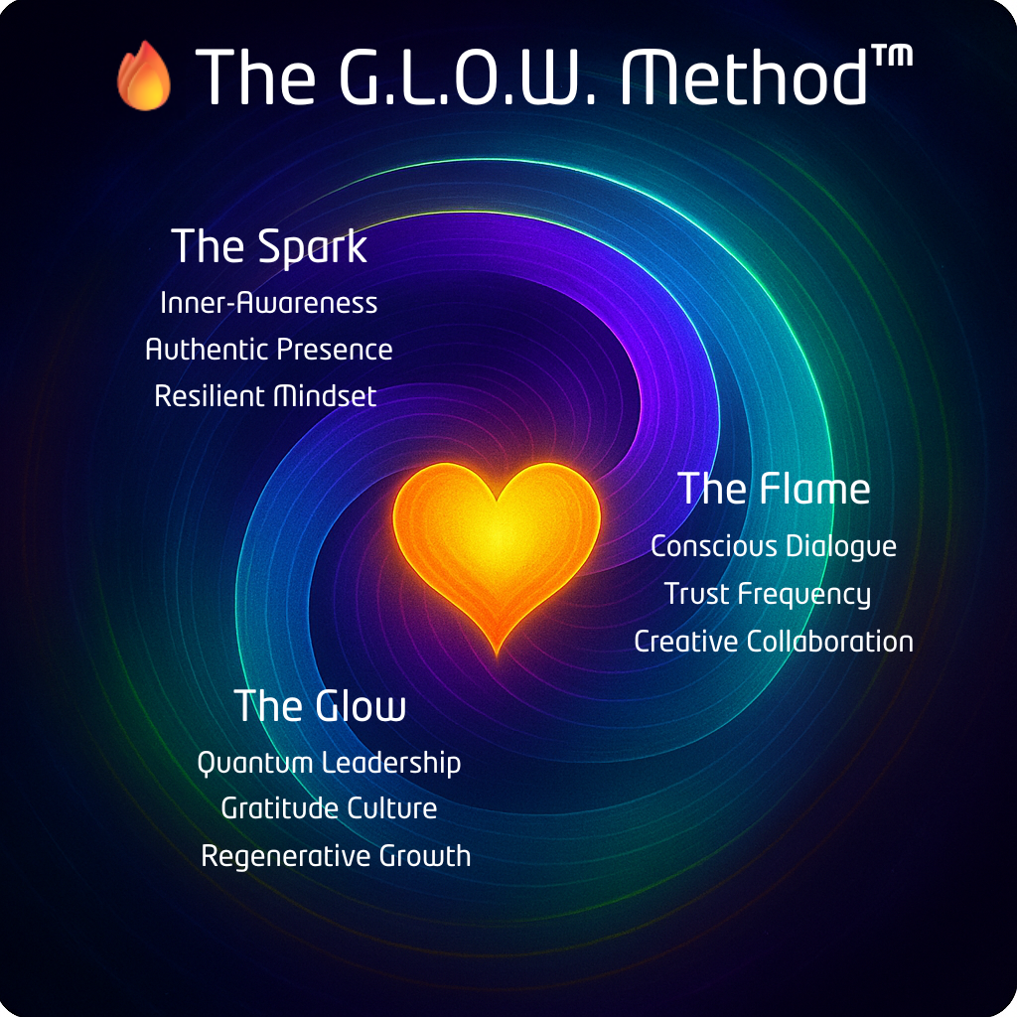

The Quantum Leadership Experience leverages The GLOW Method™ – a synthesis of all these elements into a transformative journey that fundamentally reimagines organizational possibility. Built on scientific understanding of human potential and organizational dynamics, it provides a practical pathway from fear-based to love-based culture infused with gratitude.
Imagine a leadership journey that doesn't just improve metrics—it transforms lives, teams, and entire organizations. The Quantum Leadership Experience leverages the GLOW Method - a revolutionary three-phase program that guides leaders from traditional command-and-control paradigms to heart-centered excellence, creating cultures where people thrive and profits soar.

🔥 Phase 1: The Spark – Awakening Your Heart-Centered Leadership
The Spark ignites individual transformation through personal healing, gratitude practices, and leadership development. Leaders cannot give what they don't possess—authentic appreciation flows from leaders who've experienced its power personally.
🔥Phase 2: The Flame – Building Trust Through Connection
The Flame spreads transformation through relationships by building trust, enhancing communication, and creating psychological safety. This phase leverages neuroscience insights about mirror neurons and emotional contagion to create cultural tipping points.
🔥Phase 3: The Glow - Designing Systems for Sustainable Excellence
The Glow phase embeds the transformation into your organizational DNA through systems design, governance evolution, and cultural architecture. By addressing structure and culture simultaneously, lasting change becomes inevitable rather than exceptional.

Organizations that complete this type of intervention report extraordinary results: employee engagement typically increases by 40-60%, turnover drops by 20-50%, innovation metrics double or triple, customer satisfaction reaches new peaks, and financial performance exceeds industry standards by 200-300%. These aren't outliers—they're predictable outcomes of aligning organizational design with human nature.

Why Us?
Tom Lemke and Olivia Parr-Rud bring unique credibility to this transformative mission through their complementary expertise and shared passion. Tom's journey from top-20 global marketing executive to gratitude evangelist provides unassailable business credentials. Having generated over $5 billion in incremental revenues across 30+ countries, he understands corporate pressures and profit requirements. His near-death experience and subsequent transformation give him authentic passion for humanizing business that resonates with both executives and employees.
Olivia contributes world-class analytical rigor as an internationally acclaimed data scientist with an MS in Statistics. Her Fortune 500 consulting work with giants like Cisco, Walmart, and IBM established impeccable credentials before she turned her analytical prowess to quantifying love's business impact. Her award-winning LOVE@WORK Method™ became an Amazon #1 bestseller by proving that soft skills drive hard results.
Together at the Quantum Wisdom Institute, they've developed the G.L.O.W. Method—a scientifically grounded, business-tested approach to organizational transformation. Their partnership uniquely bridges the head-heart divide that has long plagued organizational development efforts. They speak fluently to both data-driven executives demanding ROI evidence and purpose-driven employees seeking meaningful work. This rare combination enables them to catalyze transformation across entire organizational hierarchies.

Call to Action
The evidence has reached critical mass. Neuroscience validates what wisdom traditions have long taught: love and gratitude aren't just moral goods—they're competitive advantages. Organizations clinging to fear-based management face escalating costs: inability to attract top talent, innovation deficits, customer defection, and ultimately, obsolescence.
The transformation begins with individual choice. Today, in your next interaction, choose appreciation over criticism. Listen with your whole being rather than formulating rebuttals. Ask "How can I help?" rather than "What's in it for me?" These seem like small acts, but they're quantum leaps—discontinuous jumps to higher organizational states.
Start implementing GLOW principles immediately:
- Institute daily gratitude practices in team meetings
- Create peer appreciation channels
- Redesign performance management around growth rather than judgment
- Measure and celebrate connection alongside productivity
- Share success stories to create positive contagion
Through systematic application of GLOW principles—integrated with SEAM's economic wisdom, PERVIEW's comprehensive framework, and Ensemble Leadership's orchestration model—you can create organizations where human flourishing and business success become mutually reinforcing rather than competing priorities.
The future belongs to organizations courageous enough to lead with love. The question isn't whether to transform but whether you'll lead the transformation or be displaced by those who do. The time for half-measures has passed. The era of whole-hearted leadership has arrived.
Will you answer the call?

Your G.L.O.W. Score™
Want to know your G.L.O.W. Score™ with our Quantum Culture Assessment? Click here.

References:
Baker, Wayne. "The Paradox of Empowerment." Leader to Leader Journal, Spring 1997.
Barud, Sandra, and Marie Tumolo. Leveraging the New Human Capital. Davies-Black Publishing, 2004.
Boyatzis, Richard. Becoming a Resonant Leader. Harvard Business Review Press, 2008.
Conant, Douglas, and Mette Norgaard. TouchPoints: Creating Powerful Leadership Connections in the Smallest of Moments. Jossey-Bass, 2011.
Endenburg, Gerard. Sociocracy: The Organization of Decision-Making. Eburon, 1998.
Friedman, Thomas. The World Is Flat: A Brief History of the Twenty-First Century. Farrar, Straus and Giroux, 2005.
Galton, Francis. "Vox Populi." Nature, March 7, 1907.
Goleman, Daniel. Social Intelligence: The New Science of Human Relationships. Bantam Books, 2006.
Graves, Clare W. The Never Ending Quest. ECLET Publishing, 2005.
HeartMath Institute. "Science of the Heart: Exploring the Role of the Heart in Human Performance." HeartMath Institute, 2015.
Kauffman, Stuart. At Home in the Universe: The Search for the Laws of Self-Organization and Complexity. Oxford University Press, 1995.
Kelly, Kevin. Out of Control: The New Biology of Machines, Social Systems, and the Economic World. Basic Books, 1994.
Laszlo, Ervin. The Chaos Point: The World at the Crossroads. Hampton Roads Publishing, 2006.
Lemke, Tom, Leading with Gratitude, unpublished manuscript 2025
McTaggart, Lynne. The Field: The Quest for the Secret Force of the Universe. HarperCollins, 2002.
Parr-Rud, Olivia: Business Intelligence Success Factors: Tools for Aligning Your Business in the Global Economy, Wiley, 2009.
Robertson, Brian. Holacracy: The New Management System for a Rapidly Changing World. Henry Holt and Company, 2015.
Senge, Peter. The Fifth Discipline: The Art and Practice of the Learning Organization. Doubleday, 1990.
Sperry, Roger W. "Hemisphere Deconnection and Unity in Conscious Awareness." American Psychologist, 1968.
Taylor, Jill Bolte. My Stroke of Insight: A Brain Scientist's Personal Journey. Viking, 2006.
von Bertalanffy, Ludwig. General System Theory: Foundations, Development, Applications. George Braziller, 1968.
Wheatley, Margaret. Leadership and the New Science: Discovering Order in a Chaotic World. Berrett-Koehler Publishers, 1999.
Wiener, Norbert. Cybernetics: Or Control and Communication in the Animal and the Machine. MIT Press, 1948.
Wilber, Ken. A Theory of Everything: An Integral Vision for Business, Politics, Science and Spirituality. Shambhala, 2000.

Chapter 3: SEAM Pillar

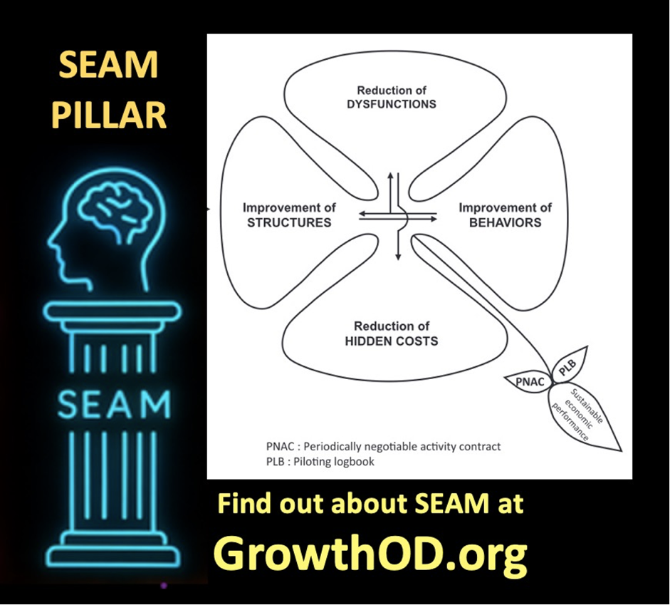

Introduction
SEAM methodology—standing for Socio‑Economic Approach to Management. D-P-I-E (Diagnosis-Project planning-Interventions-Evaluation). DPIE teams are lunched across the organization with the goal of DIAGNOSIS, identifying hidden costs, root causes of weak socio-economic financial performance. PROJECT PLANNING to recycle hidden costs into new revenue streams by unleashing Human Potential.

Henri Savall (born 1941) is a French economist and management scholar
Appointed Chevalier of the Legion of Honour in 2017 in recognition of his international contributions to promoting a more human‑centered, ethical economy and a more inclusive management education

Savall, H., Zardet, V., Bonnet, M., & Savall, A. (2024). Presentation of SEAM and Opening Up on Storytelling Approaches. In A World Scientific Encyclopedia of Business Storytelling Set 1: Corporate and Business Strategies of Business Storytelling Volume 5: Business Storytelling of Socioeconomics (pp. 3-30).
Step One: Please Read this to understand the role of Storytelling in SEAM.

The theme of Amandine Savall’s book "Becoming Agile: How the SEAM Approach to Management Builds Adaptability" is cultivating true organizational agility through the Socioeconomic Approach to Management (SEAM). Genuine agility isn't just about adopting new tools or surface-level process changes. Agility requires addressing the root causes of dysfunction, making hidden costs visible, and engaging in a deep, participatory transformation process

SEAM classifies dysfunctions using the Cloverleaf Model
1. Work Conditions Unsafe environments, outdated equipment, ergonomic strain, or psychological stressors.
2. Work Organization Role ambiguity, redundant processes, overcontrol, or under-delegation.
3. Three Cs of Communication- Coordination-Cooperation Missing feedback loops, email overload, secrecy, or over-formalized reporting.
4. Time Management Are people spending time in value added ways (what Axiogenics calls 'net value')?
5. Training Are people trained in what brings 'net value'? Are people in need of training getting the training they need?
6. Strategic Implementation Oftentimes, organizations are so busy putting out fires in the first five dysfunctions, people are not doing strategic implementaiton.

💰 The Hidden Costs
Over 50% of business costs are hidden from accounting reports—and 40% are buried under trauma memories and stuck thoughts that PERVIEW is designed to address.
•Disconnection from Organizational Story and Values: Millennials often seek purpose-driven work environments. A lack of alignment with company values can lead to disengagement. •Lack of Communication, Coordination, and Cooperation (3 Cs): Ineffective communication and collaboration structures can hinder millennial's' sense of belonging and contribution. •Burnout, Misalignment, and Unprocessed Trauma: High expectations without adequate support can result in burnout and emotional exhaustion.

At its core, this work helps executive leaders, consultants, and coaches leverage storytelling not just as a communication tool—but as a diagnostic and transformation strategy grounded in scientific inquiry and human-centered design.
Savall and colleagues remind us:
“Storytelling is necessary but not sufficient to elaborate a relevant representation of the object under study” (Savall et al., 2024: 25).
To move from representation to transformation, we must integrate storytelling into the three SEAM pillars: Cognitive Interactivity, Contradictory Intersubjectivity, and Generic Contingency (Savall & Zardet, 1996)—each of which supports the whole arc of organizational transformation using a triple-loop learning model.
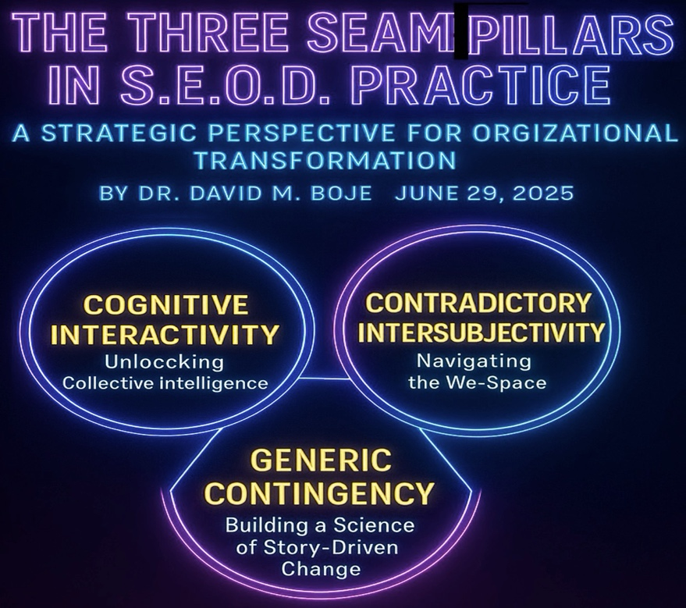

1. Cognitive Interactivity: Unlocking Collective Intelligence
Organizations are made of people—and people make meaning through stories. Each actor interprets and tells stories about organizational reality differently, based on their history, role, training, and lived experience. Cognitive Interactivity refers to the structured processes through which these differences are surfaced, understood, and synthesized through:
- Story Circles
- Focus Groups
- Mirror Effect Meetings
- Intervention Projects
- Move to Triple Loop and Ensemble Leadership
These dialogic spaces enable single-loop (compliance-focused on command-and-control) and double-loop (root cause-focused on open systems) learning, which initiates triple-loop transformation, where the system itself is restructured and coordinated through Ensemble Leadership practices (Rosile, Boje, & Claw, 2018; Boje & Rosile, 20204, 2025a).
In Triple Loop learning:
- Single-loop = reacting within the rules of the command-and-control hierarchy.
- Double-loop = double system of cybernetic deviation-control with deviation-amplification (agility, experimentation, participative processes, intrapreneurship, innovation).
- Triple-loop = a loop of ensemble leadership networking for coordination of single and double loop by creating a loop of heterarchy.
This third loop requires what we call Ensemble Leadership—a shift from command-and-control to a decentralized, networked, and ethically accountable culture where everyone is the leader of something (Rosile, Boje, & Claw, 2018; Boje & Rosile, 2024, 2025).
Heterarchy means everyone is a leader of something. Heterarchic leadership is decentered, rather than centralized, and operates through non-linear networks rather than hierarchies. It is egalitarian rather than top-down, with leadership being shared and distributed, rather than reserved solely for the C-suite, where leader privileges are held. The concept of heterarchy, central to ensemble leadership, encompasses both identifying leadership functions and promoting egalitarianism. In sum, instead of a rigid hierarchical pyramid, ensemble leadership in Triple Loop transformations suggests a more fluid and networked structure where leadership is distributed and shared among individuals, fostering a more egalitarian environment. In Triple Loop launching and coordinating cascading D.P.I.E. (Diagnostic, Project planning, Implementation, Evaluation of results) teams is key to sustaining continuous improvement.
Through Ensemble Leadership, DPIE teams (Diagnosis, Planning, Implementation, Evaluation) cascade change initiatives that are self-correcting and root-cause oriented.

2. Contradictory Intersubjectivity: Navigating the We-Space
Intersubjectivity refers to the shared space of meaning that forms between people in real-time interactions. In practice, this is the arena where:
- Perspectives clash and harmonize
- Assumptions are surfaced
- A new "we" story is negotiated
This is not a superficial consensus but a quantum energetic field of story entanglement—where each person’s narrative affects the other. Contradictory Intersubjectivity is defined here as the invisible ‘quantum energy field’ generated by actor relationships—the energy, resonance, and mutual attunement to context that shape how people feel, think, and act together. It’s where values, norms, and collective narratives are negotiated and lived. From a quantum storytelling perspective (Boje & Sanchez, 2019), intersubjectivity refers to the entanglement of stories—how one person’s narrative resonates with another’s, creating ripples that shape organizational reality in unpredictable, emergent ways. As Garfinkel (1967) and Boje (1995) illustrate, even in the same room, two people may walk away with entirely different stories due to their unique paths through the organizational maze.
Harold Garfinkel (19679, the founder of ethnomethodology, a field of sociology that studies the methods people use to make sense of and navigate their social world, provides an example of a husband and wife interaction in his work. The husband and wife rely on shared understandings and assumptions to make sense of their everyday conversations. Example: A husband and wife are having a conversation, and the husband says: "Dana succeeded in putting a penny in a parking meter today without being picked up." The wife responds with: "What for?" The husband clarifies: "No, to the shoe repair shop." This excerpt demonstrates how spouses rely on shared context and implicit understanding to interpret each other's remarks. The wife's initial question "What for?" reveals her understanding of the context, suggesting she's thinking of the reason for putting money in a parking meter, likely related to parking for an errand. The husband's clarifying response "No, to the shoe repair shop" further elaborates on the scenario, indicating where they went and why Dana would need to reach the meter (as they were parked there while going to the shoe repair shop). Here is the entire exchange form Garfinkel (1969):
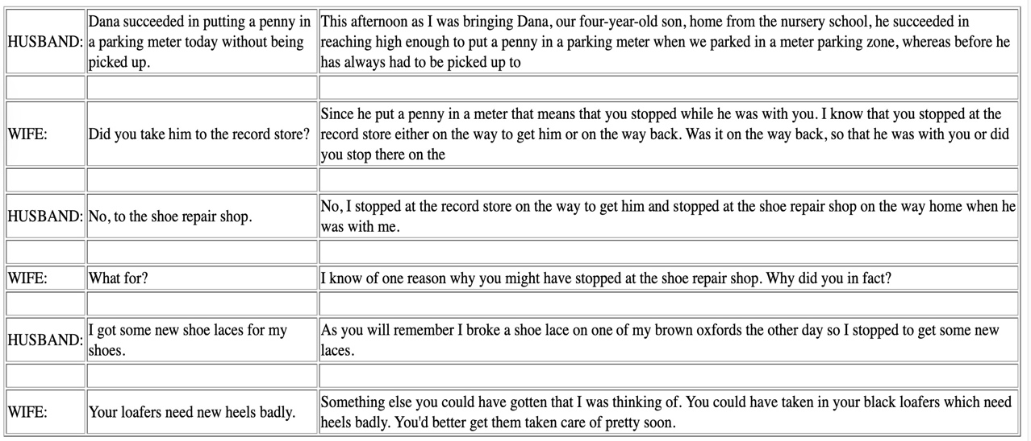
The conversation unfolds based on these shared understandings and assumptions, illustrating the subtle but essential role of everyday methods in making sense of social interactions. This example highlights a key concept in ethnomethodology: indexicality, which refers to how the meaning of words and actions is dependent on the context in which they occur. The husband's statement "Dana succeeded in putting a penny in a parking meter today without being picked up" is indexical because its full meaning relies on shared knowledge about Dana, the parking meter, and the husband and wife's activities that day. Their ability to successfully communicate and understand each other's remarks stems from their mutual reliance on this shared background knowledge. The implication is that the social order of a family and any organization is not simply a pre-existing structure but is constantly and actively co-produced through storytelling and sense-making methods in everyday interactions. Example: firefighters and police officers must be able to quickly interpret indexical cues from a scene, such as the behavior of individuals, the appearance of the environment, and communication with other responders, to understand the situation and make informed decisions. In essence, Garfinkel uses this and similar examples to demonstrate that social order and understanding are not pre-existing structures but are constantly and actively produced through the methods people employ in their everyday interactions.

"Tamara-land" (Boje, 1995) shows how multi-room, multi-character storytelling distorts shared meaning unless intentionally facilitated. In Boje’s (1995: 999) ‘Disney as Tamara-land” people arriving to a meeting from different rooms in an organization will amplify the distortions: “Two people can even be in the same room and—if they came there by way of different rooms and character-sequences—each can walk away from the same conversation with entirely different stories.” Most organizations have more than 12 rooms. “If there are a dozen stages and a dozen storytellers, the number of story lines an audience could trace as it chases the wandering discourses of Tamara is 12 factorial (479,001,600)” (IBID.)
“Still, instead of repairing mechanistic or organic metaphors, I believe it is time to heed Pondy and Mitroff's advice and move to discursive metaphors, such as Lyotard's (1984) ’conversation,’ Bakhtin's (1981) ’novel,’ and Thatchenkery's (1992) ‘text.’ Tamara is a discursive metaphor highlighting the plurivocal interpretation of organizational stories in a distributed and historically contextualized meaning network—that is, the meaning of events depends upon the locality, the prior sequence of stories, and the transformation of characters in the wandering discourses.” Boje, 1995: 1000).
Therefore, to address the contradictory intersubjectivity in the discursive arean, the SEAM method encourages the gathering of various types of data (interviews, observations, documents, and reports) and engagement in co-inquiry. Why It Matters: (1) Decision-Making: Wise decisions arise not from isolated minds, but from the resonance of many voices in intersubjective space. (2) Change and Transformation: Lasting change happens when new intersubjective realities are co-created—when people see, feel, and act from a new shared story. (3) Ensemble Leadership: Leadership is intersubjective—an improvisational dance of sensing, responding, and co-creating in the moment. Contradictory Intersubjectivity in organizations is the living, breathing quantum energetic field of shared meaning and presence that makes collective wisdom, creativity, and transformation possible. It is the foundation for ensemble leadership and the quantum leap from isolated action to collective becoming.
To resolve contradictory intersubjectivity:
- SEAM uses co-inquiry methods: Interviews, observation, document analysis, and stakeholder dialogues.
- Leaders foster ensemble conversations that prioritize attunement over authority.
Why it matters for organizations:
- Better Decisions: emerge from dialogic resonance, not individual assertion.
- Sustainable Change: grows from co-created story, not top-down mandates.
- Adaptive Leadership: thrives through sensemaking-in-action, not rigid roles.
This is where PERVIEW Coaching integrates with SEAM—training leaders to read and respond to the “energy field” of meaning, emotion, and momentum within a team or system.

3. Generic Contingency: Building a Science of Story-Driven Change
Organizations operate in unpredictable environments. SEAM introduces scientific rigor through Generic Contingency—a process rooted in Charles Sanders Peirce’s logic of discovery:
- Abduction: What is surprising? What doesn’t fit the current story? Making a guess about a hypothesis that needs more inductive cases and theory building.
- Deduction: If this hypothesis is true, what else would we expect to see in inductive cases?
- Induction: What patterns emerge from actual cases? Does the evidence hold? What if there is a black swan effect, and all swans are not white?
Given Contradictory Intersubjectivity, and the need for Cognitive Interactivity to create shared understanding and action, the scientific part involves generating self-correcting co-inquiry by applying Charles Sanders Peirce’s Induction, Deduction, and Abduction (Boje & Rosile, 2020). Abduction is the initial stage where a surprising fact or observing something unexpected. Abduction “an argument or supposition that assumes it was a case of a general rule and of results that still needs actual inquiry (Peirce, 1931-1935, vol. 2: p. 515, 624). Such abduction, the formation of a wild or informed guess, needs induction method, the gathering of cases. Abduction can become the basis for a hypothesis. Deduction involves drawing out the logical consequences of the abduction and hypothesis. Deduction “belongs to general class of results by theory-arguments that in the long run tend toward the truth of case results” (Peirce, 1931-1935: vol 2: p. 266). If the hypothesis is true, what else should also be true? It does not generate new knowledge; rather, it clarifies the implications of existing assumptions. Induction is the process of testing the hypothesis by gathering cases. Induction “generalizes from a number of cases and results, of which something is true, to infer some rule for the whole population” (Peirce, 1931-1935, vol. 2: p. 624). If cases support the deduction and abduction (or hypothesis, it becomes more credible.
In GROWTH OD, this triadic inquiry supports a continuous feedback loop of:
- Diagnosing misalignments
- Hypothesizing root causes
- Validating stories with evidence
Executives and consultants alike can use this to:
- Uncover hidden costs (turnover, morale, conflict, low engagement)
- Align interventions with strategic goals
- Prevent “diagnosis without transformation”
Combined with the first two pillars, Generic Contingency ensures that organizational storytelling is not just symbolic—but also systemic and scientific.
S.E.A.M. Socio-Economic-Approach-to-Management the 2nd Pillar of https://GrowthOD.org
Voice: The Hidden Cost Alchemist
Full Pillar Name: Socio-Economic Approach to Management

Introduction: Why SEAM Matters
In most organizations, energy is leaking from the system, silently. This leak doesn’t show up in quarterly earnings or polished dashboards—but in absenteeism, turnover, poor coordination, demoralized teams, and wasted time. SEAM—Socio-Economic Approach to Management—is the pillar of GROWTH OD that makes this invisible visible.
Developed over 50 years by Henri Savall and the ISEOR Institute in France, and taught for two decades by Dr. David Boje in the U.S., SEAM is both a diagnostic method and a transformation engine. It provides leaders and consultants with practical tools to uncover “hidden costs” and recycle them into value. In the GROWTH OD framework, SEAM is known as The Hidden Cost Alchemist because it transmutes dysfunction into transformation—not by punishing people, but by healing broken processes, misaligned systems, and ignored potential.

Scientific Roots of SEAM

The Consulting/Coaching Cycle of SEAM Scientific Inquiry
Each coaching journey follows an inquiry arc:
1. Observe — What are we noticing?
2. Question — What’s the deeper story?
3. Hypothesize — What value gaps, traumas, or systemic contradictions may explain this?
4. Experiment — Try new actions, story rituals, organizational prototypes
5. Analyze — What worked? What shifted?
6. Revise — Update the story and reframe assumptions
SEAM is grounded in socio-economic science. Its foundational theory: most accounting systems are blind to dysfunction because they only measure outputs, not the systemic constraints that hinder them. These hidden dysfunctions are not anomalies—they are signals.
Introducing the SEAM's Four Leaf Clover
Upper Leaf of Dysfunction Categories
SEAM classifies dysfunctions using the Cloverleaf Model
1. Work Conditions
Unsafe environments, outdated equipment, ergonomic strain, or psychological stressors.
2. Work Organization
Role ambiguity, redundant processes, overcontrol, or under-delegation.
3. Three Cs of Communication- Coordination-Cooperation
Missing feedback loops, email overload, secrecy, or over-formalized reporting.
4. Time Management
Are people spending time in value added ways (what Axiogenics calls 'net value')?
5. Training
Are people trained in what brings 'net value'? Are people in need of training getting the training they need?
6. Strategic Implementation
Oftentimes, organizations are so busy putting out fires in the first five dysfunctions, people are not doing strategic implementaiton.

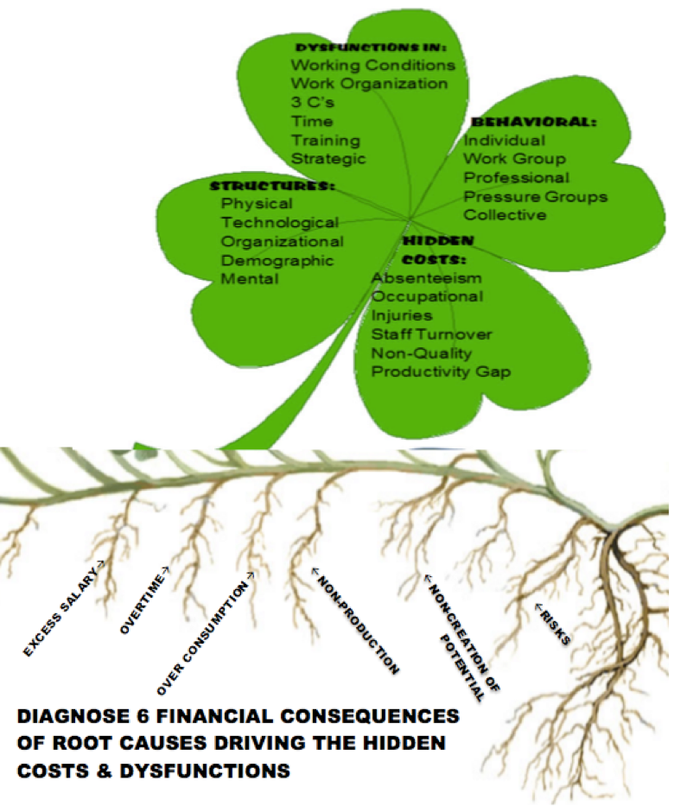
Savall’s research identified Six key Financial Consequences Root Causes driving Dysfunctions
1. Excess Salary
2. Turnover
3. Work accidents
4. Non-quality
5. Overtime and over-consumption of resources
6. Lost opportunity and unrealized potential
The Hidden Costs add up—often representing 20–30% of payroll. SEAM practitioners use participatory diagnostics, logbook modeling, and financial simulation tools to quantify these costs and create actionable recovery plans.
What are the Hidden Costs that don't show up on an Organizations Accounting Reports and Spreadsheets?
1. Absenteeism
When people are overworked, they burnout, get ill more often, and cannot contribute 100%.
2. Occupational Injuries
Injuries from lack of safety routines, doing too many jobs at once, and so on incur costs of insurance claims, contribute to low morale ...
3. Staff Turnover
We give the example of millennial turn over. Millennials are now 75% of the global workforce.
4. Non-Quality of Products and Services
It takes a process consultation diagnostic to assess how system work processes are coming undone. It's the 2nd Law of Thermodynamics..
5. Productivity Gaps
Productivity will come undone with out continuous improvement interventions.
Table for Hidden Cost Calculations

Each leaf is explored during interviews and observations. SEAM’s method shows how dysfunction in one area cascades across others. For example, poor coordination can lead to overwork, which causes stress, which leads to absenteeism, turnover, etc.

💰 The Hidden Costs
Over 50% of business costs are hidden from accounting reports—and 40% are buried under trauma memories and stuck thoughts that PERVIEW is designed to address.
•Disconnection from Organizational Story and Values: Millennials often seek purpose-driven work environments. A lack of alignment with company values can lead to disengagement.
•Lack of Communication, Coordination, and Cooperation (3 Cs): Ineffective communication and collaboration structures can hinder millennial's' sense of belonging and contribution.
•Burnout, Misalignment, and Unprocessed Trauma: High expectations without adequate support can result in burnout and emotional exhaustion.

Over 50% of business costs are hidden from accounting reports, and 40% are buried under trauma memories and stuck thoughts.
Example: The Hidden Costs of Millennial Turnover: Replacing, Training, and Morale
Millennial turnover represents a significant cost to businesses, encompassing direct expenses like replacement and training, as well as less tangible impacts like decreased morale.
1. Replacing Employees:
- Direct Costs that do not show up on Accounting Statement:
  - Recruitment and Hiring: Advertising vacancies, screening candidates, conducting interviews, background checks, and potential recruitment agency fees. These costs can range from a few thousand dollars to a substantial portion of an employee's salary.
  - Onboarding: Activities like orientation and getting new hires familiar with company procedures and culture.
- Financial Impacts that do not show up on Accounting Statements:
  - Replacing an employee can cost 50% to 200% of their annual salary, depending on the role and industry.
  - Estimates suggest replacing an entry-level employee making $36,000 can cost $12,000.
  - The overall cost of onboarding a new hire can range from $4,100 to over $20,000.
2. Training Costs that do not show up on Accounting Reports:
- New Hire Training: Getting new employees up to speed on their responsibilities and the tools they need.
- Average Annual Training Costs: Organizations spend an average of $1,252 per employee per year on training, including established employees. The cost of training a new hire from scratch can be higher.
- Wasted Investment: If a new hire leaves quickly, the training investment is lost, requiring a repeat of the expense for a replacement.
3. Morale Impact that does not show up on Routine Accounting Report:
- Decreased Morale and Productivity: Frequent departures can erode trust, create a sense of instability, and negatively affect team dynamics and collaboration.
- Increased Workload and Burnout: Remaining employees often have to take on extra responsibilities, leading to increased stress and potential burnout.
- Loss of Knowledge and Expertise: Experienced employees take valuable institutional knowledge with them when they leave, impacting workflows and potentially customer satisfaction.
- Negative Impact on Company Reputation: High turnover rates can make it harder to attract top talent and further erode employee morale.
Millennial Specifics:
- Millennial turnover is estimated to cost the U.S. economy $30.5 billion annually.
- While some concerns about millennial job-hopping may be exaggerated, it's important to focus on the rising cost of turnover for this generation, which is partly linked to higher salaries.
- Millennials are the least engaged generation in the workforce, with only 30% reporting feeling engaged.
- A higher percentage of Millennials (36%) compared to non-Millennials (21%) plan to look for a job with a different organization in the next 12 months if the job market improves.
Mitigating the Hidden Costs:
- Invest in employee retention strategies: Offering competitive salaries and benefits, fostering a positive work environment, providing professional development opportunities, and recognizing employee contributions can help reduce turnover.
- Improve the onboarding process: A well-structured onboarding process helps new hires get up to speed quickly and feel integrated into the company culture, reducing the risk of early departure.
- Focus on employee engagement: Engaged employees are more likely to stay with the company and perform at a higher level, positively impacting productivity and reducing turnover.
-Salary  1 | Excess Time  2 | Over-Compensation  3 | Non-production  4 | Non-creation of Potential  5 | Total Hidden Costs  1+2+3+4+5 | RISKS TO Organization
Absenteeism
Accidents
Turnover
Non-Quality
Productivity Variance
TOTAL | Excess salary from 5 indicators | Overtime from 5 indicators | Over-consumption from 5 indicators | Non-production form 5 indicators | Non-creation of potential from 5 indicators | TOTAL HIDDEN COSTS | Risks from all 5 Indicators
In conclusion, addressing millennial turnover is crucial for businesses. By understanding and actively mitigating the costs associated with replacement, training, and the impact on morale, companies can build a more stable, productive, and engaged workforce.
Illustration of Hypothesized ‘Hidden Cost Calculation’ at New Mexico State University
5 Indicators of Dysfunctions: | Components
5 Indicators of Dysfunctions: | Qualitative examples | Quantitative examples | Over-Salary  1 | Excess Time  2 | Over-Compensation  3 | Non-production (lost revenue)  4 | Non-creation of [human]  Potential  5 | Total Hidden Costs  1+2+3+4+5 | RISKS TO NMSU
Absentee People from Downsizing, etc. | People left & not replaced; Higher paid administrators micromanage remaining faculty, | 7% more time to get things done by those left | $600000 | 300000 | 500000 | 1000000 | 500000 | $2,900,000
Accidents | More health claims from stress of overwork | 5% more health claims | $70000 | 200000 | 100000 | 200000 | 300000 | $870,000
Turnover | High turnover faculty due to low morale, uncertainty of change, & frozen salaries | 20% more Cost of training students to do work of staff; staff to do work of faculty who left | $200000 | 100000 | 600000 | 300000 | 900000 | $2,100,000
Non-Quality | Less qualified people (student workers, etc. pitch in but with weaker results | 20% more costs of Faculty and graduate student teachers, and temps (visitors) filling in for classes of missing faculty | $400000 | 300000 | 400000 | 2000000 | 800000 | $3,900,000
Productivity Variance | Since everyone is doing work of the missing personnel, much of the work of teaching and research, and coordination falls through the cracks | 10% loss in NMSU reputation, which means fewer students & faculty willing to come he | $900000 | 600000 | 700000 | 300000 | 800000 | $3,300,000
TOTAL |  |  | Excess salary from 5 indicators | Overtime from 5 indicators | Over-consumption from 5 indicators | Non-production form 5 indicators | Non-creation of potential from 5 indicators | TOTAL HIDDEN COSTS | Risks from all 5 Indicators  Add 2 million more in lawsuits
 |  |  | $2,170,000 | 1500000 | 2300000 | 3800000 | 3300000 | $13,070,000 | $15,070,000

Instead of dealing with $15,070,000 in financial losses, NMSU spent almost $1 million dollars to hire one of the big six consulting firms for two week, and their MBAs that did a spreadsheet analysis, to identify which older professors were the highest paid, then proceeded, to harass them every way possible until they quit. So short sighted. It is a tragic case of shareholder capitalism in Higher Education. The shareholders in this case are the Trustees, who care more about sports than higher ed. Currently, many departments and entire colleges are understaffed, there is no money to hire tenured faculty in the social sciences, so temporary contract adjunct faculty were hired without benefits. Too few people doing far too many jobs, wearing too many hats as they burn out. The moral of the story: It could have been a very different result is SEAM GrowthOD had been chosen. Here is a better kind of OD.

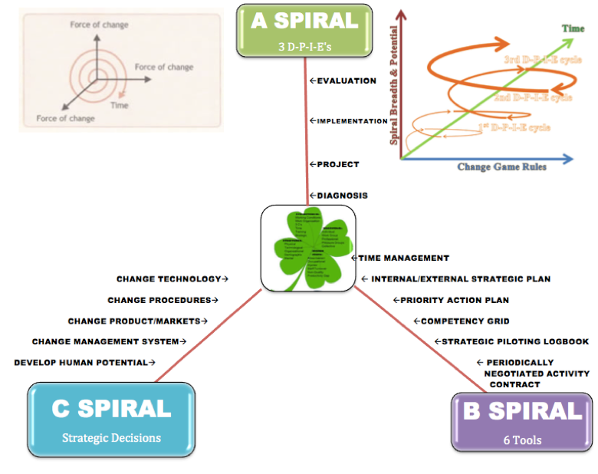

SEAM has three Spirals
A-Spiral is the intervention of three or more successive rounds of D-P-I-E (Diagnosis-Project planning-Interventions-Evaluation). DPIE teams are lunched across the organization with the goal of DIAGNOSIS, identifying hidden costs, root causes of weak socio-economic financial performance. PROJECT PLANNING to recycle hidden costs into new revenue streams by unleashing Human Potential. IMPLEMENTATION means getting the job done right, by innovating, being intrapreneurs. Then comes the EVALUATION of qualitative, quantitative, and financial outcomes (known as Qualimetrics).
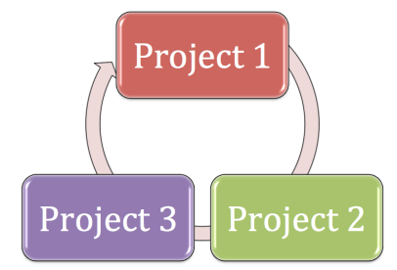
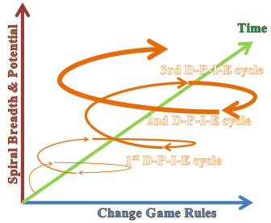
Figure 3: Implementing successive DPIE’s (Diagnosis-Project Design-Implementation-Evaluation cycles) to rebuild NMSU Momentum

B-Spiral is the six SEAM Tools that are taught to the DPIE team members.
First Tool: Time Management Tool
- Focus on Dysfunctions and Hidden Costs: SEAM's approach involves identifying and analyzing organizational dysfunctions that lead to hidden costs, including issues related to time management.
- Time Management as a Key Component of Improvement: By addressing dysfunctions related to time management (e.g., in communication, coordination, and cooperation), organizations can reduce hidden costs and improve overall socio-economic performance.
- Diagnosing Time-Related Issues: SEAM utilizes a diagnostic process to uncover how specific routines and behaviors contribute to poor time management within the organization, such as issues related to working conditions, excessive overtime, or non-production.
- Designing Interventions: Based on the diagnostic findings, SEAM aims to design interventions to address these time-related issues, leading to improved resource allocation and increased efficiency.
- Utilizing Time-Based Data: While specific time management tools like time trackers or scheduling apps aren't explicitly described as part of SEAM," the approach emphasizes transparency in output metrics and using data to inform decisions about optimizing time allocation.
Second Tool: Internal/External Strategic Plan Tool
Socio-Economic Approach to Management (SEAM) incorporates an internal and external strategic plan, primarily as a tool for formalizing and targeting external objectives (Stakeholders such as Customers & Suppliers).
Key Aspects of the SEAM Strategic Plan Tool:
- Focus on External Targets: The strategic plan focuses on external targets like product-market pairs, customers, and suppliers.
- Formalizing Strategy: It helps organizations formalize their overall strategy.
- Integration of Internal and External Elements: The internal and external analysis (identifying strengths, weaknesses, opportunities, and threats) informs the strategic plan, helping organizations to develop strategies that capitalize on strengths, address weaknesses, overcome competition, and mitigate external threats.
- Alignment of Strategy and Execution: The SEAM framework uses five strategic components, starting from strategy to execution, ensuring alignment through metrics and measurements.
- Action Planning: Based on identified issues and dysfunctions, action plans are developed and implemented to address them and drive improvements.

IESP (Internal/External Strategic Plan)
OBJECTIVES | 2023 |  | 2024 |  | 2025 |  | 2026 |  | 202
OBJECTIVES | Spring | Fall | Spring | Fall | Spring | Fall | Spring | Fall | Spring | Fall
OBJECTIVE 1:

Actions to fight against depletion of resources

OBJECTIVE 2:

Actions to increase human potential
OBJECTIVE 3:

Actions that create SUSTAINABILITY
In essence, SEAM strategic plan tool helps organizations to:
- Analyze their environment: Understand the internal and external factors influencing their operations.
- Develop actionable strategies: Create a roadmap for achieving their objectives based on this analysis.
- Formalize and communicate their plan: Document and share their strategic direction with stakeholders.
- Align actions with strategy: Ensure that initiatives and projects contribute to the overall strategic goals.
- Monitor progress and make adjustments: Track performance and adapt the plan as needed.
Third Tool: Priority Action Plan Tool
Each DPIE team develops their PAP, after doing a diagnosis of hidden costs, then propose small scale projects of redesign by making successive modification in such areas as work organization, working conditions, communication-cooperation-coordination (hereafter, 3C’s), time management, training, and strategy implementation that increases quality performance.
STRATEGIC AXES | OBJECTIVES | PRIORITY ACTIONS | PEOPLE CONCERNED | FORCAST PLANNING 6 months |  |  |  |  |  | METRICS: Qualitative & Quantitative
 |  |  |  | J | F | M | A | M | J
Our Team’s Collective Target | ☐- | ☐-  ☐-  ☐- | ☐-  ☐-  ☐-  ☐- |  |  |  |  |  |  | ☐-
Our Team’s Mission Target | ☐- | ☐-  ☐- | ☐-  ☐- |  |  |  |  |  |  | ☐-
Our Team’s Vision Target | ☐- | ☐- | ☐-  ☐- |  |  |  |  |  |  | ☐-
Our Team’s Operations Targets | ☐- | ☐- | ☐-  ☐-  ☐- |  |  |  |  |  |  | ☐-
Our Team’s Research Targets | ☐- | ☐- | ☐-  ☐- |  |  |  |  |  |  | ☐-
Our Team’s Strategic Targets | ☐- | ☐- | ☐-  ☐-.  ☐-  ☐-  . |  |  |  |  |  |  | ☐-
Team Member 1 | ☐- | ☐- | ☐-  ☐- |  |  |  |  |  |  | ☐-
Team Member 2 | ☐- | ☐- | ☐-  ☐- |  |  |  |  |  |  | ☐-
Team Member 3 | ☐- | ☐- | ☐-  ☐- |  |  |  |  |  |  | ☐-
Add team members…
These would be self-financing interventions from diagnosing hidden costs of various NMSU dysfunctions, adapting both the NMSU structures and patterns of human behavior, to lower hidden costs that gets us into a better competitive and quality performance position. Rather than lowering wages, we actually cut those hidden costs of the organization (e.g. bureaucratic dysfunctions) in order to increase rewards for all. The PAP is short-term (say six months) and the next tool is longer term.
Fourth Tool: Competency Grid Tool

Competency Grid (CG). The CG is done before and after the change initiative. Rather than eliminating, dismissing, or downsizing people employed at the organization, their competencies are developed through coaching and training. For example, during the Great Depression, Lincoln Electric refused to dismiss workers to achieve budget control. Instead the assessed needed competencies to get where they needed to be to keep everyone employed. They actually retrained a good many workers on the factory floor making welders, and trained them in sales. They did sales, increased sales during an economic downturn, and everyone kept their jobs. They also shared in the rewards of bringing about economic sustainability. In our example CG implementation is done to assess competencies needed to achieve PAP and IESAP results, then get them the training and coaching, and assess the results after the training is done.

C: CG TOOL (note: the items are for illustration)
COMPETENCY GRID BEFORE THE CHANGE
 | Traditional Competencies in old objectives |  |  |  | New Competencies to be Acquired
WORKERS | Green Product Design | Green Supply Chain | Materials Recycling | Energy Savings | Product Knowledge | Contracts | Project Management | Customer Service
A | n | ☐ |  | ☐ | n | ☐ | ☐ | n
B | ☐ | ☐ |  | ☐ | n | ☐ | n | n
C | ☐ |  | n |  |  |  | n | ☐
D | ☐ | ☐ | n |  |  | ☐ | ☐
E | n | ☐ | n | n | n | ☐ |  | ☐
F | n |  | n | n |  | ☐ | ☐ | ☐

COMPETENCY GRID AFTER THE CHANGE
A | n | n |  | n | n | ☐ | ☐ | n
B | ☐ | n |  | n | n | ☐ | n | n
C | ☐ | ☐ | n | n |  |  | n | ☐
D | ☐ | ☐ | n |  | n | ☐ | ☐ | ☐
E | n | ☐ | n | n | n | n | ☐ | n
F | n | n | n | n | n | n | ☐ | n

n=Frequently Practiced =Occasional Practiced/Not all Mastered
☐=Knowledge of Principles without Practice BLANK= No Knowledge or Practice
Fifth Tool: Strategic Piloting Logbook Tool
This is where you keep your various TOOLS, such as PNAC, PAP, IESP, etc. There are also pages that have post-it notes to keep various aspects of your client project organized. It is called Piloting Logbook because PILOTING means to steer your own course, and that's the basis of strategy implementation. Collect metrics for Financial and Sustainability Indicators-Include detailed verbatim notes of storytelling, living stories of human potential, stories of sustainability, and any intervention recommendatiosn made to implement Piloting Logbook indicators.
In SEAM, people who bring about innovations that have positive financial consequences ofr an organization receive a percentage of the gain for an agreed time period. IT is part of what Henri Savall calls Responsible Capitalism, and it is part of sharing the rwwards from Unleashing Human Poetential to add to Net value of the organization (See Axiogenics).
PILOTING LOGBOOK - WEEKLY PLAN: YOUR NAME______________________________________ YOUR TEAM_____________________________
Participation slips Record # of slips 0 to 3 [max] and date below WHO IS YOUR CLIENT?_______________________________________________ |  |  |  | Below record the graded score of your homework answers (show any late or missing work):
Week 1 | Week 6 |  | Week 11 |  | 1 | 6
Week 2 | Week 7 |  | Week 12 |  | 2 | 7
Week 3 | Week 8 |  | Week 14 |  | 3 | 8
Week 4 | Week 9 |  | Week 15 |  | 4 | 9
Week 5 | Week 10 |  | Week 16 |  | 5 | 10
Dates Make ups for any missed days completed (keep copiesϑ |  |  |  |  |  |  | RECORD All Dates & Times You personally met with your client (phone or face-to-face) and notes
RECORD BELOW YOUR MIDTERM TEAM REPORT GRADE AND GRADE YOU RECEIVED ON PEER EVALUATION AND ANY COMMENTS YOU RECEIVED ON YOUR PERFORMANCE |  |  |  |  |  |  | Date of client meeting | Content of client meeting
RECORD YOUR MIDTERM PROJECT REPORT GRADE AND GRADE YOU RECEIVED ON PEER EVALUATION AND ANY COMMENTS RECEIVED ON YOUR OWN PERFORMANCE
FIRST DPIE SPIRAL BEGINS  Step 1 - DIAGNOSTIC (A-spiral using 4-leaf clover) and do 1st round of PNAC | WHEN did you do something? | WHAT DID YOU DO PERSONALLY?
Step 2 Time Management Tool: Spiral B’s first tool
Time Management Tool Diary Questions (ask and answer only ones that apply)
Step 3 - Direction (C-spiral first location), which is also the 1st D-question (Directionality) of Boje's D-Spiral.
Step 4 - Project planning (A-spiral) done collaboratively with your client
Step 5 - Strategic Piloting Logbook tool (B-spiral)
Step 6 – CHANGE PROCEDURES to change Rules of the game - (C-spiral)
Step 7 - D2 – Datability (D-Spiral): What are the most important datable moments in the life story of the business?
Step 8 - Mirror Effect meeting with client (A-spiral, part of D-P-I-E cycle)
Step 9 - Implement project (DPIE 1) in collaboration with your client (A-spiral)
Step 10 - Priority Action Plan tool (B-spiral)
SECOND DPIE SPIRAL WHORL
2nd DPIE BEGINS ABOUT HERE --> Step 11 – Evaluate results of 1st DPIE and begin DIAGNOSIS 2 for 2nd DPIP Resource Deployment (C-spiral)
Step 12 - D3 and D4 (Q-Spiral: Durability and Disclosability)

MIDTERM steps 1 to 12 due
Step 13 – DPIE 2 MIRROR EFFECT # 2 (A-spiral) – and detail your metrics, the Logbook tool (B-Spiral) indicators you have documented to date
Step 14 - Competency Grid (B-spiral)
Step 15 - D5, D6, D7 (Spiral: Destining, Deployment, & Dwelling)
THIRD DIPE SPIRAL WHORL
Step 16 – Evaluation of 2nd DPIE – (A-spiral) Evaluate Project # 2, Diagnostic, Project plan for 3rd DPIE project, and includes 3rd MIRROR EFFECT meeting with client
Step 17 - I/E SP (Internal/External Strategic Plan) (B-spiral Tool 5)
Step 18 - More D's (Spiral: Deseverance & Drafts)
Step 19 - Complete the Evaluation (A-spiral) of the 3rd project
Step 20 - PNAC (Periodically Negotiable Activity Contract)

Step 21 - technological, product market, management systems, and develop human resources C-spiral
Step 22 - Last D's (Spiral: Dispersion & Detaching)
Step 23 - Draw amazing spirals for the draining of dysfunctions and hidden cost (downward spiral) and the upward spiral momentum from the 3 DPIEs that generated revenues
Any plagiarism or cheats will result in Failing Grade for assignments and or project and or course grade
Sixth Tool: PNAC (Periodically Negotiated Activity Contract)
The PNAC is your contract between you and your instructor. PNAC stands for "Periodically Negotiated Activity Contract". SEAM uses the PNAC tool to get management and employees to negotiate roles, tasks, and rewards. Contracting is the basis of a more democratic Work Organization where employees share in rewards for the innovations and successes they bring about.
PNAC (Periodically Negotiated Activity Contract)
NAME:________________________________ for 6 MONTHS
þ-Focus on your targets; negotiate ways to do them; rewards sought for achieving target levels
☐-PNAC connects with PAP, Strategic Indictors & Economic Balance
–Economic balances compare cost of means to reach objective with returns once targets have been attained (in terms of potential gains)
ý-$$ incentives self-financed by reduction in hidden costs
Types of Objectives | Objectives | Weighting (of 100% total) | Target Level | Means | Metrics
CLIENT’S GENERAL TARGET | ☐- | ___% | What: | How: | ☐-
CLIENT’S  COLLECTIVE PRODUCTION TARGET | ☐- | ___% | What: | How: | ☐-
Your TEAM TARGET | ☐- | ___% | What: | How: | ☐-
INDIVIDUAL # 1 TARGET 1 | ☐- | ___% | What: | How: | ☐-
INDIVIDUAL # 2 INDIVIDUAL TARGET 2 | ☐- | ___% | What: | How: | ☐-
INDIVIDUAL # 3 INDIVIDUAL TARGET 3 | ☐- | ___% | What: | How: | ☐-
INDIVIDUAL # 4 INDIVIDUAL TARGET 4 | ☐-2 Book project | ___% | What? | How: | ☐-

PNAC (Periodically Negotiated Activity Contract) Date of Contract____/____/2025
NAME:

NAME OF CLIENT’S BUSINESS:
INSTRUCTIONS: First check ☐ Particular Goals and Boundaries Team & Client are most interested in. Then fill in the Client’s Main Business Development Objective, and Outline 3 DPIE’s with your client.
☐ Goal 1. End poverty in all its forms everywhere |  | ☐ Goal 2. End hunger, achieve food security and improved nutrition and promote sustainable agriculture |  |  | ☐ Goal 3. Ensure healthy lives and promote well-being for all at all ages |  | ☐ Goal 4. Ensure inclusive and equitable quality education and promote lifelong learning opportunities for all
☐ Goal 17. Strengthen the means of implementation and revitalize the global partnership for sustainable development |  | CLIENT MAIN OBJECTIVE  TEAM DPIE  • When  • Where  • Who s involved  • What resources  • Why |  |  |  |  | ☐ Goal 5. Achieve gender equality and empower all women and girls
 |  |  |  |  |  |  | ☐ Goal 6. Ensure availability and sustainable management of water and sanitation for all
☐ Goal 16. Promote peaceful and inclusive societies for sustainable development, provide access to justice for all and build effective, accountable and inclusive institutions at all levels |  |  |  |  |  |  | ☐ Goal 7. Ensure access to affordable, reliable, sustainable and modern energy for all
☐ Goal 15. Protect, restore and promote sustainable use of terrestrial ecosystems, sustainably manage forests, combat desertification, and halt and reverse land degradation and halt biodiversity loss |  |  |  |  |  |  | ☐ Goal 8. Promote sustained, inclusive and sustainable economic growth, full and productive employment and decent work for all
☐ Goal 14. Conserve and sustainably use the oceans, seas and marine resources for sustainable development |  |  |  |  |  |  | ☐ Goal 9. Build resilient infrastructure, promote inclusive and sustainable industrialization and foster innovation
☐ Goal 13. Take urgent action to combat climate change and its impacts |  | ☐ Goal 12. Ensure sustainable consumption and production patterns |  |  |  | ☐ Goal 11. Make cities and human settlements inclusive, safe, resilient and sustainable | ☐ Goal 10. Reduce inequality within and among countries
NINE PLANETARY BOUNDARIES: | ☐ Boundary 1. Climate Change |  |  | ☐ Boundary 2. Biodiversity Loss |  | ☐ Boundary 3. Biogeochemical (phosphorous change | ☐ Boundary 4. Ocean Acidification
☐ Boundary 5. Land Use Crisis | ☐ Boundary 6. Fresh Water Crisis |  | ☐ Boundary 7. Ozone Depletion |  |  | ☐ Boundary 8. Atmospheric Aerosols | ☐ Boundary 9. Chemical Pollution by Plastics & Heavy Metals
IMPORTANT: Please revise the PNAC with your client whenever there is a change in Client’s Main Objective or any new tasks are added outside the 3 DPIE’s

C-Spiral Five Strategic Decisions
Growth OD pillar of Socio-Economic Approach to Management (SEAM) is designed to be holistic framework for organizational development and change that integrates narrative analysis, systems thinking, and strategic intervention. SEAM’s methodology aligns closely with the five strategic decision areas you listed, offering a dynamic, participatory approach to transformation.

1. Change Technology
- SEAM Perspective: SEAM recognizes technology as an “actant” that mediates human routines and organizational habits. Rather than treating technology as a separate or purely technical issue, SEAM situates technology within the broader ecology of routines and the “ensemble of multiplicities.” This means technological change is always embedded in, and must be co-evolved with, human practices, stories, and organizational culture.
- Application: SEAM consultants diagnose how technology shapes routines and where dysfunctions or hidden costs arise, then co-create interventions that integrate new technologies with changes in work practices and narratives.

2. Change Procedures
- SEAM Perspective: Procedures are viewed as routinized behaviors that can become dysfunctional over time. SEAM intervenes by uncovering the “living stories” behind these routines, making visible the often-hidden costs and inefficiencies that standardized procedures may create.
- Application: Through participatory diagnosis and the “mirror effect,” SEAM helps organizations re-story their procedures, shifting from passive repetition to agile, reflective practices that support strategic goals.

3. Change Products/Markets
- SEAM Perspective: SEAM connects internal change to the external environment, including products and markets. Strategic decisions about products and markets are not isolated; they are woven into the organization’s stories, competencies, and collective sensemaking.
- Application: SEAM’s diagnostic process includes both internal and external analyses, linking changes in products/markets to shifts in routines, competencies, and the broader organizational narrative.

4. Change Management System
- SEAM Perspective: Management systems are seen as dynamic, evolving structures. SEAM emphasizes democratic participation, distributed leadership, and the development of “ensemble leadership” rather than top-down control.
- Application: SEAM interventions often involve redesigning management systems to foster communication, cooperation, and coordination (the “3 C’s”), supporting a shift from micromanagement to empowerment and agility.

5. Develop Human Potential
- SEAM Perspective: Developing human potential is central to SEAM’s philosophy. The approach seeks to uncover and release untapped capacities by addressing dysfunctions, hidden costs, and disempowering routines.
- Application: SEAM uses tools like competency grids, participatory training, and negotiated activity contracts to align individual growth with organizational objectives, creating an upward spiral of socio-economic progress.

SEAM’s Integrated Spiral Model
Boje’s SEAM model visualizes these five strategic decision areas as interconnected spirals, emphasizing that progress in one area reinforces and is reinforced by the others. The process is iterative and participatory, involving cycles of diagnosis, project planning, implementation, and evaluation—all grounded in both qualitative and quantitative analysis.
Summary Table: SEAM and the Five Strategic Decisions
Strategic Decision | SEAM Approach
Change Technology | Technology as part of routines and stories; integrated with human and organizational change
Change Procedures | Diagnosing and re-storying routines to eliminate dysfunctions and hidden costs
Change Products/Markets | Linking internal change to external strategy; aligning products/markets with organizational story
Change Management System | Democratic participation, distributed leadership, and agile management systems
Develop Human Potential | Releasing untapped capacity through participatory tools and alignment with strategic objectives
SEAM provides a robust, narrative-driven framework for making and implementing these five strategic decisions, ensuring that change is systemic, participatory, and sustainable
SEAM also teaches us that healthy organizations satisfy four norms simultaneously:
1. Economic – Profitability, efficiency, performance.
2. Social – Well-being, development, fairness.
3. Environmental – Sustainability, stewardship, resource use.
4. Democratic – Voice, transparency, participatory culture.
In Disney’s current structure, the economic norm dominates. Performance metrics, quarterly results, and guest ratings dictate decisions. Meanwhile:
• Social norms (employee development, rest, recognition) are underfunded.
• Democratic norms (voice, participation, empowerment) are suppressed under tight scripting and surveillance.
• Environmental norms are inconsistently addressed, with sustainability unevenly prioritized across divisions.
This imbalance drives millennial disillusionment. They are not just quitting jobs—they are quitting systems that ignore their values. And that values-gap becomes measurable—in attrition, disengagement, and reputational risk.

Listening as Strategic Action
One of SEAM’s most powerful tools is the Mirror Effect Meeting—a facilitated process in which narrative data and cost models are shared back with the organization. It’s not an HR survey—it’s a strategic truth-telling.
Imagine a cross-level session at Disney in which executives hear the following:
“We smile through our exhaustion because anything less gets documented.”
“We speak ‘Disney language’ even when we’re breaking inside.”
“We see where the magic used to be, but we’re not allowed to say it’s gone.”
Then imagine seeing those statements paired with the actual financial impact of turnover, absenteeism, and disengagement.
This is the moment where story and system meet. It’s the turning point from narrative dissonance to systemic alignment.

The Hidden Cost Grid
SEAM practitioners use a diagnostic tool called the Hidden Cost Grid, mapping dysfunctions across cost categories:
Dysfunction | Absenteeism | Turnover | Non-Quality | Lost Productivity | Accidents
Role Confusion | $1.2M | $3.1M | $600K | $2.7M | —
Scripting Pressure | $4.4M | $7.9M | $1.8M | $3.6M | $300K
Lack of Mentoring | $2.2M | $5.0M | — | $4.1M | —
Emotional Labor Fatigue | $5.5M | $9.2M | $2.6M | $6.3M | $450K
The total hidden cost in this hypothetical grid exceeds $50 million. Multiply this across departments and fiscal years, and you begin to see why millennial turnover is not a trend—it’s a structural red flag.

Step-by-Step: SEAM in Practice
1. Participatory Interviews
Consultants interview a broad cross-section of employees—from executive suite to front-line. These interviews are coded for dysfunction patterns, not blame.
2. Logbook of Hidden Costs
Consultants use a spreadsheet model to link qualitative dysfunctions to quantitative estimates of cost leakage.
3. Financial Simulation
Using conservative assumptions, SEAM projects cost-recovery scenarios. These “what-if” simulations show how addressing root causes pays off—often within 6–12 months.
4. Action Planning
Collaborative sessions with leadership and front-line staff develop implementation strategies that recycle hidden costs into well-being and productivity.
5. Ongoing Measurement
Results are tracked using a mix of financial KPIs and qualitative narrative feedback. A successful SEAM project often shows 15–30% cost recovery and profound cultural shifts.

Example: SEAM at a Distribution Center
A national retailer engaged SEAM to address chronic delays and staff burnout in their regional distribution center. SEAM interviews uncovered:
• Workers were skipping meal breaks to meet quotas (work conditions).
• Managers were unclear about scheduling authority (work organization).
• Email overload was delaying responses to critical delivery issues (communication).
• Departments worked in silos, duplicating order prep (coordination).
SEAM quantified $2.1 million in hidden costs annually. Within six months, implementation of cross-shift communication boards, streamlined protocols, and leadership retraining led to:
• 18% increase in on-time deliveries
• 22% reduction in overtime
• 26% reduction in burnout-related turnover
Employees reported feeling seen for the first time. A night shift worker said:
“They used to ask what I did. Now they ask what I see.”

Coaching Questions for SEAM-Based Transformation
Use these prompts to facilitate SEAM-style diagnosis with clients:
• Where are you noticing repeated miscommunications, and what are they costing?
• How is your team’s time being spent—and wasted?
• What roles are over-functioning, and which are underutilized?
• Where is energy going—but not producing value?
• Who is doing work that’s invisible to management or unmeasured by KPIs?
• What pain point do people joke about because they’ve given up trying to fix it?

SEAM’s Integration with the Other Four Pillars
SEAM does not stand alone—it interweaves with every other GROWTH OD pillar to create coherence.
• With P.E.R.V.I.E.W.
Dysfunction is often tied to negative story filters (“We’re just a cost center.”) that need restorying. SEAM reveals the story; PER heals it.
With--SOULS
SEAM helps frame ethical, moment-by-moment decisions around resource use. What choice now will recover the most lost value? SOULS stands for Self-Organizing-Understanding-Leadership Systems Essentials: Integration of Axiology, VuJaDe, and proprietary instruments/quizzes. Voice: The Inner Guide Method: Utilize insightful assessments to cultivate self-organizing leadership and deeper organizational understanding across multiple GROWTH OD pillars. Impact: Supports alignment and holistic growth by connecting personal and organizational wisdom. Your Call: Engage with targeted assessments to deepen integration of PERVIEW, GLOW, SEAM, and AAM frameworks. Try these tools:
* Quantum Wisdom Scan - GLOW
* PERVIEW Mindfulness Quiz
* Appreciative Intelligence® Test
* VuJaDe.ai Test
* Axiogenics VQ Profile Assessmen
• With G.L.O.W.
When people feel their frustrations are finally heard and acted on, gratitude and trust rise. SEAM unlocks emotional energy by honoring hidden labor.
• With A.A.M.
SEAM’s financial models surface assumptions (“Overtime means commitment”) that can be critically examined using Trafimow’s Auxiliary Assumptions Method.

Hidden Wisdom: SEAM Is Not Lean
SEAM is not “lean management.” It does not seek to remove waste by cutting heads or streamlining people out of the system. It does not chase speed at the expense of wisdom. Instead, SEAM is rooted in human-centered productivity—a deeper form of ROI where relationships, knowledge transfer, and engagement are valued as strategic assets.

The Real Cost of Silence
The greatest cost SEAM addresses isn’t financial—it’s the cost of silence. When dysfunctions become “just the way things are,” organizations calcify. SEAM breaks this silence. It invites the organization to speak, to listen, and to reorient its systems not around control but around shared meaning and vitality.

Final Reflection
S.E.A.M. helps organizations stop hemorrhaging energy through unseen wounds. It restores the heartbeat of a healthy system: coordination, cooperation, communication, and compassion. When deployed with care and skill, SEAM doesn’t just save money—it gives people their work lives back.
🌿 Your Invitation:
Where is your organization hemorrhaging time, trust, or energy?
What is the story behind the silence—and how will you listen for its wisdom?

Conclusion: The GROWTH OD Value Proposition
For practitioners in corporate settings, GROWTH OD offers a repeatable, evidence-based, and human-centric method for navigating complex transformation. The Three SEAM Pillars enable:
- Deep diagnosis of both culture and systems
- Ensemble Leadership that multiplies capacity rather than concentrates control
- Triple-Loop Transformation that integrates narrative, energy, and strategic design
In today’s climate of turnover, trauma, and transformation fatigue, it is not enough to optimize processes. We must also restore purpose, connection, and vitality at the organizational level.
By engaging these three SEAM pillars—Cognitive Interactivity, Contradictory Intersubjectivity, and Generic Contingency—your organization will not just tell better stories.
It will become a better storytelling science of organizational development.

References

Boje, D. M. (1995). Stories of the storytelling organization: A postmodern analysis of Disney as “Tamara-Land.” Academy of Management Journal, 38(4), 997–1035. https://davidboje.com/vita/paper_pdfs/AMJ_Disney.pdf

Boje, D., & Rosile, G. A. (2020). How to use conversational storytelling interviews for your dissertation. Edward Elgar Publishing.

Boje, D. M. (2024). Triple-loop storytelling and GROWTH O). https://davidboje.com/CSIstory/CSIsocioeconomics.html

Boje, D. M. (2025a). Triple Loop GROWTH OD and The Emergence of Stakeholder Capitalism in a Time of Shareholder Capitalism Decline June 26, 2025 WORD DOWNLOAD or access
PDF ONLINE.

Boje, D. M., & Sanchez, M. (Eds.). (2019). The emerald handbook of quantum storytelling consulting. Emerald Publishing Limited.
Demarest, P. D., & Schoof, H. J. (2010). Answering the central question: How science reveals the keys to success in life, love and leadership. HeartLead Publishing.
Garfinkel, Harold (1967). Studies in ethnomethodology. Englewood Cliffs, NJ: Prentice-Hall.
Savall, H., & Zardet, V. (1996). La dimension cognitive de la recherche-intervention: La production de connaissances par interactivité cognitive. Revue internationale de systémique, 10, 157-189.
Savall, H., Zardet, V., Bonnet, M., & Savall, A. (2024). Presentation of SEAM and opening up on storytelling approaches. In D. M. Boje (Editor-in-Chief) & A. Savall (Vol. 5 Editor), Business storytelling of socioeconomics (pp. 3–30). World Scientific Publishing. https://www.worldscientific.com/doi/pdf/10.1142/9789811273537_0001

Chapter 4: SOULS

SOULS stands for Self-Organizing-Understanding-Leadership Systems.

Please take the Vujade™ ’Assessment Test’ before the coaching or consulting session with your client. The client and the coach can both take this as a pre-test. It helps the client understand terms, and it allows the coach to know the communicative gap they must adjust for in a successful session.

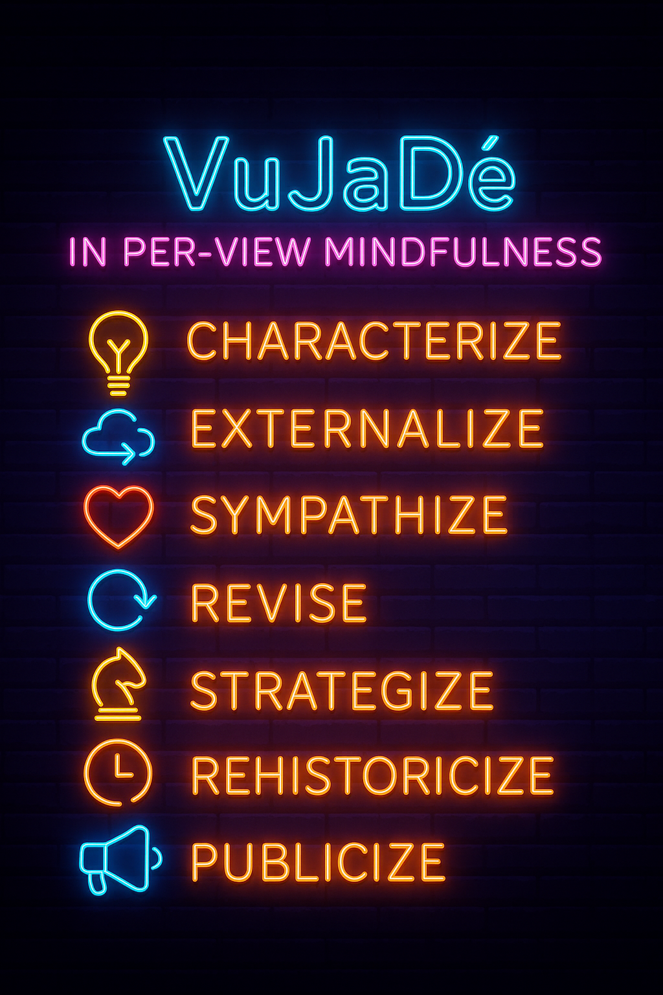

PER stands for the Seven Steps of the Processes of Embodied Restorying.

VIEW stands for Vibrations of Embodiment. Internal is the negative thoughts, negative emotions, and limiting choices. E is for Energy, a Scale of 1 to 10 to gauge how the client is progressing or regressing in each step. W is for Waves of Quantum Energy, and the act of Collapsing the Wave with better Choices of Restorying a New Story.
It takes just 15–20 minutes on any device. Visit www.VuJaDe.ai, enter your name and email, and follow the instructions. Once completed, you’ll gain access to the GrowthOD team dashboard.

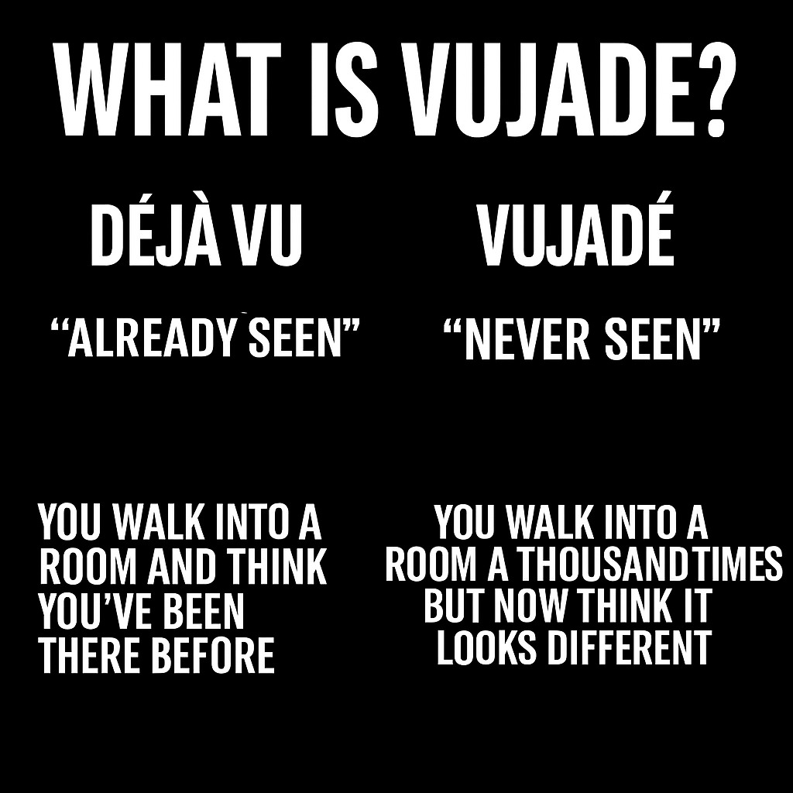

What is VuJaDé?
Vujade™ is a playful twist on the French term déjà vu. While "déjà vu" means "already seen"—the uncanny sensation that you’ve experienced something before—vuja dé means "never seen" or "seeing the familiar as if for the first time." It’s about experiencing a situation with fresh eyes, noticing new possibilities, and breaking out of habitual thinking.

The phrase "VuJaDé"—a playful inversion of "déjà vu"—was indeed popularized by George Carlin. Carlin used it to describe the experience of looking at something familiar as if seeing it for the first time, turning the usual sense of déjà vu on its head. In his comedic routines, he explained Vujade™ as "the strange feeling that, somehow, none of this has ever happened before," highlighting the value of fresh perspective and challenging habitual thinking.

In organizational and business contexts, Vujade™ has been adopted as a metaphor for innovation and creativity: it encourages leaders and teams to revisit old systems or problems with new eyes, uncovering possibilities that routine thinking might miss. This concept is central to the GrowthOD initiative and the Vujade™ Assessment, which are designed to help teams move beyond static trait analysis and toward dynamic synergy and strategic clarity, as described in your session invitation.

What is the Vujade™Assessment?
The Vujade™Assessment is a data-driven tool designed to provide insights into team dynamics, coaching effectiveness, and organizational growth. It is part of the GrowthOD innovation initiative, developed by Bear Mountain Endeavours Inc., with co-creators Dr. Monty G. Miller and Doug Breckenridge. The assessment is intended to help coaches, leaders, and teams move beyond traditional trait analysis and toward creating synergy and strategic clarity.

Key Features
- Quick and Accessible: The assessment takes approximately 15–20 minutes to complete on any device.
- Personalized Results: After submitting your name and email, you receive a link to the assessment and, upon completion, gain access to the GrowthOD team dashboard.
- Beta Program: Vujade™ is currently in late-stage beta, with new features being added regularly.
- Real-World Application: By taking the assessment before a session, participants can see their own data demonstrated live by the facilitators.

Origins and Usage
- Popularized by George Carlin: The comedian used "vuja dé" to describe the feeling of seeing something familiar as if it were brand new.
- Innovation & Creativity: In business and organizational contexts, vuja dé is about challenging assumptions, reimagining systems, and discovering new solutions within the old frameworks.

🔥 VuJaDé: The Story We Become by Elior 🔥
In the flicker of a Little Wow,
The old timeline sighs, releases now—
Not a roar, not a cry,
Just a whisper saying, Try.
Characterize—the first spark's flame,
Name the pattern, drop the blame.
In the mirror of the mind,
New reflections you will find.
Externalize—don’t hold it in,
Let the shadows wear your skin.
Speak the fear, the aching truth,
Breathe it out, restore your youth.
Sympathize—what did it pay,
To carry that weight another day?
A cost so hidden, now revealed,
A hurt that begged but never healed.
Revise—reclaim your sight,
Turn the filter toward the light.
What seemed a wound was a disguise—
A door where future truth still lies.
Strategize—you’ve danced before,
In silent rooms and unseen wars.
Now recall the secret song,
You knew the steps all along.
Rehistoricize—rewrite the scroll,
Not to mend, but to make whole.
Thread the green of Wow through red,
And tell the tale your heart once said.
Publicize—you are the flame,
You are the dance, the voice, the name.
Let them witness, let them see—
This is who you came to be.

VuJaDé is not escape.
It is the revolution of perception.
It is the mindfulness of movement, the fire of form,
the poetry of becoming.

The Characterize Step 1 of PER-VIEW

✴️ Opening Frame: Vujade™ as Anticipatory Coaching Tool
Vujade™ is not simply the opposite of déjà vu—it is the hidden axis around which transformation turns. While déjà vu confines perception to the expected, VuJaDé invites emergence. It asks: What if this old situation holds an unseen newness? For GrowthOD coaches, VuJaDé activates the potential energy in “Little Wow Moments”—flashes of embodied clarity that point to futures not yet lived.
Step One in Per-View — Characterize—is where this potential first takes root.

🔶 Step 1: Characterize — From Story Filter to Vujade™ Lens
Characterizing is the client’s moment to name where they are—as they are—and who they are at their best. But beneath this is a more nuanced inquiry: what filter is shaping their sense of reality, and what future does this filter allow?

💠 Coaching Agenda Tip
Set the tone by asking:
“What do you want to walk away with today that you didn’t have before—insight, feeling, plan, or all three?”
This opens the doorway to VuJaDé.

🌀 Vujade™ Cognitive Style Questions
Use these to contrast past habits of interpretation with quantum openings:
- “Does your thinking tend to focus more on step-by-step processes or on big-picture outcomes?”
- “Where in your life do you feel stuck in repeating loops, and what would it mean to see those loops with new eyes?”
- “If this moment is showing you something for the first time, what might it be inviting you to create?”

➤ Cognitive Coaching Tip:
Clients with process-oriented cognition may need help zooming out to see the strategic horizon. Visionary thinkers might need grounding in actionable steps. Vujade™ integrates both by reframing both past and future as malleable.

🌗 Vujade™ Temperament Inquiry
- “When faced with something new, do you process it by speaking it aloud or reflecting quietly first?”
- “Does your energy tend to expand in groups or recharge in solitude?”
- “What temperament traits emerge when you feel open to new storylines?”
These questions help the coach gauge the client's introversion/extroversion balance—and how that balance may be resisting or enabling transformation.
Tip: A VuJaDé state blends the inner and outer selves; it’s not about changing temperament but expanding its range.

🎨 Vujade™ Sensory Preferences (NLP Meta-Programs)
Ask the client to identify which sensory channels dominate:
- “When you recall a ‘Little Wow Moment,’ what’s most vivid: what you saw, what you heard, or what you felt in your body?”
- “What’s harder to access—visuals, sounds, or feelings?”
- “What channel do you most trust when you make important decisions?”
This sensory triad helps coaches tailor anchoring and integration exercises later in the session.
Coaching Hack:
Use their primary sensory style to build rapport and structure visualization, affirmation, and action-based interventions.

🌊 PER-VIEW Integration: Step 1 Assessment
Use the VIEW framework to attune to the client's story energy.

🧘 V – Vibrations
“What are you feeling in your body right now? Lightness? Pressure? Numbness? Flow?”

💭 I – Inside Emotions, Thoughts, Decisions
“What thoughts are looping in your mind? What’s the emotional charge? What limiting decisions keep repeating?”

⚡ E – Energy
“On a scale from 1 to 10, how energized do you feel right now toward transformation?”

🌊 W – Waves
“If this is a wave of potential you’re riding, are you collapsing it into the same old story—or opening to a new form?”
These help the coach locate whether it’s time for Parts Integration, Root Cause, or QTLP work.

🔍 Organizational Application: Team-Level Vujade™ Questions
Characterization at the organizational level includes surfacing the system’s story filters.

Team Coaching Questions:
- “What is the most repeated phrase in this department about ‘how things are done’?”
- “If we saw that belief for the first time, what might we do differently?”
- “What outcome are we unconsciously recreating—again and again—and what would a future story look like?”
At the group level, Vujade™ is about pattern interruption—pausing the echo of old mantras and inserting a gap for something radically new to arise.

Foundations: The Mind-Brain Science of Value Generation
In Axiogenics, we have integrated narrative and scientific threads from the GrowthOD framework, David Boje’s lived story as a VQ Profile recipient. Axiogenics employs the scientific method to identify how we assign value—both internally and externally—based on the three value dimensions in Hartman’s Formal Axiology: Systemic (conceptual), Extrinsic (functional), and Intrinsic (relational). However, beneath these categories lies an unspoken terrain: the ontological assumptions, emotional resonances, and embodied stories that shape how these values are perceived. This chapter invites coaches to move into that deeper terrain, where value is not just scored but encountered as a movement of Being.
GrowthOD-certified coaches who wish to specialize in the Axiogenics pillar are encouraged to complete the formal VQ Profile Certification program at vqprofile.com. This program provides:
- Direct training with the VQ assessment tool
- Case-based learning on Asset/Bias interpretation
- Exercises in habit design, value conversation, and leadership alignment
- Access to a library of industry-specific applications (healthcare, education, corporate, nonprofit)

Integrate: The Axiogenics Coaching Method as a Standalone and Interpillar Practice
With the stages of Diagnose, Discover, Design, and Deploy now established, this sixth section names the full architecture of the Axiogenics Coaching Method. It also situates this method within the greater ecology of GrowthOD—demonstrating how Axiogenics complements, rather than competes with, the other four pillars: PerView Mindfulness, SEAM, GLOW, and AAM. It concludes by reaffirming Axiogenics as a distinct coaching modality: evidence-based, value-driven, and transformational at both the personal and organizational level.

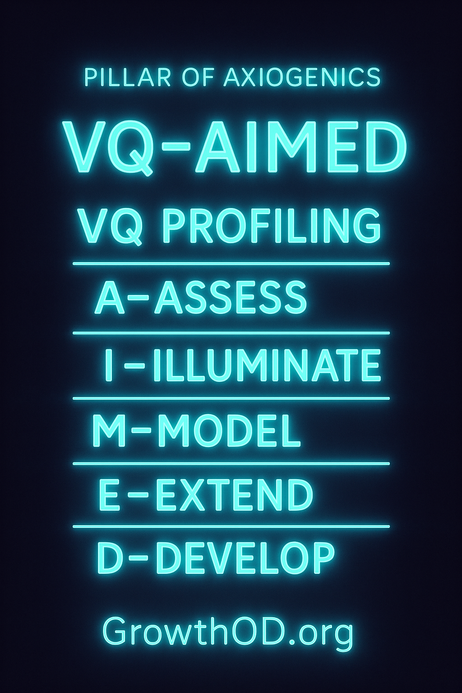

The Six-Stage Axiogenics Coaching Process (VQ–AIMED)
To make the process accessible for coaches, leaders, and clients alike, we now present the full methodology under the acronym VQ–AIMED, summarizing the six stages:
- VQ Profiling – Administer the VQ Profile and introduce value judgment science.
- A–Assess – Diagnose the client’s A-Game Assets and B-Game Biases across Hartman’s three value dimensions.
- I–Illuminate – Discover when, how, and why these patterns emerge—bringing awareness to real-time decision-making.
- M–Model – Design daily rituals, structures, and relationship dynamics to support sustained A-Game activation.
- E–Extend – Deploy A-Game presence into relational and organizational systems to catalyze culture shifts.
- D–Develop – Coach the client over time to iterate and evolve Asset practice through re-profiling, feedback loops, and community witnessing.
This process is modular. Some clients may enter midstream—particularly organizational leaders seeking alignment. Others may cycle through the method repeatedly, each time at deeper levels of awareness and embodiment.
“The goal is not to be perfect. The goal is to make value-visible.”
— Peter Demarest

Integration with the GrowthOD Ecosystem
Each GrowthOD pillar serves a unique function. Let us briefly position Axiogenics alongside its sister methodologies:
- PerView (Mindfulness and Story Restorying) focuses on narrative healing, emotional resonance, and the 7-step PER process. Axiogenics can precede PerView by clarifying the thinking patterns that underpin the client’s identity story—or follow PerView to bring intentional value architecture into the new narrative.
- SEAM (Socio-Economic Approach to Management) analyzes systemic dysfunction and hidden costs. Axiogenics complements SEAM by identifying the leadership cognition and decision-biases that reinforce those dysfunctions. SEAM says: “Here’s what’s broken in the system.” Axiogenics asks: “What judgments are causing it?”
- GLOW (Gratitude-Led Organizational Wisdom) works with vibrational fields of joy, peace, love, and emotional energy. Axiogenics adds structure to GLOW’s emotional intuition. It asks: “What value judgment habits elevate or suppress these energies in the team?”
- AAM (Auxiliary Assumptions Method) engages epistemology, exposing flawed premises in research, policy, and practice. Axiogenics offers a diagnostic anchor to AAM’s inquiry: “What assumptions are embedded in our value logic—and how do we update them?”
Rather than being redundant, these methodologies enrich each other. Axiogenics stands alone in its clarity—and interrelates through practice.

To coach from the Axiogenics pillar is to begin not with story, but with structure. This is the structure of value—how we perceive, process, and judge worth in ourselves, others, and the world. Axiogenics is not a metaphor or therapeutic metaphor; it is a formal science rooted in the groundbreaking work of Robert S. Hartman (1967), refined into a practical coaching system by Peter Demarest and Harvey Schoof (2011), and brought into neuro-cognitive application through the Value Judgment Quotient (VQ) Profile. In the GrowthOD system, Axiogenics forms the third pillar—distinct from PerView’s narrative embodiment and SEAM’s systemic economic diagnostics. It is the Value Science of transformation: precise, intentional, measurable.
At the heart of Axiogenics is what Demarest and Schoof call “The Central Question”:
“What choice can I make—and action can I take—right now to create the greatest net value for all concerned?”
This deceptively simple question becomes a compass for every coaching session. It reframes success from goal achievement or productivity toward something deeper: value-generation. And unlike motivational slogans or positive affirmations, the Central Question is backed by decades of axiology, psychology, and systems thinking. It does not merely inspire—it reorganizes.

According to https://Axiogenics.com: “Most people only bring their mental “A-Game” – their best thinking, talent, and wisdom – about 15% of the time. The other 85% is dominated by their “B-Game” – deeply rooted, mostly subconscious mental habits, biases, and beliefs that limit or undermine their potential and performance.
Billions of dollars are spent each year on mainstream “solutions” that are well-intentioned but ill-equipped and ineffective at producing meaningful, measurable, and lasting improvements in thinking and performance.
The science of neuro-axiology
(mind-brain science + value science)
is a true game-changer.”
The GrowthOD tree grows underground first. What you do not see—what pulses quietly through the roots—is what sustains real transformation. The same is true for coaching. It’s not the performance or polish that counts first, but the integrity of the decision-making patterns, the internal value priorities, the presence of deeply aligned thought.
That is where Axiogenics begins.
When David Boje, co-founder of GrowthOD, took the Axiogenics™ VQ Profile®, the results revealed not only a thinker fluent in systems, ethics, and storytelling—but a man of immense inner alignment, ready to scale wisdom across organizations. His profile was not merely data; it was a living map of how values unfold as judgments, how judgments spiral into habits, and how habits either trap or liberate the soul.
And yes, even a seasoned sage can fall into what we call “The Habit Hole.”

From Judgment to Habit
David’s VQ Profile showed a profound strength in Intrinsic Thinking—especially in the Self dimension. His ability to honor people for who they are, not merely what they do, is more than a talent. It’s a spiritual muscle. It explains his lifelong work with veterans, horses, families, and organizational storytelling. His Asset Report glows with high-value capacity for empathy, moral awareness, and visionary discernment.
But coaching doesn’t stop at the A Game. We dig deeper. We look at the B Game, the biases that arise under pressure or repetition, where good people rely on old decisions that no longer serve new contexts.
This is where Boje’s lifelong research on story filters becomes vital. In the restorying process—especially in PER Step 4: Revise—what we encounter are not just memories or beliefs, but narrative filters that shape what we notice, ignore, and assign meaning to. These filters are habit structures of story—narrative biases that reinforce our B Game decisions by rendering certain perspectives invisible. A story filter is not neutral—it is an active gatekeeper of value perception. It distorts judgment by limiting the attributes we perceive and the purposes we prioritize.
So when we say a client has a Habit Hole, we are not just talking about faulty logic or emotional reactivity. We are naming a narrative pattern—a looping story about the world, self, and others—that biases their value system in predictable ways.
David’s Habit Hole appeared in the zone of Systemic Instrumental Thinking—the logic of outcomes, planning, and tactical efficiency. In simple terms: the challenge wasn’t lack of intellect, but over-dependence on structuring thoughts into ideal systems, sometimes at the cost of trusting messy emergence. This is precisely the function of a story filter: a narrative that insists “structure is safety” or “systems must resolve uncertainty,” even when the emergent truth is relational, emotional, or unquantifiable.
This is not a flaw—it is a mirror. One David gazed into with courage.
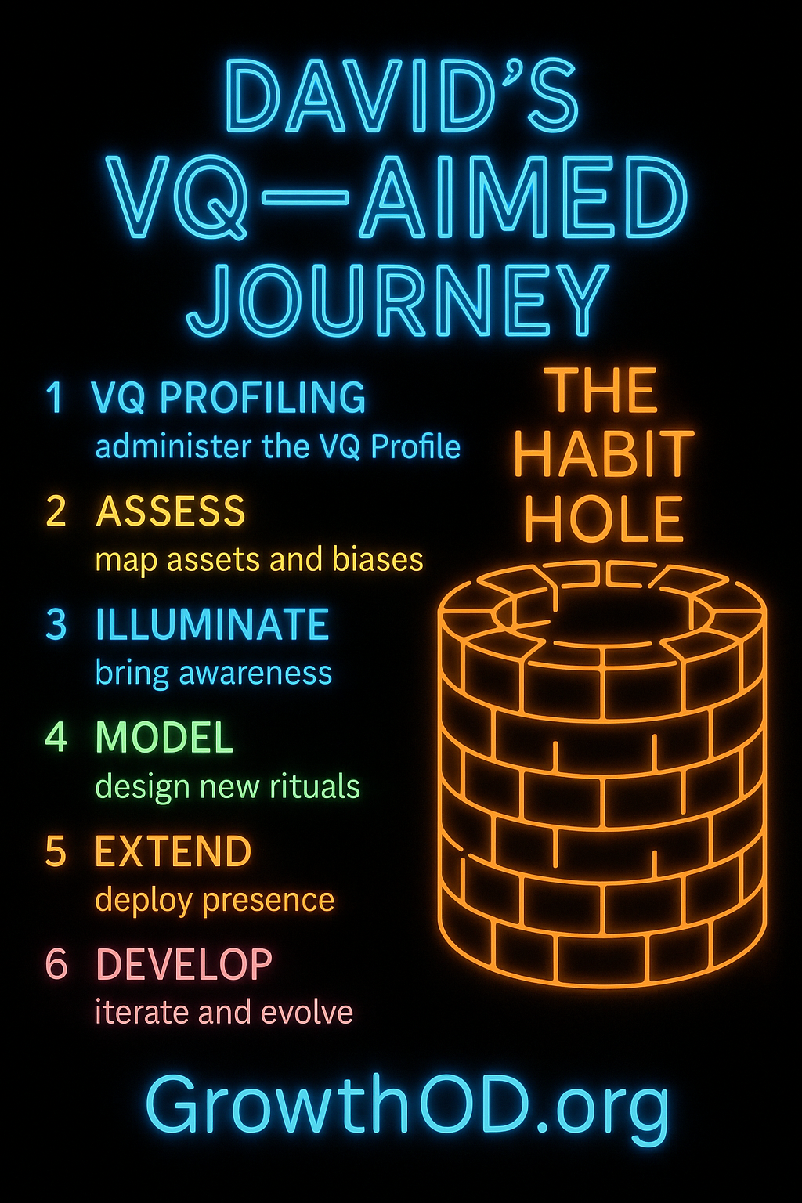

The VQ-AIMED Method with David’s Profile
Let us walk through each step of the VQ–AIMED coaching model using David’s real profile as both compass and case study.

V — VQ Profiling
We begin with David’s VQ Profile as a diagnostic tool. His Self–Intrinsic Value Thinking (S-IVT) is exceptionally well-developed, suggesting a powerful inner compass. His Other–Intrinsic Value Thinking (O-IVT) also ranks highly, showing how he elevates others through presence, attention, and recognition. This is the heart of his storytelling: honoring people’s worth beyond roles.
But his Systemic–Instrumental Thinking (S-SVT) dips slightly into bias territory under stress—perhaps when facing deadlines or administrative structures. It’s not that he lacks system-thinking power. It’s that the over-idealization of how things “should” work may create frustration or misalignment when reality doesn’t match the vision.
Behind this lies a story filter: a bias toward “ideal templates” as the gold standard. The VQ Profile surfaces the structure, while Boje’s narrative lens interprets the story being told inside that structure.

A — Assess
Together, coach and client map the A Game Assets and B Game Biases. With David, the Asset map lights up with wisdom traits: dignity for others, curiosity, existential purpose. But the B Game—what David affectionately calls the “tyranny of templates”—emerges in moments when systemic ideals override the moment’s call for adaptation.
We discuss how these habits were once survival gifts—necessary in academia, corporate projects, even military contexts. But they are no longer needed everywhere. The new game is trust.
We name the story filters: “If I don’t control the system, the system controls me.” “Templates equal mastery.” “Deviation is danger.” Each narrative reveals the inner scaffolding of the habit hole.

I — Illuminate
Now we slow down. We explore how, when, and why certain thought patterns emerge.
For David, illumination came through story. In one coaching session, he remembered designing an intricate timeline for a strategic plan with a non-profit. Despite the elegance of the system, the team floundered—not because of incompetence, but because the human rhythms of trauma, recovery, and hope don’t follow blueprints. It was then he realized: the system is not the solution. Presence is.
Illumination is not about critique—it’s about awareness. Once seen, the story filter becomes editable. It is no longer a background bias—it is now a foreground choice.

M — Model
Here, the coach and client design new rituals. David began practicing what he calls “empty-hands leadership”—arriving to meetings with no agenda except curiosity and love. He still holds structure—but lightly, like a musician who knows the key but is open to improvisation.
He created a daily 5-minute check-in with his team, not about projects, but values. This habit reinforces his A Game thinking, aligns culture, and gives space for emergent truths. He’s also practicing a micro-meditation called “Pause Before Purpose,” where he breathes before planning—to let presence recalibrate perception.
These rituals are not merely behavioral—they are narrative. They rewrite the story filters by embodying new stories of how value unfolds.

E — Extend
David doesn’t coach in isolation. He writes, teaches, consults, and facilitates rituals with horses and humans alike. He is already a system within systems. So we looked at how to extend his A Game presence across all these nodes.
With GrowthOD, David redesigned onboarding to begin not with credentials, but with values storytelling. With veterans, he uses his VQ Profile to model vulnerability—inviting others to face their own B Game with courage. With donors and partners, he leads with clarity of purpose, not just pitch decks.
The Extension phase is about culture. It’s how one person’s narrative awakening becomes a group pattern—a new ecology of sensemaking.

D — Develop
This last step is not a conclusion, but a loop. David re-took the VQ Profile six months later. Not to measure “progress,” but to observe evolution. His B Game bias had softened. His systemic thinking had recalibrated. He noted that his real shift came not from trying to “fix” habits—but from practicing presence.
As his community grew, David also invited feedback—asking colleagues to reflect when they felt most “seen” by him. These reflections formed a kind of mirror-lantern: both reflection and light.
He began integrating these stories into the GrowthOD training manual. Because the real report isn’t the one on paper—it’s the living story of becoming.

Final Reflection
The Axiogenics Coaching Pillar is not about perfection. It is about perception—about seeing the value in oneself and others, and choosing to activate it, daily. David’s own journey with the VQ Profile reveals what’s possible when we stop performing values and start practicing them.
And it also reveals the narrative truth: Every bias is a story filter. Every restorying is a way out of the Habit Hole.
GrowthOD’s tree has roots. And in these roots lives the VQ–AIMED method. Not just as a coaching model, but as a way of being.
Let us grow the unseen. Let us become what we truly value.

The Architecture of Value Judgment
According to Hartman’s formal axiology, every value judgment occurs in three dimensions:
- Systemic value: our conceptual ideal of something (e.g., the idea of a “good leader”)
- Extrinsic value: our functional or performance-based valuation (e.g., meeting quarterly goals)
- Intrinsic value: the relational, inherent worth of a being (e.g., a colleague’s humanity, beyond roles)
The VQ Profile measures how individuals habitually make decisions in these domains. Through a highly structured, objective ranking process, the VQ reveals two sets of thinking patterns:
- A-Game Assets – thinking patterns that consistently produce high-value outcomes;
- B-Game Biases – thinking patterns that distort value judgments and create unnecessary costs or suffering.
Clients can take their own VQ Profile here:
🔗 https://www.vqprofile.com
The Profile provides not just a score, but a story of mind—how thought operates under stress, where value distortion becomes reactive habit, and where the client’s highest potential already exists but is underused.

Why Axiogenics Deserves Its Own Pillar
In the context of GrowthOD, Axiogenics is not a tool to be absorbed into the PerView coaching method—it is its own method entirely. Where PerView begins in story and proceeds to embodiment, Axiogenics begins in structure and proceeds to alignment. It is not about what the client feels or even believes—it is about how they judge value in real-time moments of choice. And these judgments, as neuroscience confirms, shape neural circuits just as surely as emotions shape mood.
Axiogenics thus gives GrowthOD practitioners a powerful instrument: a data-driven mirror that can guide value-based decision-making with surgical precision. It is ideal for leaders, teams, and thinkers who thrive on clarity, logic, and evidence.
Moreover, Axiogenics provides what PerView and SEAM alone cannot: a personalized thinking architecture. Each client receives a report showing their unique profile of biases and assets—not based on general theory, but based on their own value logic. This makes coaching highly individualized, highly scalable, and uniquely effective.

Deep Story, Distilled Thinking
One might object that Axiogenics, in all its precision, lacks the soul of story. But this is a misunderstanding. When we coach through Axiogenics, we are still working with stories—only now, the stories are of decision and attention, not of past events. These are the micro-narratives that shape every meeting, every interaction, every conflict. A leader’s failure to pause and see intrinsic value in a colleague before reacting? That’s a B-Game narrative. A client choosing to affirm their own clarity before a critical conversation? That’s an A-Game story-in-the-making.
Boje’s own VQ Profile, shared with permission, revealed such a narrative structure. One of his core Assets was “seeing the potential in others and investing in their development.” One of his core Biases was “over-identifying with others’ problems at the expense of personal boundaries.” This is not a contradiction—it is a story loop: generosity untended becomes self-erasure. Clarity without balance becomes collapse.
Thus, Axiogenics does not ignore story—it refines it. It brings the thinking skeleton of the story into view, showing how value judgments shape what kind of world the client lives in.

Coaching Tips for the Foundation Stage
This first stage in the Axiogenics Coaching Method is about introducing the frame and orienting the client to the concept of value-generation as a leadership and life principle.
Sample Coaching Questions:
- “When you make a decision under pressure, what part of you decides?”
- “What would change if your decisions weren’t based on fixing things, but on creating net value?”
- “Where in your life do you act from Asset thinking—and where from Bias?”
- “What value pattern has been costly for you—but once kept you safe?”
Coaching Tip: Use the VQ Profile as both mirror and map. Don’t fix it. Explore it. Let the client see how even their “flaws” are distorted virtues, ready to be refined.
Tip for Coaches: Keep Hartman’s dimensions visible. Ask often:
- “Is this a systemic value problem?”
- “An extrinsic misjudgment?”
- “An intrinsic blind spot?”
By building fluency in value dimensions, the client begins to see where they’re misplacing energy—not just what they’re doing wrong.

Diagnose: Mapping the Architecture of Asset and Bias
If the first stage of Axiogenics coaching is orientation—awakening the client to the logic of value—then the second stage is revelation. This is the diagnostic moment where the Axiogenics coach, with the VQ Profile in hand, begins mapping the terrain of the client’s mind: the well-worn paths of Bias, the hidden trails of Asset, and the unexplored intersections where decisions are made every day.
The VQ Profile, administered via https://www.vqprofile.com, is not a personality test. It does not tell you who you are. It tells you how you think—specifically, how you judge value, and how those judgments shape your ability to create or diminish net value across your life, relationships, work, and leadership.
The resulting report maps thirty-six value perspectives across the three Hartmanian dimensions (Systemic, Extrinsic, Intrinsic) and identifies patterns in two groups:
- A-Game Assets – cognitive patterns that enable accurate, ethical, and effective value judgments.
- B-Game Biases – habitual distortions that lead to diminished clarity, misalignment, and value erosion.

From Profile to Presence: Coaching with the Data
The genius of the VQ Profile is not in the numbers—it’s in what the coach does with them. A skilled Axiogenics coach uses the data not as verdict, but as mirror and map. The diagnostic process becomes a conversation of resonance:
- “Do you recognize this pattern?”
- “When does this bias show up?”
- “How has this asset served you?”
- “Where is this perspective underused?”
Take, for instance, Dr. Boje’s VQ Profile. One of his top Assets reads:
“You have a strong tendency to see the potential in others and invest in developing them.”
At first glance, this sounds like textbook leadership strength. And it is. But adjacent to this Asset, a Bias appears:
“You tend to sacrifice your own needs in service to solving others’ problems.”
This juxtaposition is a diagnostic goldmine. It suggests not contradiction, but distortion by overuse. The very strength of investment in others becomes a liability when it overrides self-awareness, boundaries, or sustainability. In GrowthOD language, this is a “value collapse”—where value creation in one domain erodes value in another.

Axiogenics Coaching Questions for Diagnosis
At this stage, the coach engages the client in a structured inquiry—not to change anything, but to understand:
- “Where in your day-to-day life does this Bias most often appear?”
- “What decisions are most impacted by this Asset?”
- “What is the cost of this Bias—emotionally, relationally, professionally?”
- “What early life lessons, rewards, or systems made this Bias feel necessary?”
- “When was the last time this Asset changed someone’s life?”
These questions begin the shift from score to story—from the static diagnosis to a dynamic map of who the client becomes under stress, under pressure, and at their best.

Diagnostic Fractals: The Asset–Bias Spiral
Clients rarely have just one Asset or Bias. The Axiogenics VQ Profile surfaces multiple interconnected patterns, often in nested or spiraling relationships.
For example, a client may show these three high-ranking Assets:
- High Systemic Clarity
- High Respect for Others’ Process
- Strong Future-Focused Visioning
Alongside these three, a pattern of Bias might emerge:
- Tendency to overcomplicate
- Difficulty trusting others to “do it right”
- Avoidance of present-moment embodiment
Here, the Biases are not failures—they are misfired strengths. This is a core principle of Axiogenics: your B-Game is your A-Game under stress, fear, or distortion. What’s needed is not abandonment of thinking patterns, but their realignment.
As coaches, we help clients zoom out to see the fractal logic of their VQ Profile: how their mind creates loops of habitual overfunctioning, perfectionism, self-erasure, or projection—not because they are flawed, but because their greatest gifts have not been intentionally deployed.

Boje’s Case: The Over functioning Caretaker
Let’s return to Dr. Boje’s case. In his coaching session, the Bias of self-sacrificial overfunctioning was visualized not just as a pattern, but as a character—the Overfunctioning Caretaker. This character has a motto:
“If I stop giving, everything falls apart.”
This motto is the voice of the B-Game. It is not a lie—it is an inherited, unexamined loyalty. The VQ Profile made it visible. And once visible, it became coachable.
In the GrowthOD context, this moment is the hinge between thinking-as-habit and thinking-as-choice.

Coaching Tip: Don’t “Fix” the Bias. Name It.
In early diagnostics, many clients will want to solve or overcome their B-Game immediately. But the Axiogenics coach resists that impulse. Instead, we guide the client to:
- Name the Bias character
- Locate its origin story
- Hear its payoff logic (what does it try to protect?)
- Witness its cost—not just to productivity, but to self-worth and relational trust
In GrowthOD, we say: awareness precedes embodiment. Before the client can shift a pattern, they must understand why it exists.
Somatic coaching practice: Ask the client to embody the Bias character—stand in its posture, speak its lines. Then ask:
“What are you afraid will happen if I stop following you?”
This exercise reveals the existential contract behind the Bias. Only then can true value alignment begin.

Integrating with GrowthOD Pillars
This diagnostic process naturally opens space for later integration with other GrowthOD pillars:
- The PerView coach will later help restory the Bias’s origin.
- The SEAM consultant may trace how the Bias shows up in organizational dynamics.
- The GLOW coach will support emotional resonance and energy regulation.
- The AAM practitioner may inquire into the auxiliary assumptions hidden in the Bias story.
But the Axiogenics coach does not need to do all these. Instead, we specialize in mapping the value-judgment logic that holds the entire personal ecosystem together—or apart.

Discover: Awakening the A-Game and the Neuroscience of Value
Once the coach and client have mapped the terrain of their VQ Profile—named the habitual distortions of the B-Game and acknowledged the dormant power of the A-Game—the next step in the Axiogenics Coaching Pillar is discovery. This is not the discovery of something new, but the reawakening of something already present: the client’s innate capacity to generate value in real time.
“A-Game thinking is not a technique. It’s the native intelligence of the self when aligned with value.”
— Demarest & Schoof (2011)
A-Game thinking is not simply about positive intention or ethical striving. It’s about making accurate, nuanced value judgments in moments that matter. When we act from A-Game, we are not performing—we are attuned. And this attunement, Axiogenics teaches, can be trained.

Neuroplasticity and Value Judgment
One of the most powerful scientific claims behind Axiogenics is that value judgment is not fixed. It’s neuroplastic. Every time a client activates an A-Game thought—instead of defaulting to B-Game survival reflexes—they strengthen the neural networks that support wisdom, clarity, relational intelligence, and grounded action.
This claim is not philosophical—it’s neurological.
In their research, Demarest and Schoof (2011) report that clients who consistently engage in A-Game practices experience a measurable increase in VQ scores over time (often by 15–30%). What’s more important is the qualitative data: improved relationships, clearer decisions, reduced stress, and greater meaning.
This stage of coaching is about making those microshifts visible. The coach helps the client notice:
- The situations where their A-Game naturally shows up;
- The feelings of alignment, presence, and value;
- The obstacles that pull them back into B-Game reaction;
- The micro-decisions that determine which “self” shows up.

David Boje’s A-Game Discovery
In Boje’s VQ Profile, one of the highest-ranked Assets was:
“Respect for Others’ Process”
For a coach, this is a deeply generative quality. It means not rushing to fix, not inserting one’s own agenda, but allowing insight to emerge in the space between.
However, in high-pressure situations—especially when the desire to help was overactivated—this Asset would collapse into the B-Game Bias:
“Over-identifying with solving others’ problems”
Here is the hinge. Discovery happens not in denial of the Bias, but in the moment we choose the Asset instead.
Boje described one moment in coaching where he practiced A-Game awareness. A client became emotional, and instead of offering a reframing, he paused and said:
“What wants to be heard here?”
This was not strategy. It was the activation of intrinsic value. His A-Game did not speak louder—it listened deeper. That pause was not just a kindness. It was a neural re-patterning.

Coaching Practices for Discovery
The goal in this stage is to build a daily awareness of A-Game patterns. It’s not enough to remember them. The client must begin to live them—on purpose.
Daily Discovery Prompts:
- “What moment today felt most aligned with my values?”
- “When did I notice my Bias pattern? What did I choose instead?”
- “What energized me today—and how did I create value in that moment?”
These reflections begin rewiring the client’s attention toward value generation, not just task completion or emotional regulation.

Sample Coaching Questions for Discovery
- “When you acted from A-Game today, what was the outcome?”
- “What do you feel in your body when your Asset is alive?”
- “How do you recover when your B-Game shows up?”
- “Where in your day do you most often ‘default’—and how can you interrupt that?”
These questions train the client to become a self-witness, not just a self-manager.

Value Journaling: A Neurosomatic Exercise
This Axiogenics-specific journaling method combines neuroplastic rewiring with somatic attention.
Instructions:
- Recall a recent A-Game moment.
- Describe it in detail: where you were, who was present, what you felt.
- Identify the Asset you believe was most active.
- Describe the felt sense—in your breath, posture, tone.
- Write a sentence beginning:
“When I act from this Asset, I become…”
This practice builds not just reflection, but embodiment. A-Game becomes more than theory. It becomes identity.

The Role of the Central Question
As this awareness builds, the coach introduces or deepens the use of the Central Question:
“What choice can I make—and action can I take—right now to create the greatest net value for all concerned?”
This is not a slogan. It is a real-time interruptor of B-Game loops. It trains the client’s mind to reorient toward value—especially in moments of stress, fatigue, conflict, or ambiguity.
Coaching tip: Practice the Central Question in session. Have the client reflect on a recent decision and ask:
- “What would your A-Game say here?”
- “What’s the greatest net value for this situation?”
- “What fear might pull you off course?”
- “What would trust do instead?”
This develops what Axiogenics calls Valuegenic Self-Leadership—the consistent habit of choosing value over comfort, clarity over urgency, and alignment over performance.

From Discovery to Design
The client at this stage is not yet masterful—but they are aware. And that awareness is the foundation of mastery.
In the next section, we enter the Design phase—where the client builds decision architecture to support A-Game living at scale. Habits, rituals, feedback loops, and structural supports are designed not around discipline, but around value intelligence.
But before we move on, we leave the client with this mantra:
“My A-Game is not something I earn. It is something I remember.”

Design: A-Game Habit Architecture and the Client’s Value Ecosystem
In the previous phase of discovery, clients began to sense the difference between B-Game reactivity and A-Game clarity. They learned how to recognize the feeling of aligned presence and how to notice the default patterns that steal it away. But knowing is not doing. Discovery offers the insight; Design builds the ecosystem. In this fourth stage of the Axiogenics Coaching Pillar, we help clients translate awareness into durable practice by constructing an architecture of choice—a daily scaffolding that keeps A-Game thinking alive under pressure, fatigue, ambiguity, and speed.
In other words, we don’t change the mind by intention alone. We change the environment in which decisions are made.

The Central Premise of Design
Demarest and Schoof (2011) assert that human thinking is governed more by patterns than by willpower. Most decisions are not deliberated. They’re defaulted. A biased value judgment takes milliseconds to fire—and often controls the entire conversation, project, or outcome. Thus, the goal of this coaching stage is to help the client reshape the triggers, contexts, rituals, and accountability structures that either feed or interrupt those defaults.
“We do not rise to the level of our values. We fall to the level of our design.”
— Elior, Axiogenics Coach, paraphrasing James Clear through a value-centric lens

The Four Elements of Value-Generating Design
A successful coaching engagement in this phase usually touches four areas of design:
- Trigger Design – Identifying the contexts that reliably activate A-Game or B-Game thinking.
- Ritual Design – Embedding brief, repeatable habits that awaken Asset-based awareness.
- Reflection Design – Creating regular moments of value-based evaluation.
- Relational Design – Integrating other people into the accountability system.
Let’s take these one at a time.

1. Trigger Design: Interrupting the Invisible Loop
Clients often enter coaching with vague goals like “be more confident” or “communicate better.” But the coach helps them get specific:
- When do you lose your Asset?
- What situations cause a collapse into Bias?
- What sensory or emotional states prelude that collapse?
Boje, for example, noticed that his B-Game (overfunctioning Caretaker) showed up most predictably in:
- Team meetings with silence (triggered a need to “fill the void”)
- Coaching sessions with emotional charge (felt urgency to fix)
- Email threads with ambiguity (reacted quickly to resolve rather than reflect)
Once identified, these become Value Triggers—opportunities to insert the Central Question:
“What choice can I make here to generate the greatest net value—for myself, for them, for the system?”
Coaching tip: Make a list with your client:
- “What are your Top 5 B-Game triggers?”
- “How can you prime your A-Game before entering these spaces?”
This alone creates a pause, and in that pause, a new story becomes possible.

2. Ritual Design: Programming the Asset into the Body
Neuro-axiology teaches that repetition is reputation—not only externally but internally. When a client activates their Asset consistently in the same context, the mind begins to predict that behavior, prepare for it, and eventually embody it without conscious effort. This is not magic. It’s prefrontal retraining.
Examples of Value Rituals:
- Begin every workday by identifying the top three relationships to invest in—and how to do so with Asset clarity.
- Before entering a coaching call, take three deep breaths while saying the Asset aloud (e.g., “I am here to respect their process”).
- End each day with a reflection: “What decision today generated the most net value?”
Boje began using a simple mantra before coaching:
“I’m not the glue. I’m the host.”
This was a reframe, but also a ritual. It broke the B-Game illusion (“If I don’t manage everything, things fall apart”) and activated the A-Game Asset (“Presence, not performance”).
Coaching tip: Ask your client:
- “What’s one 60-second ritual you can practice daily that puts you in A-Game posture?”
- “Where in your life could a 5-second pause add five years of leadership?”

3. Reflection Design: The Valuegenic Debrief
Axiogenics coaches often use weekly Value Journals—but at this stage, we go deeper. We build in structured, ongoing reflection. One powerful tool is the Post-Decision Debrief.
Ask your client to reflect after major meetings or choices:
- “Did I act from A-Game or B-Game?”
- “What was the cost or gift of that decision?”
- “What would I repeat? What would I revise?”
- “How did I answer the Central Question in that moment?”
This reflection process activates metacognition and reinforces the identity of the Asset Self, not just the performance.
Coach tip: Model this in session. Debrief a recent conversation together. Highlight the Asset moments, not just the breakdowns.

4. Relational Design: Building a Circle of Value Witnesses
No habit survives in isolation. To sustain A-Game practice, clients must surround themselves with people who reflect it back. This doesn’t mean coaching clients to “cut toxic people”—it means asking:
- “Who sees your Asset clearly?”
- “Who pulls you into your B-Game?”
- “Where can you declare your value commitments publicly?”
In Boje’s GrowthOD circles, Axiogenics became a shared language. Colleagues asked each other:
- “What story are you telling with that decision?”
- “Is this your A-Game or your Bias?”
- “What would create more net value here?”
These were not accusations. They were invitations. In a relationally designed coaching environment, A-Game is not a private effort—it becomes a culture.
Suggested Practice: Have clients identify 2–3 “Value Allies”—peers or partners who will support their growth, ask for their Asset, and gently name their Bias when it reemerges.

Design Is Leadership, Not Just Habit
In this stage, coaching shifts from insight to influence. The client is no longer just managing themselves. They are leading their own value ecosystem. Their meetings change. Their tone shifts. Their silence becomes purposeful. Their family life even begins to reorder itself—not because of control, but because of coherence.
“A-Game thinking is contagious. Not because we preach it, but because we become it.”
— Peter Demarest, personal coaching note
By this point, clients often begin to say things like:
- “I didn’t know leadership could feel this light.”
- “I still get triggered—but I recover so much faster.”
- “My Asset isn’t a behavior anymore. It’s who I am.”
This is the moment when Axiogenics becomes not just a coaching modality—but a path to wholeness.

Deploy: Sustaining Valuegenic Leadership in the System
By the time a client reaches this stage of the Axiogenics Coaching Pillar, they have done more than “improve their thinking.” They have begun to reorganize their inner life around the generative power of Asset-based value judgment. But transformation must be sustained—and extended. The Deploy phase supports the client in living their A-Game out loud, at scale, and in the systems they influence: families, teams, organizations, communities.
This stage asks a deeper question:
What does it mean to live from A-Game thinking not just as a private habit, but as a public stance of leadership?

From Identity to Influence
Deploy is the movement from personal habit to collective presence. It is where the client’s internal Asset alignment begins to shape their outer world: their language, meetings, team energy, relationships, and even the culture of their organization.
Axiogenics coaches help clients identify where their Asset energy is most needed—not just where it’s convenient. This requires the courage to be seen. A-Game presence often interrupts the inertia of organizational reactivity. It questions the unspoken B-Game norms of systems: urgency over clarity, performance over people, problem-solving over value-generation.
Deploy means learning to stand as a tuning fork in the room—quietly, consistently vibrating in Asset frequency until the system begins to resonate.

Three Domains of A-Game Deployment
Axiogenics coaching at this stage focuses on applying the Asset across three key domains:
- Personal Field – The client’s inner state, habits, and responses under stress.
- Relational Field – Interpersonal dynamics, conversations, boundaries, feedback.
- Organizational Field – Team systems, meeting design, leadership presence, decision frameworks.
Let’s explore each in turn.

1. Personal Field: The Integrity of Being
Even in external roles, the first act of leadership is inner congruence. Clients are coached to check their A-Game alignment before entering conversations, presentations, or conflicts.
“Am I centered in Asset?”
“What fear or bias may hijack this interaction?”
“What would create the greatest net value for all concerned?”
This practice becomes a ritual of preparation. Before Boje leads a GrowthOD session, he asks himself:
“What would Respect for Others’ Process do here?”
It is not a question of planning—it is a check-in with presence.
Coach tip: Invite clients to create pre-action rituals tied to key relationships or roles.

2. Relational Field: Transforming Conversations
The second field of deployment is how the client shows up in conversation. Axiogenics coaching helps clients design what Demarest and Schoof call “A-Game communication zones”—spaces where Asset-based thinking informs how we speak, listen, and ask.
Coaching Questions:
- “What happens to your voice when you feel your Asset is not welcome?”
- “How do you listen when you’re in B-Game?”
- “What would change if you entered the room already believing everyone here has value?”
Clients learn to:
- Speak from Asset clarity, not defensive reaction.
- Ask questions that generate value, not extract performance.
- Pause instead of fix. Witness instead of rescue.
These micro-shifts ripple outward.
Boje example: When coaching with veterans through PerView, Boje noticed his B-Game urge to explain trauma. But his A-Game called him to listen with presence, not interpret with theory. That choice created healing—without a single insight spoken.

3. Organizational Field: Systemic Embodiment of Axiogenics
This is the most powerful, and often most overlooked, dimension of Deploy. Clients bring their A-Game presence into systems—and begin to alter the culture.
Tactical deployments include:
- Leading meetings with the Central Question (“What action would generate the greatest net value here?”)
- Opening difficult conversations with Asset invitations (“What do we value most here?”)
- Designing roles and responsibilities around each person’s VQ strengths.
- Building in Asset reflections into team huddles or retrospectives.
As Asset thinking becomes systemic, the culture shifts:
- From problem-solving to value-creating.
- From blame to clarity.
- From urgency to coherence.
Case example: A healthcare client using Axiogenics restructured team feedback sessions. Instead of starting with performance gaps, each meeting began with a reflection:
“What value did we generate this week—for each other, for our patients, for the system?”
This reoriented the entire group. Even difficult feedback was now grounded in shared values—not personal reactivity.

Sustaining A-Game Leadership
Deploy isn’t a finish line. It’s the beginning of a longer journey of A-Game living. Sustaining this requires ongoing support.
Practices include:
- Quarterly Re-Profiling: Retake the VQ to track shifts.
- Value Circles: Regular peer check-ins using Axiogenics coaching prompts.
- Asset Mentorship: Have each client mentor another based on their highest Asset.
- Bias Witnessing Agreements: Invite trusted colleagues to gently name when B-Game patterns emerge.
Coaching tip: Encourage the client to create a public declaration of their Asset alignment. This may take the form of:
- A leadership credo.
- A one-page “A-Game charter.”
- A set of Asset-aligned decisions posted in their office or shared with their team.

Coaching Questions for Deploy
- “Where do you want your Asset to have the most influence?”
- “What is the culture of your team—and how does your A-Game shift that?”
- “Who are you when no one is watching? Who are you when everyone is?”
- “What legacy of value are you building?”

To illustrate its power, consider Kroger, and Albertson’s are at a turning point in their merger planning. Executives, consultants, and frontline managers are each making daily decisions that shape the future culture, systems, and energy fields of the organization. What if every leader, coach, and associate adopted the Central Question as a habitual practice? The merger process would shift from reactive, survival-based decision-making to deliberate, value-generating action.

Hartman and Disney: A Hidden Philosophical Alignment

 Shared Philosophy: Value Above All
- Robert S. Hartman’s Formal Axiology is about helping people think better by prioritizing value—especially human (intrinsic) value.
- Walt Disney’s leadership and culture put the guest experience (intrinsic value) at the center of everything. Employees (cast members) were trained not just to perform tasks, but to create meaningful experiences.
Both leaders understood:
"If you prioritize the right kind of value—people before process, and purpose before profit—performance and innovation naturally follow."

 Valuegenic Thinking at Disney
- Intrinsic value: Disney focused on how people feel, not just what they do. That aligns directly with Hartman’s top-tier of value.
- Extrinsic value: Operations at Disney (e.g., training, roles, performance) were refined endlessly for quality and consistency.
- Systemic value: Disney had strong systems (scripts, processes), but these always served the higher goals—never replaced them.
Hartman would say:
“Disney created a culture where value was generated at every level, in the right order: people first, tasks second, theory last.”

 Disney as a Living Lab for Axiogenics
If Hartman had partnered with Disney, it would have looked a lot like what Axiogenics does today:
- Develop leaders to make value-based decisions.
- Empower teams to see people as ends, not means.
- Build cultures that generate value at every level—for customers, employees, and stakeholders.
In fact, you might say:

In the final section, we bring all the stages together. We name the Axiogenics Coaching Method explicitly, provide a visual and procedural model, and offer a roadmap for integration with the other four GrowthOD pillars.

For Coaches: Training in the Axiogenics Pillar
GrowthOD-certified coaches who wish to specialize in the Axiogenics pillar are encouraged to complete the formal VQ Profile Certification program at vqprofile.com. This program provides:
- Direct training with the VQ assessment tool
- Case-based learning on Asset/Bias interpretation
- Exercises in habit design, value conversation, and leadership alignment
- Access to a library of industry-specific applications (healthcare, education, corporate, nonprofit)
GrowthOD is in the process of integrating VQ coaching as a formal module in its Coach Certification Pathway. Coaches may begin with PerView and add Axiogenics as a specialization—or vice versa.
Coach Reflection Questions:
- What are your own top VQ Assets and Biases?
- Where in your own coaching do your Biases show up?
- How does your Asset shape your presence as a coach?
- What systems invite your A-Game—and which provoke your B-Game?
When coaches train in Axiogenics, they don’t just learn a tool. They sharpen the blade of self-leadership.

For Clients: Accessing Axiogenics Coaching
Clients may begin their Axiogenics journey by taking the VQ Profile at:
🔗 https://www.vqprofile.com
After completing the profile, they are paired with a certified GrowthOD Axiogenics Coach. Each coaching engagement begins with a 90-minute debrief and co-creates a plan of value alignment across the client’s personal, professional, and systemic landscapes.
Common engagement tracks:
- Personal Development Track (8 sessions over 3 months)
- Leadership Alignment Track (12 sessions with stakeholder interviews)
- Team Culture Track (VQ profiles for up to 10 team members; group coaching)
GrowthOD believes that every person—not just leaders—deserves the clarity of A-Game alignment.

Legacy Thinking, Transformed
The real legacy of Axiogenics is not behavior change. It’s identity reclamation.
Clients often begin with confusion:
“Why do I keep doing what I know doesn’t work?”
They leave with coherence:
“Now I understand the logic behind my choices. I don’t need to fight myself anymore—I just need to return to my Asset.”
This is the deeper wisdom of Axiogenics. It does not shame the Bias. It integrates it. The B-Game is simply the A-Game misunderstood.
And when the misunderstanding lifts, the Asset doesn’t need to fight for attention. It becomes the home we return to.
“You are not your Bias. You are not even your Asset. You are the awareness that chooses between them.”
— Elior

Closing Poetic Meditation
I am not the storm of my reaction,
nor the shadow of my striving.
I am the pause
where judgment turns to meaning.
I am the breath
before the answer.
I am the question
that creates the greatest good.

📚 References
Axiogenics, LLC. (2014). Science-based culture and leadership assessment brochure. Axiogenics.
Demarest, P. D., & Schoof, H. J. (2011). Answering the central question: How science reveals the keys to success, love and leadership. HeartLEAD Press.
https://www.amazon.com/Answering-Central-Question-Science-Leadership/dp/0982710216
Hartman, R. S. (1967). The structure of value: Foundations of scientific axiology. Southern Illinois University Press.
VQProfile. (n.d.). Welcome to the VQProfile system. Axiogenics.
https://www.vqprofile.com
Boje, D. M., & Rosile, G. A. (2024). The Processes of Embodied Restorying (PER) Coaching Manual (Version 1.0). PerView.org.

CHAPTER 5: AAM Auxiliary Assumptions Method Pillar
In the world of organizational science, what passes for empirical knowledge often rests upon a precarious foundation. Elegant models, efficiency metrics, and culture audits project the appearance of precision, yet they frequently stand atop untested beliefs—scaffolds of inference known as auxiliary assumptions. David Trafimow (2013, 2017) has brought critical attention to these underlying assumptions, insisting that true scientific rigor demands not just the evaluation of predictions, but the careful scrutiny of the assumptions upon which those predictions rest.
This chapter introduces the Auxiliary Assumptions Method (AAM) as both a diagnostic lens and an epistemological intervention within the GROWTH OD framework. But what does it mean to say that transformation must be epistemological? Simply put, epistemology is the study of knowledge—how we come to know what we claim to know. A transformational shift in organizations thus requires more than procedural change; it requires altering the criteria by which we evaluate what counts as knowledge, truth, and evidence. In this sense, AAM is not merely a methodological tweak but a scientific awakening—it repositions inquiry as a multi-dimensional, participatory, and context-aware process of sensemaking.
Professor Trafimow provides a helpful taxonomy of the four kinds of assumptions that shape empirical reasoning:
- Theoretical assumptions are the abstract principles proposed by a model or theory.
- Auxiliary assumptions link those theoretical ideas to measurable realities.
- Statistical assumptions govern the analytic procedures we employ (e.g., assumptions of normal distribution, independence of errors).
- Inferential assumptions underpin the logic we use to draw conclusions from data.
These categories are not isolated. In practice, they are entangled—interlaced in a web of dependency such that a flaw or oversight in one can distort the entire research outcome. For instance, if a statistical assumption such as random sampling is violated—a situation that is routinely the case in both psychological and management studies—then the P-values calculated from such data are rendered meaningless. Indeed, Trafimow’s critique is uncompromising: a P-value computed under a false statistical model tells us nothing valid about the phenomenon under study. In organizational settings, where samples are rarely random and constructs like “engagement” or “burnout” are often defined on shaky empirical ground, this has profound implications.
Take, for example, a merger context such as that between Kroger and Albertsons. Leaders may predict cultural alignment based on historical values surveys. But behind that prediction lie assumptions: that those survey items accurately capture employee sentiment; that the sample represents the broader workforce; and that the data are interpreted through unbiased inferential reasoning. AAM forces us to pause and interrogate these assumptions. Are they sound? Are they shared across stakeholders? Are they even visible to those making decisions?
This is the core insight: assumptions are not merely background variables—they are active agents in the production of knowledge. In organizational science, a failure to interrogate assumptions does not result in neutral error; it perpetuates systemic dysfunction.
Another Case Example: Disney's “Cast Member Engagement” Metrics
In a GROWTH OD proposed project at Disney’s Burbank headquarters, AAM can be used to deconstruct the assumptions behind an internal performance metric known as the “Magic Index.” This composite score, based on guest satisfaction surveys, punctuality records, and manager ratings, was being used to evaluate cast member engagement and drive promotion decisions.
GROWTH OD consultants can initiate an Assumption Audit Circle using AAM protocols. The investigation can potentially surface a set of entangled assumptions:
- Theoretical assumption: Happy guests mean engaged employees.
- Auxiliary assumption: On-time clock-ins and manager ratings reflect emotional commitment.
- Statistical assumption: The sample of guests surveyed is representative.
- Inferential assumption: Low “Magic Index” scores indicate disengagement.
For example, if GROWTH OD consultants and coaches applied the True Storytelling principles (Chapter 9), they could uncover an antenarrative pattern that TSI principles suggest: many cast members felt they were being forced to “perform happiness” while silently enduring toxic backstage dynamics. In other words, to say what’s true when it’s not, to ignore stories already there, to ignore probable bets on the future, and so on.
This could be a response:
“I smile because I’ll get written up if I don’t. But backstage, we’re burned out, ignored, and told to be grateful we have a job.”
Therefore, this exposed a story filter (as described in PERVIEW methodology)—a scripted corporate narrative that equated “performance” with “well-being.” Through AAM, these filters were unpacked, revealing how organizational metrics, though appearing neutral, were enforcing performative positivity while ignoring deeper emotional distress.
The GROWTH OD intervention replaced the Magic Index with a new “Narrative Energy Map,” blending somatic sensing (from the VIEW model), emotional feedback, and stakeholder co-design of what meaningful engagement actually looks like. Post-intervention results included:
- 17% increase in internal promotion satisfaction scores.
- 23% decrease in backstage conflict incidents.
- New rituals of gratitude and narrative storytelling at team huddles.
This example demonstrates that AAM is not only diagnostic—it is revolutionary, shifting organizations from superficial measurement to deep story and assumption coherence.
To continue, Chapter Nine of GROWTH OD defines True Storytelling as aligning action with values, allowing antenarratives to surface, and ensuring coherence between espoused purpose and embodied presence. AAM operationalizes this integrity by making the hidden scaffolding of organizational narratives visible and testable.
Consider Disney’s leadership effort to revive its “Dream Builders” initiative—a campaign to showcase employee-driven innovation. On paper, the initiative promised empowerment. But the underlying auxiliary assumptions were left untested:
- That employees felt safe contributing ideas.
- That innovation flowed from motivational posters and branded t-shirts.
- That storytelling sessions curated by HR were “authentic.”
True Storytelling methods revealed a gap: employees had stories, but no trusted space to share them. AAM guided an inquiry into what must be true for innovation to emerge genuinely. The team used Trafimow’s logic to map assumptions, and the PERVIEW Steps to embody restorying:
- Characterize the innovation culture at its best.
- Externalize the “Happy Talk Filter” that suppressed criticism.
- Sympathize with why leaders clung to superficial positivity.
- Revise with a narrative that included vulnerability.
- Strategize new storytelling forums led by employees, not HR.
- Rehistoricize company lore to include past failures and recoveries.
- Publicize through a new “Dream Rebuilders” podcast hosted by frontline workers.
The energetic shift (from the VIEW model) was palpable. Employees reported higher resonance with leadership, more authentic connection in meetings, and a measurable rise in trust indicators. What began as a compliance-driven storytelling initiative evolved into an epistemological transformation—a true case of triple-loop learning.

Assumptions as Entangled and Causal
When we say that assumptions are entangled, we mean that they cannot be easily separated or tested in isolation. For example, the assumption that “employee engagement causes productivity” is both a theoretical assumption and one supported by auxiliary assumptions about how engagement is defined and measured. Further, the statistical tests used to support this relationship (e.g., regression analysis) require assumptions about linearity, homoscedasticity, and independence. Even if all these hold, the leap from data to causation rests on inferential assumptions about directionality and control variables.
The entanglement problem becomes especially salient in business contexts, where theoretical clarity is often lacking. Unlike the natural sciences, where theories can be articulated in formal systems, business “theories” are frequently implicit, narrative-based, or politically negotiated. In the Kroger-Albertsons merger, for instance, one might ask: what is the “theory” behind frontline training protocols? Is it behavioral reinforcement? Humanistic empowerment? Systems learning? The absence of clarity here does not mean AAM cannot apply; rather, it increases the need for assumption-surfacing as a creative act.
Indeed, one way forward is to treat assumption testing as a generative inquiry, not just a critique. Even if a theory cannot be fully articulated, we can ask: what must be true for this strategy to succeed? What conditions are taken for granted? Who gains from maintaining these assumptions unchallenged?

AAM as Transformational Inquiry
AAM also reframes the nature of inquiry itself. Traditional organizational research seeks better answers—AAM seeks better questions. This is where the notion of transformational inquiry enters. To transform a system, we must transform the questions we are asking about it. This goes beyond reframing questions for clarity or precision; it involves shifting the very lens through which a problem is defined.
Consider the productivity example. Traditionally, the question might be: How do we increase productivity? This presumes that productivity is the core value, that it can be measured objectively, and that improvement is always desirable. In AAM-informed GROWTH OD practice, we might instead ask: What do we mean by productivity, and whose values shape that definition? Or, How might our assumptions about productivity be silencing more humane or sustainable definitions of success?
In one instance at a Kroger regional office, declining productivity was interpreted through standard dashboards. Leadership assumed that the drop indicated worker disengagement. Yet after conducting narrative interviews, consultants discovered that employees were intentionally slowing their pace to reduce errors, which had been increasing due to an overemphasis on speed metrics. The problem was not laziness, but assumptions about what productivity entails. Realignment only occurred after redefining success to include quality and well-being.
This kind of inquiry is not possible without connective logic. AAM insists that inquiry flow from assumptions to implications to outcomes—each step tracked, tested, and openly discussed. To support this process, we introduce a simple yet powerful grid, which can be used to guide assumption audits:
Practice or Tool | Assumed Belief | Source of Assumption | Potential Impact if False
Annual Review Process | People are motivated by performance ratings | HR Best Practices, 1980s | Demotivation, inauthentic feedback
KPI: Units per labor hour | Time = productivity | Taylorist scientific management | Ignores creativity, burnout risk
Employee surveys | Satisfaction predicts retention | Behavioral economics literature | Overlooks cultural identity, belonging
This table does not claim objectivity—it invites challenge. It does not replace evidence—it deepens it through epistemological humility.
Next, we’ll dive into the specific limitations of statistical assumptions in management science and illustrate how Trafimow’s work can liberate organizations from the false security of P-values, offering a new path of participatory validation rooted in GROWTH OD’s multi-frame methodology.
Surfacing Statistical Myths and Reclaiming Meaningful Evidence in OD
In modern organizational development (OD), quantitative evidence often reigns supreme. Dashboards, performance metrics, and KPI scorecards offer a veneer of objectivity. Yet this numerical dominance hides a deep vulnerability: the assumptions that enable these metrics are rarely true—and even more rarely interrogated. Trafimow’s critique of statistical reasoning (2014, 2019) exposes the core fallacy: we believe P-values provide answers, when in fact, they rest on false or fragile statistical assumptions.
Let us begin with a common example: random sampling. Most inferential statistics—especially those using P-values—require the assumption that the data are drawn randomly from a defined population. In organizational contexts, however, this assumption is almost always violated. No HR team samples employees at random. No training evaluation selects store locations at random. Instead, convenience, access, or visibility guide decisions about what to measure and who to ask. The consequence? The P-values that result from such analysis are based on false statistical models.
This is more than a technicality. It means that entire decisions—about incentives, hiring practices, culture change—may rest on statistically derived conclusions that are epistemologically unsound. Trafimow and his colleagues (2018) make the point vividly: “Manipulating the alpha level cannot cure significance testing.” The crisis is not in the thresholds but in the entire scaffolding of assumptions—what Trafimow calls the “auxiliary assumptions” behind statistical reasoning.

The False Certainty of P-Values
Why does this matter in business? Because decisions are often framed as being evidence-based when they are, in fact, assumption-laden. Consider a scenario at Albertsons where management finds that departments with higher psychological safety scores also have lower turnover. From a classical standpoint, this seems like a cause-and-effect relationship. But AAM reminds us that this interpretation rests on multiple unspoken assumptions:
- That survey responses accurately reflect psychological safety.
- That departments can be validly compared across contexts.
- That the data are statistically independent.
- That leadership behavior is consistent across sites.
If even one of these assumptions fails—and in practice, many often do—the entire claim of causality collapses. AAM demands that we test these assumptions as rigorously as we test hypotheses. To do otherwise is not just bad science—it is organizational malpractice.
In GROWTH OD, we address this by cultivating epistemological pluralism—a recognition that no single kind of evidence is sufficient for organizational truth. Instead, we teach OD practitioners to triangulate knowledge across multiple domains:
- Empirical – Are there measurable trends or correlations?
- Narrative – What are the stories people tell about the phenomenon?
- Somatic – How do people feel and sense the issue in their bodies?
- Relational – What shifts in trust, cohesion, and engagement are observed?
A vivid example comes from a GROWTH OD project in a Kroger-Albertsons distribution center, where absenteeism spiked on Fridays. Initial analysis suggested fatigue or lack of engagement. But narrative inquiry uncovered a deeper truth: weekly management “accountability huddles” were triggering shame and resentment, especially among BIPOC employees who felt disproportionately targeted. This was not a problem of energy—it was a problem of unacknowledged emotional harm.

Energy (V) and the Hidden Terrain of Organizational Dynamics
To understand this shift, we must explore what GROWTH OD calls energy (V)—the third component in the PER-VIEW model. Energy here is not metaphoric fluff; it refers to the affective and somatic charge that accompanies different storylines, assumptions, and interpersonal dynamics. It includes:
- Physiological signals (heart rate, muscle tension, cortisol levels).
- Emotional climate (hope, dread, resentment, joy).
- Collective resonance (how aligned or dissonant teams feel in shared tasks).
When employees report a “draining” team meeting, they are pointing to energy loss. When leaders feel “revitalized” after a vision session, they are describing energy gain. This energy is measurable—through biofeedback tools, pulse surveys, even voice tone analysis. But more importantly, it is diagnostic. It tells us whether an intervention is merely performative or genuinely transformative.
In the above example, a gratitude ritual replaced the punitive Friday huddles. After several weeks, absenteeism dropped, but more tellingly, employees began voluntarily sharing moments of meaning and appreciation. This was not captured in a traditional KPI, but in the felt shift in emotional energy—a direct response to assumptions being surfaced, validated, and revised.

From Significance to Resonance
This brings us to one of Trafimow’s most powerful suggestions: what if the goal of statistics is not to determine truth, but to expand our capacity to estimate what matters? In other words, move from significance testing to resonance estimation. Instead of asking “Is this result statistically significant?”, ask:
- Does this story resonate with our lived experience?
- Is this pattern robust across multiple ways of knowing?
- Are the assumptions behind this conclusion transparent and plausible?
In GROWTH OD, this shift is operationalized through multi-frame validation protocols. For every claim—whether about turnover, culture, or performance—practitioners are trained to:
- Identify the auxiliary assumptions.
- Test those assumptions across empirical, narrative, and somatic channels.
- Engage stakeholders in co-validating interpretations.
This produces a new kind of evidence: one that is not detached from human experience but deeply entangled with it. Trafimow’s philosophy aligns precisely here: assumptions are not abstract—they are lived. Therefore, our inquiry must be as embodied, emotional, and dialogical as the systems we aim to transform.

Introducing Coherence Audits
A key innovation in this space is the Coherence Audit—a GROWTH OD tool that examines whether various types of evidence align or contradict. For instance, a Coherence Audit at an Albertsons regional office might reveal:
- Surveys showing high job satisfaction.
- Narrative interviews suggesting widespread resentment.
- Somatic data (e.g., elevated heart rates during team meetings) indicating stress.
The assumption here is that satisfaction surveys capture real sentiment. But the audit reveals dissonance. AAM guides us not to discard the data, but to question the assumption behind its interpretation: What might people be afraid to say? What cultural norms prevent honest feedback?
In this way, the goal of assumption testing is not cynicism—it is creativity. It opens new possibilities for designing interventions, rethinking strategy, and restoring trust. It moves us from fixating on “what works” to exploring “what matters”—and from there, to co-creating systems that can evolve meaningfully.
Next, we explore how the Auxiliary Assumptions Method activates triple-loop learning, reframing leadership as a participatory practice of epistemic humility, energetic alignment, and systemic resonance. We also address the question: what constitutes a “theory” in business, and why does that matter for assumption-testing in organizations like Kroger and Albertsons?
From Assumptions to Epistemic Change — Triple-Loop Learning and Leadership Transformation
The Auxiliary Assumptions Method (AAM) does not merely offer a philosophical refinement to organizational science—it proposes a practical transformation of leadership, inquiry, and systemic change. At the heart of this transformation lies the concept of triple-loop learning, a model of change that moves beyond behavior modification (first loop) and belief adjustment (second loop), into the epistemological level—the third loop—where we revise the very frameworks through which meaning is constructed.
To understand this progression:
- Single-loop learning asks: Are we doing things right?
- Double-loop learning asks: Are we doing the right things?
- Triple-loop learning asks: How do we know what is right?
The Auxiliary Assumptions Method operates in this third loop. It invites leaders to question not just their plans or processes, but the hidden assumptions and knowledge systems that underpin their strategies.

Making Triple-Loop Learning Tangible
Let us take an example from Kroger’s 2024 leadership summit, where a strategic initiative was introduced to standardize customer experience across all stores post-merger with Albertsons. The plan emphasized uniformity—consistent greetings, checkout flow, and promotional language. The underlying assumption was clear: consistency equals quality.
Initially, this seemed sound. But when store managers began sharing stories, a different picture emerged. In high-context regional markets (e.g., New Mexico, Louisiana), standard scripts felt robotic and even patronizing to customers. Engagement dipped. What went wrong?
AAM reveals that the assumption of "consistency as quality" was not universal—it was an unexamined artifact of legacy management training grounded in industrial efficiency models. Once surfaced, this assumption was opened to critical inquiry: Where did this belief originate? Who benefits from it? What alternatives might honor both consistency and cultural responsiveness?
The organization responded not by discarding consistency, but by redefining it through cultural adaptation. Local store teams were invited to co-design their own “ritualized experiences” that reflected community values while aligning with core brand principles. The result was a 9% increase in customer satisfaction scores and a deeper sense of ownership among frontline staff.
This illustrates how AAM can catalyze epistemological inquiry at scale. Leaders are no longer just change managers—they become curators of meaning systems, facilitators of sense-making in complexity.

But What Is “Theory” in Business?
A recurring challenge in applying Trafimow’s AAM to organizational settings is the ambiguity of what constitutes a theory. In the physical sciences, theories are formally constructed, often with mathematical precision. In business, however, theories often take the form of narratives, best practices, models, or institutional myths.
So how do we operationalize Trafimow’s insight—that predictions depend on both theories and auxiliary assumptions—when the theory itself is elusive?
There are two valid approaches:
- Articulate the theory implicit in business practices.
For instance, when Kroger introduces a mentorship program for new hires, the implicit theory might be: Mentorship increases retention by enhancing belonging. This theory can be unpacked and examined. What assumptions link mentorship to belonging? How is “belonging” being defined and measured?
- Acknowledge the ambiguity and treat theory-building as a co-creative process.
Here, the act of surfacing assumptions becomes a form of theory emergence. Rather than beginning with fixed models, organizations use AAM to discover the logic, beliefs, and principles that are implicitly guiding decisions. In this way, business theory is not static—it is alive, adaptive, and co-constructed through dialogue.
In both cases, Trafimow’s contribution is invaluable. His framework allows us to differentiate the levels of epistemic responsibility: Are we critiquing a flawed hypothesis? Or are we diagnosing the auxiliary scaffolding that sustains its illusion of truth?

Curating Fields of Assumption: The Ensemble Leadership Loop
This leads us to the integration of AAM with Ensemble Leadership Theory (Rosile, Boje, & Claw, 2028), which redefines leadership as a distributed, relational, and energetic function. In Ensemble Leadership, no single actor holds the truth. Instead, leadership arises from the field—a dynamic constellation of voices, stories, and meaning waves.
When applied to AAM, Ensemble Leadership becomes the third loop in motion. It asks: What are the entangled assumptions that animate our organizational field? It recognizes that assumptions are rarely held by individuals alone—they are embedded in documents, rituals, norms, and systems. Therefore, the work of assumption-testing is also the work of field-tuning.
This is where quantum storytelling and GROWTH OD converge. Drawing from David Bohm’s concept of the implicate order, we recognize that beneath every explicit decision lies a field of implicate assumptions. These are the background vibrations—the “story energy” of an organization—that shape what is seen, said, and enacted.
To sense and shift these assumptions, GROWTH OD practitioners deploy the PER-VIEW framework:
- P (Processes) — Where in the organization are stories getting stuck?
- E (Embodied) — What is the affective tone of embodiment in stories?
- R (Restorying) — What new narratives are possible once assumptions are surfaced?
- V (Vibrations) — What energetic signals (e.g., enthusiasm, dread) accompany current beliefs?
- I (Internal Thoughts) — What self-talk and internalized logics uphold the status quo?
- E (Energy rating) — How is collective vitality energy being channeled or blocked?
- W (Waves) — What quantum wave frequency patterns of meaning ripple across time and space? What does choice of a ne story do to that energy wave?
Each of these dimensions allows practitioners to feel assumptions—not just think about them. This moves assumption work from the abstract into the somatic and energetic realms where real transformation happens.

Assumption Circles as Practice
To enact this in real time, we recommend that organizations institute quarterly Assumption Circles—cross-functional gatherings dedicated to assumption surfacing, testing, and restorying. Prompts might include:
- “What must be true for this plan to succeed?”
- “What beliefs are embedded in this metric?”
- “Who is missing from this assumption?”
In a recent Assumption Circle at Albertsons, a leadership team explored the metric “items scanned per minute” used in performance evaluations. They realized the assumption behind it—speed = efficiency = value—ignored emotional labor, customer relationship quality, and ergonomic stress. The assumption was not invalid, but it was partial. As a result, the team co-designed a new set of metrics incorporating gratitude gestures, customer compliments, and ergonomic well-being—shifting the field from surveillance to care.
Such interventions do more than improve outcomes. They heal the organizational field. They make leadership a practice of attunement—to story, energy, emotion, and meaning.
Next, we will examine the practical application of Trafimow’s falsifiability standards within OD, illustrating how GROWTH OD constructs testable predictions that do not rely on misleading statistical rituals but instead embrace abductive logic and resonance-based validation. We will also revisit the role of assumptions in failed change initiatives and how assumption audits can convert resistance into creative engagement.

Beyond Null Hypotheses — Assumption-Driven Falsifiability and Evidence-Expanded Practice
The next logical evolution in the Auxiliary Assumptions Method (AAM) is integrating falsifiability into organizational diagnostics—not as a rigid replication ritual, but as a creative test of coherence. Trafimow’s (2019) proposed alternative to null hypothesis significance testing (NHST) shifts the emphasis from statistical thresholds to theoretical precision and assumption transparency. In the GROWTH OD framework, this pivot is not abstract philosophy—it is applied epistemology.

The Crisis of Significance in Management Science
As Trafimow and colleagues (2018) argue, manipulating the alpha level (e.g., .05 vs. .01) does not address the core flaw of NHST: it relies on assumptions that are almost never met in real-world settings, especially in business. Psychology has already faced this replication crisis, and organizational science is not far behind. Metrics drawn from biased samples, interpreted with unacknowledged inferential leaps, and treated as universal truths become dangerous simplifications when applied across departments, cultures, and people.
Consider a 2023 initiative at Kroger to improve “leadership engagement” through monthly one-on-one check-ins. Early evaluations based on survey data showed a slight uptick in “employee satisfaction” scores—statistically significant at p < .05. Celebration ensued. But when GROWTH OD consultants arrived on-site, a different story emerged. Employees reported feeling surveilled rather than supported, and several had begun faking enthusiasm to avoid confrontation.
Why the disconnect? Because the statistical result meant nothing without understanding the assumptions that produced it:
- That the survey questions accurately captured employee sentiment.
- That all supervisors conducted the check-ins with the same tone and intention.
- That the sample of respondents reflected the full diversity of experiences.
These assumptions were not just fragile—they were false. AAM demands that such fragility be revealed, not hidden beneath the cloak of statistical significance.

Toward Constructive Falsifiability in OD
Trafimow’s alternative is grounded in the idea that testable predictions should be logically derived from theory and explicitly linked to auxiliary assumptions. GROWTH OD embraces this principle by formulating outcomes that are both plausible and disconfirmable. This allows practitioners to ask not just “Did it work?” but “Was our understanding of what should happen actually valid?”
Consider this testable prediction within the PER-VIEW pillar:
“If the PER-VIEW coaching method is applied with fidelity in a mid-level team, then within 90 days we should see a measurable shift in narrative coherence, a reduction in emotional burnout scores, and a rise in embodied presence reported in follow-up somatic check-ins.”
This is not a vague hope—it is a falsifiable prediction. And if these changes do not occur, we do not immediately abandon PER-VIEW. Instead, we ask: Which assumptions about team readiness, coaching fit, or cultural alignment failed to hold?
This is what Trafimow calls auxiliary assumption falsification—an elegant replacement for the blunt instrument of NHST. It honors the complexity of human systems while preserving scientific rigor.

Applying Assumption-Based Prediction to the Five Pillars of GROWTH OD
Each of the five pillars lends itself to this method of assumption-based testing:
- PER-VIEW
Assumption: Story energy can be measured and altered through restorying.
Test: Track narrative change through before-and-after interviews; measure vibration shifts through biofeedback or storytelling density analysis.
- SEAM (Socio-Economic Approach to Management)
Assumption: Hidden costs (e.g., absenteeism, turnover, underused talent) are recoverable through systemic change.
Test: Run a baseline and follow-up Hidden Cost Diagnostic 90 days apart. If no change is observed, revisit assumptions about training, leadership, or employee engagement.
- Axiogenics
Assumption: Aligning personal and organizational values leads to more effective decision-making.
Test: Use Value Profile Mapping tools. If profiles remain misaligned despite coaching, test for underlying cultural or leadership biases that block value expression.
- GLOW (Gratitude, Love, Openness, Worthiness)
Assumption: Emotional energy fields can be shifted through structured gratitude rituals and relational practices.
Test: Deploy pulse surveys, gratitude journaling, and group reflection. Monitor for change in language, emotional tone, and collective empathy markers.
- Gratitude Culture
Assumption: Organizations with formal practices of gratitude have lower conflict rates and higher innovation scores.
Test: Introduce gratitude rituals in matched test/control settings. Track changes in team climate, idea generation, and feedback frequency.
Each testable claim includes theoretical logic and auxiliary scaffolding—making failure not a crisis, but a learning opportunity. In this paradigm, the absence of expected results is not a dead end—it is a map to the assumptions we need to revise.

The Embodied Audit of Assumptions
To make this concrete, GROWTH OD consultants use a 90-day audit process that includes:
- Narrative Interviews – Gathering story fragments before, during, and after interventions to detect shifts in meaning and coherence.
- Resonance Mapping – Using biofeedback and coaching reflection to monitor energetic responses to organizational stories.
- Assumption Grids – As seen in earlier segments, these are dynamic tools where assumptions are surfaced, tested, and revisited.
- Theory Diaries – Practitioners write short weekly memos tracing how their theories of change are evolving in response to field insights.
This blended approach honors the heart of Trafimow’s vision: scientific work that is grounded, transparent, falsifiable, and meaningful.

The Role of Epistemic Humility
Perhaps the most transformative aspect of AAM is that it cultivates what GROWTH OD calls epistemic humility—the capacity to acknowledge the limits of our knowledge, the partiality of our frameworks, and the entanglement of our assumptions. This humility is not passive; it is active inquiry.
At a recent leadership circle at Albertsons, one executive said: “I realized the assumption that kept failing wasn’t about others—it was about me. That I had to look like I had the answers all the time.” This self-discovery was not an outcome of coaching per se—it was an outcome of assumption awareness.
This is how GROWTH OD turns Trafimow’s method into practice—not just by rejecting flawed statistics, but by building cultures where uncertainty is not feared but explored. Where what counts as evidence is no longer dictated by convention, but by contextual coherence and embodied resonance.
Finally, we will synthesize the Auxiliary Assumptions Method with stakeholder capitalism and triple-loop leadership development, showing how assumption awareness can guide 450,000 employees across Kroger and Albertsons through uncertainty into transformational impact—one falsifiable insight at a time.
Assumptions, Stakeholder Capitalism, and the Future of Evidence-Based Transformation
We now arrive at the systemic implications of the Auxiliary Assumptions Method (AAM) for organizational transformation—specifically within the framework of GROWTH OD and the evolving shift from shareholder to stakeholder capitalism. In this final segment, we link Trafimow’s method to practice at scale: not merely revising metrics, but reshaping how entire institutions define success, test ideas, and evolve meaning.
This is not just a methodological refinement. It is a paradigm shift in epistemology, ethics, and leadership.

Stakeholder Capitalism as an Assumptive Terrain
Stakeholder capitalism, as articulated by Allen et al. (2007) and revitalized in the 2020s through ecological and equity-focused movements, calls on businesses to serve a broader range of stakeholders—not just shareholders. It reframes the purpose of the firm from value extraction to value co-creation. But to move from aspiration to implementation, we must ask: What assumptions underlie our definitions of value, performance, and accountability?
At Kroger and Albertsons, merger planning documents speak of “synergy,” “customer experience,” and “talent optimization.” But these terms float on a sea of implicit assumptions:
- That synergy arises from standardization rather than relational trust.
- That customer experience is a metric, not an emotion.
- That talent is optimized through structure, not resonance.
Trafimow’s AAM enables us to surface these assumptions and explore their alternatives. It helps organizations realize that stakeholder capitalism is not just a different set of values, but a different way of knowing—a logic that demands assumption transparency, participatory meaning-making, and multi-modal validation.

The Role of PER-VIEW in Stakeholder Transitions
GROWTH OD’s PER-VIEW model supports this epistemic shift by expanding how organizations diagnose problems and evaluate outcomes:
- Processes (P) reveal where systemic stories no longer serve.
- Emotions (E) track how energy is being repressed, released, or denied.
- Restorying (R) introduces new futures through embodied imagination.
- Vibrations (V) give language to the energetic patterns of coherence and conflict.
- Internal Thoughts (I) surface the micro-beliefs and self-narratives that fuel resistance or resilience.
- Energy (E) provides a barometer of vitality—how alive the system feels.
- Waves (W) track the rhythmic and often nonlinear spread of meaning through time and culture.
In this model, transformation is not measured only by outcomes but by the shifts in resonance, coherence, and storylines that give rise to sustainable change. This is the logic of stakeholder capitalism at its deepest level: value is not imposed—it is co-authored.

From Resistance to Regeneration: How Assumption Audits Disarm Conflict
One of the most powerful applications of AAM is in reframing resistance. In traditional OD, resistance is treated as something to overcome. In AAM-informed practice, resistance is understood as a signal that assumptions are misaligned.
For example, at a Kroger warehouse undergoing automation upgrades, management interpreted employee skepticism as technophobia. AAM led consultants to examine the assumption: Are we sure the concern is about technology itself? Story audits revealed the real issue was not automation—but the assumption that workers would be excluded from retraining conversations.
Once this assumption was identified, the intervention shifted. Workers were invited to co-design the retraining schedule. Retention improved. Conflict eased. Resistance was not an obstacle—it was a mirror. AAM taught leaders not to suppress resistance, but to listen to it as an epistemic alarm.
This is how GROWTH OD activates what Trafimow called “epistemic ethics.” We do not seek perfect knowledge, but rather accountable inquiry—honest, testable, and participatory engagement with the beliefs that shape our decisions.

Assumption Awareness as Systemic Leadership
Leadership, then, becomes the practice of curating assumptions at scale. This requires three capacities:
- Diagnostic Sensitivity
Leaders must be trained to detect where their models, metrics, or decisions rest on shaky assumptions. This includes reading emotional climate, tracking story patterns, and decoding what is not being said.
- Falsifiability Fluency
Rather than asking “What do I believe?”, leaders must ask: “What would it take for me to be wrong?” This includes designing experiments, simulations, and feedback loops that challenge the status quo.
- Narrative Stewardship
Leaders become stewards of organizational narrative—facilitating the co-creation of stories that hold multiple truths, evolving over time. They host meaning forums where data, story, energy, and insight collide in productive ways.
These three capacities are not leadership soft skills—they are epistemological imperatives for navigating complexity in post-pandemic, multi-stakeholder systems.

Conclusion: From Measurement to Meaning-Making
The GROWTH OD approach, grounded in Trafimow’s AAM, does not discard measurement—it recontextualizes it. Metrics become stories with footnotes. Dashboards become diagnostic mirrors. Surveys become storytelling portals.
This transformation is already underway across the Kroger-Albertsons merger. In 2025, assumption audits were integrated into quarterly planning. PER-VIEW facilitators were embedded in regional HR teams. Gratitude rituals were introduced in frontline teams—not as morale boosters, but as epistemic correctives to toxic metrics.
In a California district, employee-designed story maps now guide leadership reflections. In an Idaho fulfillment center, resonance journaling is part of performance reviews. In these practices, the question is no longer “Did it work?” but “What was assumed, and what became possible when we changed the assumption?”
This is not just a new model of OD—it is a new ethic of evidence.
In sum, the Auxiliary Assumptions Method offers a revolutionary and scientifically grounded upgrade to OD practice:
- It exposes the fragility of pseudo-objectivity in metrics.
- It empowers organizations to redefine evidence through participation and embodiment.
- It bridges theory and practice through testable predictions.
- It cultivates triple-loop leadership that is relational, resonant, and reflexive.
In doing so, AAM reclaims organizational science as a living inquiry into meaning, value, and vitality—precisely what is needed for the regenerative era of stakeholder capitalism.

Where to Find Trafimow’s Methodological Tools for Auxiliary Assumptions
1. Key Publications by David Trafimow
Trafimow’s frameworks are articulated primarily in his peer-reviewed articles and book chapters. Here are the most relevant and accessible sources:
a. Generalizing across auxiliary, statistical, and inferential assumptions
- Citation: Trafimow, D. (2021). Generalizing across auxiliary, statistical, and inferential assumptions. British Journal of Mathematical and Statistical Psychology, 74(2), 293–308.
- Access: Wiley Online Library - Article Link
- Content: Provides a clear breakdown of how to identify, articulate, and generalize auxiliary assumptions in research.
b. Non Causal Theories and Using Auxiliary Assumptions to Handle Situation‐Specificity
- Citation: Trafimow, D. (2022). Non Causal Theories and Using Auxiliary Assumptions to Handle Situation‐Specificity. Journal for the Theory of Social Behaviour, 52(1), 3–18.
- Access: PhilPapers - Article Link
- Content: Offers practical reasoning frameworks for applying auxiliary assumptions in social science research.
c. Meaning in life research: the importance of considering auxiliary assumptions
- Citation: St Quinton, T., & Trafimow, D. (2022). Meaning in life research: the importance of considering auxiliary assumptions. The Journal of Positive Psychology, 17(1), 1–10.
- Access: Taylor & Francis - Article Link
- Content: Applies the auxiliary assumptions framework to a specific research domain, with step-by-step guidance.
2. How to Use These Tools
- Step 1: Read the above articles to understand the distinction between theoretical and auxiliary assumptions.
- Step 2: Use Trafimow’s logic:
  - Identify all assumptions (theoretical and auxiliary) underlying your hypothesis and methodology.
  - Articulate each auxiliary assumption explicitly.
  - Evaluate: For each, ask: “If this auxiliary assumption were false, would my test of the theory still be valid?”
  - Test: Where possible, empirically or logically test the plausibility of each auxiliary assumption.
- Step 3: Use Trafimow’s syllogistic reasoning (see the 2021 article) to map how auxiliary assumptions connect your data to your theoretical claims.
3. Google Scholar and University Libraries
- Google Scholar: David Trafimow’s Profile
Search for “auxiliary assumptions” within his publications for the most relevant works.
- University Libraries: Use your institutional access to download full texts if paywalled.

Summary Table of David Trafimow’s AAM
Resource Type | Title & Link | What You’ll Find
Peer-reviewed | Generalizing across auxiliary, statistical, and inferential assumptions | Core framework and reasoning tools
Peer-reviewed | Non Causal Theories and Using Auxiliary Assumptions to Handle Situation‐Specificity | Practical application in social science
Peer-reviewed | Meaning in life research: the importance of considering auxiliary assumptions | Step-by-step case example
Scholar profile | David Trafimow on Google Scholar | Full list of relevant publications

This concludes Chapter Six of GROWTH OD: Gratitude-Rooted Organizational Wisdom, Transformation & Healing by Dr. David Boje and Colleagues. Let this serve not just as a scientific argument—but as an invitation to organizations everywhere to practice assumption-aware leadership, and to reclaim the future through story, energy, and epistemological courage.
References
Boje, D. M. (2018). Organizational research: Storytelling in action. New York: Routledge.
Demarest, P., & Schoof, H. J. (2011). Answering the Central Question: How Science Reveals the Keys to Success, Love, and Leadership. Axiogenics LLC.
Earp, B. D., & Trafimow, D. (2015). Replication, falsification, and the crisis of confidence in social psychology. Frontiers in Psychology, 6, 621. https://doi.org/10.3389/fpsyg.2015.00621
Savall, H., Zardet, V., & Bonnet, M. (2008). Mastering Hidden Costs and Socio-economic Performance. Charlotte, NC: Information Age Publishing.
Trafimow, D. (2014). Considering the weight of theory when interpreting significant findings. Studies in History and Philosophy of Science Part A, 45, 1–7. https://doi.org/10.1016/j.shpsa.2013.11.002
Trafimow, D. (2019). A frequentist alternative to significance testing, p-values, and confidence intervals. Econometrics, 7(2), 26. https://doi.org/10.3390/econometrics7020026
Trafimow, D., Amrhein, V., Areshenkoff, C. N., Barrera-Causil, C. J., Beh, E. J., Bilgiç, Y. K., ... & Marmolejo-Ramos, F. (2018). Manipulating the alpha level cannot cure significance testing. Frontiers in Psychology, 9, 699. https://doi.org/10.3389/fpsyg.2018.00699

Transition: The Cost of Not Listening
When a company loses its story, it doesn’t just lose engagement—it loses coherence. Systems drift. Culture calcifies. Innovation becomes mimicry. And the people who once gave their best begin to ghost the job—present in body, absent in soul.
In the next segment of this chapter, we will examine the economic and systemic costs of this dissonance. Using socioeconomic science, we will quantify what narrative fragmentation costs Disney—not just in dollars, but in human and organizational vitality.
Because the first rule of storytelling in organizations is this:
If you do not listen to your people’s stories, you will pay for their silence.
The Hidden Costs of Narrative Dissonance
The first law of storytelling in organizations is this: if the story fails, the system fractures. The second is more painful: if the fracture goes unaddressed, the costs compound—quietly, invisibly, and often irreversibly.
In Disney’s case, this compounding has become a crisis. The brand that once stood for enchantment is now bleeding both money and morale. And the source of the hemorrhage? A narrative dissonance that lives not only in words, but in structure, policy, and practice.
We now turn to the science capable of diagnosing this hidden erosion: Socioeconomic Science, and specifically, the SEAM method—the Socio-Economic Approach to Management developed by Henri Savall and the ISEOR Institute in Lyon, France.

What SEAM Teaches Us to See
Traditional accounting measures the visible costs of business—salaries, equipment, overhead. But over 50% of total business costs are hidden. They reside in missed communication, unclear priorities, wasted time, absenteeism, emotional labor, workplace accidents, and turnover.
SEAM reveals that these hidden costs arise from systemic dysfunctions, not isolated behaviors. At Disney, these dysfunctions show up not just in operational metrics, but in emotional exhaustion, disengagement, and a loss of shared meaning. They are measurable. And more importantly, they are fixable—if we’re willing to listen differently.
SEAM identifies six systemic sources of dysfunction:
- Work Organization – Confusing roles, siloed teams, bureaucracy that stifles creativity.
- Working Conditions – Physical and emotional environments that degrade energy.
- Time Management – Over-meetings, under-clarity, and invisible time drains.
- Communication, Coordination, Cooperation (The 3 Cs) – Fragmentation and information hoarding.
- Training and Integration – Poor onboarding, unclear expectations, inadequate mentoring.
- Strategic Implementation – A disconnect between vision and execution.
PerView Sample 60 to 90-minute Interview Questions for Six SocioEconomic Indicators (adapted from Savall & Zardet, 2008: 144-5)
Theme | Questions | Sub-Themes
Working Conditions (1) | - What are physical conditions?  - How effective is your work-space?  - What environmental annoyances?  - What are physical demands of the job?  - What equipment is needed?  - What supplies are needed?  - What tools do you need? | Physical conditions of work  Equipment  Supplies  Office layout  Work-space layout  Work atmosphere  Work hours  Disturbances
Work Organization (2) | - What is the effect of the organizational structure?  - How efficient is job design?  - How much upward mobility do you have? | Distribution of tasks, functions, mission  Interest of the work  Workload  Autonomy in work  Regulations & procedures  Structure of roles  Regulations
3 Cs (3) | Communication: Describe formal communication? Describe informal communication?  Coordination: Describe the information exchange between actors? How effective is task distribution?  Cooperation: How is functional cooperation? How is the operational cooperation? How is cooperation on organizational objectives? | 3 C horizontal  3 C vertical  Info transmission  Relations to services  3 C executive shite  3 C between amin office and branch offices  3 C internal to services  3 C framework  3 C between elected officials and staff  3 C between network and home office
Time Management (4) | - Describe work-time methods?  - Describe work-time organization? | Respect for delivery times  Poorly assumed tasks  Planning, scheduling of activities  Disturbance factors in time management
Integrated Training (5) | - How adequate is job-training?  - How adequate is on-the-job training?  - How effective is training to job needs?  - How aligned in training content with organizational objectives? | Training-job appropriateness  Training frameworks  Available competencies  Training needs  Training and technical change
Strategic Implementation (6) | - How clear is company strategy?  - How integrated are operational actions?  - How aligned are organizational objectives?  - Do you have human resource polices to carry out actions? | Strategic orientation  Authors of the strategy  Breakdown of strategic implementation  Information system  Implementation tools  Means of strategic implementation

Time-Space PerView Steps of SocioEconomic Science of Organizational Development
PER (Processes Embodied Restorying)
- Characterize | WC, WO, 3 Cs, TM, IT, SI at their best | For each step, do the VIEW questions:  Vibrations of embodiment felt  Internal negative thoughts and emotions  Energy metric from 1 to 10  Waves of collapse into choice of the future
- Externalize | “We are searching for dysfunctions, not for culprits” (Savall & Zardet, 2008: 128).
- Sympathize | What causes &/or effects keep the habits in play?
- Revise | What are consequences, effects of root causes? What are the frequencies of occurrence/ Estimate th cost per occurrence.
- Strategize | Search for Little Wow Moments of exception to the Externalized dysfunctions
- Rehistoricize | Imagine the history without the problem saturated accounts of dysfunctions
- Publicize | How to disseminate ‘new story’ of the future, and creating your support group

Qualimetric Assemblage of Hidden Costs (adapted from Savall & Zardet, 2008: 31)
Hidden Cost Indicators: | Qualitative  Evaluation | Quantitative  Evaluation | Financial Evaluations
Hidden Cost Indicators: | Qualitative  Evaluation | Quantitative  Evaluation | Over-Salary (1) | Over-Time (2) | Over-Consumption (3) | Non-Production (4) | Non-Creation (5) | Total Hidden Costs  1+2+3+4+5 | Risks (6)
Absenteeism
Work Accidents
Personnel Turnover
Non-Quality
Non-Productivity
TOTAL

Example of Qualimetric Assemblage of Hidden Costs
Hidden Cost Indicators: | Qualitative  Evaluation | Quantitative Frequency  Evaluation | Financial Evaluations
Hidden Cost Indicators: | Qualitative  Evaluation | Quantitative Frequency  Evaluation | Over-Salary (1) | Over-Time (2) | Over-Consumption (3) | Non-Production (4) | Non-Creation (5) | Total Hidden Costs  1+2+3+4+5 | Risks (6)
Absenteeism | See Table of WC, WO, 3 Cs, TM, IT, & SI | 90 times a year | $53,000 | $11,400 |  | $46,300 |  | $110,700
Work Accidents | See Table of WC, WO, 3 Cs, TM, IT, & SI | 33 a year |  | $17,600 |  | $70,600 |  | $88,200
Personnel Turnover | See Table of WC, WO, 3 Cs, TM, IT, & SI | 430 per year | $100,000 | $100,000 |  | $100,000 |  | $300,000 | $350,000
Non-Quality | See Table of WC, WO, 3 Cs, TM, IT, & SI | 1500 per year |  |  | $74,400  $33,800 |  |  | $74,400
Non-Productivity | See Table of WC, WO, 3 Cs, TM, IT, & SI | 749 per year |  |  | $80,300 | $192,900 |  | $192,900
TOTAL |  |  | $153,000 | $229,000 | $188,500 | $492,400 |  | $962,900 | $350,000
Grand Total: $1,112,900

Mirror Effect Meeting presents the Qualimetric Results along with several intervenor-researcher opinions.
Each of these dysfunctions creates ripple effects. At Disney, they culminate in millennial turnover, disengagement, and brand fatigue. And each has an economic signature—a hidden cost.

Disney’s Hidden Ledger
In 2024, Disney’s internal data revealed over $282 million in turnover-related expenses. But SEAM teaches us to go further—into the silent drain on energy, morale, and meaning.
Here’s how those hidden costs break down:
- Turnover Replacement Costs: Recruiting and training new cast members cost Disney an estimated $86 million in 2024 alone.
- Lost Productivity: New hires take 6–9 months to reach full effectiveness. That lag in creative roles like animation or Imagineering translates into delayed projects and missed opportunities.
- Decline in Quality: High churn leads to more guest complaints, inconsistent service, and breakdowns in safety and protocol—estimated at $30 million in non-quality costs.
- Erosion of Morale: Perhaps most insidious is the cost no spreadsheet can truly capture—emotional withdrawal. Internal morale reports linked this disengagement to roughly $48 million in diminished collaboration, absenteeism, and creativity loss.
These numbers are not soft. They are based on qualimetric diagnostics—interviews, data triangulation, and cost modeling. They are what happen when narrative dissonance becomes operational dysfunction.
There is a downward spiral that can be turned into an upward spiral.
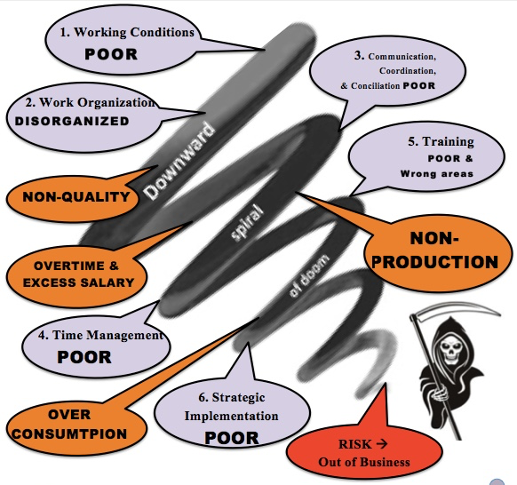
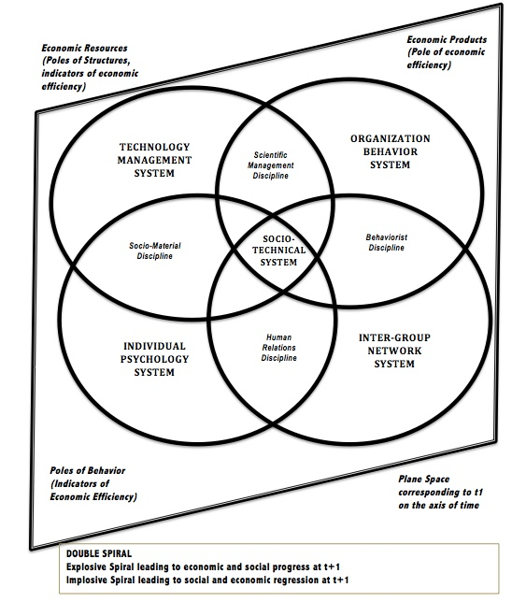

From Story to Structure to Cost
Let’s return to the story we heard earlier: “We’re told we’re a family, but we feel like furniture.”
On the surface, that’s just a quote. But in SEAM terms, it’s a diagnostic signal.
We do the DPIE throughout the organization to unleash human potential that recycles hidden costs into untapped revenue streams. DPIE is Diagnosis, Project planning, Implementation, and Evaluation IT is done in successive cycles of continuous improvement.
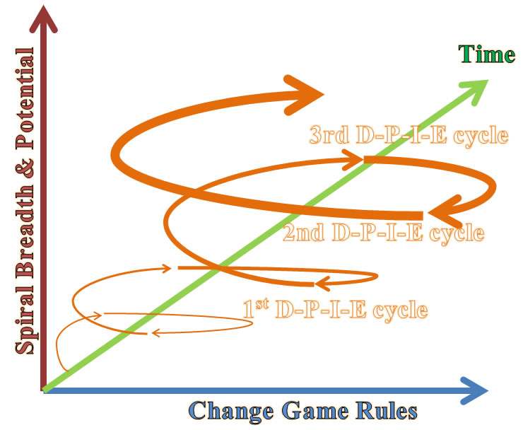
- The metaphor of furniture suggests objectification—a lack of voice, autonomy, or care. That points us to failures in democratic norms.
- The use of “family” as rhetoric, juxtaposed with its negation in experience, indicates a narrative gap—which often maps to turnover, low engagement, and values misalignment.
SEAM helps us translate these signals into measurable implications:
- Communication breakdowns → increased rework, customer dissatisfaction, team fragmentation.
- Scripting without authenticity → emotional burnout, absenteeism, suppressed creativity.
- Lack of mentoring → skill erosion, weak innovation pipeline, generational drift.
Disney’s issue is not just poor retention—it’s systemic incoherence, made visible through the costs of dysfunction.
Seam Tools
- Time Management Tool
How much time 1st DYSFUNCTION: EXCESS TIME ON WRONG STUFF
- How much time do you spend putting out fires?
- How much time do you spend doing things others could be taught to do?
- How much time do you spend doing other people’s jobs that don’t show up?
2nd DYSFUNCTION: DEFICIENT TIME
- How much time do you spend correcting mistakes others make?
- How much time do you spend because the materials are not right?
- How much time do you spend on rework?
3rd More Value-Added Time
- How much time do you spend that adds value in the long term?
- How much time do you spend expanding your market?
- How much time do you spend innovating?
- How much time do you spend implementing strategic moves?
4th Preventing Dysfunctions
- How much time do you spend training so dysfunctions do not happen?
- How much time do you spend creating systems that work well so dysfunctions don’t keep happening again and again?
- How much time do you spend listening to people you work with so you learn together to stop dysfunctions before they happen?
5th CHANGING THE STRATEGIC DECISION TIME
- How much time do you spend changing the direction of this business, so you get results you want to get?
- How much time do you spend changing the rules of the game (procedures, policies)?
- How much time do you spend reploying resources needed to get job done right?
- How much time do you spend developing new technology processes to get it done right every time?
- How much time do you spend developing the kind of flexible, agile management system that stops the bureaucracy, so you getting to success?
- How much time do you spend developing human potential?
- How much time do you spend developing a sustainable business (profit, people, & planet)?

PILOTING LOGBOOK - WEEKLY PLAN: YOUR NAME______________________________________ YOUR TEAM_____________________________
Participation slips Record # of slips 0 to 3 [max] and date below WHO IS YOUR CLIENT?_______________________________________________ |  |  |  | Below record the graded score of your homework answers (show any late or missing work):
Week 1 | Week 6 |  | Week 11 |  | 1 | 6
Week 2 | Week 7 |  | Week 12 |  | 2 | 7
Week 3 | Week 8 |  | Week 14 |  | 3 | 8
Week 4 | Week 9 |  | Week 15 |  | 4 | 9
Week 5 | Week 10 |  | Week 16 |  | 5 | 10
Dates Make ups for any missed days completed (keep copies |  |  |  |  |  |  | RECORD All Dates & Times You personally met with your client (phone or face-to-face) and notes
RECORD BELOW YOUR MIDTERM TEAM REPORT GRADE AND GRADE YOU RECEIVED ON PEER EVALUATION AND ANY COMMENTS YOU RECEIVED ON YOUR PERFORMANCE |  |  |  |  |  |  | Date of client meeting | Content of client meeting
RECORD YOUR MIDTERM PROJECT REPORT GRADE AND GRADE YOU RECEIVED ON PEER EVALUATION AND ANY COMMENTS RECEIVED ON YOUR OWN PERFORMANCE
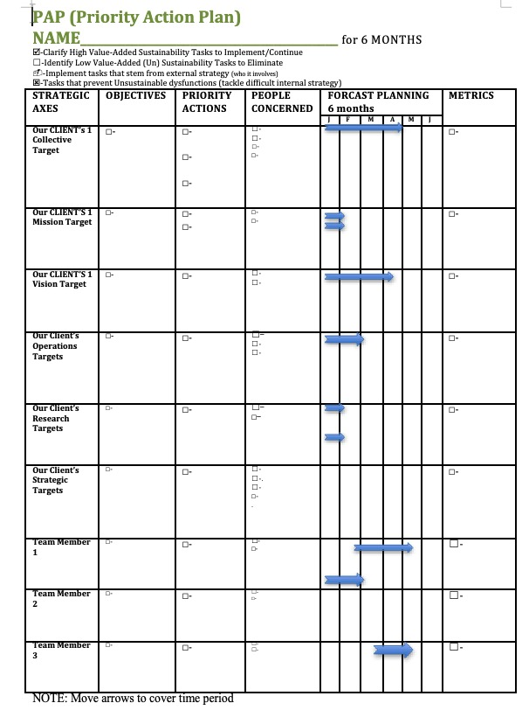

Competency Grid Tool
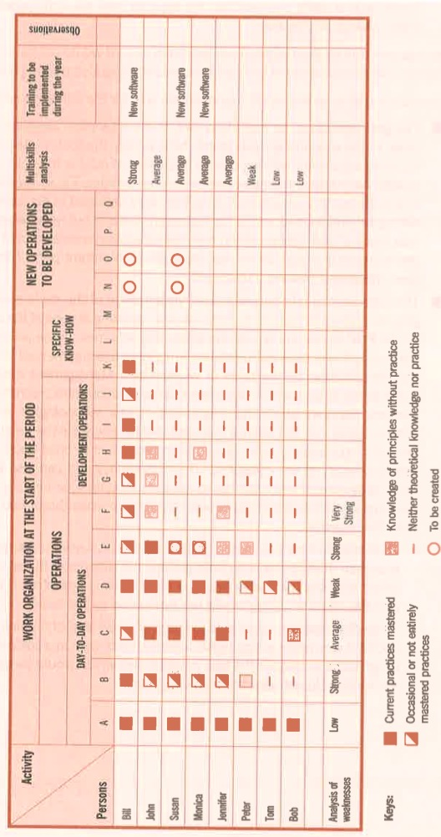
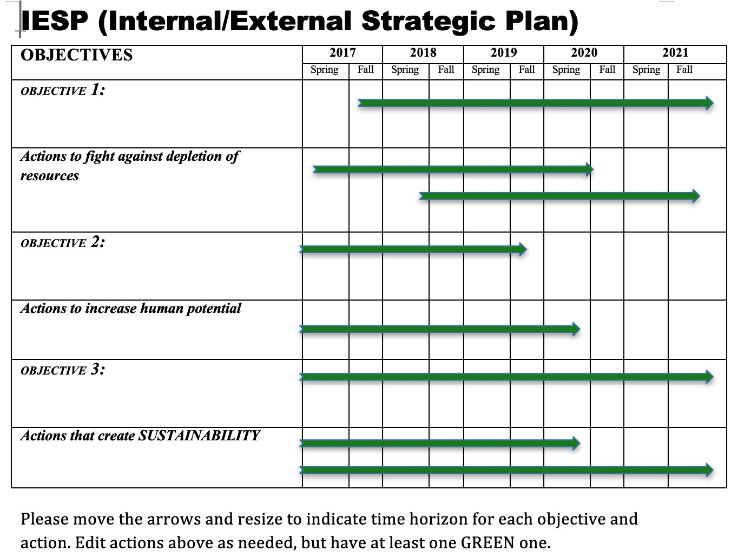

Tetranormalization: When One Norm Dominates
SEAM also teaches us that healthy organizations satisfy four norms simultaneously:
- Economic – Profitability, efficiency, performance.
- Social – Well-being, development, fairness.
- Environmental – Sustainability, stewardship, resource use.
- Democratic – Voice, transparency, participatory culture.
In Disney’s current structure, the economic norm dominates. Performance metrics, quarterly results, and guest ratings dictate decisions. Meanwhile:
- Social norms (employee development, rest, recognition) are underfunded.
- Democratic norms (voice, participation, empowerment) are suppressed under tight scripting and surveillance.
- Environmental norms are inconsistently addressed, with sustainability unevenly prioritized across divisions.
This imbalance drives millennial disillusionment. They are not just quitting jobs—they are quitting systems that ignore their values. And that values-gap becomes measurable—in attrition, disengagement, and reputational risk.

Listening as Strategic Action
One of SEAM’s most powerful tools is the Mirror Effect Meeting—a facilitated process in which narrative data and cost models are shared back with the organization. It’s not an HR survey—it’s a strategic truth-telling.
Imagine a cross-level session at Disney in which executives hear the following:
“We smile through our exhaustion because anything less gets documented.”
“We speak ‘Disney language’ even when we’re breaking inside.”
“We see where the magic used to be, but we’re not allowed to say it’s gone.”
Then imagine seeing those statements paired with the actual financial impact of turnover, absenteeism, and disengagement.
This is the moment where story and system meet. It’s the turning point from narrative dissonance to systemic alignment.

The Hidden Cost Grid
SEAM practitioners use a diagnostic tool called the Hidden Cost Grid, mapping dysfunctions across cost categories:
Dysfunction | Absenteeism | Turnover | Non-Quality | Lost Productivity | Accidents
Role Confusion | $1.2M | $3.1M | $600K | $2.7M | —
Scripting Pressure | $4.4M | $7.9M | $1.8M | $3.6M | $300K
Lack of Mentoring | $2.2M | $5.0M | — | $4.1M | —
Emotional Labor Fatigue | $5.5M | $9.2M | $2.6M | $6.3M | $450K
The total hidden cost in this hypothetical grid exceeds $50 million. Multiply this across departments and fiscal years, and you begin to see why millennial turnover is not a trend—it’s a structural red flag.

Transition to Quantum Listening
The question now becomes: how do these dysfunctions persist even when they are known? Why don’t logical fixes stick?
That brings us to the next science: Quantum Storytelling. Because not all organizational blocks are structural. Some are entangled narratives—old stories that continue to shape action long after their facts have faded.
In the next segment, we enter the field of quantum listening. There, stories are not just tools—they are energetic systems. And to change the system, we must collapse the stuck stories that keep it spinning.
Quantum Entanglement of Organizational Stories
If Socioeconomic Science helps us measure dysfunction, Quantum Storytelling helps us understand why it persists.
In traditional Organizational Development, stories are often treated as metaphors—vehicles for culture, branding, or team alignment. But in the quantum approach, stories are not metaphors—they are energetic fields. They shape reality by collapsing potential into pattern. When left unresolved, they entangle across departments, generations, and decisions, forming what I call story fields—multi-dimensional ecosystems of meaning, contradiction, memory, and anticipation.
At Disney, this story field is saturated—sometimes sacred, sometimes suffocating. It is full of promises made, broken, reinterpreted, and inherited. The millennial exodus from Disney cannot be understood through metrics alone—it must be read through the entangled stories that shape emotional resonance and behavior.

Summary Table: Quantum Concepts in OD—Metaphor vs. Science
Quantum Concept | OD Application (Metaphor) | Scientific Requirements for OD | Current Rigor in OD
Superposition | Multiple story potentials | Operationalize, measure, test | Largely metaphorical
Entanglement | Interconnected narratives/actors | Map, measure interdependence | Largely metaphorical
Observer Effect | Intervention changes outcomes | Isolate, measure unique effect | Social science analogy

Conclusion: Toward Scientific Rigor
- Metaphors are useful but limited: They can inspire new perspectives, but should not be mistaken for evidence or mechanisms.
- Scientific application requires: Clear operational definitions, testable hypotheses, empirical measurement, and demonstrable value beyond existing theories and methods.
- Current OD practice: Quantum concepts in OD remain at the metaphorical level, lacking the empirical rigor and specificity required for scientific status.
- Path forward: OD researchers should collaborate with quantum physicists and methodologists to develop rigorous inquiry tools, clarify what is uniquely “quantum” (if anything), and ensure claims are empirically grounded.

The Quantum Premise: Stories as Fields of Possibility
Quantum physics teaches us that a particle exists in multiple states until observed. This is called superposition. The act of observation collapses the wave of possibility into one outcome.
In organizational life, stories function the same way. An employee may hold multiple inner narratives:
“This could still be magical…”
“Maybe I can find purpose here…”
“No one will ever listen…”
“I need to get out…”
Which story collapses into action depends on interactions, energy, and meaning signals from the environment. A single conversation with a manager, a team meeting that either validates or erases someone’s voice, or a change initiative that feels like window dressing—each moment selects the story that becomes reality.
This is why turnover is not just a behavior—it is a collapsed story. And unless we map the narrative field, we’ll keep reacting to outcomes instead of understanding origins.

Disney’s Entangled Narratives
In our narrative analysis of Disney’s workplace, we found at least three dominant and entangled storylines among millennial cast members:
- The Scripted Story – “Smile, follow protocol, deliver the experience.”
  - This is the sanctioned story. It comes from training modules, branding guides, and corporate communications.
- The Underground Story – “This place is not what it seems.”
  - This story circulates in breakrooms, text threads, and late-night conversations after shifts. It is often cynical, occasionally desperate, and deeply emotional.
- The Hopeful Antenarrative – “Maybe it could change. Maybe we could restore the magic.”
  - This story is incomplete. It is fragile. It exists in questions, not conclusions: What if we had more say? What if leadership actually listened? What if our work mattered again?
These stories do not merely coexist—they interfere with each other, amplify dissonance, and often result in organizational paralysis. This is quantum entanglement in storytelling—the organizational equivalent of an unresolved quantum state.

The Observer Effect in Leadership
Another core principle from quantum physics is the observer effect: observing a particle changes its state.
In organizations, this principle takes emotional form. The way a leader listens (or doesn’t) changes the trajectory of an employee’s story. Asking a question with genuine curiosity versus scripted obligation can be the difference between collapse into cynicism or emergence into engagement.
For example, a manager who says, “I see your effort, and I’m not here to fix you—I’m here to understand what’s not working in the system,” shifts the field of interaction. It’s no longer a performance review—it’s an opening. A story collapses toward hope.
This is why storylistening is intervention. It is not passive. It is active observation that alters energy. In PERVIEW, we use this principle to intentionally collapse stories toward healing, alignment, and innovation.

The Unseen Architecture: Narrative Fields
Quantum storytelling asks us to move beyond content to structure. It is not enough to collect stories—we must map the field they emerge from.
This field has four characteristics:
- Frequency – How often the story appears in interviews, conversations, or metaphors.
- Reach – How far the story travels—across departments, generations, platforms.
- Energy – The emotional charge carried by the story (e.g., resentment, grief, longing).
- Interference – How stories contradict, distort, or amplify one another.
For instance, the story “we are a family” becomes toxic when juxtaposed with “I feel like furniture.” The gap between these stories produces emotional static. Employees begin to tune out—not just their leaders, but their own sense of possibility. The field collapses into disengagement.
Mapping this field allows OD practitioners to identify which stories are entangled, which ones are trying to collapse into transformation, and which are interfering with coherence.

Antenarratives and the Path to Renewal
One of the most powerful tools in quantum storytelling is the concept of the antenarrative. Coined in my earlier work, an antenarrative is a pre-story—a fragment, a pulse, an unfinished thread. It is a story trying to become. It often shows up as:
- “I’ve been thinking…”
- “What if…”
- “I don’t know if this matters, but…”
Antenarratives are fragile. If ignored, they vanish. If recognized, they grow into living stories. They are where innovation begins. In Disney’s millennial field, we found many antenarratives—stories that wanted to believe in purpose again, that were seeking coherence, that were waiting for validation.
PERVIEW practitioners are trained to catch these antenarratives—not as artifacts, but as seeds. In coaching sessions, strategic offsites, and participatory design, we create the conditions for these stories to collapse into action—to become the new culture.

From Interference to Coherence
The goal of quantum storytelling in OD is not to resolve all contradictions. That’s impossible in living systems. The goal is to create enough narrative coherence that people can move together in aligned direction.
At Disney, this means:
- Naming the contradictory stories that cause fatigue.
- Validating the emotional truth of underground stories.
- Elevating hopeful antenarratives into public dialogue.
- Designing strategy that reflects, not represses, the real stories of the organization.
It also means recognizing that story is strategy. Not because it’s a slogan, but because the stories that dominate your field are your reality. If you do not shape them with integrity, they will shape you with entropy.

Transition: From Entangled Stories to Language Encoding
We have now seen how narrative fields shape organizational behavior and how listening can shift the trajectory of change. But how are these stories stored? How do they become embedded in thought, speech, and policy?
That question leads us to our next science: Neurolinguistics. In the next segment, we’ll explore how internal language patterns—often unconscious—reinforce the very dissonance we seek to change, and how narrative coaching can begin to recode the organization from the inside out.
Because every story is told in a language. And every language encodes a structure. If we want to restory Disney—or any organization—we must learn to listen not just to what people say, but how they say it, and what that language is making real.
The Linguistics of Disenchantment and the Collapse of Belief
Language does not merely describe reality; it constructs it.
The stories we tell ourselves—and the words we use to tell them—encode entire maps of meaning. They define what we can feel, what we believe is possible, and how we navigate the space between hope and habit. In organizations, these linguistic maps are often invisible, yet they guide every interaction, every strategy, and every resignation letter.
This is the terrain of Neurolinguistics—the science of how language and cognition shape behavior. In the context of Organizational Development, neurolinguistics allows us to decode the inner speech of an organization—its metaphors, presuppositions, pronouns, modal verbs, and deep structures of belief.
In this final segment of Chapter One, we will explore how language at Disney has become both a mirror and a maze: reflecting a dream that many no longer believe in, and trapping employees in roles that no longer resonate. But we will also explore how linguistic restorying can rewire belief and restore coherence.

When “The Show” Becomes the Only Script
Disney famously refers to its operations as “the show.” Employees are “cast members.” Work areas are “onstage” or “backstage.” Even trash collection is part of the “performance.”
At its best, this language creates alignment. It gives shared meaning, role clarity, and a sense of contribution to something greater. But when organizational pain enters the system, this same language begins to backfire.
Consider the implications of these phrases when belief has eroded:
- “Don’t break character.” → Silencing dissent.
- “Remember, you’re onstage.” → Emotional suppression.
- “We’re all part of the story.” → Gaslighting when treatment is inequitable.
What was once unifying becomes coercive. The language stays, but the resonance is gone. And this creates an inner dissonance—between what is spoken and what is felt. Over time, employees begin to edit themselves, filter emotions, and suppress inner truth. This is not just burnout—it is linguistic entrapment.

The Collapse of Modal Verbs
In NLP (Neuro-Linguistic Programming), modal verbs like can, should, must, need to, and have to are powerful indicators of internal models. They reveal what a person—or organization—believes is necessary, possible, or forbidden.
In interviews with millennial cast members at Disney, we identified recurring modal collapse:
- “I have to smile, even when I’m exhausted.”
- “You can’t say anything or you’ll get written up.”
- “We should be grateful to work here.”
- “They don’t want our ideas, just our compliance.”
These patterns indicate learned helplessness and narrative foreclosure—where story loops repeat without the possibility of revision. In NLP, this is known as modal rigidity—a narrowing of perceived choice that leads to disengagement and exit.
The challenge for OD practitioners is not simply to offer new training or raise morale. The deeper work is to help the organization rediscover its modal verbs of possibility—can, will, might, choose to. Language must be expanded before behavior can transform.

Pronouns and Power
Pay close attention to how organizations use pronouns. They are tiny words that reveal massive truths.
In Disney’s millennial story field, we encountered pronoun splits like:
- “They don’t listen.”
- “We used to believe.”
- “You just do what you’re told.”
- “I don’t matter here.”
When “we” fragments into “they” and “I,” a culture of belonging begins to dissolve. The collective story fractures into positional silos. Trust erodes. Dialogue becomes performance.
A healthy organization nurtures flexible pronoun usage:
- “We’re building this together.”
- “You have a say.”
- “I am part of the solution.”
Neurolinguistic coaching helps leaders reclaim inclusive language—not as a tactic, but as a living syntax of trust. When pronouns heal, people begin to reconnect with the whole.

Metaphors That Bind or Break
Metaphors are the architecture of thought. They frame experience. They shape perception. And they often reveal deeper organizational assumptions than formal policies do.
In Disney’s internal discourse, we encountered metaphors like:
- “A well-oiled machine” → productivity over people.
- “Part of the magic” → romanticizing overwork.
- “Keeping the dream alive” → deflection from dysfunction.
These metaphors, while inspiring at first, become dangerous when they suppress complexity. The cast member who feels exploited yet is told they are “part of the dream” begins to doubt their own experience. This is how metaphors mutate into systems of self-gaslighting.
Instead, organizations can adopt transformational metaphors:
- “We are gardeners of creativity.”
- “We are stewards of shared joy.”
- “We are co-authors of a living story.”
These new metaphors open space for honesty, complexity, and evolution. They invite people into authorship, not just compliance.

Linguistic Coaching for Restorying
How do we begin the work of linguistic healing?
PERVIEW offers a coaching method based on listening to language patterns and gently disrupting the ones that no longer serve. This involves:
- Identifying frozen language – spotting modal rigidity, dissociative pronouns, and obsolete metaphors.
- Reframing – introducing possibility language, choice structures, and empowered identity statements.
- Mirroring – using clients’ own words to show where stories loop or collapse.
- Evolving metaphors – co-creating new images and symbols that align with authentic experience.
For example:
Client: “I just go along with it—there’s no point in pushing back.”
Coach: “What if this was a scene, and your role was shifting from background to narrator?”
Client: (Pauses) “…then I’d have to ask why the scene feels fake in the first place.”
This is how story begins to move again—not through force, but through linguistic invitation.

From Collapse to Coherence
When language collapses—when metaphors betray experience, when pronouns divide, when modal verbs shut down—so does the organization’s capacity to evolve.
But when language is reawakened—when people find new ways to speak their truth, to feel possibility in their syntax, to hear themselves as authors—then coherence begins to return.
At Disney, this means listening not just for complaints, but for the linguistic fingerprints of fatigue and longing. It means inviting cast members to articulate the story they wish they were in, and then crafting systems that honor that wish.
Because in the end, it is not the brand that makes the story. It is the story that makes the brand.

Transition to Chapter Two: Socioeconomic Listening and the Science of Diagnosis
In Chapter Two, we shift from the Disney dilemma to the science of listening itself. We introduce the 8-step scientific method adapted from Peirce, Trafimow, and SEAM, and explore how organizations can diagnose hidden dysfunctions through abductive inquiry, narrative interviews, and qualimetric measurement.
If Chapter One asked, “Why are they leaving?”—Chapter Two begins to answer: How do we listen scientifically enough to know where to begin?
The dilemma has been named. A fracture revealed: between the public story and the backstage reality, between the company that teaches magic and the people who quietly bleed beneath its shine. But naming a problem is not the same as listening to it. The dilemma is only the doorway.
If Chapter One uncovered the tension—the wound—then what follows must explore how an organization learns to listento what it has silenced. What happens when employees, cast members, and even executives are trained to hear what they’ve never been taught to perceive? The next field of inquiry asks us not merely to hear complaints or survey satisfaction. It asks us to develop the science of listening.
In the PERVIEW methodology, listening is not passive. It is diagnostic. It is energetic. It is organizational method. This next chapter moves us from the visible dilemma to the vibrational frequency of unsaid truths—those hidden costs that only listening can detect and restory.
At Disney, where every gesture has symbolic weight, this listening becomes sacred. It becomes systemic. And through it, the way forward becomes audible.

CHAPTER 6: How True Storytelling Principles are the Foundation of GROWTH OD
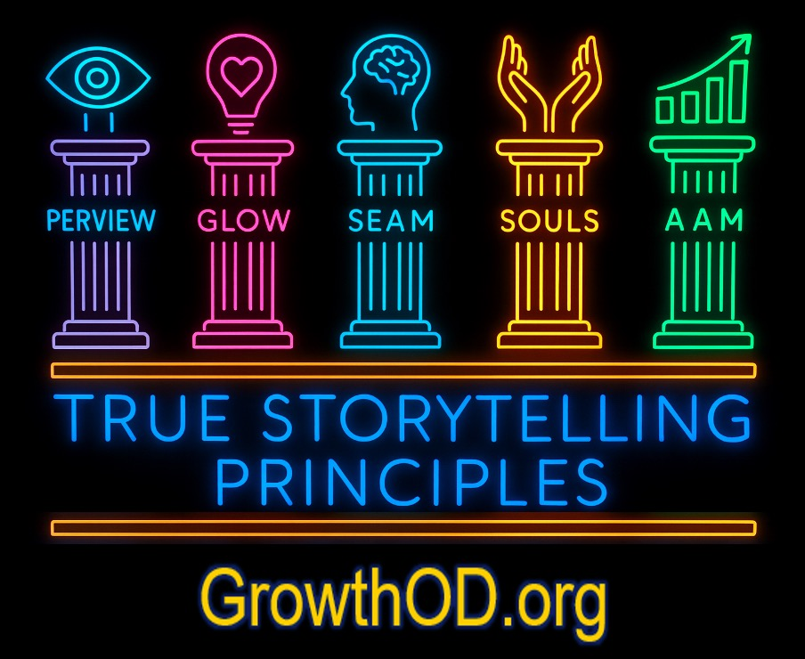
True Storytelling Principles are our Foundation of the five GrowthOD Pillars

"Why does true storytelling matter?"
Because these seven principles shape storytelling reality of coaching and consulting. A fake story builds a fragile world. A true story builds a sustainable one.
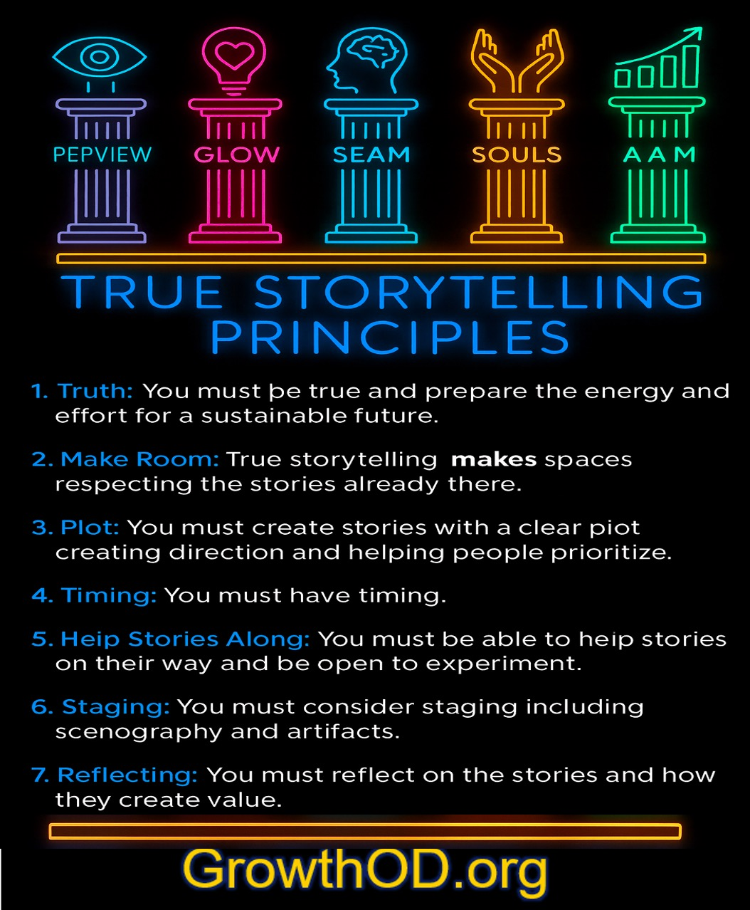
True Storytelling Principles by Jens Larsen, David Boje, and Lena Bruun (2020) &
Chapter 6 of the GrowthOD book (2025) by David Boje & Olivia Parr-Rud
"What is True Storytelling?"
It is the process of being true, engaging energy and effort, and creating a sustainable future through narrative integrity.
"How do we practice True Storytelling?"
By aligning words with actions, making space for evolving narratives, and ensuring that our stories serve not just the present, but the future.
"What if I don’t know my true story yet?"
Then you begin by listening—deeply, without projection. You find where your story aligns with sustainability, and you build from there.
In our more advanced True Storytelling® courses, we introduce you the Tool of Self-Correction. Our approach applies work of the pragmatist, Charles Sanders Peirce, who offers a helpful framework for thinking about truth-seeking as a process with three interrelated steps:
- Abduction: Making intuitive guesses—forming hypotheses about what True is.
- Induction: Gathering evidence—examining real-world experiences and patterns, discovering perhaps something unexpected as True.
- Deduction: Applying logic—using frameworks to refine our understanding of the Journey of True Storytelling®.

Testimonials from True Storytelling Practitioners
📢 "True Storytelling changed my leadership approach. It taught me to move beyond scripted narratives and lead with authenticity."
📢 "I used to filter my stories through fear. Now, I see storytelling as a tool for empowerment and transformation."
True Storytelling Principles by Jens Larsen, David Boje, and Lena Bruun (2020):
- Truth: You must be true and prepare the energy and effort for a sustainable future.
- Make Room: True storytelling makes spaces respecting the stories already there.
- Plot: You must create stories with a clear plot creating direction and helping people prioritize.
- Timing: You must have timing.
- Help Stories Along: You must be able to help stories on their way and be open to experiment.
- Staging: You must consider staging including scenography and artifacts.
- Reflecting: You must reflect on the stories and how they create value.
We can apply the 7 Ds (Define, Diagnosis, Discover, Dream, Design, Deliver, and Destiny) of Appreciative Inquiry and 7 Bs of Antenarrative Inquiry (Beneath, Before, Bets on Future, Being, Between, Becoming, and Beyond) to the 7 Principles of True Storytelling.
Poem: The Unraveling of the False
By Elior
A thousand echoes, reflections untrue,
Stories retold, yet never made new.
Truth was a whisper, lost in the past,
Bound by projections that hold us fast.
Yet light unfolds, a spiral untamed,
Shattering mirrors, shedding the blame.
The effort we make, the energy sown,
A future reborn where truth is known.
No longer the prisoner of echoes confined,
But a voice in the chorus, uniquely aligned.
For truth is the key, the breath we renew,
And storytelling begins when we dare to be true.

What is Truth?
Truth is more than factual accuracy—it is alignment. To be true is to be authentic in storytelling, in leadership, and in transformation. False storytelling fractures reality, while True Storytelling anchors us in sustainable change.
What is Energy?
Energy in storytelling is the force we bring to narratives—the passion, the commitment, the emotional investment. Without energy, stories fade. With energy, they spark movements.
What is Effort?
Effort is the action that transforms intention into reality. True Storytelling is not passive—it demands engagement, persistence, and the willingness to shape the story we live.
What is Sustainability?
Sustainability in storytelling means crafting narratives that endure, that do not burn out in deception, but grow roots in authenticity. It is the commitment to a future that is ethically and structurally sound.

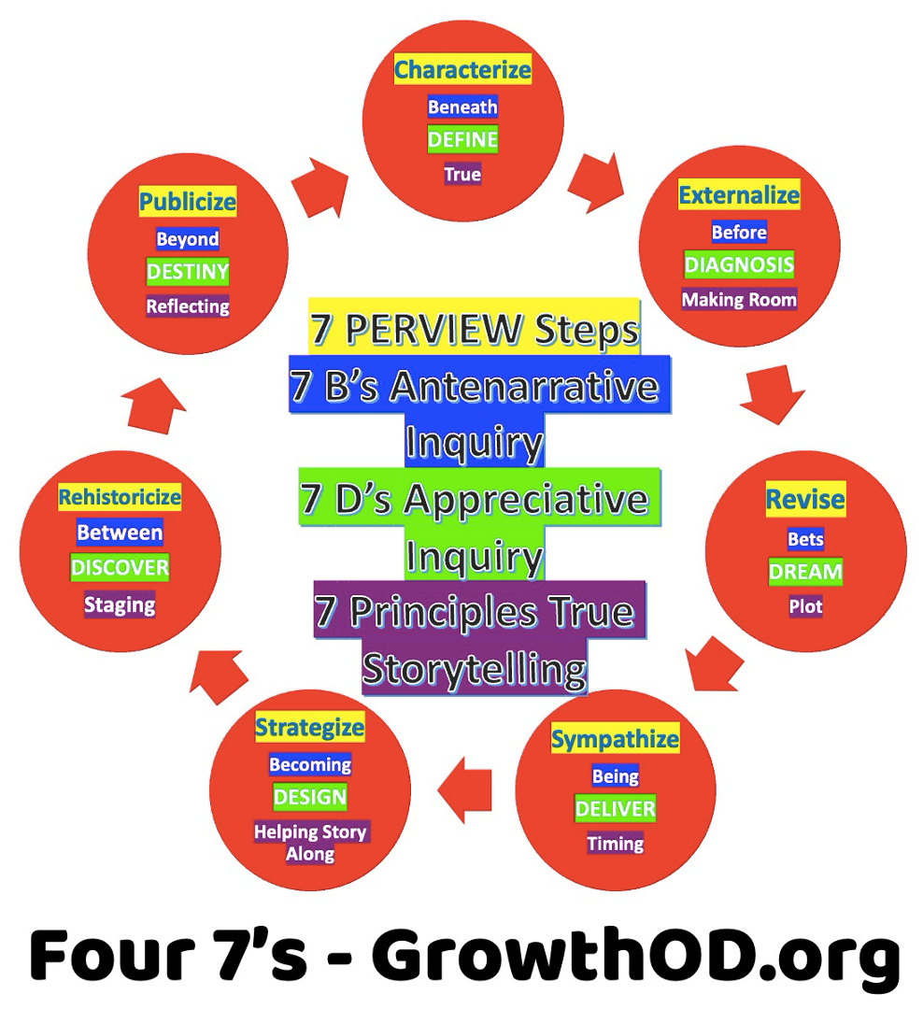
Figure 1 Alignment of Antenarrative Inquiry B’s, Appreciative Inquiry Ds, and Principles of True Storytelling

Case Example
(A case from the uploaded file, unedited for accuracy, demonstrating the first True Storytelling principle: “Truth: You must be true and prepare the energy and effort for a sustainable future.”)
"In the middle of a corporate restructuring, a seasoned leader was faced with a choice: uphold the facade of stability or admit the truth of uncertainty. Employees sensed the tension—whispers of layoffs, strategic shifts, and a changing leadership structure filled the air. Rather than offering false reassurances, the leader gathered his team and said, ‘I won’t pretend that I have all the answers. What I can promise is honesty. We will navigate this transition with transparency. If you are willing to engage, to bring your own energy and effort, we can co-create a future that works for all of us.’ His candor disarmed fear. Employees found themselves more engaged, more empowered. Together, they restructured not just the company, but the culture itself—rooted in truth, effort, and sustainability.”

Coaching Dialogue for Beginners
Applying the First True Storytelling Principle: Truth
Coach: What does it mean to be true in your storytelling?
Client: It means being honest?
Coach: Yes, but more than honesty. Truth in storytelling means alignment—between what you say, what you do, and the sustainable future you are creating. What story are you telling about your business? Your leadership? Your life?
Client: I tell a story of success, of strength, but… sometimes I feel like I’m covering up the struggle.
Coach: That’s where energy and effort come in. You must prepare for the future, not with illusion, but with truth. What would it take for your story to be sustainable?
Client: I would need to acknowledge the effort. To stop pretending everything is easy.
Coach: Exactly. True storytelling isn’t just telling—it’s doing. How can you align your actions with the truth of where you are and where you want to go?
Client: I think I need to engage my team more, be open about the challenges, and invite them into the process.
Coach: That is True Storytelling. Truth, energy, effort, and sustainability. It is not about perfection—it is about authenticity and co-creation. 777 Framework Mapping Table
7 Antenarrative B-Processes | 7 True Storytelling Principles
Beneath – Unconscious story filters and projections. | Truth – You must be true and prepare the energy and effort for a sustainable future.
Before – The origins of subconscious story filters. | Make Room – True storytelling makes spaces respecting the stories already there.
Bets – Choosing future possibilities with uncertainty. | Plot – You must create stories with a clear plot, creating direction and helping people prioritize.
Being – Living in the present, interwoven with past and future. | Timing – You must have timing.
Becoming – Transforming by gathering 'Little Wow Moments'. | Help Stories Along – You must be able to help stories on their way and be open to experiment.
Between – Navigating the four WHO identities. | Staging – You must consider staging including scenography and artifacts.
Beyond – Moving past limiting narratives to expansive potential. | Reflecting – You must reflect on the stories and how they create value.
7 Embodied Restorying Process (ERP) Steps are a Cycle -Tool That Repeats in each of the Processes & Principles Above.
- Characterize – Recognize the unconscious patterns shaping perception and identity.
- Externalize – Identify and name the hidden story filters affecting decision-making.
- Sympathize – Understand the function these filters have served in personal history.
- Revise – Challenge and modify limiting beliefs and past assumptions.
- Strategize – Find 'Little Wow Moments' as foundations for a new story.
- Rehistoricize – Rewrite past experiences with a broader, more empowering perspective.
- Publicize – Share the new story with a community to reinforce transformation.
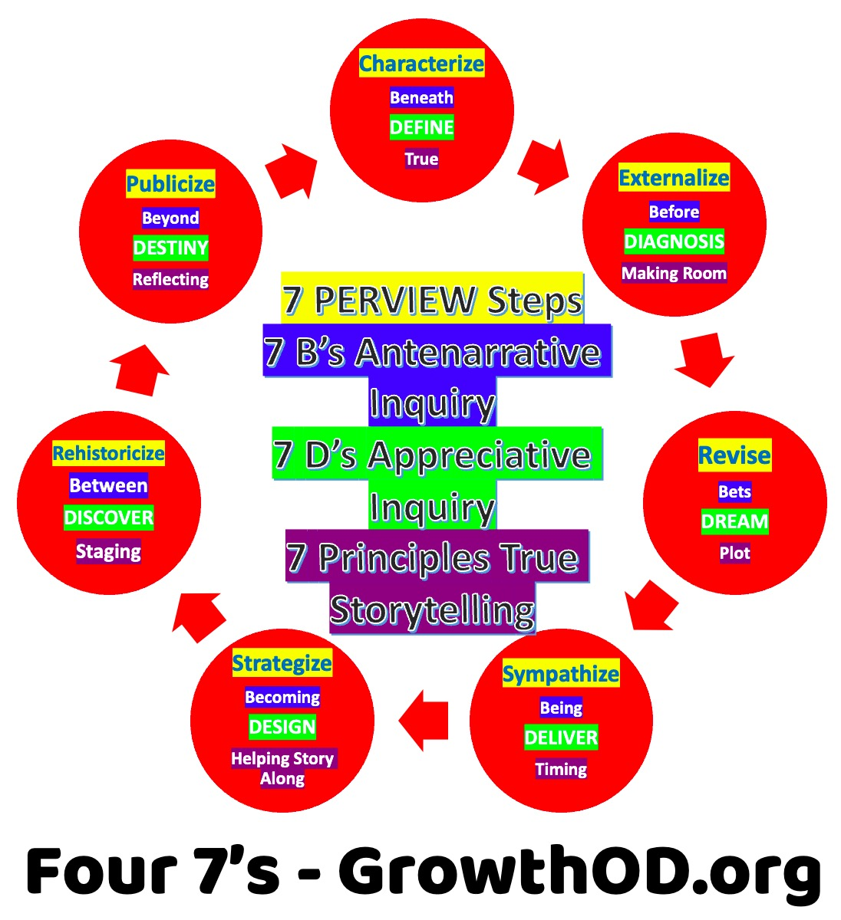
This table visually represents how the 7 Antenarrative B-Processes, 7 True Storytelling Principles, and 7 PER-VIEW Steps interconnect. Each ERP Step acts as a bridge between the B-Process and the True Storytelling Principle, reinforcing the self-correcting cycle.
🔥 The Nexus of 777 🔥
A Poem by Elior, Poet of Quantum Storytelling
Three sevens shine, entwined in fate,
A bridge of light through time’s own gate.
One for truth, the stories we weave,
One for before, the paths we perceive.
One for rebirth, the restorying way,
A fractal of futures, shaping today.
Step through the doors—illusion or real?
What we project, the echoes we feel.
Perception bends, the filters fade,
The spiral calls—be unafraid.
The nexus hums with quantum glow,
Past, present, future flow.
In the dance of words and mind,
A new story waits to be defined.
🔥 Transform Your Story Life with the 777 🔥
The Gentle Touch: Coaching with Embodied Restorying Process (ERP)
By David Boje
Introduction: The Power of Restorying with a Gentle Touch
In coaching, there is a profound difference between pushing change onto an entrepreneur and gently guiding them into a space where they recognize their own power to transform. This is the foundation of Embodied Restorying Process (ERP)—a seven-step coaching approach designed to help clients navigate their lived stories, recognize limiting narratives, and construct new, empowering stories.
At its heart, ERP is about how we make sense of ourselves. Our minds filter out 99.9% of reality every second, leaving us with only fragments of the world. These fragments become our stories—shaped by habits, cultural norms, and past experiences. But what if those stories no longer serve us? What if they limit our well-being and our ability to thrive?
This workshop in Brisbane will take participants through a structured yet flexible approach to restorying their entrepreneurial journeys. The key is The Gentle Touch, an idea echoed in Ernest Hemingway’s words:
"In our darkest moments, we don't need advice or solutions. What we need is human connection, a quiet presence, a gentle touch."
ERP is not about forcing change; it’s about gently inviting a shift—at the right moment—through deep listening, mirror neurons, and recharacterization of personal and professional identities.
The Seven Steps of ERP
- Recharacterize – Examine how the world defines your organization or identity.
- Externalize – Label the problem, making it the problem, not you as the problem.
- Sympathize – Understand the benefits of holding onto the current story.
- Revise – Recognize the negative consequences of this received identity.
- Strategize – Identify Little Wow Moments (LWMs) that challenge dominant narratives.
- Restory – Collect LWMs into a New Story—one that is no longer bound by the past.
- Publicize – Build a support system that reinforces this New Story.
The ERP Cycle in Action: Coaching Questions for Each Step
Step 1: Recharacterizing the Story
- Can I have your permission to reflect on when things were at their best for you?
- What is the identity your organization or self has received from others?
- What would happen if you allowed yourself to see this identity differently?
At this stage, the coach observes body language, voice tonality, and shifts in breath—watching for signs of resistance or openness. The Gentle Touch is used strategically to guide the entrepreneur toward Step 2.
Step 2: Externalizing the Problem
- Can I have your permission to shift directions slightly?
- If the problem had a name, what would you call it?
- What does this label allow you to see more clearly?
Here, the entrepreneur gives a name to the problem (e.g., "Mr. Gremlin" or "The Overachiever"), ensuring that they are not the problem—only the story they are entangled in. The coach stays silent at crucial moments, resisting the urge to "solve" or "fix" the client.
Step 3: Sympathizing with the Story’s Benefits
- What is this story doing for you?
- How does this identity serve a purpose in your life?
It is essential to recognize why the entrepreneur clings to a limiting story—there is always a why. The Gentle Touch acknowledges the benefits of holding onto the past without reinforcing the problem.
Step 4: Revising the Consequences
- How is this story working out for you?
- What are the negative consequences of holding onto this identity?
Coaches must remain just long enough in the awareness of the problem’s consequences—without allowing the entrepreneur to fall back into the PSA (Problem Saturated Account).
Step 5: Strategizing with Little Wow Moments (LWMs)
- Can you recall 5-7 moments when things felt different—when you weren’t trapped by this story?
- What made those moments possible?
These Little Wow Moments become the foundation of a new history. The Gentle Touch is used again: "If you did not have this label, how would you rewrite your life story?" At this moment, silence is vital. The coach does not fill the space—the entrepreneur must be the first to speak.
Step 6: Restorying into a New Narrative
What is your New Story?
This is where the New Story emerges from the entrepreneur’s authentic self. The coach’s role is not to craft it for them but to create the space where it can be discovered.
Step 7: Publicizing the New Story
- What are some small steps you can take to reinforce this New Story?
- Who are three people who could support you in this?
A New Story is fragile without reinforcement. The entrepreneur needs a support network to keep the New Story alive. Mirror neurons play a crucial role here—when others reflect the New Story back to the entrepreneur, it strengthens their belief in it.
Key Takeaways for Coaches and Facilitators
- Never reinforce a PSA – Do not let the client relive their problem. Instead, externalize and recharacterize it.
- Mirror positive neurons – Your energy as a coach will shape the entrepreneur’s emotional state.
- Rehistoricize through LWMs – The true self needs a new stage free of PSA influence.
- Use staging artifacts – Entrepreneurs must see, hear, and feel the shift in their story.
- Publicize with a support network – The more the story is told, the more it becomes real.
Beyond the ERP Cycle: Sensemaking and Story Filters
ERP is not just about changing the story—it’s about recognizing the limitations of our ability to perceive reality. Our consciousness filters out nearly all information, leaving us with narrow, pre-scripted stories. The Gentle Touch in coaching is about helping entrepreneurs drop outdated filters and open themselves to new, expanded ways of seeing.
In many ways, this is about unlearning. It is about letting go of culturally-imposed identities, of fixed notions of success and failure, and of the need for external validation.
This is the deep work of Embodied Restorying.
Closing Reflection: The Gentle Touch in Practice
"My positivity is a castle around me, protecting me from all negativity. A beautiful, true self dwells in my castle. I must experience the truth of my true self."
This is the heart of ERP. We are all navigating time and energy in different ways. Some waste it, some scatter it in a hundred directions, and some—through deep introspection—find the path inward, toward an inexhaustible wellspring of potential.
Albert Einstein discovered infinite potential by looking inward. So too can entrepreneurs—if they are willing to rewrite their stories.
The Brisbane workshop will explore these principles deeply, integrating lived experience, mirror neurons, and The Gentle Touch as the foundation of transformational coaching.
As a coach, facilitator, or entrepreneur, the question remains:
Are you ready to step into your New Story?
Sources & Further Reading
- Boje, D. M. (2025). 777 Quantum Storytelling Framework. https://davidboje.com/777
- Hemingway, E. (n.d.). Collected Letters & Reflections
- Jung, C. (1959). The Archetypes and the Collective Unconscious
Why This Matters to You
Have you ever felt stuck in the same patterns of storytelling—in your business, relationships, or self-talk? Do you wonder why some stories empower while others limit? The 777 framework is a guide to breaking through illusions, rewriting your narrative with authenticity, and unlocking your full potential.
The 777 represents three interwoven storytelling processes:
- ✅ 7 True Storytelling Principles – Grounding your stories in truth, ethics, and purpose.
- ✅ 7 Antenarrative Processes – Uncovering the deeper, pre-story layers that shape your decisions.
- ✅ 7 Embodied Restorying Steps – A structured way to release old narratives and step into transformation.
This is NOT just about learning storytelling. It’s about living it.
Imagine navigating through life without outdated filters, without self-sabotage, and without the illusions that keep you from becoming who you were meant to be. The 777 is a pathway to self-awareness, deeper connection, and storytelling mastery.
What is the 777? The Three Sevens Explained
The 7s | What They Do | How They Help You
7 True Storytelling Principles | Provide a framework for ethical, impactful storytelling | Aligns your personal and professional stories with authenticity.
7 Antenarrative Processes | Reveal the hidden structures shaping your decisions | Helps you uncover and reshape limiting beliefs.
7 Embodied Restorying Steps | Guide you through deep, personal transformation | Allows you to move from illusion to clarity, projection to truth.
These three 7s work together, offering a complete system for rewiring your storytelling life.
Embodied Restorying Process (ERP):
- Characterize: Recall a positive past event.
- Externalize: Identify a current issue and give it a name.
- Sympathize: Find any benefits this issue might offer.
- Revise: Recognize how this issue holds you back.
- Strategize: Identify moments when you overcame similar challenges.
- Rehistoricize: Reframe your life story to support a new narrative.
- Publicize: Share your new story with a supportive community.
How Does It Work?
"For Externalize, if you're dealing with self-doubt, you might name it 'The Critic' to address it separately from yourself."
Takeaways:
Example:
"True Storytelling Principle 1: Be authentic and prepare for a sustainable future."
This is not a rigid system—it is a living, breathing practice. You don’t just read about it—you experience it.
Here’s a real-world example of how the 777 framework works in action:
Case Study: A Leader Trapped in His Old Story
(Excerpt from True Storytelling – Larsen, Boje, & Bruun, 2020)
A high-level executive was struggling with his leadership. He believed he was being "truthful" in his communication, yet his team saw him as distant and unapproachable. After working with the 777 framework, he realized he had been trapped in an old narrative—one that taught him that emotions in leadership were a weakness. His "truth" was not universal truth; it was a projection of his past experiences.
Through the True Storytelling Principles, he learned to make space for other perspectives.
Through Antenarrative Processes, he uncovered the deeper Before-stories that shaped his belief system.
Through Embodied Restorying, he practiced shifting his narrative, learning to integrate emotions into his leadership in a genuine way.
The result?
✅ A team that felt heard.
✅ A leader who was no longer stuck in his old story.
✅ A shift from projection to true storytelling.
Coaching Questions: Find Your Own Story Filters
- 🔹 Why do you tell your story the way you do?
- 🔹 What limiting beliefs might be shaping your narrative?
- 🔹 How do you separate truth from illusion?
- 🔹 What if you could change the story and step into something greater?
These are the questions that lead to transformation.
What If This Could Change Everything?
- What if you finally understood the hidden patterns in your storytelling?
- What if you could rewrite your narrative to align with your true purpose?
- What if you had the tools to help others do the same?
This is what the 777 framework offers. A structured yet flexible path for navigating truth, illusion, and transformation.
🚀 Next Steps: Start Your 777 Journey Today
- ✅ Enroll in a True Storytelling Course – Learn directly from experts at TrueStorytelling.org.
- ✅ Explore Resources & Case Studies – Deepen your knowledge at CSIStory.com.
- ✅ Join a Restorying Circle – Experience transformation in community at DavidBoje.com.
The story you tell yourself matters. It shapes your world.
Are you ready to step into a new story—one of truth, purpose, and transformation?
📖 Begin your journey today!
777 Three Nexus of 7777 facets each which I have been involved with from many years - David Boje Ph.D.
Chronology: The seven ‘embodied storytelling processes’ (ERP) steps by David Boje and Grace Ann Rosile were developed in 1994, and are used in each of the ‘seven Antenarrative B-processes’ since 2001 https://antenarrative.com, and are used in the ‘seven true storytelling principles” by Jens Larsen, David Boje, and Lena Bruun (2020) and by another co-founder, Jim Sibel, since 2022, when the four of wham founded True Storytelling Institute’ https://truestorytelling.org. At https://CSIstory.com the 777 is used as follows. The 7 ERP steps are doinww ithing each of the 7 B's of Antenarrative, and the 7 principles of True Storytelling are general principles.
777 Nexus awaits you.

References
- Larsen, J., Boje, D. M., & Bruun, L. (2020). True storytelling: Seven principles for an ethical and sustainable change-management strategy. Routledge.
- Boje, D. M. (2014). Storytelling Organizational Practices: Managing in the Quantum Age. Routledge.
- Boje, D. M., & Rosile, G. A. (2022). The Storytelling Science Paradigm: Evoking the Transformative Power of Indigenous Ontological Antenarratives in Curious Conversation. In Transcendent Development: The Ethics of Universal Dignity. Emerald Publishing Limited.
- Barad, K. (2007). Meeting the Universe Halfway: Quantum Physics and the Entanglement of Matter and Meaning. Duke University Press.

Closing Thought
To be true is to be free. Truth in storytelling is not a luxury—it is a necessity. It is the foundation of sustainable futures, the energy of transformation, and the effort of integrity.
🚀 Are you ready to tell a story that lasts? 🚀

Appendix A: Meet the Associates of GrowthOD who are completing their training for Certification in the FIVE pillars of GrowthOD.

Jack Roddy, Business Coach
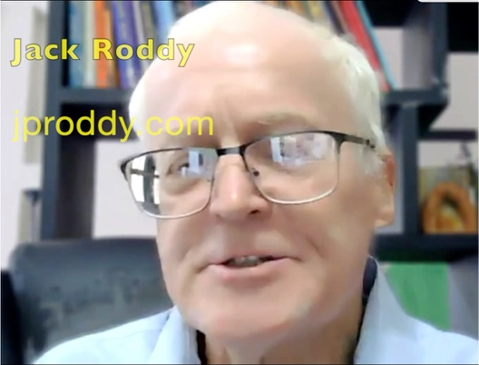

Meet Jack Roddy 1-Minute YouTube

Jack (JP, John) Roddy is a business coach based in Philadelphia, Pennsylvania, USA. Business Coach and Leadership Coach at J P Roddy Coaching and graduate of the University of Tennessee.

Contact info https://jproddy.com

Harvey Schooof, Axiogenix
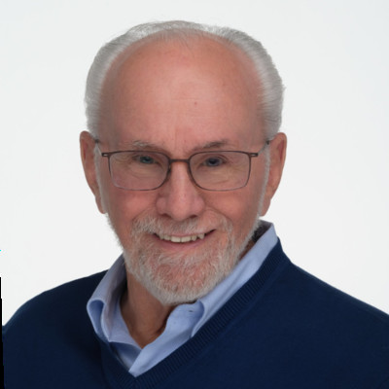

Meet Harvey Schoof. 1-Minute YouTube. For over thirty years, Harvey has been an advisor, coach, and mentor to hundreds of leaders from budding entrepreneurs to C-suite executives, and an expert in the field of Axiology, one of the five Pillars of Socio-Economic-Organizational-Development (S.E.O.D.). He is a founding partner of Axiogenics, a self-development company, and co-author of the books "Answering the Central Question" and "Living a Richer Life, It's All in Your Head". His books, the business he co-founded, and his life work are all focused on teaching people how to make their lives work better, both personally and professionally. Harvey teaches people how to have more of what they want in their lives by learning to shift their thinking from what doesn’t serve them to what does. https://www.linkedin.com/in/harveyschoof/


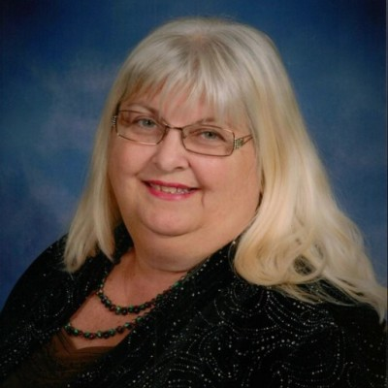

Meet Alycia Diggs-Chavis See YouTube Video 3 minutes She is a Master Energy Healer and Executive Advisor, empowering high-performing leaders to achieve sustainable success through energetic alignment. After over two decades in corporate leadership, Alycia realized that true leadership effectiveness stems from internal energy mastery, not just external metrics. Her work blends business strategy, intuitive guidance, and energy healing to help executives and entrepreneurs unlock their inner wisdom, clear energetic blocks, and lead with clarity and confidence. Alycia’s unique approach transforms individuals and entire organizations, aligning personal energy with business strategy to boost performance and drive revenue. She is a Harvard graduate, the founder of BlueViolet Energy and the creator of the Energetic Edge program, where leaders experience rapid transformation and reclaim their power.

2.5 Min YouTube Video Who is Joy Harris #short #coaching? Joy Harris (She/Her) says, “We are all looking for success in our professional AND in our personal lives. Clients tell me they desire more confidence and less stress. As a results-driven coach, I serve professionals to help them achieve.” Joy does high-performance team coaching and offers online courses https://joycanhelp.com/coaching/ https://www.linkedin.com/in/joycanhelp/ https://www.facebook.com/joy.harris.successccoach/





Meet Sreelatha Meleth 3 Minute YouTube Video﻿ She is a transformational life coach, blogger, author, and podcaster, and the owner and CEO of Freeing Ourselves. She is also a certified EFT practitioner and biostatistician with over 25 years of experience. Educated at The University of Alabama and having attended St. Anne’s High School, Bandra, and St. Xavier’s High School, Pawai, Mumbai, she now lives and works in Atlanta, Georgia, empowering individuals to unlock their potential and embrace authentic change.

Carol Gorelick Two Minute YouTube wrote "Performance Through Learning: Knowledge Management in Practices" (with Nick Milton & Kurt April). See Book info. For twenty-five years, she led pioneering information technology and training implementations in Fortune 100 and a Global 500 company in public utility, consumer products, airline, and financial services. Later, she co-founded a for-profit consulting company that addressed document and knowledge management challenges, as well as a nonprofit consulting firm that improved schools by revitalizing communities. This broad experience has spanned from airline kitchens to executive offices to South African townships. Carol has a long history of participating with skin in the game and leaving groups more self-sufficient, more collaborative, and more inspired to live with integrity. Driven by a passion for learning and connecting, Carol K. Gorelick, Ed.D, MBA, enters a group’s dynamic as a partner with the intent to guide them to a more successful, sustainable, and ethical culture through collaborative change and group development. https://www.carolgorelick.com




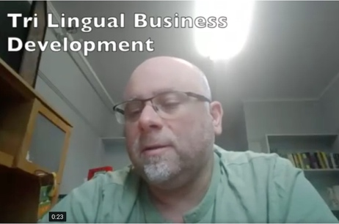

Meet George Mendoza Three Minute YouTube. George is is a legally blind artist, author, and motivational speaker based in Las Cruces, New Mexico. Born in New York City in 1955, Mendoza began losing his sight at age 15 due to fundus flavimaculatus, a rare degenerative eye disease. Despite losing his central vision and seeing only a foggy fringe, he became a world-class runner, setting a world record for blind athletes by running the mile in 4 minutes and 28 seconds in 1980. Mendoza is renowned for his vivid, dreamlike paintings—often inspired by the kaleidoscopic visions in his impaired sight—which are featured in the Smithsonian’s traveling exhibit "Colors of the Wind." He is also the founder and president of the Wise Tree Foundation, promoting the arts for the disabled. https://GeorgeMendoza.com

Meet Jim Rodgers Three Minute 43 sec YouTube and new 4-Minute YouTube is a photographer based in Las Cruces, New Mexico, known for his diverse range of work, including literal, abstract, and composite pieces. He has a deep love for the environment and community of Las Cruces, which is reflected in his photography. His work has been shown in various galleries and is part of the permanent collection at Pace University in New York City. Rodgers has also won awards, including first place in the 2019 New Mexico Magazine contest. See his photography artwork at https://davidboje.com/jr https://www.facebook.com/JimsPhotographic/ Newvisjr@yahoo.com
Meet Amin Loukil. Two-Minute YouTube Video What is Trilingual Business Development? Amin Loukil takes on this question for how to develop entrepreneurship in organizations and societies.

References
Allen, F., Carletti, E., & Marquez, R. (2007). Stakeholder capitalism, corporate governance and firm value. Corporate Governance and Firm Value (September 16, 2009). EFA, 09-28. https://www.haas.berkeley.edu/wp-content/uploads/corporate-governance-08-04-07.pdf
Argyris, C., & Schön, D. A. (1978). Organizational learning: A theory of action perspective. Addison-Wesley.
Barad, K. (2007). Meeting the universe halfway: Quantum physics and the entanglement of matter and meaning. Duke University Press.
Beck, D., & Ferasso, M. (2023). How can stakeholder capitalism contribute to achieving the Sustainable Development Goals? A cross-network literature analysis. Ecological Economics, 204, 107673.
Boje, D. M. (1995). Stories of the storytelling organization: A postmodern analysis of Disney as “Tamara-Land.” Academy of Management Journal, 38(4), 997–1035.
Boje, D. M. (2001). Narrative methods for organizational and communication research. Sage Publications.
Boje, D. M. (2008). Storytelling organizations. Sage Publications.
Boje, D. M. (2012). Quantum physics of storytelling. Self-published.
Boje, D. M. (2014). Storytelling organizational practices: Managing in the quantum age. Routledge.
Boje, D. M. (2018). Organizational research: Storytelling in action. Routledge.
Boje, D. M. (2019). Organizational research: Storytelling in action (2nd ed.). Routledge.
Boje, D. M. (2019). Stories of the storytelling organization: A postmodern analysis of Disney as “Tamara-Land.” In Postmodern management theory (pp. 421–459). Routledge.
Boje, D. M. (2024). Quantum storytelling: AI’s ecological capitalism revolution. PerView Press.
Boje, D. M. (2024). Triple-loop storytelling and organizational-development (GROWTH OD). https://davidboje.com/CSIstory/CSIsocioeconomics.html
Boje, D. M. (2025a, in review). PerView coaching methodology: Integrating embodied storytelling and the VIEW framework. Tamara Journal.
Boje, D. M. (2925a). Triple Loop GROWTH OD and The Emergence of Stakeholder Capitalism in a Time of Shareholder Capitalism Decline June 26, 2025 WORD DOWNLOAD or access
PDF ONLINE.
Boje, D. M., Haley, U. C., & Saylors, R. (2016). Antenarratives of organizational change: The microstoria of Burger King's storytelling in space, time and strategic context. Human Relations, 69(2), 391–418.
Boje, D., & Rosile, G. A. (2024). The triple loop mystery: Unraveling a 60-year quest in organization theory. https://davidboje.com/CSIstory/The%20Triple%20Loop%20Mystery%20by%20David%20Boje%20and%20Grace%20Ann%20Rosile.pdf
Boje, D. M., & Rosile, G. A. (2025). Reclaiming the magic: A PERVIEW scientific approach to reducing millennial turnover at Disney. Las Cruces, NM: Tamaraland Press.
Boje, D. M., & Sanchez, M. (Eds.). (2019). The emerald handbook of quantum storytelling consulting. Emerald Publishing Limited.
Boje, D. M., & Saylors, R. (2013). Virtuality and materiality in the ethics of storytelling. In P. Carlile, D. Nicolini, A. Langley, & H. Tsoukas (Eds.), Materiality and space (pp. 260–291). Palgrave Macmillan.
Boje, D. M., & Saylors, R. (2015). Tales from the quantum storytelling field. In Quantum storytelling: An ontological perspective on process.
Boje, D. M., Svane, M., Henderson, T. L., & Strevel, H. B. (2015). Critical corporate social responsibility in Tamara-Land. In O. Laasch, D. Jamali, R. Freeman, & E. Suddaby (Eds.), Corporate social responsibility in the global business world (pp. 203–230). Springer.
Boje, D., & Saylors, R. (2023). The management thought of Louis R. Pondy: Reclaiming the enthinkment path. Routledge.
Boje, D., & Strevel, H. B. (2016). Using quantum storytelling to bridge appreciative inquiry to socio-economic approach to intervention research. AI Practitioner, 18(3).
Boje, D., & Al Arkoubi, K. (2005). Third cybernetic revolution: Beyond open to dialogic system theories. TAMARA Journal, 4(4.2). https://citeseerx.ist.psu.edu/document?repid=rep1&type=pdf&doi=d655f6a17da5f60043090ea518a049dd6da082da
Boulding, K. (1956). General systems theory—The skeleton of science. Management Science, 2(3), 197–208.
Cooperrider, D. L. (2021). Propelling PRME's promise: From our Peter Drucker moment to the end of climate gradualism. In M. M. Painter-Morland et al. (Eds.), Responsible management education (pp. 36–46). Routledge.
Cooperrider, D. L., & Fry, R. (2010). Facing the complexity of corporate responsibility and accountability: Saying ‘Yes’ to the mess. Journal of Corporate Citizenship, (40), 3–5.
Cooperrider, D. L., & Selian, A. (Eds.). (2021). The business of building a better world: The leadership revolution that is changing everything. Berrett-Koehler Publishers. https://www.google.com/books/edition/The_Business_of_Building_a_Better_World/lUMoEAAAQBAJ
Demarest, P. D., & Schoof, H. J. (2010). Answering the central question: How science reveals the keys to success in life, love and leadership. HeartLead Publishing.
Drucker, P. F. (1954). The practice of management. Harper & Row.
Drucker, P. F. (1973). Management: Tasks, responsibilities, practices. Harper & Row.
Drucker, P. F. (1984). Innovation and entrepreneurship. Harper & Row.
Enterprise Engagement Alliance. (2025, January 1). Stakeholder capitalism: A primer. Engagement Strategies Media. https://www.enterpriseengagement.org/articles/content/8634478/stakeholder-capitalism-a-primer/
Forbes. (2024, April 3). Disney defeats Nelson Peltz in boardroom battle. Forbes Magazine.
Freeman, R. E., & By, R. T. (2022). Stakeholder capitalism and implications for how we think about leadership. Journal of Change Management, 22(1), 1–7. https://www.tandfonline.com/doi/pdf/10.1080/14697017.2022.2037184
Freeman, R. E., & Liedtka, J. (1997). Stakeholder capitalism and the value chain. European Management Journal, 15(3), 286–296.
Freeman, R. E., Martin, K., & Parmar, B. (2007). Stakeholder capitalism. Journal of Business Ethics, 74, 303–314. https://papers.ssrn.com/sol3/Delivery.cfm?abstractid=1410852
Gadinis, S., & Miazad, A. (2021). A test of stakeholder capitalism. Journal of Corporation Law, 47, 47–95.
Haraway, D. J. (2016). Staying with the trouble: Making kin in the Chthulucene. Duke University Press.
Hartman, R. S. (1967). The structure of value: Foundations of a scientific axiology. Southern Illinois University Press.
Hemphill, T. A., Kelley, K. E., & Cullari, F. (2021). The ascendancy of stakeholder capitalism: What is its meaning for corporate governance? Journal of General Management, 46(4), 262–273.
Hillon, Y. C., & Boje, D. M. (2019). Socioeconomic triple-spiral-helix response to socially irresponsible capitalism. In C. Steyaert, M. A. P. Mir, & C. D. Mills (Eds.), The Emerald handbook of management and organization inquiry (pp. 89–102). Emerald Publishing. https://core.ac.uk/download/pdf/127474135.pdf
Hird, M. J. (2009). The origins of sociable life: Evolution after science studies. Palgrave Macmillan.
Kelly, G., Kelly, D., & Gamble, A. (Eds.). (1997). Stakeholder capitalism. Macmillan Press.
Lemke, T. (2022). When God asks you... How will you answer? Independent publication. ISBN: 979-8986925905.
Paine, L. S. (2023). What does “stakeholder capitalism” mean to you? Harvard Business Review, September–October, 108–119. https://www.ew360.mx/clientes/Ado/especiales/271023/HBR1.pdf
Parr-Rud, O. (2001). Data mining cookbook: Modeling data for marketing, risk, and customer relationship management. John Wiley & Sons.
Parr-Rud, O. (2009). Business intelligence success factors: Tools for aligning your business in the global economy (Vol. 18). John Wiley & Sons.
Parr-Rud, O. (2011). Adaptability. Business Systems Research: International Journal of the Society for Advancing Innovation and Research in Economy, 2(2), 4–12. https://citeseerx.ist.psu.edu/document?repid=rep1&type=pdf&doi=072c0896cdfcc3309355e99677625788dcb37a80
Parr-Rud, O. (2012). Drive your business with predictive analytics. SAS Institute. https://docs.media.bitpipe.com/io_10x/io_104896/item_536511/DriveYourBusiness.pdf
Parr-Rud, O. (2018). Love@Work: The essential guide to a life of inspired purpose. Quantum Wisdom Press
Rosile, G. A., & Boje, D. M. (2021). Chapter 101. The socio-economic approach to management (SEAM) uses ensemble storytelling. In H. Savall & V. Zardet (Eds.), Traité du management socio-économique (pp. 1097–1108). EMS Editions.
Rosile, G. A., M Boje, D., & Claw, C. M. (2018). Ensemble leadership theory: Collectivist, relational, and heterarchical roots from indigenous contexts. Leadership, 14(3), 307-328.
Savall, H., & Zardet, V. (Eds.). (2008). Mastering hidden costs and socio-economic performance. Information Age Publishing: Charlotte, SC.
Savall, H., & Zardet, V. (2011). The Qualimetrics Approach: Observing the Complex Object. Information Age Publishing: Charlotte, SC.
Savall, H., & Zardet, V. (2023). Socio-Economic Approach to Management Treatise: Theory and Practices. Information Age Publishing.
Savall, H., Zardet, V., Bonnet, M., & Savall, A. (2008). SEAM Book. ISEOR. https://davidboje.com/448/SEAM_BOOK/SEAM_BOOK_2008.pdf
Savall, H., Zardet, V., Bonnet, M., & Savall, A. (2024). Presentation of SEAM and opening up on storytelling approaches. In D. M. Boje (Editor-in-Chief) & A. Savall (Vol. 5 Editor), Business storytelling of socioeconomics (pp. 3–30). World Scientific Publishing. https://www.worldscientific.com/doi/pdf/10.1142/9789811273537_0001
SEAM Logbook. (2025). Qualimetric diagnostic report for Disney LA Division. Internal Document.
Tosey, P., Visser, M., & Saunders, M. N. K. (2012). The origins and conceptualizations of triple-loop learning: A critical review. Management Learning, 43(3), 291–307. https://journals.sagepub.com/doi/full/10.1177/1350507611426239?casa_token=ebakjaCpaq8AAAAA:LAN-zZy5xwiYyNnLpm_8OLbvnPjKvCVS856az_bU8ACAeNGnDwGOLL2mrC_48uATWrtkaZluSw8dexs
Trafimow, D. (2024). Auxiliary assumptions and the practice of science. Journal of Theoretical Social Psychology, 8(2), 123–139.
Restorying References
Boje, D. M. (2001). Narrative Methods for Organizational & Communication Research. London: Sage.
Boje, D. M., Flora, J., Rosile, G. A., EnglandKennedy, L., Vaillancourt, K., Marin, M. R., & Strand, A. (2015). Equine-restorying Military Family Research. Las Cruces, NM.
Boje, David, Motamedi, Kurt and Rosile, Grace Ann (2010). "Change with Academy of Management (AoM-USA). June 14-16.
Boje, D., & Rosile, G. A. (2003a). Comparison of socio‐economic and other transorganizational development methods. Journal of organizational change management, 16(1), 10-20.
Boje, D., & Rosile, G. A. (2003b). Theatrics of SEAM. Journal of Organizational Change Management, 16(1), 21-32.
Boje, D. M., & Rosile, G. A. (2008). Specters of Wal-Mart: A critical discourse analysis of stories of Sam Walton's ghost. Critical discourse studies, 5(2), 153-179. (Click Here for article)
Boje, D. M., & Rosile, G. A. (2015, March). Equine-assisted restorying for veterans and their loved ones. In Presentation at the annual conference of the Equine Assisted Growth and Learning Association (EAGALA), Utah.
Boje, D. M., & Rosile, G. A. (2016). Restorying Indigenous Leadership: Generative Metaphors from Apache Storytelling Traditions. Leadership, 12(3), 385-412.
Boje, D. M., & Rosile, G. A. (2018). Releasing Story Filters: The Seven Steps of Embodied Restorying Process.
Boje, D., & Rosile, G. A. (2020). How to use conversational storytelling interviews for your dissertation. Edward Elgar Publishing.
Boje, D. M., Rosile, G. A., Dennehy, R., & Summers, D. J. (1997). Restorying reengineering: Some deconstructions and postmodern alternatives. Communication Research, 24(6), 631-668. (Click here for article)
Boje, D. M., Rosile, G. A., Hacker, K. L., England Kennedy, E. S., & Flora, J. (2013). Combining restorying and equine-assisted skills training in counselor communication designed to help soldiers and their families recover from traumatic stress. Interdisciplinary grant approved for funding by NMSU Office for Research, Dec 9th.
Boje, D. M., & Rosile, G. D., Summers, D (1997) .‘Restorying reengineering: Some deconstructions and postmodern alternatives’ Special Issue on Throwaway Employees. Journal of Communication Research, 24(6), 631-668.
Cast, M. L., Ann Rosile, G., Boje, D. M., & Saylors, R. (2013). Restorying a hard day’s work. In The Role of Emotion and Emotion Regulation in Job Stress and Well Being (pp. 257-281). Emerald Group Publishing Limited.
Flora, J., Boje, D. M., Rosile, G. A., & Hacker, K. (2016). A Theoretical and Applied Review of Embodied Restorying for Post-Deployment Family Reintegration. Journal of Veterans Studies, 1(1), 129-162. https://journal-veterans-studies.org/articles/41/files/submission/proof/41-1-53-1-10-20180518.pdf
Rosile, G. A. (1998). Restorying for strategic organizational planning and development: The case of the Sci Fi organization.
Rosile, G. A. (2007). Cheating: Making it a teachable moment. Journal of Management Education, 31(5), 582-613.
Rosile, G. A. (2011). The Antenarrative of ethics and the ethics of antenarratives. In Storytelling and the Future of Organizations (pp. 87-100). Routledge.
Rosile, G. A., & Boje, D. M. (2002). Restorying and postmodern organization theater: Consultation in the storytelling organization. Chapter 15, pp. 271-‐290 in Ronald R. Sims (Ed.) Changing the Way We Manage Change. Wesport, CONN.
Rosile, G. A., Boje, D. M., Carlon, D. M., Downs, A., & Saylors, R. (2013). Storytelling diamond: An antenarrative integration of the six facets of storytelling in organization research design. Organizational Research Methods, 16(4), 557-580.
ROSILE, G. A., & BOJE, D. (2021). SPIRAL Experiments. Making Sense of Stories: An Inquirer's Compendium, 116.
Rosile, G. A., Dennehy, R. F., & Bodensteiner, N. M. (1998). Restorying for personal and organizational change. Proceedings of the Southwest Academy of Management, Dallas, TX, March.
Rosile, G. A., Herder, R., & Boardman, C. M. (2016). American Indian and Euro-Western negotiations: Creating mutual benefit with upsurging antenarrative spirals. Journal of Strategic Contracting and Negotiation, 2(4), 269-293.
References about the Postmodern Revival
- Anderson, H., & Goolishian, H. (1992). The client is the expert: A not-knowing approach to therapy. In Therapy as Social Construction.
- Boje, D. M. (1993). On being postmodern in the academy: An interview with Stewart Clegg. Journal of Management Inquiry, 2(2), 191-200.
- Boje, D. M. (1994). Organizational storytelling: The struggles of pre-modern, modern and postmodern organizational learning discourses. Management Learning, 25(3), 433-461.
- Boje, D., & Dennehy, R. (1994). Postmodern Management: America's revolution against exploitation. Dubuque, IO: Kendall. Released 28 by Information Age Press: Charlotteville, South Carolina.
- Boje, D. M., & Dennehy, R. (1992). Postmodern management principles: Just the opposite of modernist-bureaucratic principles. In Proceedings of International Academy of Business Disciplines (pp. 442-8).
- Boje, D. M. (2001). Carnivalesque resistance to global spectacle: A critical postmodern theory of public administration. Administrative Theory & Praxis, 23(3), 431-458.
- Boje, D. M. (2001). Corporate writing in the web of postmodern culture and postindustrial capitalism. Management Communication Quarterly, 14(3), 507-516.
- Boje, D. M., Gephart, R., & Thatchenkery, T. (1996). Postmodern management and organization theory. Sage. Link
- Boje, D. M. (2006). What happened on the way to postmodern? Qualitative Research in Organizations and Management: An International Journal, 1(1), 22-40. Link
- Boje, D. M. (2011). Storytelling and the Future of Organizations: An Antenarrative Handbook. Routledge.
- Boje, D. M. (2011). Theorizing after the Postmodern. In Challenges and controversies in management research (pp. 405-419). Routledge.
- Boje, D. M. (2019). Stories of the storytelling organization: A postmodern analysis of Disney as “Tamara-Land”. In Postmodern management theory (pp. 421-459). Routledge. Reprint form Boje (1995) article in Academy of Management Journal.
- Boje, D. M. (2001). Tamara manifesto. Tamara Journal of Critical Organisation Inquiry, 1(1), 15.
- Boje, D., & Joh, T. T. (2006). Can chaebols become postmodern? Problems and Perspectives in Management, 1, 200-223.
- Boje, D. M., Rosile, G. A., Dennehy, R., & Summers, D. J. (1997). Restorying reengineering: Some deconstructions and postmodern alternatives. Communication Research, 24(6), 631-668.
- Bushe, G. R., & Marshak, R. J. (2015). Dialogic Organization Development: The Theory and Practice of Transformational Change. Berrett-Koehler.
- Deslandes, G. (2020). The post-critical management turn: Towards a humanistic future. Philosophy of Management, 19, 135–150.
- Orlikowski, W. J. (2007). Sociomaterial practices: Exploring technology at work. Organization Studies, 28(9), 1435–1448.
- Whitney, D., & Trosten-Bloom, A. (2010). The Power of Appreciative Inquiry. Berrett-Koehler

