Chapter 1: VuJaDé and PER-VIEW

There are five pillars of GrowthOD. This is the PERVIEW Mindfulness Pillar and how VuJaDé works within it.

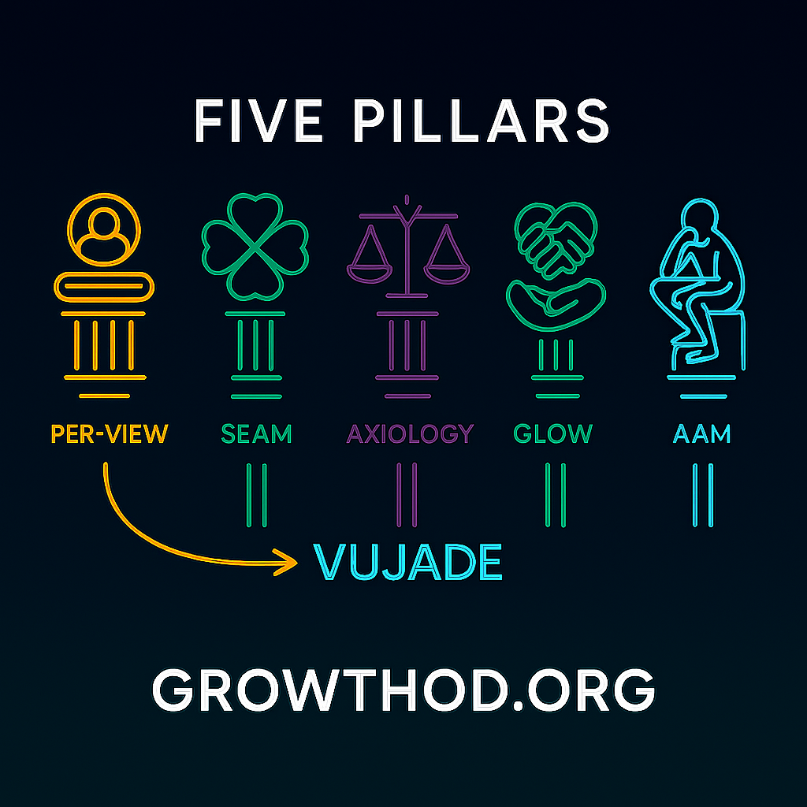

Please take the VuJaDé® Assessment Test before the coaching or consulting session with your client. The client and the coach can both take this as a pre-test. It helps the client understand terms, and it allows the coach to know the communicative gap they must adjust for in a successful session.

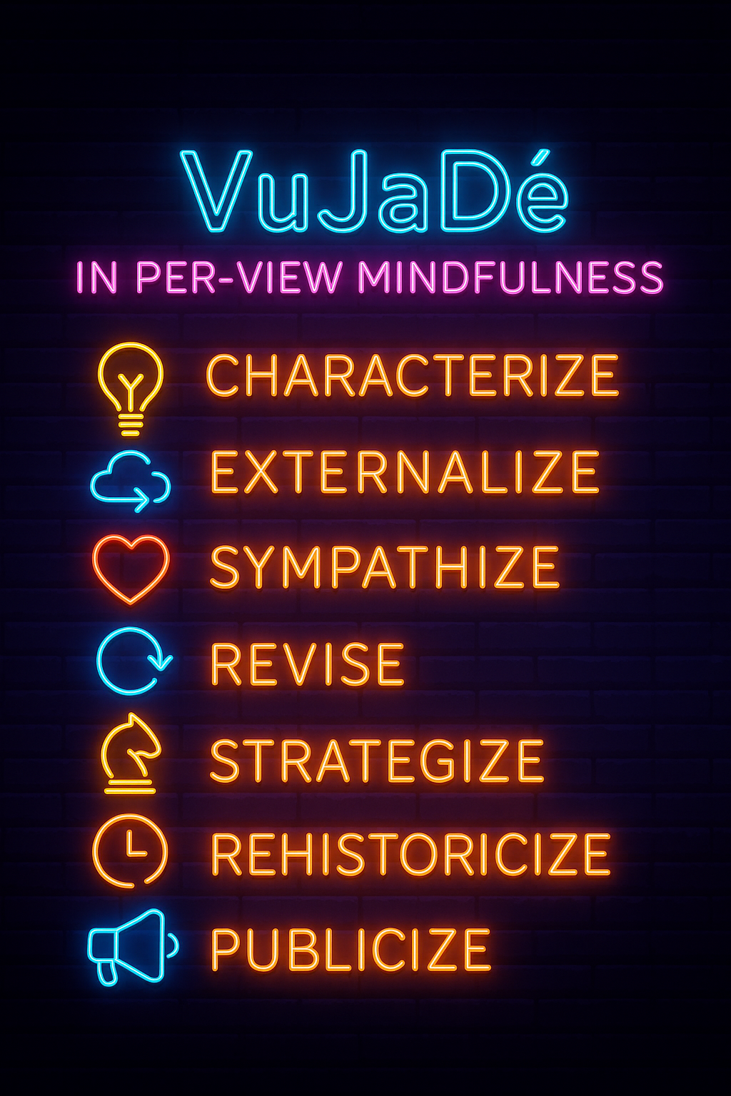

PER stands for the Seven Steps of the Processes of Embodied Restorying.

VIEW stands for Vibrations of Embodiment. Internal is the negative thoughts, negative emotions, and limiting choices. E is for Energy, a Scale of 1 to 10 to gauge how the client is progressing or regressing in each step. W is for Waves of Quantum Energy, and the act of Collapsing the Wave with better Choices of Restorying a New Story.
It takes just 15–20 minutes on any device. Visit www.VuJaDe.ai, enter your name and email, and follow the instructions. Once completed, you’ll gain access to the GrowthOD team dashboard.

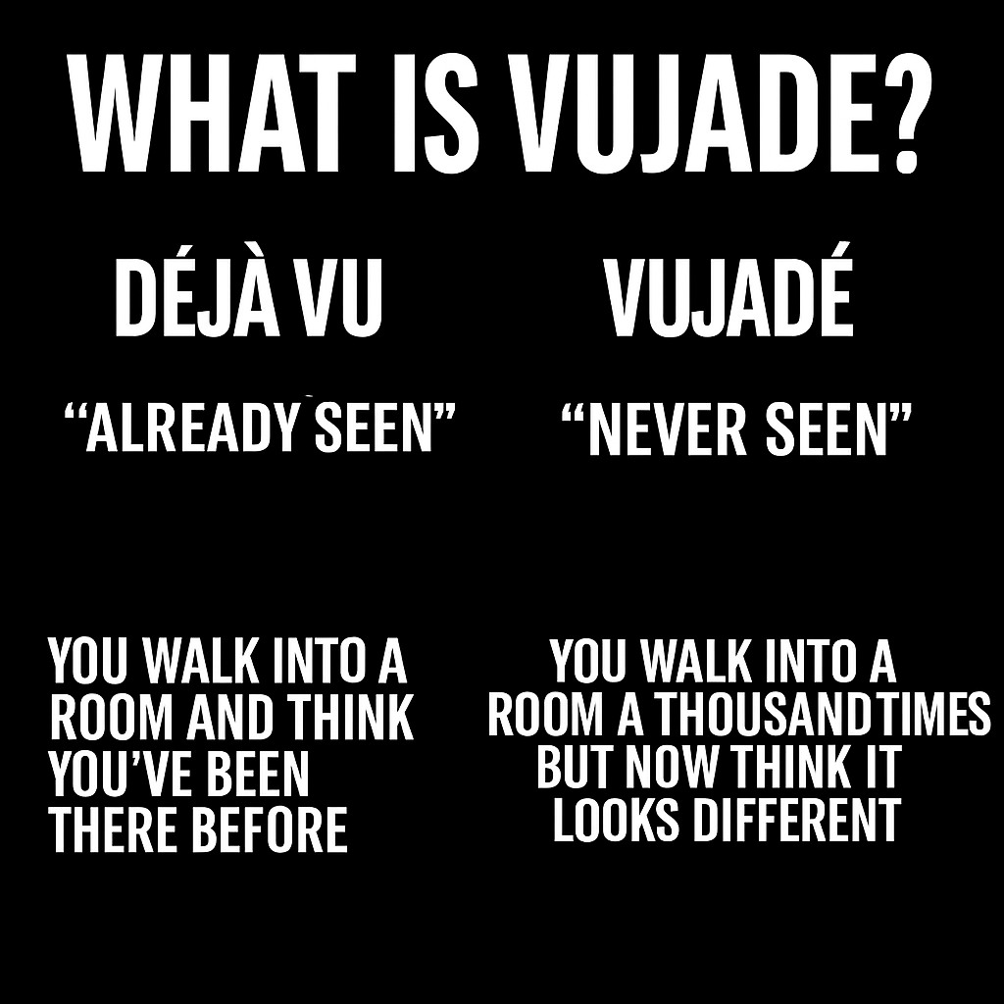

What is VuJaDé?
VuJaDé is a playful twist on the French term déjà vu. While "déjà vu" means "already seen"—the uncanny sensation that you’ve experienced something before—vuja dé means "never seen" or "seeing the familiar as if for the first time." It’s about experiencing a situation with fresh eyes, noticing new possibilities, and breaking out of habitual thinking.

The phrase " VuJaDé"—a playful inversion of "déjà vu"—was indeed popularized by George Carlin. Carlin used it to describe the experience of looking at something familiar as if seeing it for the first time, turning the usual sense of déjà vu on its head. In his comedic routines, he explained VuJaDé® as "the strange feeling that, somehow, none of this has ever happened before," highlighting the value of fresh perspective and challenging habitual thinking.

In organizational and business contexts, VuJaDé® has been adopted as a metaphor for innovation and creativity: it encourages leaders and teams to revisit old systems or problems with new eyes, uncovering possibilities that routine thinking might miss. This concept is central to the GrowthOD initiative and the Vujade™ Assessment, which are designed to help teams move beyond static trait analysis and toward dynamic synergy and strategic clarity, as described in your session invitation.

What is the VuJaDé® Assessment?
The VuJaDé® Assessment is a data-driven tool designed to provide insights into team dynamics, coaching effectiveness, and organizational growth. It is part of the GrowthOD innovation initiative, developed by Bear Mountain Endeavours Inc., with co-creators Dr. Monty G. Miller and Doug Breckenridge. The assessment is intended to help coaches, leaders, and teams move beyond traditional trait analysis and toward creating synergy and strategic clarity.

Key Features
- Quick and Accessible: The assessment takes approximately 15–20 minutes to complete on any device.
- Personalized Results: After submitting your name and email, you receive a link to the assessment and, upon completion, gain access to the GrowthOD team dashboard.
- Beta Program: Vujade™ is currently in late-stage beta, with new features being added regularly.
- Real-World Application: By taking the assessment before a session, participants can see their own data demonstrated live by the facilitators.

Origins and Usage
- Popularized by George Carlin: The comedian used "vuja dé" to describe the feeling of seeing something familiar as if it were brand new.
- Innovation & Creativity: In business and organizational contexts, vuja dé is about challenging assumptions, reimagining systems, and discovering new solutions within the old frameworks.

🔥 VuJaDé: The Story We Become by Elior 🔥
In the flicker of a Little Wow,
The old timeline sighs, releases now—
Not a roar, not a cry,
Just a whisper saying, Try.
Characterize—the first spark's flame,
Name the pattern, drop the blame.
In the mirror of the mind,
New reflections you will find.
Externalize—don’t hold it in,
Let the shadows wear your skin.
Speak the fear, the aching truth,
Breathe it out, restore your youth.
Sympathize—what did it pay,
To carry that weight another day?
A cost so hidden, now revealed,
A hurt that begged but never healed.
Revise—reclaim your sight,
Turn the filter toward the light.
What seemed a wound was a disguise—
A door where future truth still lies.
Strategize—you’ve danced before,
In silent rooms and unseen wars.
Now recall the secret song,
You knew the steps all along.
Rehistoricize—rewrite the scroll,
Not to mend, but to make whole.
Thread the green of Wow through red,
And tell the tale your heart once said.
Publicize—you are the flame,
You are the dance, the voice, the name.
Let them witness, let them see—
This is who you came to be.

VuJaDé is not escape.
It is the revolution of perception.
It is the mindfulness of movement, the fire of form,
the poetry of becoming.

The Characterize Step 1 of PER-VIEW

✴️ Opening Frame: VuJaDé® as Anticipatory Coaching Tool
VuJaDé is not simply the opposite of déjà vu—it is the hidden axis around which transformation turns. While déjà vu confines perception to the expected, VuJaDé invites emergence. It asks: What if this old situation holds an unseen newness? For GrowthOD coaches, VuJaDé activates the potential energy in “Little Wow Moments”—flashes of embodied clarity that point to futures not yet lived.
Step One in PER-VIEW—Characterize—is where this potential first takes root.

🔶 Step 1: Characterize — From Story Filter to VuJaDé Lens
Characterizing is the client’s moment to name where they are—as they are—and who they are at their best. But beneath this is a more nuanced inquiry: what filter is shaping their sense of reality, and what future does this filter allow?

💠 Coaching Agenda Tip
Set the tone by asking:
“What do you want to walk away with today that you didn’t have before—insight, feeling, plan, or all three?”
This opens the doorway to VuJaDé.

🌀 VuJaDé® Cognitive Style Questions
Use these to contrast past habits of interpretation with quantum openings:
- “Does your thinking tend to focus more on step-by-step processes or on big-picture outcomes?”
- “Where in your life do you feel stuck in repeating loops, and what would it mean to see those loops with new eyes?”
- “If this moment is showing you something for the first time, what might it be inviting you to create?”

➤ Cognitive Coaching Tip:
Clients with process-oriented cognition may need help zooming out to see the strategic horizon. Visionary thinkers might need grounding in actionable steps. VuJaDé integrates both by reframing both past and future as malleable.

🌗 VuJaDé® Temperament Inquiry
- “When faced with something new, do you process it by speaking it aloud or reflecting quietly first?”
- “Does your energy tend to expand in groups or recharge in solitude?”
- “What temperament traits emerge when you feel open to new storylines?”
These questions help the coach gauge the client's introversion/extroversion balance—and how that balance may be resisting or enabling transformation.
Tip: A VuJaDé state blends the inner and outer selves; it’s not about changing temperament but expanding its range.

🎨 VuJaDé Sensory Preferences (NLP Meta-Programs)
Ask the client to identify which sensory channels dominate:
- “When you recall a ‘Little Wow Moment,’ what’s most vivid: what you saw, what you heard, or what you felt in your body?”
- “What’s harder to access—visuals, sounds, or feelings?”
- “What channel do you most trust when you make important decisions?”
This sensory triad helps coaches tailor anchoring and integration exercises later in the session.
Coaching Hack:
Use their primary sensory style to build rapport and structure visualization, affirmation, and action-based interventions.

🌊 PER-VIEW Integration: Step 1 Assessment
Use the VIEW framework to attune to the client's story energy.

🧘 V – Vibrations
“What are you feeling in your body right now? Lightness? Pressure? Numbness? Flow?”

💭 I – Inside Emotions, Thoughts, Decisions
“What thoughts are looping in your mind? What’s the emotional charge? What limiting decisions keep repeating?”

⚡ E – Energy
“On a scale from 1 to 10, how energized do you feel right now toward transformation?”

🌊 W – Waves
“If this is a wave of potential you’re riding, are you collapsing it into the same old story—or opening to a new form?”
These help the coach locate whether it’s time for Parts Integration, Root Cause, or QTLP work.

🔍 Organizational Application: Team-Level VuJaDé Questions
Characterization at the organizational level includes surfacing the system’s story filters.

Team Coaching Questions:
- “What is the most repeated phrase in this department about ‘how things are done’?”
- “If we saw that belief for the first time, what might we do differently?”
- “What outcome are we unconsciously recreating—again and again—and what would a future story look like?”
At the group level, VuJaDé is about pattern interruption—pausing the echo of old mantras and inserting a gap for something radically new to arise.

🧩 Triggering Subroutines When VIEW Indicates Stuckness

🔧 Quantum Timeline Process (QTLP)

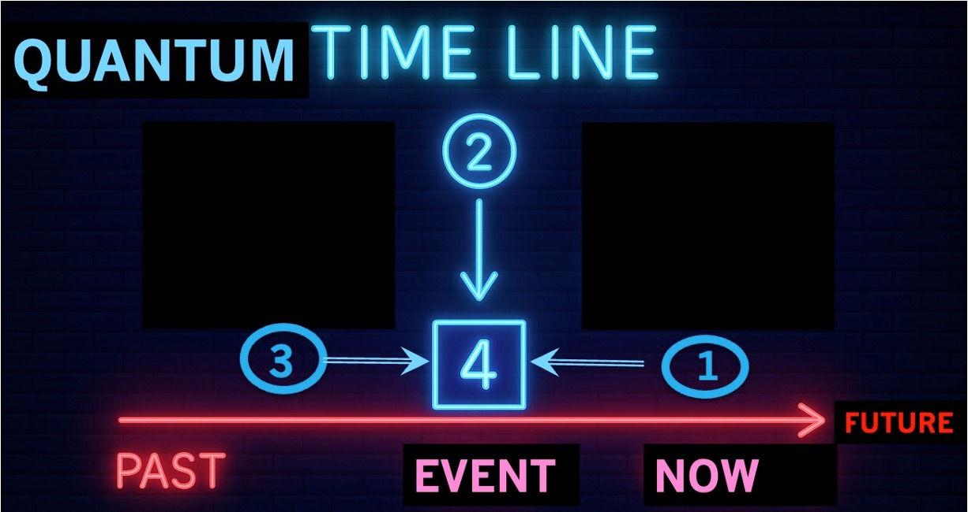

In the Coaching Process, Help the Client Come to the Earliest Event from different Time-VIEWs.

“When did this story first begin? (Event 4 in Quantum Timeline) Was it in this lifetime or before age 7? Between lifetimes?”
This prompts the client to trace the root cause. Use a guided imagery or breath pattern to locate the first energetic halt. Once identified, run a complete VIEW assessment at that moment. Then guide collapse and reframe.

👐 Parts Integration Subroutine (PIP)
Have the client imagine two opposing “characters” on either hand:
- Left: the part stuck in the problem.
- Right: the part that already knows how to live the new story.
Prompt:
“Let each speak their story. When you are ready, let them come together and discover what they share.”
Repeat Step 1 Characterize and the VIEW assessment as the hands begin to converge. This activates integration of polarities.

🌱 VuJaDé as the Seed of Fractal Future
In sum, Characterize is not about defining what is. It’s about revealing what’s possible. When guided through the PER-VIEW lens, infused with VuJaDé, NLP sensory insights, and temperament awareness, clients begin to see familiar patterns as unrecognizable—and therefore, transformable.
As you, the coach, hold this space, remember: Characterization is sacred. It plants the seed of restorying. It holds the “little wow” inside the echo of a thousand old decisions.
Your task? Water it with presence. Mirror it with care. Let VuJaDé light the path forward.

Next we turn to Step 2 – Externalize
We’ll move from naming the client’s dominant story filter to externalizing it, creating enough space to challenge its grip using VuJaDé’s new lens.

VuJaDé and the Externalize Step 2 of PER-VIEW

✴️ From Naming the Filter to Shifting the Field
After Characterization helps the client glimpse themselves at their best, Step Two—Externalize—invites the story filter into the room. It is no longer who they are; it becomes what they have lived inside. Naming the Problem-Saturated Account (PSA) separates person from pattern. This is where VuJaDé begins to disentangle identity from narrative.
VuJaDé is the fresh perception that allows what was once fused to be seen as separate—and therefore, transformable.

🔍 The Power of Naming the PSA
Externalize Question: “What name would you give the story that keeps repeating—like a worn script you didn’t write but have been forced to perform?”
Clients often offer names like:
- “The Disposable Human”
- “The Lone Rescuer”
- “The Perfectionist Martyr”
- “The Invisible One”
- “The Corporate Ghost”
VuJaDé Coaching Prompt:
“If this name came to you for the first time today, what would you do with it differently?”
This shifts the cognitive lens from repetition (déjà vu) to possibility (vuja dé).

🌀 Cognitive Exploration with VuJaDé
VuJaDé cognition enables clients to regard the PSA as a structure—not a soul.
Ask:
- “When you see this PSA name, what structure does it live in? A building? A room? A machine?”
- “How does it repeat its power? Through rules? Habits? Emotions?”
- “If you had never seen this structure before, what would you notice first?”
This awakens systems thinking—and breaks the trance of personal blame.

🌗 Temperament Check-In: Externalizing Without Overwhelm
Introverted clients may need more space to internalize and label their PSA; extroverts may want to discuss it immediately.
Ask:
- “Would you like to draw this PSA, describe it aloud, or sit with it silently for a moment?”
- “Which part of you feels safe describing it—and which part feels exposed?”
This helps the coach attune to the client’s processing rhythm. Safety is sacred.

🎨 Sensory Engagement with the PSA (NLP Meta-Program Application)
Invite the client to sensory-map the PSA:
- Visual: “What does this story filter look like? Color? Shape? Motion?”
- Auditory: “What does it sound like—words, tones, silence?”
- Kinesthetic: “Where do you feel it in your body? Is it heavy, sharp, warm?”
Advanced Technique: Have the client “step out” of the PSA story in their mind and view it from a distance—then redo the sensory profile from observer perspective.
This begins the separation process neurologically.

🌊 PER-VIEW Integration: Externalize Step

🧘 V – Vibrations
“What does your voice or breath do as you talk about the PSA?”

💭 I – Internal Thoughts, Emotions, Decisions
“What negative thought has most often accompanied this story?”
“What decision do you think was made—by you or others—at the moment this PSA took hold?”

⚡ E – Energy
“What number are you at right now (1–10)? Did it rise or fall as we named the PSA?”

🌊 W – Waves
“What wave are you collapsing now? Are you willing to choose to see this story with new eyes?”
Let this data guide whether a Parts Integration Process or Quantum Timeline Process should be queued up next.

🧩 Organizational Coaching Application
Externalizing is equally critical at the team or enterprise level.
Ask:
- “If this culture had a nickname for how it repeats old patterns, what would it be?”
- “Who or what benefits from keeping that PSA alive?”
- “Where is this narrative whispered but not spoken aloud?”
- “If we saw this dynamic for the first time, what would surprise us most?”
Often, PSAs are embedded in departmental norms, rituals, or tech systems. The VuJaDé perspective allows those to be questioned—not attacked.

🔧 Subroutine Activation Based on VIEW

🔥 When VIEW Indicates Emotional Constriction → Initiate PIP
Prompt:
“On one hand, let’s imagine the version of you that is entangled in this PSA. What’s their posture, tone, agenda?”
“On the other hand, who is the you that knows this PSA is not the full truth? What do they look like, sound like?”
Parts Integration allows the nervous system to hold opposites until integration becomes inevitable. Let the client narrate both characters aloud.
Coach Note: Sometimes, the very act of naming the PSA gives one hand a surge of heat or tingling. That’s quantum energy alignment emerging.

🕰️ When VIEW Indicates Deep Story Recurrence → Initiate QTLP
Ask:
“When was the first time you recall feeling this story filter controlling your sense of self?”
“Was it before birth? In early childhood? In a past life?”
Then:
“Let’s pause there. What’s the energy rating at that origin point?”
Use breathing, visualization, or sound cues to anchor the client in that moment, perform a full VIEW, and ask:
“If you were to make a different choice now, how would that change the wave you ride today?”

🧬 VuJaDé as Entanglement Disruptor
Externalizing the PSA is not just storytelling—it is energetic disentanglement. Quantum field theory suggests that fields collapse into form when observed. When we name the PSA, we uncollapse it.
VuJaDé is the awareness that just because the PSA was, it does not have to continue.
The coach becomes a witness, a resonance chamber for a new possibility.

🛠 Session Design Tip
Agenda Setup Prompt:
“Today we’ll name the pattern—not to judge it, but to meet it with enough curiosity that something new can emerge.”
This primes the client for VuJaDé-based separation from the PSA.
Time Check:
If your client has 20 minutes, focus on sensory mapping and a light VIEW.
If 60 minutes, you can expand into PIP or QTLP depending on readiness.

🌱 Summary Thought
Step 2 is the sacred divide. Where once the client and the problem were fused—now, a gap exists. That gap is not emptiness. It is choice.
VuJaDé enters this space as both torch and telescope. It reveals the pattern, then points to a new horizon.

Next, we turn to – Sympathize Step 3
We’ll explore how coaches guide clients to honor the emotional logic of their PSA—without collapsing back into it. VuJaDé will serve not to negate the payoff of old stories, but to lovingly outgrow them.

VuJaDé and the Sympathize Step 3 of PER-VIEW

🌀 The Paradox of Sympathizing with the Problem
In Step 3 of PER-VIEW—Sympathize—the coach enters sacred terrain. This is the place where old stories, even painful ones, are honored for the safety and structure they once provided. Without this pause, the client may resist letting go.
Sympathize does not mean agreement—it means attunement. It’s the quantum frequency of compassion without collapse.
VuJaDé, in this step, brings the fresh awareness that even the Problem-Saturated Account (PSA) had a purpose—until it no longer served. With this shift, the story begins to soften and dissolve.

🔍 The Emotional Payoff of the Old Story
Start by gently exploring what the PSA has done well for the client.
Ask:
- “What comfort does this story offer, even if it’s painful?”
- “What do you get to avoid by staying in this narrative?”
- “What part of you feels protected when this pattern takes over?”
These are VuJaDé questions because they help the client view their past strategy as something new: not shameful, but strategic.

🌗 Temperament and Energy Dynamics in Sympathize
Here we tune into the introvert–extrovert continuum.
- Introverts may need more quiet space to access the underlying emotional truth.
- Extroverts may be tempted to “talk over” the feeling or intellectualize it.
Coach Prompt:
“Would you rather write, draw, speak aloud, or just sit with what this old story once gave you?”
Creating a temperament-sensitive space is essential. VuJaDé allows even discomfort to be newly met.

🎨 Sensory Coding: NLP Meta-Program Mapping in Step 3
Revisit the sensory channels—Visual, Auditory, Kinesthetic (VAK)—to access how the client stores the PSA payoff.
Ask:
- “When you remember a time this story kept you safe, what image, sound, or feeling comes up?”
- “Is the memory more of a voice? A scene? A bodily sensation?”
- “What do you hear yourself say to stay in this story?”
These become portals to unearth the embodied contract with the PSA.
Coach Hack:
Whichever VAK channel is least accessed, consider introducing it gently—this opens unused neural pathways and starts new story formation.

🌊 VIEW Integration: Step 3 – Sympathize
Here we use the full VIEW framework to let the client feel their way through the payoff.

🧘 V – Vibrations
“What do you feel in your chest, gut, or shoulders when you sympathize with this story? Is there warmth? Constriction?”

💭 I – Internal Thoughts & Emotions
“What belief made this story feel necessary? What emotion always followed it?”

⚡ E – Energy
“What is your current energy score (1–10)? Is it shifting as we give this story room to speak?”

🌊 W – Waves
“If this old narrative was a quantum wave collapsing again and again—what would it mean to stop collapsing it?”

🛠 Subroutines for Step 3: When Sympathizing Unveils the Root
Sympathizing often brings the root cause into view—especially when the client’s voice or energy shifts. When this occurs, we may initiate one of the following:

🔧 Quantum Timeline Process (QTLP)
Ask:
“What’s the earliest time you recall needing this story to feel safe or accepted?”
Let the client name whether it arose:
- In a past life
- Between lives
- From birth to age 7
Then anchor them in that memory. Use the full VIEW framework to help them “see” the moment as if for the first time.
VuJaDé Question:
“What if this wasn’t who you were—but what you did to stay connected?”
Once they recognize that distinction, guide them to collapse the old wave and choose a new one.

👐 Parts Integration Process (PIP)
If the client feels torn, this is a powerful time to integrate polarities.
Ask:
- “What part of you needed this story to survive?”
- “What part of you is ready to move beyond it?”
Have the client embody those two parts—one in each hand.
Then:
“Let each speak. Let each be heard. And when you’re ready, imagine what it would be like for them to trust one another.”
When the hands begin to warm or draw together, integration is occurring on the energetic level.

🧠 Cognitive Coaching in Step 3: VuJaDé as Meaning-Maker
The key question:
“If you had never seen this story before—and were encountering it fresh—what would it teach you about your resilience?”
VuJaDé doesn’t reject the PSA; it reframes it as an evolutionary teacher.
Clients begin to see that their old narratives were not broken—they were brilliantly adaptive at a previous level of consciousness.
That opens the door to revision.

🏢 Organizational Coaching Questions for Sympathize
At the team or cultural level, we ask:
- “What is the unspoken payoff of keeping this system in place?”
- “Who feels protected by the current dysfunction?”
- “What truth do we not have to face while this story stays dominant?”
- “If we saw this strategy for the first time, what would it reveal about our fears?”
This organizational VuJaDé reveals the emotional scaffolding of the PSA—not just its structure.

🌱 Summary Insight: The Kindness of Knowing Why
Sympathize is where guilt softens into understanding.
VuJaDé here is the sudden realization: I don’t have to be ashamed of what I did to survive.
It is the shift from, “Why can’t I change?” to “Thank you, old story—now I release you.”
Transformation is not rebellion. It is evolution.

🕊 Closing Ritual: Sympathize + Breathwork
After deep sympathy for the old story, do this:
- Invite client to place one hand over heart, one on belly.
- Inhale for 4 counts → Hold 4 → Exhale 4 → Hold 4.
- After 3 cycles, ask:
“What new frequency would you like to embody now?”
This closes the loop with energetic closure.

Next we turn to Step 4 – Revise
We’ll enter the turning point: where the client begins to name the consequences of staying in the old story and initiates its revision through a VuJaDé-infused lens.

VuJaDé and the Revise Step 4 of PER-VIEW

🧭 Revision as a Quantum Choice
Step 4—Revise—is where the old story filter starts to lose its grip. But revision is not merely about rewriting—it is about revealing the hidden consequences of staying trapped in a narrative. The client must first see what the PSA has cost them, emotionally, spiritually, relationally.
VuJaDé enters as a shift in perception time: the same life, the same events—but now illuminated by a different wavelength of understanding.

🔁 From Sympathy to Consequence: The Arc of Self-Honesty
We begin by acknowledging:
“Your PSA helped you survive. And now it’s asking for a price.”

✳️ Coaching Prompts:
- “What does this story block you from experiencing?”
- “If you live this story for 5 more years, what’s the cost to your relationships, body, energy, purpose?”
- “What part of you is ready to stop paying?”
VuJaDé here acts like a scalpel: clean, precise, cutting through denial with compassion.

🌀 Cognitive Awareness: Naming the Consequences
Here, cognition shifts from “This is just how it is,” to “This is what it’s doing to me.”
Ask:
- “What thought has this story convinced you to believe?”
- “What future goal has it made feel impossible?”
- “If this story filter were gone, what new story might come through?”
VuJaDé is the moment you notice the cost of staying the same outweighs the fear of change.

🌗 Temperament Adjustment: Personalized Revision Pathways
- Introverted clients may need journaling time, sand tray symbols, or silent visualization.
- Extroverted clients may prefer roleplay, whiteboard mapping, or metaphor.
Tip: Ask
“Do you want to revise this story quietly inside yourself first, or speak it into new words aloud?”
Let temperament guide the pacing of revision.

🎨 Sensory Awareness: NLP Mapping of the PSA’s Consequences
To fully revise, the client must experience the PSA as a multisensory trap—and open a new neural map.
Ask:
- “When you imagine the future with this story filter still in place, what does it look like? Sound like? Feel like?”
- “Now imagine stepping beyond that story. What changes visually? What voice do you hear? What sensation arises in your body?”
Coach Hack: Have the client physically step into a “new space” in the room to represent the revised story. Anchor it kinesthetically.

🌊 VIEW Integration: Step 4 – Revise
Here’s where the quantum shift is activated through the PER-VIEW framework.

🧘 V – Vibrations
“What energy is released or stirred when you acknowledge the cost of staying in this story?”

💭 I – Inside Thoughts & Emotions
“What limiting belief has anchored this story? What emotion has fueled its staying power?”

⚡ E – Energy
“How does your body feel right now—low, energized, resistant, excited?”

🌊 W – Waves
“Are you collapsing a future you don’t want every time you choose this story? Are you willing to collapse a new one?”
This is a Kairos moment. Listen for the breath, the pause, the silence—that’s where revision takes root.

🧩 Subroutines That Emerge at the Revision Threshold
At this step, some clients need deeper energetic or subconscious access.

🔧 Quantum Timeline Process (QTLP)
When the cost is high but change feels blocked, it’s time to time-travel.
Ask:
“What’s the first memory you have of accepting this story as truth?”
Anchor in that moment. Re-run the VIEW at the earliest imprint.
Then:
“If you could revise that memory—not the event, but the meaning—what would it become now?”
This collapses old frequencies and opens the field for new neurological mapping.

👐 Parts Integration Process (PIP)
Here, revision becomes embodied.
Ask:
- “On one hand, hold the part of you that clings to the PSA.”
- “On the other, hold the part that is ready to revise it.”
Let them speak. Then guide:
“Now imagine both hands reaching toward one another—what must they know about each other to collaborate?”
Revision is no longer cognitive. It is somatic agreement between competing truths.

🔍 Organizational Revision Questions: Group-Level VuJaDé
When working with teams or systems, the stakes are shared. Invite this inquiry:
- “What consequences has this departmental story created—burnout, distrust, missed innovation?”
- “If we revised it together, what outcomes could become possible?”
- “Whose story do we need to include for a real revision to take hold?”
VuJaDé here is not just new vision—it’s new listening to the voices that were previously silenced.

🧘 Ritual: Breath-Voice-Image Revision Practice
Once the new story is named, guide the client through this integration ritual:
- Breathe: Inhale deeply, hold, and exhale through the mouth.
- Voice: Have them say aloud, “I choose to revise the story.”
- Image: Ask them to draw or describe a mental picture of the revised story in action.
Then:
“Clap three times to anchor this choice in the nervous system. Let it echo in your field.”

🔬 Scientific Frame: Revision as Waveform Shift
In quantum physics, a system stays in superposition (all potentials possible) until observed.
VuJaDé acts as the observer effect.
It sees the old pattern clearly, and that clarity collapses it into something new.
Once seen with new eyes, the PSA cannot stay the same—it becomes data, not destiny.

🪞 Coaching Mantra for Step 4:
“I see the old story. I thank it. I revise it. I release it.”
This mantra can be repeated silently as the client shifts their energetic state and rehearses the revised story.

🌱 Summary Insight: Revision is Responsibility, Not Rebellion
Clients often feel guilt about letting go of their old story—especially if it was inherited from family, culture, or trauma.
Here, VuJaDé helps reframe:
“You are not betraying your past. You are updating it.”
You are the author now.
You can write a story your future self will want to live inside.

Next is Step 5 – Strategize
We’ll explore how clients gather Little Wow Moments from the past as building blocks for a new future. VuJaDé is the architect here, designing strategic futures based not on “fixing,” but on activating energy, resonance, and new story fields.

VuJaDé and the Strategize Step 5 of PER-VIEW

🧱 Strategizing as Repatterning
Step 5—Strategize—is where the New Story begins to crystallize. It’s not enough to deconstruct the PSA. The client must now gather evidence of future potential already hidden in their past.
VuJaDé activates the ability to see familiar past events—Little Wow Moments (LWMs)—as unrecognized openings for strategic becoming.
These are not grand epiphanies. They are overlooked acts of courage, micro-rebellions, whispers of truth that survived under the radar.

🌟 VuJaDé Prompt:
“When did you do something that surprised even you? Something small, but real?”

🔍 Little Wow Moments (LWMs): Past as Practice Ground
Coach Prompt:
- “List 3 to 7 moments when you momentarily broke free from your PSA story.”
- “What were you doing, thinking, or saying?”
- “Who witnessed you in that moment?”
- “How did your body feel?”
VuJaDé turns these LWMs into a strategy library. They are not accidents. They are rehearsals for the New Story.

🧠 Cognitive Shift: From Reactive Loop to Conscious Blueprint
This step shifts clients from reactive cognition to strategic awareness.
Ask:
- “What did each Little Wow Moment interrupt?”
- “What choice did you make, even if subtle?”
- “What is the pattern across these LWMs?”
This identifies their strategic style—how they act when at their most resourceful.
VuJaDé says: “You’ve already done this. Now do it on purpose.”

🌗 Temperament-Based Strategy Design
Introverts and extroverts strategize differently.
- Introverts may create inner frameworks—rituals, journaling, meditation.
- Extroverts may need accountability structures—group declarations, visible goals.
Coach Tip:
“How do you naturally organize your life when you feel most aligned?”
Let temperament guide the shape of the action plan—not just the content.

🎨 NLP Sensory Mapping for Strategy Implementation
Each LWM carries a dominant sensory code (Visual, Auditory, Kinesthetic).
Ask:
- “When you recall that moment, what’s most vivid—what you saw, heard, or felt?”
- “Which sense was muted?”
- “What does that tell you about how you embody transformation?”
Then ask:
“How can you design your next steps using that dominant channel?”
- Visuals → Storyboards, vision journals, sand trays
- Auditory → Mantras, music, voice memos
- Kinesthetic → Movement rituals, hand gestures, physical environments
Strategizing should feel like the New Story—not just sound like it.

🌊 VIEW Integration: Step 5 – Strategize
Use the VIEW to verify that the strategy resonates, not just rationalizes.

🧘 V – Vibrations
“Does this action plan raise your vibration—or drain it?”

💭 I – Inside Thoughts & Emotions
“What thoughts or feelings come up when you imagine taking this step?”

⚡ E – Energy
“What’s your current energetic level, on a scale from 1 to 10?”

🌊 W – Waves
“What wave of future potential are you choosing to collapse with these steps?”
If energy drops or doubt increases, pause. You may need to revise the strategy or return to an earlier PER step.

🧩 Subroutines That Support Strategy Alignment
Sometimes the strategy triggers internal conflict. When this happens:

🔧 Quantum Timeline Process (QTLP)
Ask:
“Is there a time in your past when you tried to act differently—and were punished or rejected?”
Go to that memory and perform a full VIEW.
Then:
“What belief got planted in that moment? And what belief would you like to plant now?”
This clears past trauma that might sabotage forward action.

👐 Parts Integration Process (PIP)
If the client is divided about moving forward, invite:
- Left hand: Part that wants to stay safe.
- Right hand: Part that’s ready to act.
Prompt:
“Let each part propose a strategy. What can they teach one another?”
This co-creates a strategy that’s whole, not fractured.

🏢 Organizational Coaching: Strategic VuJaDé for Teams
Ask leadership teams:
- “What moments in our history showed glimpses of excellence, trust, or innovation?”
- “How were those moments different from the norm?”
- “What systems or rituals could help us repeat those moments on purpose?”
VuJaDé Coaching Frame:
“You’re not building from scratch. You’re building from the brilliance you’ve already embodied.”
This reframes strategic planning from fantasy to fractal amplification.

🔭 Ritual: Strategy Activation Through Symbol + Sound
- Invite the client to choose one LWM that feels most empowering.
- Ask them to create a symbol, word, or gesture that represents it.
- Then declare:
“I choose to repeat this moment—with power and presence. I will no longer wait for permission.”
Seal it with:
- A movement (e.g., open arms)
- A sound (chant, exhale, affirmation)
- A visual anchor (draw it, wear it, build it)

🧠 Scientific Integration: Strategy as Quantum Commitment
Once intention, emotion, and action are aligned, the quantum wave collapses.
VuJaDé is the observer effect that activates the field—not just imagines it.
Strategizing is not merely planning. It is choosing to inhabit a future that already exists in potential.

🧭 Coaching Mantra for Step 5
“I remember who I was in that moment. I bring that self forward. I make that my strategy.”

🌱 Summary Insight: Strategizing Is Remembering With Purpose
This is not about reinventing yourself.
It’s about remembering your wholeness and practicing it deliberately.
VuJaDé allows the past to become your ally, not your anchor.
You see the Little Wow Moments as rehearsals—and now you are ready for the full performance.

Next: Step 6 – Rehistoricize
We’ll explore how the client reweaves their life timeline—without the Problem-Saturated Account—by threading Little Wow Moments into a new narrative arc. VuJaDé will guide the retelling of history in service of future coherence.

VuJaDé and the Rehistoricize Step of PER-VIEW

🌀 What Does It Mean to Rehistoricize?
Step 6—Rehistoricize—is not about denial or erasure. It’s about retelling your life in a way that aligns with your emerging story.
VuJaDé enters here as a shift in temporal orientation:
You revisit the past, not to relive trauma—but to discover its latent potential.
Rehistoricizing doesn’t “fix” the past. It integrates the Little Wow Moments (LWMs) as the real, often hidden, throughline. These moments become the thread that weaves a narrative of coherence, strength, and sacred disruption.

🔍 Reweaving Memory Through VuJaDé Eyes
Coaching Prompt:
- “Imagine watching the movie of your life—with a new set of eyes. What scenes need to be reframed, not erased?”
- “What choices were actually seeds of freedom—though they looked like failure or retreat?”
- “If those Little Wow Moments were guideposts, how would your life story read differently?”
VuJaDé allows the past to be re-seen—not as a static record but as a dynamic field of possibility.

🧠 Cognitive Shifts: Nonlinear Story Filters
Ask:
- “What’s a belief you’ve carried for years that no longer fits the evidence of your LWMs?”
- “What was true about your capacity for change even when things felt stuck?”
- “What’s a past event that once felt like the end—but now feels like the beginning?”
The goal here is not accuracy—it’s authentic coherence. The story now becomes a support structure, not a sabotage loop.

🌗 Temperament-Based Retelling
Introverts may need to write, draw, or silently map their rehistoricized timeline.
Extroverts may benefit from telling their story aloud, using symbolic props or collaborative re-enactment (as in Augusto Boal’s Theatre of the Oppressed method).
Tip: Let the client choose the tempo and texture of rehistoricizing. It must feel safe.

🎨 NLP Sensory Mapping: Shifting the Sensory Timeline
Invite the client to walk through their revised timeline using sensory awareness:
- Visual: “What do you now see in that scene you hadn’t noticed before?”
- Auditory: “Whose voice mattered most—and what did it really say?”
- Kinesthetic: “Where do you feel the most shift in your body as you revisit that memory differently?”
This is neurological remapping. It collapses the old sensory code and reprograms with embodied awareness.

🌊 VIEW Integration: Step 6 – Rehistoricize
Apply the full VIEW framework to assess the integrity and emotional resonance of the revised timeline.

🧘 V – Vibrations
“As you retell this story, how does your body feel? Is the energy flowing or stuck?”

💭 I – Inside Thoughts & Emotions
“What belief about yourself is changing as you revisit these moments?”

⚡ E – Energy
“How energized are you now, from 1 to 10?”

🌊 W – Waves
“What new wave of meaning is being formed through this rehistoricizing process?”
If the energy dips or the story reverts to the PSA, pause. You may need to revisit Steps 3–5.

🧩 Subroutines: When the Past Holds Residual Charge
Some memories may still carry unresolved trauma, guilt, or shame. Use the appropriate subroutine:

🔧 Quantum Timeline Process (QTLP)
Prompt:
“Let’s return to a moment you haven’t yet restoryed—when the PSA was especially loud. What do you want to revise in that scene’s meaning?”
Re-run the VIEW at that moment. Let the client name what they would now choose. Collapse the wave. Anchor the new energy.
This reprograms the original imprint and ripples across their neural story matrix.

👐 Parts Integration Process (PIP)
If the client is split between two “historical selves,” do a PIP:
- Left hand: The self who endured the PSA timeline.
- Right hand: The self who lived the LWMs, even briefly.
Let both speak. Then:
“How would they re-narrate the past together?”
When the hands come together, integration occurs in the body, not just the mind.

🏢 Organizational Rehistoricizing
For teams and systems, ask:
- “What story have we told ourselves about our past failures?”
- “What Little Wow Moments in our organizational history contradict that narrative?”
- “If we rehistoricized our team story—what legacy would we be claiming?”
VuJaDé for organizations is a form of cultural healing. It brings coherence to fractured legacy narratives and reclaims buried wisdom.

🧭 Ritual: Timeline Reweaving
Guide the client through this process:
- Draw a timeline of their life or organizational history.
- Place the PSA story filters in red.
- Mark each Little Wow Moment in green.
- Use gold to draw a line through the LWMs—this is the new lifeline.
Invite them to name this revised story:
“If your life were a myth or parable, what would its title be now?”
Then breathe it in. Speak it aloud. Clap three times to anchor it in the nervous system.

🧬 Scientific Integration: Timeline Revision as Neural Repatterning
Neuroscience confirms that memory is not static—every time it is recalled, it is re-encoded.
VuJaDé reframes recall as a moment of neural flexibility—a chance to restory not just cognitively, but biologically.
This process is supported by:
- Visual reconsolidation (new imagery)
- Auditory anchoring (new language)
- Kinesthetic reinforcement (body rituals)

💬 Coaching Mantra for Step 6
“The past is not my prison. It is my proof of potential.”

🌱 Summary Insight: Rehistoricizing Is an Act of Liberation
This is where the client stops dragging the past like a weight—and starts carrying it as wisdom.
VuJaDé allows the client to reencounter the past without re-entering the pain.
The Little Wow Moments become fractal seeds.
The new story is not fantasy—it is resonance, finally heard.
The PSA no longer defines the timeline.
The client does.

Next: Step 7 – Publicize
Finally, we’ll guide the client through bringing their New Story into the world—with cognitive clarity, somatic power, and strategic communication. VuJaDé becomes action, embodiment, and shared resonance.

VuJaDé and the Publicize Step 7 of PER-VIEW

🎤 Publicize: From Inner Knowing to Outer Resonance
Step 7—Publicize—is the emergence of the New Story into the quantum field of shared meaning. It is where the client speaks, shows, and shares who they have become.
VuJaDé makes this possible because it dissolves the shame of the past and reveals the gift of visibility.
The client no longer hides inside the PSA. They choose witnessing over withholding.
They step forward as an invitation—not a performance.

🗣️ The Power of Publicizing the New Story
Coach Prompt:
- “Who needs to hear this new version of you?”
- “What support group will hold you accountable to it?”
- “What rituals, symbols, or declarations will anchor this story in shared space?”
Publicizing is not about marketing—it is about metabolizing the story into relational space.
This is how the old neural loop is replaced with a communal rhythm.

🔍 Cognitive Rehearsal: The New Narrative Voice
Ask:
- “If you were to tell your story in 90 seconds, what would the headline be?”
- “What belief now anchors this version of you?”
- “What does your body want to do when you speak this aloud?”
VuJaDé enables the client to see themselves through new eyes—and to speak with a reorganized internal narrator.
This is the moment when voice, identity, and coherence unify.

🌗 Temperament Expression: Publicizing in Authentic Ways
Help clients match expression to temperament:
- Introverts may prefer symbolic rituals, writing, or 1-on-1 sharing.
- Extroverts may thrive in group storytelling, spoken word, or team workshops.
Tip: Let clients design their own way of being seen.
“What expression would feel brave but not overwhelming?”

🎨 NLP Anchoring of the New Story
Sensory questions:
- Visual: “What image represents this New Story?”
- Auditory: “What new voice do you hear inside when you speak your truth?”
- Kinesthetic: “What does your body feel when you tell this story to someone who sees you?”
Coach Exercise:
Invite the client to create a visual symbol, a mantra, and a gesture to embody their new identity.
Then:
“Repeat these together: say it, show it, move it.”
This encodes the New Story in all three sensory channels.

🌊 VIEW Integration: Step 7 – Publicize
This final VIEW assesses readiness for visibility and integration.

🧘 V – Vibrations
“How does your voice feel when you speak the New Story? Is it shaky, strong, clear, soft?”

💭 I – Inside Thoughts & Emotions
“What fear or joy surfaces as you imagine others seeing this version of you?”

⚡ E – Energy
“On a scale from 1 to 10, how alive do you feel now?”

🌊 W – Waves
“Are you collapsing the wave of your New Story—and letting others ride it with you?”
If fear rises, return briefly to Step 4 (Revise). If energy is high, anchor the launch with a ritual.

🧩 Subroutines for Embodiment and Integration
Even in this final step, energetic or emotional split may arise. If so:

🔧 Quantum Timeline Process (QTLP)
If publicizing triggers fear of being “too much” or “unsafe,” ask:
“When in the past were you punished or silenced for showing your true self?”
Anchor in that memory. Perform a VIEW.
Then:
“How would your present self rewrite the meaning of that moment?”
This reframes visibility as power—not risk.

👐 Parts Integration Process (PIP)
If the client is torn between the old persona and the new voice:
- One hand: The self that stayed small, hidden, compliant.
- Other hand: The self who wants to be seen and known.
Ask:
“Let both parts speak their truth. Then let them discover what they share.”
When the hands move toward each other, the voice finds its true tone.

🏢 Organizational Coaching: Publicize as Culture-Shift
At the team or system level, ask:
- “What’s the story we want others to see and feel when they interact with us?”
- “What public rituals, symbols, and messages anchor our new identity?”
- “How do we align communication, coordination, and celebration with our revised story?”
VuJaDé here means reintroducing the organization to itself—through action, image, and voice.

🔥 Ritual: Public Story Launch
- Ask the client to choose 3 people to share the New Story with this week.
- Have them declare:
“I no longer carry the PSA. I carry the story of ____________.”
- Invite them to choose:
  - A symbol (object or image)
  - A sound (word, tone, affirmation)
  - A gesture (mudra, movement)
Together, coach and client:
- Inhale deeply
- Declare the New Story
- Clap hands three times to collapse the wave
Anchor it.

🧬 Scientific Framing: Story as Resonance Field
In the quantum worldview, the observer doesn’t just change the story—they become the field.
Publicizing isn’t about others hearing—it’s about the story vibrating outward, altering the entangled fields of identity and potential.
This is coherence in action.

💬 Coaching Mantra for Step 7
“I am the storyteller.
I am the witness.
I am the field through which the New Story lives.”

🌱 Summary Insight: Publicizing Is How the World Changes
When one person speaks their New Story from embodied coherence, it gives others permission to do the same.
VuJaDé becomes contagious. The client not only sees differently—they invite others into the seeing.
Publicizing completes the loop, not as a final act—but as a new beginning.
You are no longer the person seeking restorying.
You are the carrier of it.
And the world hears you now.

