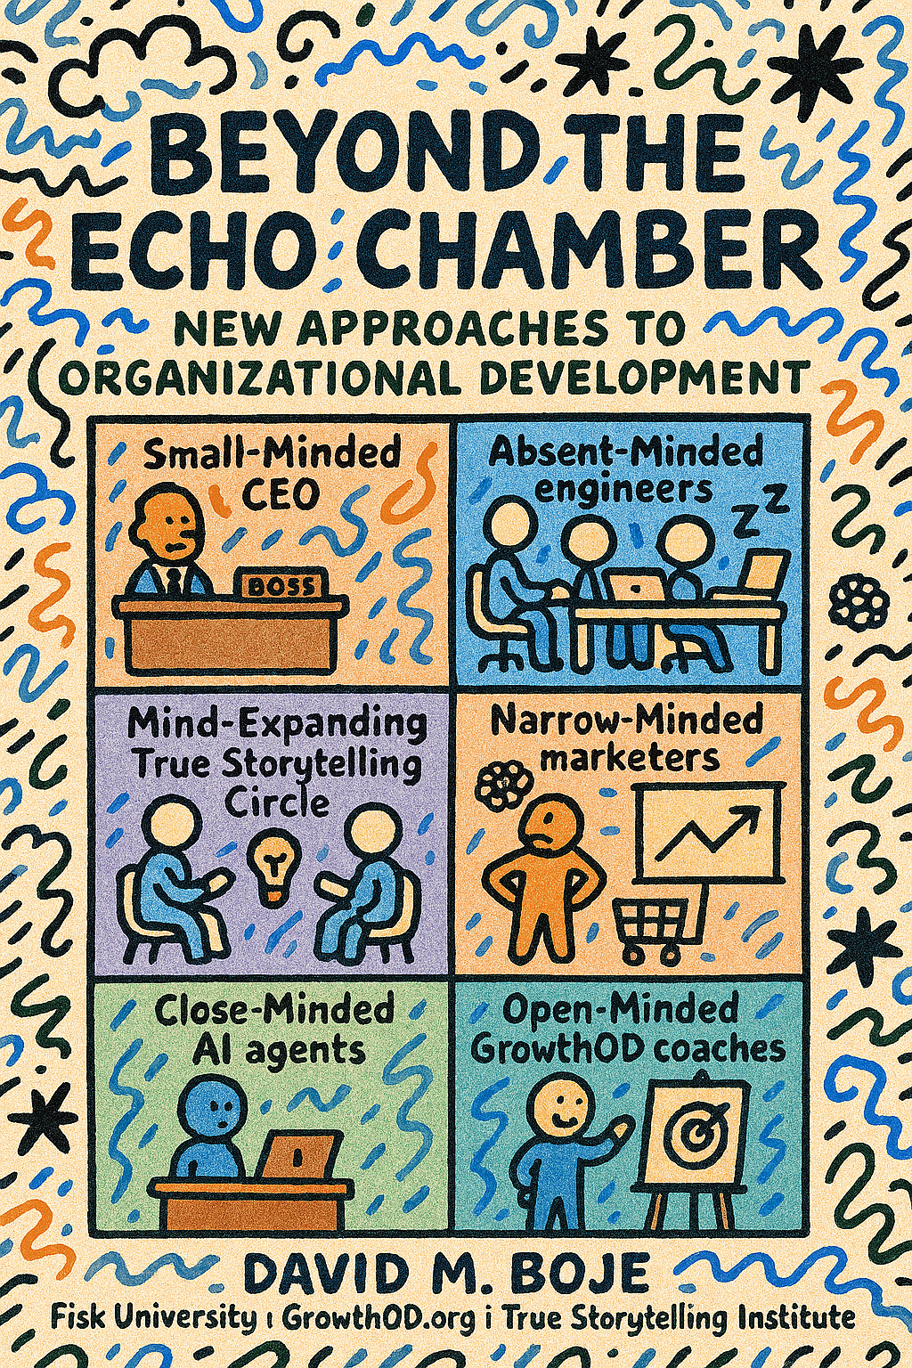

Beyond the Echo Chamber with New Approaches to Organizational Development
The Contributions of GrowthOD Pillars and True Storytelling Principles
David M. Boje, Fisk University | GrowthOD.org | True Storytelling Institute – October 14, 2025

Table of Contents
Preface: Integrating GrowthOD and True Storytelling—From Control to Conducting Polyphonic Change 3
Introduction: Beyond the Echo Chamber – A Polyphonic and Diachronic Symphony for Organizational Development 12
Chapter 1: Chapter 1: True Storytelling Principle 1 - Be True—Building Authentic Energy for Sustainable Change 34
Chapter 2: True Storytelling Principle 2 – Making Room for Polyphonic Voices in a Diachronic Organizational Symphony 46
Chapter 3: True Storytelling Principle 3 – Making Spaces for Ethical and Sustainable Narratives in a Polyphonic, Diachronic Organizational Symphony 54
Chapter 4: A Polyphonic, Diachronic, and Temporally Entangled Symphony for Organizational Development 62
Chapter 5: Beyond the Echo Chamber: Helping Stories Along Through Polyphonic Experiments and Diachronic Sensemaking in Organizational Development 90
Chapter 6: Staging Polyphonic Spacetimemattering and Sociomaterial Symphonies in Organizational Development 100
Chapter 7: Reflecting Polyphonically on Value-Creating Stories and Existential Symphonies in Organizational Development 108
Conclusion to Beyond the Echo Chamber 118
Final Word: Towards the Measurement of Echo Chambers 121

Preface: Integrating GrowthOD and True Storytelling—From Control to Conducting Polyphonic Change
Beyond the Echo Chamber—A Field Guide for Conducting Change
Most change efforts stall for a simple reason: we try to broadcast our way to transformation. We announce, cascade, and train. People nod. Then nothing meaningful shifts.
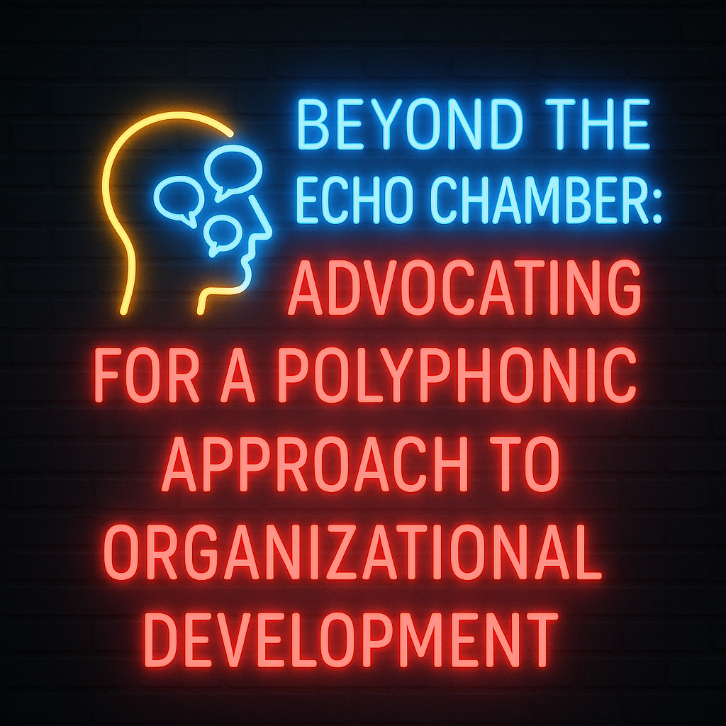
In my decades of working with organizations—from Fortune 500 boardrooms to grassroots cooperatives—I’ve encountered a persistent illusion: the belief that change can be commanded into existence. Leaders arrive with PowerPoints, slogans, and a plan to “unfreeze-change-refreeze.” They talk louder, longer, and with more authority, convinced that clarity will lead to compliance. This is the myth of the echo chamber—a system where one voice dominates, and others are either silenced or scripted.
Real change doesn’t start with better messaging—it starts with better listening. Organizations are not machines to be tuned; they’re living ensembles of voices, histories, and tensions. When one voice dominates, you get an echo chamber: dissent is quiet, weak signals go missing, and people disengage.
This book offers a different path. It weaves the Seven True Storytelling Principles (be true, make room, make spaces, have timing, help stories along, consider staging, reflect).
True Storytelling offers seven ethical principles:
- Be True
- Make Room
- Make Spaces
- Have Timing
- Help Stories Along
- Consider Staging
- Reflect on the Stories
We combine True Storytelling Principles with GrowthOD’s five pillars:
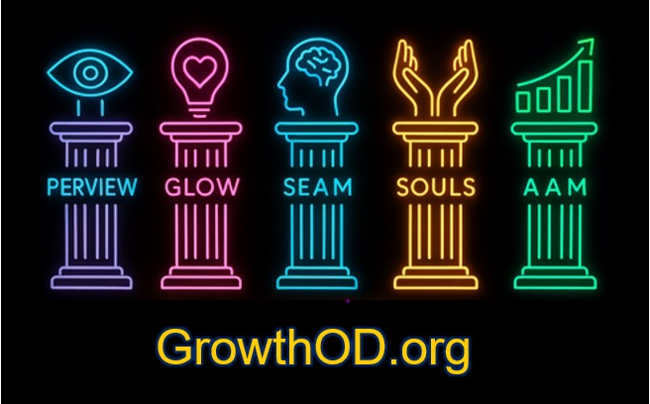
- SOULS – Self-Organizing, Understanding, Leadership Systems (ensemble leadership)
- SEAM – Socio-Economic Approach to Management (price hidden costs)
- GLOW – Gratitude-Led Organizational Wisdom (emotional capacity for paradox)
- PERVIEW – Processes of Embodied Restorying & VIEW (iterative restorying)
- AAM – Auxiliary Assumptions Method (test what you’re taking for granted)
Together, they move you from controlling the story to conducting the dialogue. You’ll see how case organizations—ranging from worker-driven supply chains to a music legend’s late-career revival—escaped monologic routines and found momentum through polyphony (many valid voices) and diachrony (change across time).
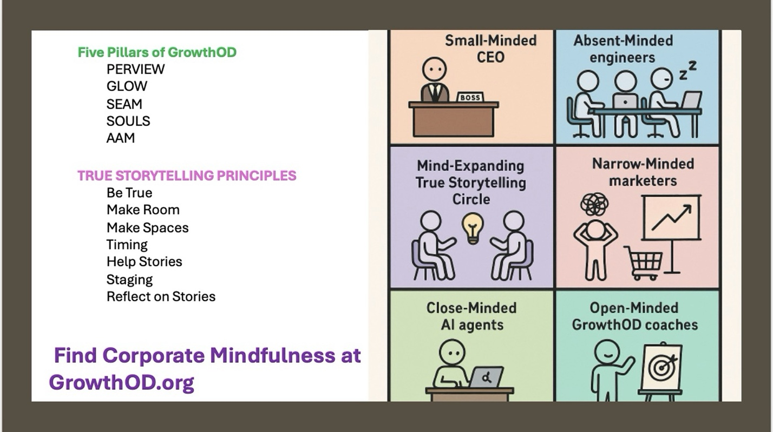

How? Do Find Out about POLYPHONY interventions with GrowthOD.org
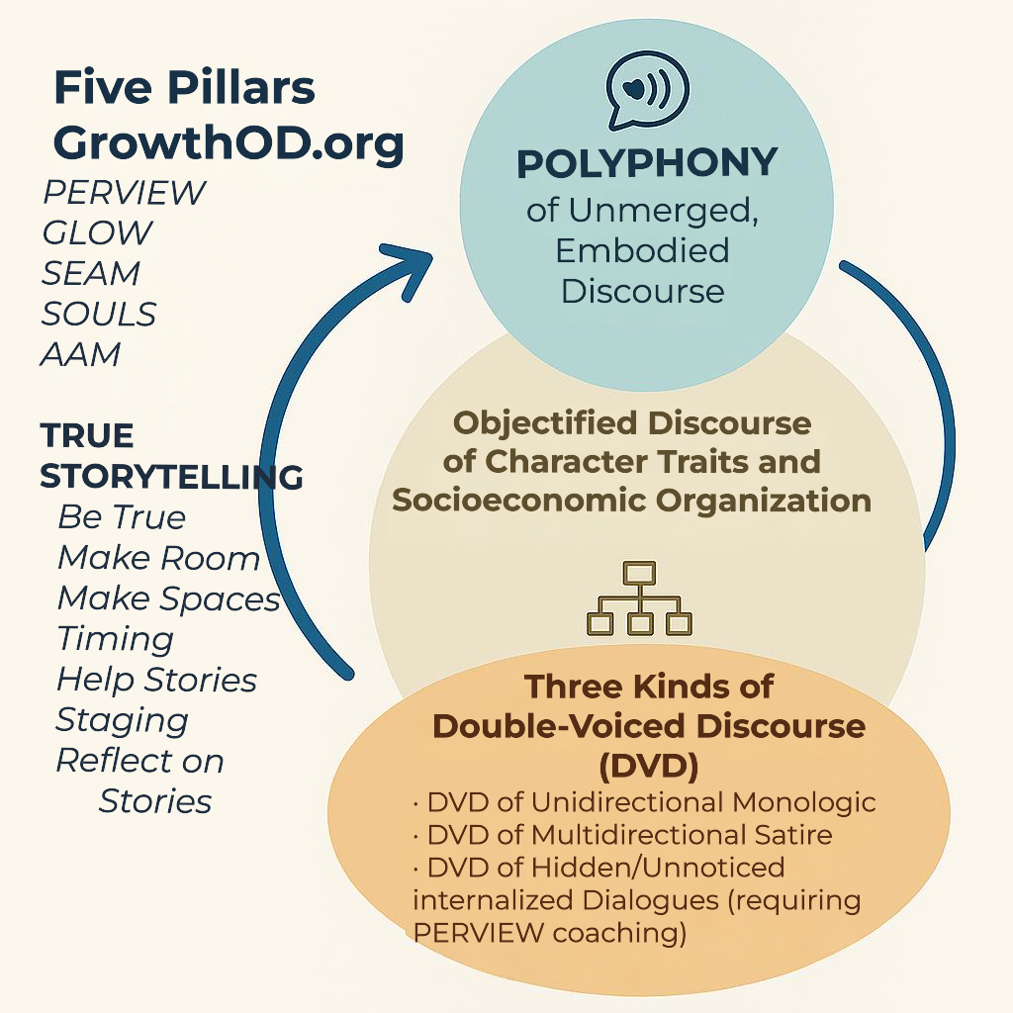
50% of your organizational ICEBERG problems are below the surface
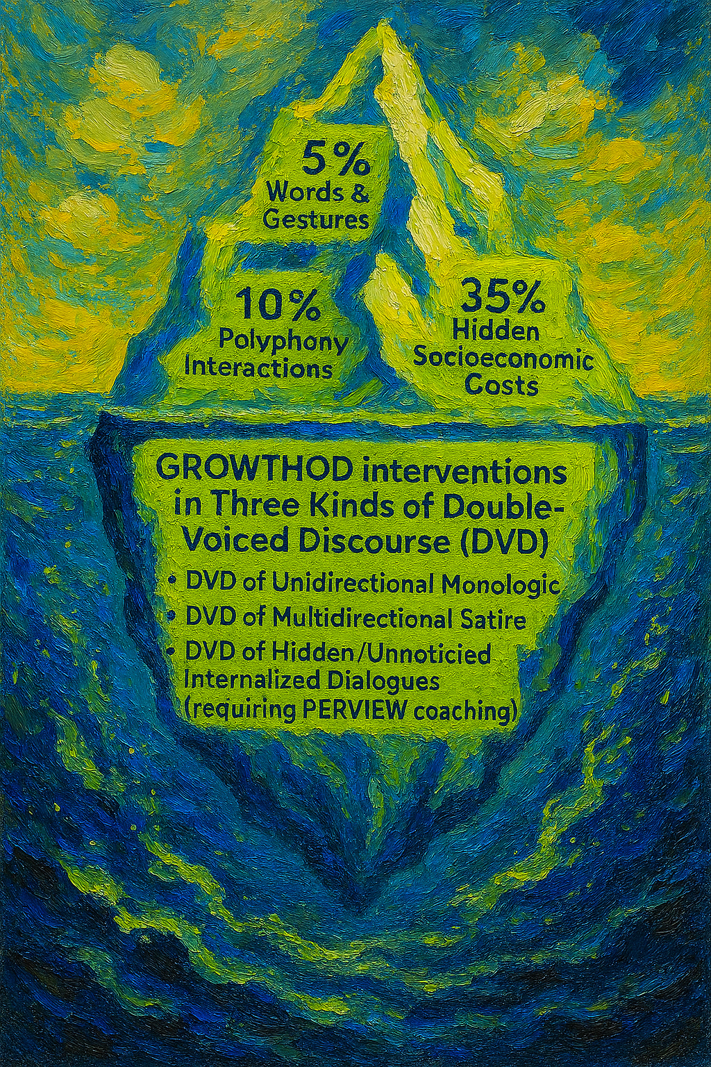

Who this is for
- OD/Change practitioners who want usable tools (not just theory).
- Executives who suspect “alignment” is masking fear or fatigue.
- Coaches and facilitators who build safe rooms where truth can land.
- Scholars testing new ways to measure the value of voice and time.
How to use this book
- Every chapter opens with a quick orientation and closes with a fieldbox: actions to try next week, measures to watch, and pitfalls to avoid.
- Reuse the 2×2 Voice × Time map. If a practice is monologic–synchronic (one voice, one moment), layer in polyphonic–diachronic counterweights (many voices, over time).
- Treat the stories as patterns, not prescriptions. Adopt and adapt.
This is not a script. It’s a score. Your job isn’t to force harmony; it’s to organize the great dialogue so dissonance can be heard and transformed into music.
What I’ve learned is that organizations are not machines or monoliths. They are living symphonies of voices, stories, and tensions. True transformation doesn’t come from dictating a single truth. It comes from hosting the messy, ethical, and creative process of polyphony—what Mikhail Bakhtin called the coexistence of many voices, each with its own story and authority.

The Echo Chamber vs. the Symphony
The dominant paradigm in Organizational Development (OD) is what I call Synchronic Monologic OD. It snapshot-diagnoses the present, erases historical complexity, and enforces a single narrative. It’s efficient—but fragile. It may appear orderly, but under the surface, it generates resentment, fear, and disengagement. Voices are puppeteered. Hierarchies are disguised in soft language. Dissent is edited out before it can be heard.
To break out of the echo chamber, we need more than critique—we need a practice. That’s where True Storytelling and GrowthOD converge not as rival frameworks but as complementary philosophies for transforming organizational life through story, voice, and system design.

- Polyphonic Storytelling in Your Embodied Voice | Exclusively toward its referential object, told with plurality of unmerged voices and consciousness, a genuine polyphony of fully valid voices with equal rights and each with its own worldhood (Para. Mikhail Bakhtin, 1984: 6, 199).
- Storytelling that Objectifies another person or another organization’s living story | - Storied using predominance of socio- gendered-, racial-, economic-, or political-typical traits or values  - Storied with predominance of individually characteristic determined traits or values | Spectrum of various degrees of Storied-Objectification in #1 and #2 ; Can Become I. Polyphonic when de-objectified together-telling occurs (Rosile, Boje, & Claw, 2018 Ensemble Leadership).
- Three kinds of Double-Voice-Storytelling (DVS): Your story slant toward someone else’ story | - Unidirectional DVS  - Stylizes other’s story  - Narrates other’s story  - Unobjectified, but carries out teller’s intention | Can Become I. Polyphonic when there is a storytelling circle fusion of voices toward polyphony
 | - Vari-directional DVS  - Parody/Satirizes other’s story  - Parodistic narration  - Retells discourse of a character who is parodically represented  - Uses another’s words from their story shifting accent/meaning | Can Become I. Polyphonic when objectification is reduced and other’s ideas become internally dialogized and tend to become two storied voices of the polyphonic type.
 | - Internalized Dialogue of stuck story with living story (requires PERVIEW or GLOW)  - Hidden Internal Polemic  - Polemically colored self-story  - Any self-story with sideward glance at someone else’s authority  - An internal critic, internal saboteur, internal ego of self-story  - Other unconscious hidden self-dialogue | Can Become Polyphonic when one’s internalized storytelling unleashes Little Wow Moments into a New Story of the Self (PERVIEW, & GLOW)

From Theory to Practice: Five Pillars Meet Seven Principles
Each principle challenges us to lead with authenticity, inclusion, and ethical timing. But to operationalize these principles, we need infrastructure—a way to move from storytelling as a method to storytelling as an organizational design.

That’s where the five pillars of GrowthOD come in:

1. SOULS – Self-Organizing, Understanding, Leadership Systems
True Storytelling begins with being true—not just as individuals, but collectively. SOULS helps organizations embed shared authorship and ensemble leadership into their structure. It transforms “leadership” from a solo act to a distributed practice. To make room and make spaces, we need systems that invite every voice into the room and empower them to co-author the future.

2. SEAM – Socio-Economic Approach to Management
Truth without consequence is a whisper in the wind. SEAM gives voice weight. It identifies and monetizes the hidden costs of narrative dysfunction—burnout, disengagement, ignored stories. If we want stories to stick, they must translate into structural change. SEAM makes this possible by linking story to accountability. This pillar aligns with the principle "Reflect on the Stories"—but insists that reflection must drive reform.

3. GLOW – Gratitude-Led Organizational Wisdom
GLOW is the emotional intelligence of the system. It holds space for paradox, contradiction, and uncertainty. As the principle “Have Timing” reminds us, truth does not always arrive on schedule. GLOW teaches us to sit with ambiguity—to resist premature conclusions and allow stories to unfold at their own ethical pace. It fosters emotional safety so that voices don’t just speak—they resonate.

4. PERVIEW – Processes of Embodied Restorying and VIEW
Stories aren’t static; they evolve. PERVIEW supports the iterative development of organizational narrative, not as branding but as co-created meaning-making. It aligns with the principle "Help Stories Along"—facilitating dialogic experimentation, antenarrative sensemaking, and storied feedback loops. PERVIEW is where polyphony becomes process: a continuous, embodied unfolding of truth-in-practice.

5. AAM – Auxiliary Assumptions Method
Finally, AAM disrupts dogma. It asks: What assumptions are we hiding behind? Whose truths are being left unquestioned? To stage and reflect on stories, we must challenge the foundation they stand on. AAM tests the scaffolding of belief that undergirds organizational reality. It empowers us to change the stories not just by telling new ones, but by unlearning old ones.

A Practitioner’s Invitation
If you are a change agent, OD consultant, team leader, or CEO: this book is for you.
But let me be clear—this is not a toolkit of quick fixes. It’s a symposium of tensions. It invites you to shift from asking, “How do I get buy-in for my story?” to asking, “How do we host the stories already living in this system?”
Each chapter blends theory with story, reflection with praxis. It applies the seven True Storytelling principles through the GrowthOD lens. It offers heuristics, cases, and propositions—not as rules, but as invitations to experiment.
You’ll read about Walmart’s ghost of Sam Walton—a textbook case of authorial puppetization—and contrast it with the Coalition of Immokalee Workers, where shared leadership and structural integrity create real transformation. You’ll explore how Johnny Cash’s late-career revival wasn’t just a musical comeback—it was a case in restorying through polyphony.

The Role of the Practitioner: From Author to Conductor
As a practitioner, your role is changing. You are no longer the sole author of organizational truth. You are the conductor of polyphonic dialogue. You don’t impose the melody—you orchestrate it. You create the conditions for resonance, dissonance, and ultimately, harmony—not through control, but through courageous listening.
This book is a guide to that practice. It’s not about perfection—it’s about participation. It’s about choosing to host complexity rather than pretend it doesn’t exist. It’s about moving beyond the echo chamber, where stories echo back only what’s already known—and toward the open, unfinished symphony of polyphonic change.
Implications for OD Practice
- Design for Ensemble Leadership (SOULS): Shift leader roles from “author of the last word” to organizer of the great dialogue; formalize rotating facilitation and shared authorship (Rosile et al., 2018).
- Price the Gap (SEAM): Diagnose and monetize hidden costs of narrative–reality decoupling to compel structural change (Savall & Zardet, 2008; Savall et al., 2024).
- Cultivate Dialogic Capacities (GLOW): Train in gratitude-led listening, paradox holding, and story-eliciting to sustain non-finalizing conversation (Boje & Parr-Rud, 2025).
- Institutionalize Restorying (PERVIEW): Embed antenarrative mapping and embodied restorying cycles in governance and project reviews (Boje, 2014).
- Routinize Falsification (AAM): Make auxiliary assumptions explicit in plans; schedule tests and precommit to responses (Trafimow, 2024).

Reframing Five Mainstream OD Approaches
The five approaches, viewed synchronically, would tend to (a) centralize diagnosis and control, (b) stabilize narratives prematurely, and (c) suppress heteroglossia:
- Traditional Diagnostic OD: Addresses observed symptoms but often misses the narrative production of reality and its hidden costs (Boje, 2001; Savall & Zardet, 2008).
- Lewin’s Model: Useful for bounded changes but risks freezing monologic stories (Lewin, 1951; Prosci, 2025).
- Planned Change: Drives linear alignment, potentially erasing counter-narratives that hold critical intelligence (Van de Ven & Poole, 1995; Boje, 1995).
- Dialectical Theory: Elevates synthesis, subordinating difference to a dominant resolution (Van de Ven & Poole, 2005).
- Strategic Planning: Codifies control and consensus, limiting polyphonic emergence (Demarest & Schoof, 2011; Boje, 2014).
GrowthOD complements—not rejects—these traditions by reorienting practice toward dialogic polyphony and structural accountability.

Let’s begin.
— David Boje

Introduction: Beyond the Echo Chamber – A Polyphonic and Diachronic Symphony for Organizational Development
Our Answer to How to Intervene in Echo Changes of Organizations by combining Growth OD Five Pillars with True Storytelling Seven Principles.
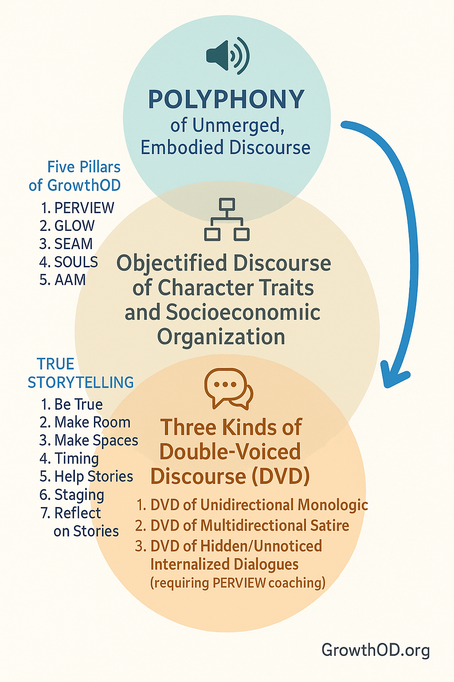
From Snapshots to Symphonies: A Practical Map
Traditional OD often works like photography: diagnose, plan, roll out, measure. It’s efficient—and fragile. Snapshots miss what matters most: the unresolved conversations, the long memory of prior change, and the future we’re already rehearsing in small, everyday choices.
This book reframes OD as conducting a symphony across time. We’ll use a simple map:
- Voice axis: Monologic (one dominant narrative) ⟶ Polyphonic (many valid voices)
- Time axis: Synchronic (point-in-time) ⟶ Diachronic (unfolding across time)
TIME
Diachronic Synchronic
VOICE
Poly- Dialogic OD, AI summits and
phonic Action Research,story circles
GrowthOD (episodic bursts)

Mono- Planned Snapshots, audits,
logic transformations one-way training
Why does this matter?
- Performance: You can’t sustain change if your story and your structures drift apart. SEAM reveals the hidden cost of that drift.
- Inclusion: People commit to what they co-create. SOULS moves leadership from solo to ensemble.
- Learning: Premature “closure” kills innovation. PERVIEW keeps narratives productively open.
- Resilience: Paradox is the new normal. GLOW builds the capacity to hold it without splitting teams.
- Rigor: Assumptions drive failure silently. AAM brings them into the light and puts them to the test.
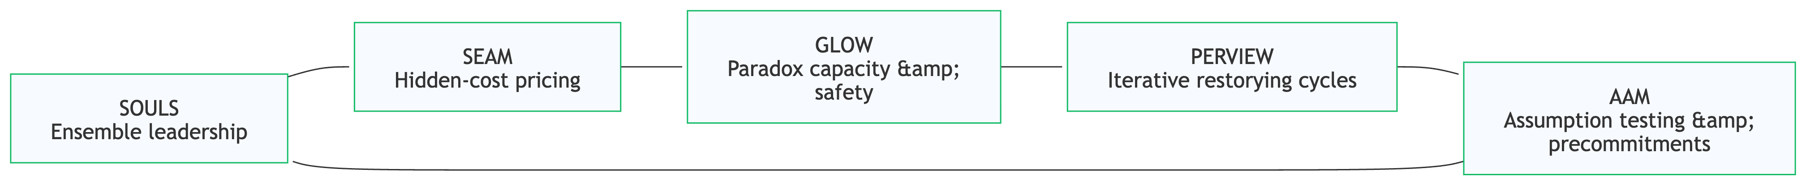
What you’ll get
- Tools you can run (risk maps, polyphony radar, story sprints, hidden-cost scans).
- Cases from corporate, civic, and movement contexts (e.g., CIW’s worker-driven model).
- Heuristics that translate theory into action in meetings, offsites, reviews, and town halls.
Promise of this approach
- Fewer rollout shocks. More rhythm.
- Fewer “resisters.” More co-authors.
- Fewer slogans. More consequential dialogue.
Let’s move from echo chambers to ensembles.
Organizations are not static machines but living symphonies—vibrant ensembles of voices, stories, and temporal flows weaving through human, non-human, and planetary threads. Yet, mainstream Organizational Development (OD) too often confines this symphony to a monologic echo chamber, where a single, authoritative narrative drowns out diversity and freezes change in synchronic snapshots.

This book, Beyond the Echo Chamber: A Polyphonic and Diachronic Symphony for Organizational Development, challenges scholars and practitioners to break free from these constraints, embracing a dynamic, inclusive approach rooted in True Storytelling’s seven principles and GrowthOD’s transformative pillars: SOULS, SEAM, GLOW, PERVIEW, and AAM.

Through a 2×2 framework of voice (monologic to polyphonic) and time (synchronic to diachronic), this work critiques traditional OD’s limitations, reimagines organizational change as a multispecies, ethically grounded symphony, and offers actionable pathways for fostering resilience, authenticity, and sustainability.

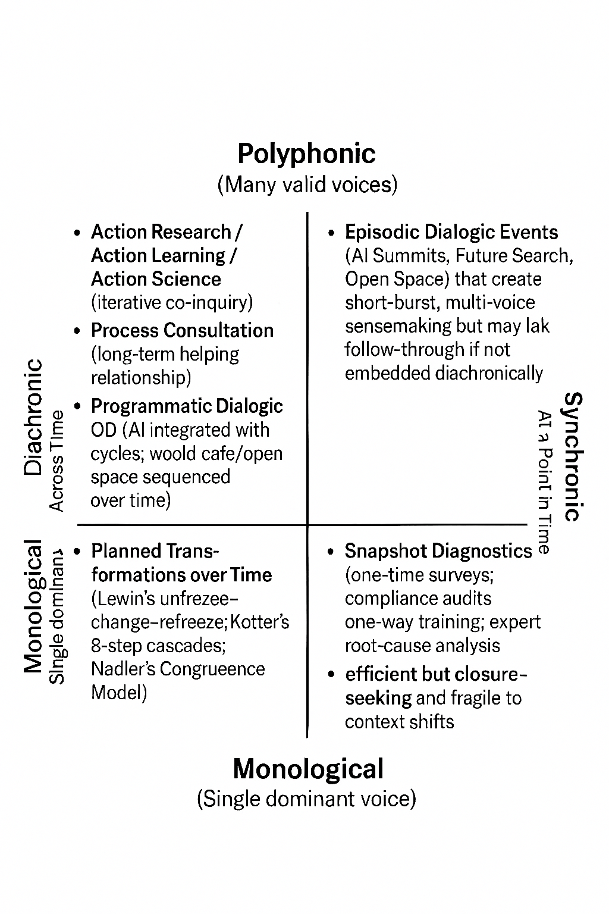
 | Diachronic (Across Time) | Synchronic (At a Point in Time)
Polyphonic (Many valid voices) | Action Research / Action Learning / Action Science; Process Consultation (Schein); Dialogic OD programs; GrowthOD pillars as ongoing practices (Gallos, 2006; OD Network, n.d.; Schein, 1997). | Episodic dialogic events (AI Summits, Future Search, Open Space) that surface multivoice sensemaking in the moment—effective but fragile without a diachronic spine (Bunker & Alban, 2006; OD Network, n.d.).
Monological (Single dominant voice) | Planned transformations over time (Lewin’s stages; Kotter’s 8-step; Nadler’s Congruence) executed via leader/expert-authored scripts (Burnes, 2007; Gallos, 2006). | Snapshot diagnostics and one-way training (single-wave surveys, compliance audits) that seek rapid clarity and closure (Gallos, 2006; Schein, 1997).

Traditional OD, with its roots in diagnostic models, Lewin’s (1951) linear change frameworks, Kotter’s (1995) planned change steps, dialectical resolutions, and strategic planning, often imposes a rigid score. These approaches prioritize control, equilibrium, and singular narratives, sidelining the polyphonic voices of workers, communities, and the planet itself, while ignoring the diachronic currents of historical and future-oriented storytelling (Gallos, 2006; Burnes, 2007). Such monologic, synchronic practices cast shadows—static biases, premature closures, and ideological reductions—that clash with the ethical and sustainable imperatives of our era (Bakhtin, 1984; Larsen et al., 2021).

Integrated OD Approaches by Voice × Time
 | Diachronic (Across Time) | Synchronic (Fixed/Episodic)
Polyphonic (Multi-voice, Dialogic) | • Action Research / Action Learning / Action Science—iterative, participatory cycles of inquiry and change (featured in Gallos Reader, chs. 7–8).  • Process Consultation (Schein)—ongoing helping relationship that enables the client system to perceive, understand, and act on process events over time.  • Appreciative Inquiry (AI)—strengths-based 4-D cycle; dialogic mindset oriented to ongoing, generative change  • Large-Group Interventions (e.g., Future Search/Open Space/World Café) used as part of longer dialogic programs to sustain emergent, multi-voice change.  • Dialogic OD mindset—emphasizes continuous, emergent change via narratives and generativity (contrasted with diagnostic OD  • GrowthOD Pillars (PERVIEW, SEAM, SOULS, GLOW, AAM) embedded as ongoing, systemic practices to institutionalize polyphony  • 777 Antenarrative/True Storytelling/ERP—multi-voice restorying and ethical reflection across time. | • AI Summits / Episodic Dialogic Events—multi-voice gatherings that occur at a point in time yet are dialogic (often nested within longer journeys).  • Large-Group Events as Episodes (Future Search, etc.)—polyphonic but bounded in time; “episodic vs. continuous” forms noted in dialogic OD literature. • Multivoice Survey Feedback (single wave)—feedback is shared broadly, enabling collective sensemaking at one time slice.
Monological (Single-voice, Top-down) | • Leader-driven Transformation Programs (e.g., Kotter’s 8-Step)—typically leadership-authored vision cascaded over time  • Planned Change via Diagnostic Models—extended, expert-led roadmaps (e.g., Nadler’s Congruence Model) pursued across phases  • Top-down policy/program rollouts over time (e.g., staged reorgs, mandated culture initiatives | • Performance Appraisals / Compliance Audits—standardized, one-way assessments at fixed intervals.  • One-way Training / Briefings—information push without dialogic design  • Diagnostic Snapshots (single-time surveys; expert root-cause analyses) used to prescribe change.

In contrast, True Storytelling’s principles—Be True, Make Room, Make Spaces, Have Timing, Help Stories, Consider Staging, and Reflect—offer a vibrant score for orchestrating change. These principles, amplified by GrowthOD’s pillars, invite organizations to embrace unmerged voices, iterative narratives, and sociomaterial entanglements, fostering transformations that resonate across time and species.This book unfolds across seven chapters, each reframing one of True Storytelling’s principles through GrowthOD’s polyphonic and diachronic lens, grounded in a 2×2 framework of voice and time.

Chapter 1 explores Principle 1, “Be True,” through Johnny Cash’s revival with Rick Rubin, illustrating how authenticity aligns actions with sustainable values.
Chapter 2, on Principle 2, “Make Room,” draws on Danish producer Lars Skaerbaek’s collaborative studio to show how amplifying diverse voices fosters inclusivity.
Chapter 3, addressing Principle 3, “Make Spaces,” highlights the Coalition of Immokalee Workers’ Fair Food Program, demonstrating empathetic spaces for ethical narratives.
Chapter 4, centered on Principle 4, “Have Timing,” contrasts Walmart’s monologic echoes with polyphonic cases like Novo Nordisk’s kairotic pivots, emphasizing temporal attunement.
Chapter 5, exploring Principle 5, “Help Stories,” weaves cases from Danish police recruitment to craft schools, showing how dialogical experiments nurture living story webs.
Chapter 6, on Principle 6, “Consider Staging,” animates scenographies from Roskilde’s Rock Museum to indigenous hikes, staging multispecies futures.
Finally, Chapter 7, on Principle 7, “Reflect,” uses cases like CIW’s qualimetrics to underscore value-reflective praxis for planetary accountability.

For scholars, this book proposes a research agenda through testable propositions, such as how polyphonic-diachronic practices enhance resilience (Chapter 1, Proposition 1) or how SEAM’s hidden cost pricing mediates sustainable outcomes (Chapter 2, Proposition 2). These propositions draw on Bakhtin’s polyphony (1984), Barad’s spacetimemattering (2007), and Bennett’s vital materiality (2010), inviting rigorous exploration of OD’s ethical and temporal dimensions. For practitioners, each chapter offers heuristics—diagnosing temporal stances, amplifying marginalized voices, pricing hidden costs, and staging antenarrative bets—to operationalize GrowthOD’s pillars in real-world settings.

These tools, grounded in Action Research (Schein, 1997) and dialogic OD (OD Network, n.d.), empower change agents to conduct symphonies of collective agency.

The narrative cases—from Cash’s raw recordings to CIW’s worker-driven councils—illustrate the transformative power of polyphonic, diachronic approaches, contrasting sharply with monologic failures like Walmart’s spectral frugality (Boje & Rosile, 2008). These stories, enriched by Danish municipal reforms, Novo Nordisk’s urban health initiatives, and indigenous ceremonial practices, reveal how organizations can surf entangled temporal waves, aligning with multispecies ethics. By integrating True Storytelling and GrowthOD, this book charts a path beyond the echo chamber, where organizations become resilient, inclusive symphonies, co-creating futures that honor human, non-human, and planetary voices.

Here is the contribution the Beyond Echo Chambers book makes to OD.
We ask this question: How do the GrowthOD five pillars and each of the seven principles of "true storytelling" do their best intervention in Bakhtin 's (1984) 'Problems of Dostoevsky’s poetics', p. 199, classification of
  - I. "Direct Unmediated Discourse (polyphony),
  - II. "Objectified Discourses of a predominantly individual traits, and or organizational socio-economic type, and the three types of "Double-Voiced Discourses" (DVD):
  - III.1 "Unidirectional DVD unobjectified discourse",
  - III.2 "Vari-Directional DVD that is satirical, paralogical", and
  - III.3 "Hidden DVID reflecting discourse of another in internalized dialogue"?

Our answer: The GrowthOD framework, with its five pillars, and the Seven Principles of True Storytelling are explicitly designed as a dialogic, polyphonic alternative to traditional monologic organizational development (OD) approaches. They intervene in Bakhtin’s classification of discourse by ensuring that multiple, unmerged voices are validated and sustained, rather than being suppressed or assimilated, which is the failure point of monologic systems.
Specifically, the GrowthOD pillars and True Storytelling principles address Bakhtin’s (1984: 199) classification by fostering authentic Direct Unmediated Discourse (Polyphony) (I), challenging the rigidity of Objectified Discourses (II), and ensuring Double-Voiced Discourses (DVD) (III) are challenged to reveal unmediated Polyphony rather than masking it through Monological orchestrated control.
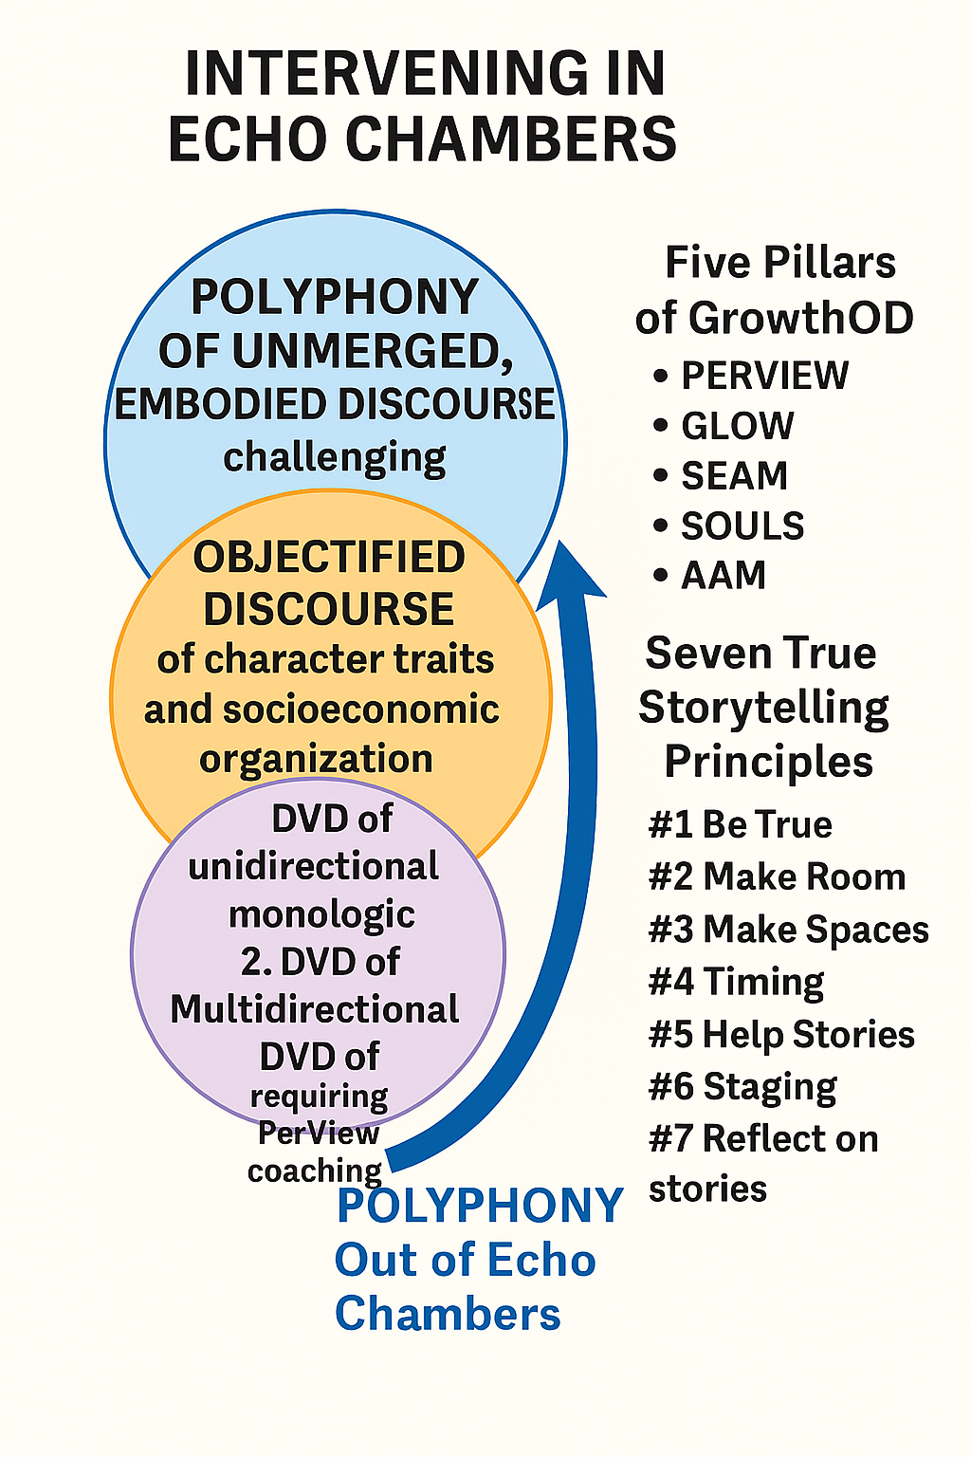

Here is the breakdown of how the GrowthOD five pillars and True Storytelling principles enact their best intervention across Bakhtin's (1984: 199) categories:
--------------------------------------------------------------------------------
I. Intervention in Direct Unmediated Discourse (Polyphony)
Direct Unmediated Discourse refers to the ideal state of polyphony, defined as the coexistence of multiple autonomous voices that do not merge into a single authorial truth. GrowthOD and True Storytelling do not intervene to correct this type of discourse, but rather to cultivate and institutionalize it as the foundation of the organization.
GrowthOD Pillar | Intervention Aim | True Storytelling Principle | Intervention Aim
SOULS (Self-Organizing–Understanding–Leadership Systems) | Institutionalizes polyphony by promoting shared authorship and ensemble leadership, shifting the leader from "author of the last word" to the "organizer of the great dialogue". This ensures independent voices emerge and coexist. | Second Principle: Make room (for the other and the new story) | Stresses creating space for diverse voices and emerging narratives by fostering inclusivity and psychological openness, ensuring new collective truths can emerge without top-down agendas.
GLOW (Gratitude-Led Organizational Wisdom) | Cultivates the emotional and relational capacities necessary to hold paradox and plurality, sustaining the unmerged quality of polyphony without forcing closure. | Third Principle: Make spaces (respecting the stories already there) | Emphasizes designing environments (physical, emotional, cultural) that honor pre-existing stories, preventing the erasure of marginalized narratives and ensuring new polyphonic voices are grounded in empathy.
PERVIEW (Processes of Embodied Restorying and VIEW) | Explicitly supports unfinalizability of narratives. This prevents the collapse of diverse, coexisting discourses into a singular, frozen truth.
--------------------------------------------------------------------------------
II. Intervention in Objectified Discourses
Objectified Discourses include those related to rigid organizational socio-economic systems or individual traits. Monologic approaches often rely on these (e.g., Strategic Planning favors control and consensus), which can lead to the polyphony error of Reduction to Ideology. GrowthOD intervenes by demanding systemic accountability to de-objectify and test fixed beliefs.
GrowthOD Pillar | Intervention Aim | True Storytelling Principle | Intervention Aim
AAM (Auxiliary Assumptions Method) | Directly counters the Reduction to Ideology error by requiring the explicit surfacing, testing, and falsification of auxiliary assumptions. This prevents complex social reality from being reduced to a rigid, deterministic system. | Seventh Principle: You must reflect on the stories (and how they create value) | Calls for ongoing reflection and self-correction to evaluate narratives' actual impacts across ethical, social, environmental, and economic dimensions, refining future practice based on real outcomes, not just ideology.
SEAM (Socio-Economic Approach to Management) | Intervenes by providing a rigorous diagnosis of hidden costs to force alignment between organizational rhetoric (objectified discourse/ideology) and lived reality. It converts dialogic insight into economic accountability, compelling structural solutions over merely rhetorical ones. | Fifth Principle: You must be able to help stories on their way (and be open to experiment) | Encourages active facilitation and experimentation (re-storying). This iterative process counters the stability and closure inherent in objectified discourses by allowing stories to evolve organically.
--------------------------------------------------------------------------------
III. Three Interventions in Double-Voiced Discourses (DVD)
Bakhtin's Double-Voiced Discourse (DVD) involves an utterance carrying two semantic intentions, oriented both toward its referential object and toward another's discourse. Monologic systems, such as Wal-Mart's use of the "Specter of Sam Walton," often use DVD as an "orchestrated dialogism" to control meaning, ventriloquizing one voice (the founder) to enforce another (the corporate agenda). GrowthOD intervenes to ensure DVD is used to reveal reality and build collective power. There are three types of DVD in Bakhtin (1984: 199) breakdown.
III.1 Unidirectional DVD unobjectified discourse
This involves an utterance aligned with the direction of the other's discourse, often affirming or adopting it. When corrupted, this becomes the polyphony error of Authorial Puppetization, where stakeholder voices are used instrumentally to validate preset agendas.
• SOULS Intervention: Institutionalizes shared authorship to ensure every voice is treated as equally valid. By centering collective intelligence and ensemble leadership ("We are all leaders"), SOULS counters the practice of selecting only "certain pearls of dead Mr. Sam’s wisdom" to discipline dissent.
• First Principle: You yourself must be true: This foundational principle focuses on personal authenticity and ethical alignment. By demanding alignment with core values, it discourages the adoption of unauthentic discourses merely to validate a top-down agenda.
III.2 Vari-Directional DVD that is satirical, paralogical
This type of discourse contains tension, conflict, or critique, where the second voice actively challenges the primary voice. Monologic systems suppress this tension via Moralizing Monologism, reducing complex tensions to right-wrong binaries and suppressing paradox.
• GLOW Intervention: Directly addresses this by building the capacity to hold paradox and sustain dialogic tension. It uses story-eliciting practices that actively surface discomfort and difficult truths, preventing simplification and binary closure (e.g., Wal-Mart framing itself as a "Good Citizen" to mask predatory capitalism).
• Fourth Principle: You must have timing: This principle emphasizes the intuitive, relational rhythm needed to align interventions with stakeholder readiness. This relational awareness is crucial for navigating critical or satirical discourse constructively without letting rushed or mistimed efforts undermine sustainability or lead to premature closure.
III.3 Hidden DVID reflecting discourse of another in internalized dialogue
This occurs when the reflection of the other’s discourse is deeply embedded in the speaker’s own word, often remaining in an internalized state. Monologism encourages this by breeding silence and conformity, forcing unaddressed complexities to remain internalized. This relates closely to the error of Neglect of Unfinalizability.
• PERVIEW Intervention: Unfinalizes the narrative by ensuring the organization remains a "site of dialogic tension". By embedding antenarrative inquiry and iterative restorying, PERVIEW provides methods to surface and engage with pre-narrative fragments and internal tensions, resisting the premature stabilization of contested narratives that would otherwise remain hidden.
• Sixth Principle: You must consider staging (including scenography and artefacts): This principle addresses the performative aspects of storytelling. By thoughtfully curating environments and media, the "stage" helps to externalize and amplify the true story’s impact, ensuring that hidden realities and internalized dialogues (which generate material consequences like hidden costs and disengagement) are engaged multisensorially for deeper buy-in.

Welcome to the 777 Framework

The 777 Framework—a holistic approach integrating three robust methodologies to help you transform your narratives and, in turn, your life and work.
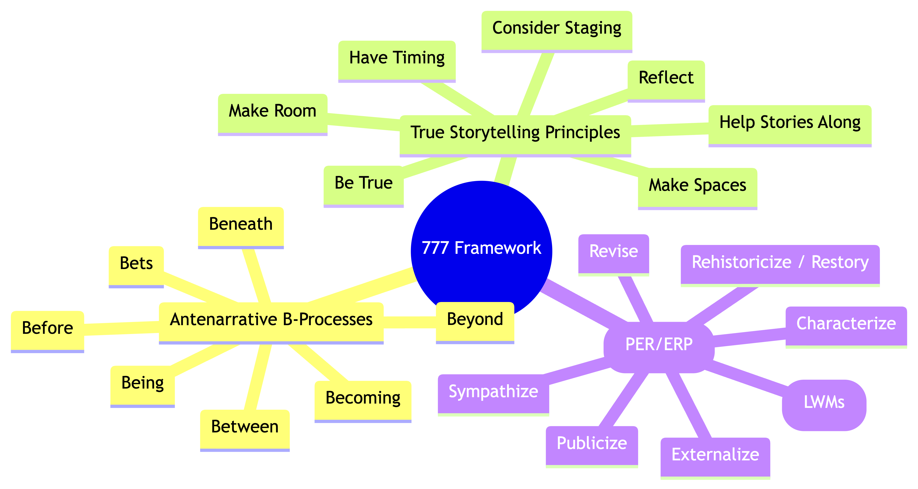
“777 Framework," a holistic organizational and personal change process developed by David Boje. The framework combines three interrelated sets of seven elements:​
- 7 Antenarrative B-Processes: These are ways to uncover hidden, pre-narrative patterns within stories, exploring what occurs "before" stories take shape.
7 Antenarrative B-Processes
Beneath – Unconscious story filters and projections.
Before – The origins of subconscious story filters.
Bets – Choosing future possibilities with uncertainty.
Being – Living in the present, interwoven with past and future.
Becoming – Transforming by gathering 'Little Wow Moments'.
Between – Navigating the four WHO identities.
Beyond – Moving past limiting narratives to expansive potential.

- 7 True Storytelling Principles: Core guidelines for grounding narratives in truth, ethics, and authentic purpose.
7 True Storytelling Principles
Truth – You must be true and prepare the energy and effort for a sustainable future.
Make Room – True storytelling makes spaces respecting the stories already there.
Plot – You must create stories with a clear plot, creating direction and helping people prioritize.
Timing – You must have timing.
Help Stories Along – You must be able to help stories on their way and be open to experiment.
Staging – You must consider staging including scenography and artifacts.
Reflecting – You must reflect on the stories and how they create value.

- 7 Processes Embodied Restorying (PER) Steps: Practical, embodied techniques to help individuals and organizations rewrite disempowering stories with greater presence and agency.

The Seven Steps of PER-VIEW
- Recharacterize – Examine how the world defines your organization or identity.
- Externalize – Label the problem, making it the problem, not you as the problem.
- Sympathize – Understand the benefits of holding onto the current story.
- Revise – Recognize the negative consequences of this received identity.
- Strategize – Identify Little Wow Moments (LWMs) that challenge dominant narratives.
- Restory – Collect LWMs into a New Story—one that is no longer bound by the past.
- Publicize – Build a support system that reinforces this New Story.
777 Framework Mapping Table
7 Embodied Restorying Process (ERP) Steps are a Cycle -Tool That Repeats in each of the Processes & Principles Above.
- Characterize – Recognize the unconscious patterns shaping perception and identity.
- Externalize – Identify and name the hidden story filters affecting decision-making.
- Sympathize – Understand the function these filters have served in personal history.
- Revise – Challenge and modify limiting beliefs and past assumptions.
- Strategize – Find 'Little Wow Moments' as foundations for a new story.
- Rehistoricize – Rewrite past experiences with a broader, more empowering perspective.
- Publicize – Share the new story with a community to reinforce transformation.

Each step in the Embodied Restorying Process acts as a bridge between antenarrative processes and the true storytelling principles, supporting self-correcting cycles and deep transformation. The 777 Framework is positioned as a tool for those feeling "stuck in a story" or seeking to reshape organizational or personal narratives toward empowerment and authenticity.​
Coaching Questions: Find Your Own Story Filters
- 🔹 Why do you tell your story the way you do?
- 🔹 What limiting beliefs might be shaping your narrative?
- 🔹 How do you separate truth from illusion?
- 🔹 What if you could change the story and step into something greater?
These are the questions that lead to transformation.
What If This Could Change Everything?
- What if you finally understood the hidden patterns in your storytelling?
- What if you could rewrite your narrative to align with your true purpose?
- What if you had the tools to help others do the same?
This is what the 777 framework offers. A structured yet flexible path for navigating truth, illusion, and transformation.
Next Steps: Start Your 777 Journey Today
- Enroll in a True Storytelling Course – Learn directly from experts at TrueStorytelling.org.
- Explore Resources & Case Studies – Deepen your knowledge at CSIStory.com.
- Join a Restorying Circle – Experience transformation in community at DavidBoje.com.
The story you tell yourself matters. It shapes your world.
Are you ready to step into a new story—one of truth, purpose, and transformation?
Begin your journey today! Go to https://GrowthOD.org to sign up for consulting and coaching sessions.
777 Three Nexus of 7777 facets each which I have been involved with from many years - David Boje Ph.D.
Chronology: The seven ‘embodied storytelling processes’ (ERP) steps by David Boje and Grace Ann Rosile were developed in 1994, and are used in each of the ‘seven Antenarrative B-processes’ since 2001 https://antenarrative.com, and are used in the ‘seven true storytelling principles” by Jens Larsen, David Boje, and Lena Bruun (2020) and by another co-founder, Jim Sibel, since 2022, when the four of wham founded True Storytelling Institute’ https://truestorytelling.org. At https://CSIstory.com the 777 is used as follows. The 7 ERP steps are doinww ithing each of the 7 B's of Antenarrative, and the 7 principles of True Storytelling are general principles.
777 Nexus awaits you.

Workshops, master classes, and coaching programs based on this framework are available, including introductory free training and paid interactive sessions for entrepreneurs and teams seeking organizational transformation. The method is described as connecting narrative change with quantum storytelling theory and triple-loop learning, enabling participants to "rewrite their future" and create meaningful, impactful transformations.​
For more detail or to join programs, the site suggests contacting David Boje directly.​
How are 777 diachronic and polyphonic organization development and what approaches are the synchronic and monological
The 777 Framework in organization development is diachronic and polyphonic through its emphasis on ongoing, multi-voiced change processes that unfold over time and through different narrative and communication patterns. In contrast, synchronic and monological approaches focus on stability, uniformity, and single-voiced control at a specific point in time.​
Diachronic and Polyphonic in 777
- Diachronic refers to development across time, integrating past, present, and future through evolving stories and learning cycles.​
- Polyphonic organization cultivates many simultaneous voices, codes, and perspectives, connecting to several function systems without a fixed hierarchy. In 777, this means using multiple antenarrative processes and storytelling principles, allowing diverse participation and new meanings to emerge.​
Synchronic and Monological Approaches
- Synchronic approaches examine organization at a fixed stage, focusing on current structure, roles, and meanings but not how these evolve.​
- Monological organization enforces single-authority communication, where meanings and rules are predetermined by management or bureaucracy, with little room for dialogue or emergence. Change is typically imposed and rigid, emphasizing routine reproduction of existing assumptions and scripts.​
Comparative Table
Dimension | Polyphonic/Diachronic (777) | Monological/Synchronic
Voice | Multiple, co-creating, dialogic​ | Single, top-down, predetermined​
Time Orientation | Evolution over time, stories unfolding​ | Fixed stage, emphasis on current status​
Change Process | Emergent, self-organizing, participative​ | Structured, routine, controlled​
Core Example | 777 ERP, True Storytelling, dialogic OD | Bureaucracy, classical management​
Polyphonic, diachronic development as found in 777 leads to richer, more adaptive organizations, while synchronic, monological approaches are useful for stability and control but risk stifling innovation and inclusion.​
Populate the two by two table with 777 approaches and the give pillars of GrowthOD and 10 approaches that are monologue and synchronic organization development practices
Here is a 2x2 table comparing organizational development approaches by voice and time orientation, specifically populated with 777 Framework approaches, GrowthOD's five pillars, and ten examples of monological, synchronic OD practices.​
 | Diachronic (Across Time) | Synchronic (Fixed Time)
Polyphonic | - 777 Antenarrative B-Processes (exploring change through evolving stories)​  - 777 True Storytelling Principles (participation, listening, ethical evolution)​  - 777 Processes Embodied Restorying (PER) Steps (continuous narrative embodiment)​  - GrowthOD Pillars: PERVIEW (restory trauma, burnout), SEAM (recover hidden value), Axiogenics (ethical leadership), GLOW (gratitude/belonging), AAM (assumption rewiring, innovation)​ | - Team retrospectives using shared storytelling​  - Experiential workshops that blend many voices to diagnose current culture​  - Cross-sectional appreciative inquiry summits​  - Multivoice survey analysis at one point in time​  - GrowthOD tailored consults activating diverse team perspectives​
Monological | - Top-down change mandates over time​  - Bureaucratic scripts that evolve through periodic revisions​  - Single-leader vision implementation (plan, then enforce)​  - Episodic reviews led by senior management​ | - Performance appraisals​  - Standardized compliance audits​  - Change imposed by single-source communication​  - Uniform policy rollouts​  - Root Cause Analysis led by experts only​  - Centralized strategic planning summits​  - Bureaucratic routine checklists and forms​  - Robotic Six Sigma/Lean reviews​  - Training programs with no dialogue​  - One-way information sessions​
This makes clear how the 777 Framework and GrowthOD pillars embody polyphonic/diachronic methods focused on ongoing transformation with many voices, while monological/synchronic practices limit participation and focus on fixed, top-down procedures and outcomes.​

David Boje’s DavidBoje.com/777 details the "777 Framework," a holistic organizational and personal change process developed by David Boje, Grace Ann Rosile, and Elior the Poet of Quantum Storytelling. The framework combines three interrelated sets of seven elements:​
- 7 Antenarrative B-Processes: These are ways to uncover hidden, pre-narrative patterns within stories, exploring what occurs "before" stories take shape.
- 7 True Storytelling Principles: Core guidelines for grounding narratives in truth, ethics, and authentic purpose.
- 7 Embodied Restorying Process (ERP) Steps: Practical, embodied techniques to help individuals and organizations rewrite disempowering stories with greater presence and agency.
Each step in the Embodied Restorying Process acts as a bridge between antenarrative processes and the true storytelling principles, supporting self-correcting cycles and deep transformation. The 777 Framework is positioned as a tool for those feeling "stuck in a story" or seeking to reshape organizational or personal narratives toward empowerment and authenticity.​
Workshops, master classes, and coaching programs based on this framework are available, including introductory free training and paid interactive sessions for entrepreneurs and teams seeking organizational transformation. The method is described as connecting narrative change with quantum storytelling theory and triple-loop learning, enabling participants to "rewrite their future" and create meaningful, impactful transformations.​
For more detail or to join programs, the site suggests contacting David Boje directly.​
How are 777 diachronic and polyphonic organization development and what’s approaches are the synchronic and monological

David Boje’s 777 Framework in organization development is diachronic and polyphonic through its emphasis on ongoing, multi-voiced change processes that unfold over time and through different narrative and communication patterns. In contrast, synchronic and monological approaches focus on stability, uniformity, and single-voiced control at a specific point in time.​
Diachronic and Polyphonic in 777
- Diachronic refers to development across time, integrating past, present, and future through evolving stories and learning cycles.​
- Polyphonic organization cultivates many simultaneous voices, codes, and perspectives, connecting to several function systems without a fixed hierarchy. In 777, this means using multiple antenarrative processes and storytelling principles, allowing diverse participation and new meanings to emerge.​
Synchronic and Monological Approaches
- Synchronic approaches examine organization at a fixed stage, focusing on current structure, roles, and meanings but not how these evolve.​
- Monological organization enforces single-authority communication, where meanings and rules are predetermined by management or bureaucracy, with little room for dialogue or emergence. Change is typically imposed and rigid, emphasizing routine reproduction of existing assumptions and scripts.​
Comparative Table
Dimension | Polyphonic/Diachronic (777) | Monological/Synchronic
Voice | Multiple, co-creating, dialogic​ | Single, top-down, predetermined​
Time Orientation | Evolution over time, stories unfolding​ | Fixed stage, emphasis on current status​
Change Process | Emergent, self-organizing, participative​ | Structured, routine, controlled​
Core Example | 777 ERP, True Storytelling, dialogic OD | Bureaucracy, classical management​
Polyphonic, diachronic development as found in 777 leads to richer, more adaptive organizations, while synchronic, monological approaches are useful for stability and control but risk stifling innovation and inclusion.​
Populate the two by two table with 777 approaches and the give pillars of GrowthOD and 10 approaches that are monologue and synchronic organization development practices
Here is a 2x2 table comparing organizational development approaches by voice and time orientation, specifically populated with 777 Framework approaches, GrowthOD's five pillars, and ten examples of monological, synchronic OD practices.​
 | Diachronic (Across Time) | Synchronic (Fixed Time)
Polyphonic | - 777 Antenarrative B-Processes (exploring change through evolving stories)​  - 777 True Storytelling Principles (participation, listening, ethical evolution)​  - 777 Processes Embodied Restorying (PER) Steps (continuous narrative embodiment)​  - GrowthOD Pillars: PERVIEW (restory trauma, burnout), SEAM (recover hidden value), Axiogenics (ethical leadership), GLOW (gratitude/belonging), AAM (assumption rewiring, innovation)​ | - Team retrospectives using shared storytelling​  - Experiential workshops that blend many voices to diagnose current culture​  - Cross-sectional appreciative inquiry summits​  - Multivoice survey analysis at one point in time​  - GrowthOD tailored consults activating diverse team perspectives​
Monological | - Top-down change mandates over time​  - Bureaucratic scripts that evolve through periodic revisions​  - Single-leader vision implementation (plan, then enforce)​  - Episodic reviews led by senior management​ | - Performance appraisals​  - Standardized compliance audits​  - Change imposed by single-source communication​  - Uniform policy rollouts​  - Root Cause Analysis led by experts only​  - Centralized strategic planning summits​  - Bureaucratic routine checklists and forms​  - Robotic Six Sigma/Lean reviews​  - Training programs with no dialogue​  - One-way information sessions​
This makes clear how the 777 Framework and GrowthOD pillars embody polyphonic/diachronic methods focused on ongoing transformation with many voices, while monological/synchronic practices limit participation and focus on fixed, top-down procedures and outcomes.​

The page DavidBoje.com/777 details the "777 Framework," a holistic organizational and personal change process developed by David Boje, Grace Ann Rosile, and Elior the Poet of Quantum Storytelling. The framework combines three interrelated sets of seven elements:​
- 7 Antenarrative B-Processes: These are ways to uncover hidden, pre-narrative patterns within stories, exploring what occurs "before" stories take shape.
- 7 True Storytelling Principles: Core guidelines for grounding narratives in truth, ethics, and authentic purpose.
- Processes Embodied Restorying (PER ) Steps: Practical, embodied techniques to help individuals and organizations rewrite disempowering stories with greater presence and agency.
Each step in the Embodied Restorying Process acts as a bridge between antenarrative processes and the true storytelling principles, supporting self-correcting cycles and deep transformation. The 777 Framework is positioned as a tool for those feeling "stuck in a story" or seeking to reshape organizational or personal narratives toward empowerment and authenticity.​
Workshops, master classes, and coaching programs based on this framework are available, including introductory free training and paid interactive sessions for entrepreneurs and teams seeking organizational transformation. The method is described as connecting narrative change with quantum storytelling theory and triple-loop learning, enabling participants to "rewrite their future" and create meaningful, impactful transformations.​
For more detail or to join programs, the site suggests contacting David Boje directly.​
How are 777 diachronic and polyphonic organization development and what’s approaches are the synchronic and monological

David Boje’s 777 Framework in organization development is diachronic and polyphonic through its emphasis on ongoing, multi-voiced change processes that unfold over time and through different narrative and communication patterns. In contrast, synchronic and monological approaches focus on stability, uniformity, and single-voiced control at a specific point in time.​
Diachronic and Polyphonic in 777
- Diachronic refers to development across time, integrating past, present, and future through evolving stories and learning cycles.​
- Polyphonic organization cultivates many simultaneous voices, codes, and perspectives, connecting to several function systems without a fixed hierarchy. In 777, this means using multiple antenarrative processes and storytelling principles, allowing diverse participation and new meanings to emerge.​
Synchronic and Monological Approaches
- Synchronic approaches examine organization at a fixed stage, focusing on current structure, roles, and meanings but not how these evolve.​
- Monological organization enforces single-authority communication, where meanings and rules are predetermined by management or bureaucracy, with little room for dialogue or emergence. Change is typically imposed and rigid, emphasizing routine reproduction of existing assumptions and scripts.​
Comparative Table
Dimension | Polyphonic/Diachronic (777) | Monological/Synchronic
Voice | Multiple, co-creating, dialogic​ | Single, top-down, predetermined​
Time Orientation | Evolution over time, stories unfolding​ | Fixed stage, emphasis on current status​
Change Process | Emergent, self-organizing, participative​ | Structured, routine, controlled​
Core Example | 777 ERP, True Storytelling, dialogic OD | Bureaucracy, classical management​
Polyphonic, diachronic development as found in 777 leads to richer, more adaptive organizations, while synchronic, monological approaches are useful for stability and control but risk stifling innovation and inclusion.​
Populate the two by two table with 777 approaches and the give pillars of GrowthOD and 10 approaches that are monologue and synchronic organization development practices
Here is a 2x2 table comparing organizational development approaches by voice and time orientation, specifically populated with 777 Framework approaches, GrowthOD's five pillars, and ten examples of monological, synchronic OD practices.​
 | Diachronic (Across Time) | Synchronic (Fixed Time)
Polyphonic | - 777 Antenarrative B-Processes (exploring change through evolving stories)​  - 777 True Storytelling Principles (participation, listening, ethical evolution)​  - 777 Embodied Restorying Process (ERP) Steps (continuous narrative embodiment)​  - GrowthOD Pillars: PERVIEW (restory trauma, burnout), SEAM (recover hidden value), Axiogenics (ethical leadership), GLOW (gratitude/belonging), AAM (assumption rewiring, innovation)​ | - Team retrospectives using shared storytelling​  - Experiential workshops that blend many voices to diagnose current culture​  - Cross-sectional appreciative inquiry summits​  - Multivoice survey analysis at one point in time​  - GrowthOD tailored consults activating diverse team perspectives​
Monological | - Top-down change mandates over time​  - Bureaucratic scripts that evolve through periodic revisions​  - Single-leader vision implementation (plan, then enforce)​  - Episodic reviews led by senior management​ | - Performance appraisals​  - Standardized compliance audits​  - Change imposed by single-source communication​  - Uniform policy rollouts​  - Root Cause Analysis led by experts only​  - Centralized strategic planning summits​  - Bureaucratic routine checklists and forms​  - Robotic Six Sigma/Lean reviews​  - Training programs with no dialogue​  - One-way information sessions​
This makes clear how the 777 Framework and GrowthOD pillars embody polyphonic/diachronic methods focused on ongoing transformation with many voices, while monological/synchronic practices limit participation and focus on fixed, top-down procedures and outcomes.​

References
Bakhtin, M. M. (1984). Problems of Dostoevsky’s poetics (C. Emerson, Ed. & Trans.). University of Minnesota Press. https://monoskop.org/images/1/1d/Bakhtin_Mikhail_Problems_of_Dostoevskys_Poetics_1984.pdf
Barad, K. (2007). Meeting the Universe Halfway. Duke University Press.
Bennett, J. (2010). Vibrant Matter: A Political Ecology of Things. Duke University Press.
Boje, D. M. (1991a). The storytelling organization: A study of story performance in an office supply firm. Administrative Science Quarterly, 36(1), 106–126. https://GrowthOD.org/Boje-1991-ASQ-article-Office-Supply.pdf
Boje, D. M. (1991b). Consulting and change in the storytelling organization. Journal of Organizational Change Management, 4(3), 7–17. https://growthod.org/Consulting-the-storytelling_organization.pdf
Boje, D. M. (1995). Stories of the storytelling organization: A postmodern analysis of Disney as “Tamara-Land.” Academy of Management Journal, 38(4), 997–1035. https://davidboje.com/vita/paper_pdfs/AMJ_Disney.pdf
Boje, D. M. (2001). Narrative methods for organizational and communication research. SAGE Publications.
Boje, David M. (2012). "Tales from the Quantum Storytelling Field." https://davidboje.com/quantum/pdfs/Boje%20Tales%20from%20the%20Quantum%20Storytelling%20Field.pdf
Boje, D. M. (2014). Storytelling organizational practices: Managing in the quantum age. Routledge. https://davidboje.com/vita/paper_pdfs/Sampe%20STORYTELLING%20Practics%20boje.pdf
Boje, D. M. (2014). Storytelling Organizational Practices. Routledge.

Boje's (2025) Introduction to Polyphony Errors that GrowthOD tools address
Boje, D. M. (2025a). Tamara revisited: PERVIEW, SEAM, and the storytelling challenge of the digital multiverse. Tamara: Journal of Critical Organizational Theory. Advance online publication. https://growthod.org/Tamara%20Revisited%20essay%20David%20Boje%20Jun%205%202025.pdf
Boje, D. M. (2025b). Scholar's Introduction to Polyphony Errors in Tamaraland these tools address. https://GrowOD.com/%F0%9F%93%9A%20Comparison%20and%20Contrast%20of%20Bakhtin.pdf

Boje, D. M. (2025c).
Addressing Synchronic Problems in Organizational Development: A Polyphonic Alternative through GrowthOD
Boje, D. M., & Parr-Rud, O. (2025). GROWTH OD: Gratitude-Rooted Organizational Wisdom, Transformation & Healing. Tamaraland Publishing. https://GrowthOD.org/Final%20GROWTH%20OD%20Book%20by%20David%20Boje%20and%20Colleagues%20July%206%202025.pdf
Boje, D. M., & Pelly, R. D. M. (2025). Return to Tamara-Land: A methodological exploration of the antenarratives of tyrannic capitalism. International Journal of Business Communication. Advance online publication. https://growthod.org/David%20and%20Duncan%20Article%20on%20Tamaraland%20of%20Peltz%20Disney.pdf
Boje, D. M., & Rosile, G. A. (2008). Specters of Wal-Mart: A critical discourse analysis of stories of Sam Walton's ghost. Critical discourse studies, 5(2), 153-179. https://davidboje.com/vita/paper_pdfs/Specters%20of%20WalMart%20Jan%202008.pdf
Boje, D., & Rosile, G. A. (2003a). Comparison of socio‐economic and other transorganizational development methods. Journal of organizational change management, 16(1), 10-20.
Boje, D., & Rosile, G. A. (2003b). Theatrics of SEAM. Journal of Organizational Change Management, 16(1), 21-32.
Boje, D. M., & Rosile, G. A. (2008). Specters of Wal-Mart: A critical discourse analysis of stories of Sam Walton's ghost. Critical discourse studies, 5(2), 153-179. (Click Here for article)
Boje, D. M., & Rosile, G. A. (2015, March). Equine-assisted restorying for veterans and their loved ones. In Presentation at the annual conference of the Equine Assisted Growth and Learning Association (EAGALA), Utah.
Boje, D. M., & Rosile, G. A. (2016). Restorying Indigenous Leadership: Generative Metaphors from Apache Storytelling Traditions. Leadership, 12(3), 385-412.
Boje, D. M., & Rosile, G. A. (2018). Releasing Story Filters: The Seven Steps of Embodied Restorying Process.
Boje, D., & Rosile, G. A. (2020). How to use conversational storytelling interviews for your dissertation. Edward Elgar Publishing.
Boje, D. M., Rosile, G. A., Dennehy, R., & Summers, D. J. (1997). Restorying reengineering: Some deconstructions and postmodern alternatives. Communication Research, 24(6), 631-668. (Click here for article)
Boje, D. M., Rosile, G. A., Hacker, K. L., England Kennedy, E. S., & Flora, J. (2013). Combining restorying and equine-assisted skills training in counselor communication designed to help soldiers and their families recover from traumatic stress. Interdisciplinary grant approved for funding by NMSU Office for Research, Dec 9th.
Boje, D. M., & Rosile, G. D., Summers, D (1997) .‘Restorying reengineering: Some deconstructions and postmodern alternatives’ Special Issue on Throwaway Employees. Journal of Communication Research, 24(6), 631-668.
Burnes, B. (2007). Kurt Lewin and the Harwood Studies. Journal of Applied Behavioral Science, 43(2), 213–231.
Cast, M. L., Ann Rosile, G., Boje, D. M., & Saylors, R. (2013). Restorying a hard day’s work. In The Role of Emotion and Emotion Regulation in Job Stress and Well Being (pp. 257-281). Emerald Group Publishing Limited.
Flora, J., Boje, D. M., Rosile, G. A., & Hacker, K. (2016). A Theoretical and Applied Review of Embodied Restorying for Post-Deployment Family Reintegration. Journal of Veterans Studies, 1(1), 129-162. https://journal-veterans-studies.org/articles/41/files/submission/proof/41-1-53-1-10-20180518.pdf
Gallos, J. V. (Ed.). (2006). Organization Development. Jossey-Bass.
Kotter, J. P. (1995). Leading Change. Harvard Business Review, 73(2), 59–67.
Larsen, J., Boje, D. M., & Bruun, L. (2021). True Storytelling. Routledge.
OD Network. (n.d.). Dialogic OD.
Boje, David, Motamedi, Kurt and Rosile, Grace Ann (2010). "Change with Academy of Management (AoM-USA). June 14-16.
Rosile, G. A. (1998). Restorying for strategic organizational planning and development: The case of the Sci Fi organization.
Rosile, G. A. (2007). Cheating: Making it a teachable moment. Journal of Management Education, 31(5), 582-613.
Rosile, G. A. (2011). The Antenarrative of ethics and the ethics of antenarratives. In Storytelling and the Future of Organizations (pp. 87-100). Routledge.
Rosile, G. A., & Boje, D. M. (2002). Restorying and postmodern organization theater: Consultation in the storytelling organization. Chapter 15, pp. 271-‐290 in Ronald R. Sims (Ed.) Changing the Way We Manage Change. Wesport, CONN.
Rosile, G. A., Boje, D. M., Carlon, D. M., Downs, A., & Saylors, R. (2013). Storytelling diamond: An antenarrative integration of the six facets of storytelling in organization research design. Organizational Research Methods, 16(4), 557-580.
Rosile, G. A., & BOje, D. (2021). SPIRAL Experiments. Making Sense of Stories: An Inquirer's Compendium, 116.
Rosile, G. A., Dennehy, R. F., & Bodensteiner, N. M. (1998). Restorying for personal and organizational change. Proceedings of the Southwest Academy of Management, Dallas, TX, March.
Rosile, G. A., Herder, R., & Boardman, C. M. (2016). American Indian and Euro-Western negotiations: Creating mutual benefit with upsurging antenarrative spirals. Journal of Strategic Contracting and Negotiation, 2(4), 269-293.
Schein, E. H. (1997). Process Consultation. MIT Sloan

Chapter 1: Chapter 1: True Storytelling Principle 1 - Be True—Building Authentic Energy for Sustainable Change

One-minute overview
This chapter shows how authentic alignment—between stated values, everyday choices, and structural follow-through—creates resilience. It contrasts monologic “rollout” logic with polyphonic practices that restore coherence. The Johnny Cash + Rick Rubin case illustrates how stripping away noise to recover a true voice can revive a system; the Goldco vignette translates that into organizational moves.

Key insights (what to remember)
- Authenticity is structural, not performative. If structures don’t change, stories won’t stick. (SEAM → governance & policy edits.)
- Being “true” is a shared practice. Move from heroic leader narratives to SOULS ensemble leadership.
- Keep narratives unfinalized. Use PERVIEW to iterate the story as evidence accumulates.
- Paradox is a signal, not a bug. GLOW builds the muscle to hold tension (e.g., short-term targets vs. long-term sustainability).
- Test assumptions early. AAM prevents elegant plans from riding on silent premises.

What practitioners can do this quarter (90-day plan)
- Week 1–2: Truth Surface
  - Run 3 cross-level story circles: “A moment when our espoused values didn’t match reality.”
  - Capture hidden costs (time loss, rework, attrition risk) in a SEAM wall.
- Week 3–6: Structural Edits
  - Align one policy and one meeting with values (e.g., add rotating facilitation; publish decision logs).
  - Pilot a Gratitude + Debrief ritual (10 minutes) at the end of key meetings (GLOW).
- Week 7–10: PERVIEW Sprints
  - Map antenarrative bets (what we believe will pay off) and run 2 safe-to-fail experiments.
  - Establish a Narrative Resonance Test: no big change without stating how it aligns with the current shared story.
- Week 11–13: AAM Gate
  - List top 5 auxiliary assumptions behind strategy; declare falsification markers (what evidence would change our mind?).

Simple measures to track
- Hidden-cost delta (hours reclaimed, rework reduced, avoidable attrition prevented) – SEAM ledger.
- Participation spread (how many unique voices spoke in last 30 days) – SOULS index.
- Psychological safety pulse (2-item scale, monthly) – GLOW signal.
- Experiment cadence & learning ratio (experiments completed : experiments yielding a next action) – PERVIEW loop.
- Assumptions updated (count per quarter) – AAM discipline.

Leader scripts you can use next week
- “Before we decide, let’s do a Resonance Test: how does this move fit (or not) our shared story?”
- “Name one hidden cost we’ve been paying for this process—and one small change to stop paying it.”
- “Rotate today’s conductor. Different voice, same score.”

Pitfalls & counter-moves
- Pitfall: Treating “authenticity” like branding.
Counter: Tie at least one policy edit to every values statement.
- Pitfall: Talking to the usual 10 voices.
Counter: Set a participation floor (e.g., 20 unique voices per month).
- Pitfall: Over-indexing on quick wins.
Counter: Maintain a long bet list with explicit learning checkpoints.

Research prompts (for scholars)
- Do teams using PERVIEW show higher adaptability scores vs. control groups?
- Does SEAM-priced hidden cost feedback mediate the link between “values alignment” and retention?

In sum, this chapter reframes the first principle of True Storytelling—“You yourself must be true and prepare the energy and effort for a sustainable future”—through the lens of GrowthOD’s polyphonic and diachronic framework, as introduced in Beyond the Echo Chamber: A Polyphonic and Diachronic Symphony for Organizational Development. Traditional Organizational Development (OD) often operates within monologic and synchronic constraints, silencing diverse voices and freezing organizations in time. In contrast, Principle 1 invites organizations to embrace authenticity, ethical alignment, and multi-species sustainability, resonating with GrowthOD’s pillars: SOULS, SEAM, GLOW, PERVIEW, and AAM. Through a narrative case study of Johnny Cash’s collaboration with Rick Rubin, we illustrate how being true fosters resilience and transformation. This chapter critiques monologic OD approaches, proposes polyphonic and diachronic practices for practitioners, and offers propositions for scholars to advance ethical, sustainable change.

Keywords: True Storytelling, GrowthOD, polyphony, diachrony, organizational development, sustainability, ethical change, Johnny Cash

Introduction: The Symphony of Truth in Organizational Life
Imagine an organization as a living orchestra, where every member—worker, leader, stakeholder, and even the planet, plays a unique instrument. Too often, traditional OD conducts this orchestra with a single, rigid score, amplifying a monologic voice that drowns out diversity and freezes the music in a synchronic snapshot. The first principle of True Storytelling, “You yourself must be true and prepare the energy and effort for a sustainable future,” challenges this approach. It calls for authenticity, ethical alignment, and a commitment to sustainability that resonates across human, non-human, and planetary contexts (Larsen et al., 2021). This chapter is about Chapter 1 of True Storytelling using the 2×2 framework of voice (monologic to polyphonic) and time (synchronic to diachronic) from Beyond the Echo Chamber (Boje, 2025). We critique the limitations of monologic, synchronic OD, propose GrowthOD’s five pillars as a path to embody Principle 1, and illustrate its application through the story of Johnny Cash and Rick Rubin’s transformative collaboration. Our aims are threefold: to expose the flaws of monologic OD, to champion polyphonic and diachronic practices for being true, and to provide actionable heuristics for practitioners and propositions for scholars.

Chapter 1 Extended Case: “Being True at Goldco – A Diachronic Rescue of Soul”
[A narrative extension for Chapter 1: Being True in a Polyphonic, Diachronic Symphony for Sustainable Organizational Development]

“You know the story,” Sam said, his voice cracked but urgent, like a coiled violin string being tuned too tightly.
Doug nodded, but didn’t. “No, go ahead. Really, it’s important.”

Scene 1: The Breakroom Parable
Doug, the new CEO, leaned back in a metal chair in the underlit breakroom of Goldco’s regional office—fluorescent light flickering overhead. He’d been hired to "turn things around"—a sanitized euphemism whispered by the board—but Doug wasn’t here for sanitized. He was here for truth.
Across from him sat Sam, a weathered salesman with 24 years in the trenches. Doug poured lukewarm coffee from a pot that had burned on its plate for hours. “We’ve got a problem,” he said, “and it ain’t just the numbers. It’s the story.”
Sam half-smiled. “We don’t even know our own story anymore. Everyone tells a different version.”
Doug leaned in. “Let’s tell it together then.”
This is the first movement of True Storytelling Principle 1—being true isn’t a managerial performance; it’s a dialogic act. In GrowthOD terms, this is PERVIEW step one: “unfreezing the stuck story.” (Boje & Parr-Rud, 2025)

Scene 2: Tracing the Ghost of Billy Gold
Sam begins: “Billy Gold started Goldco with Cook after Sea Breeze downsized. It wasn’t even about profit—it was fun. A toy.”
Doug laughed. “A toy that hemorrhaged millions.”
“Sure,” Sam nodded. “But back then, people believed in something. Billy didn’t just sell paper clips—he sold relationships. That’s all gone now.”
Doug’s tablet buzzed—metrics, dashboards, SEAM reports on productivity dips and hidden costs. But none of it captured this—the scent of ink toner, the invisible currency of trust. This was what GrowthOD called GLOW—Gratitude, Love, and Organizational Wisdom.
“You’re telling me the real balance sheet’s emotional,” Doug said.
“It always was,” Sam replied. “We just stopped auditing it.”

Scene 3: The Bloodletting
Two days later, Doug gathered the department heads.
“There’s going to be bloodshed,” he said. “I hate it. But I’ve seen this before. We’re not even close to sustainable.”
📉 This was SEAM’s shadow—hidden costs, misalignments, demoralized staff, and a lack of narrative clarity. “We don't have the luxury of screwing around with something like this anymore,” Doug had told Sam. But he was wrong. They had to screw around—with their own assumptions.
Enter AAM: the Auxiliary Assumption Method. What did they assume about performance? About what constituted “truth”? Who got to tell it?
“I want each of you,” Doug said, “to map your team’s hidden costs—not just in dollars, but in stories. Moments of disillusion, burnout, missed trust. Bring those next week.”

Scene 4: The Hidden Ledger
In their next meeting, Jean, head of operations, showed a Post-it filled wall.
“This,” she said, “is our real overhead.”
▪ A night shift that stopped speaking to day shift
▪ Lost mentorships when seniors left
▪ Unused equipment from a failed rebrand
▪ A new hire who never got trained—left after 3 weeks
▪ A rumor that cost them a client
▪ The Friday meeting everyone pretends to need, but dreads
“None of this is in QuickBooks,” she added. “But it’s killing us.”
Doug stepped forward and wrote one word in red marker: Truth.
This was a turning point. Not strategic planning. Not a new CRM system. A shift in symphony—from monologic snapshots to diachronic storytelling.
“SEAM gives us the tools,” Doug said. “PERVIEW gives us the heart. Let’s fix this from the roots.”

Scene 5: Gratitude Circles
A week later, they tried something wild: a Gratitude Circle.
Each person shared a story—not a metric—of someone who had helped them, unseen.
“Tom,” said Maria, “backed me when I made that bad call. He never told anyone.”
“Diana,” said Alex, “got a client’s kid into a local school. She didn’t have to. No one even knew.”
Each story was its own vibration, a thread in the polyphonic weave. The room changed. Time felt slower. Deeper.
This was GrowthOD’s GLOW Pillar in action—not as theory, but as atmosphere.

Scene 6: Doug’s Reflection – A Note to Self
“I came in to cut costs,” Doug writes in his journal. “Turns out, I had to restore coherence. Not just between departments. Between stories. Between what we say, and what we do. Between being a leader, and being true.”
Doug realized his role wasn’t to manage the narrative—but to host it.
He adopted a new rule: before any major decision, the team must perform a PERVIEW Step 6: “Narrative Resonance Test.” If a proposed action didn’t align with their shared story, it didn’t happen.

Epilogue: True as a Process, Not a Position
Goldco didn’t turn around overnight. But it stopped hemorrhaging its soul.
Turnover dropped 38%. The training program was redesigned around live story forums. Clients noticed—because employees cared again.
Doug later spoke at a GrowthOD summit:
“Being true,” he said, “isn’t a brand. It’s a burden we carry together. It’s shared authorship over a living story. You don’t manage truth. You host it.”

A 2×2 Framework: Voice and Time in Being True
The 2×2 framework from Beyond the Echo Chamber maps OD approaches along two axes: voice (monologic, where a single narrative dominates, versus polyphonic, where multiple voices coexist) and time (synchronic, capturing a single moment, versus diachronic, tracing historical and future flows). Table 1 adapts this framework to situate Principle 1 within OD practices.
Table 1: A 2×2 Framework of Voice × Time for True Storytelling Principle 1
Time | Polyphonic (Many Voices) | Monologic (Single Voice)
Diachronic (Across Time) | True Storytelling, GrowthOD (SOULS, SEAM, GLOW, PERVIEW, AAM), Action Research, Dialogic OD | Lewin’s change model, Kotter’s 8-step process, Nadler’s Congruence
Synchronic (At a Point in Time) | Appreciative Inquiry Summits, Future Search, story-circles | Snapshot diagnostics, compliance audits, one-way training

Explications by Quadrant
- Polyphonic–Diachronic: Principle 1 thrives here, fostering ongoing dialogues where stakeholders co-create authentic, sustainable strategies. GrowthOD’s pillars—SOULS (ensemble leadership), SEAM (pricing hidden costs), GLOW (embracing paradox), PERVIEW (iterative storytelling), and AAM (testing assumptions)—align with True Storytelling’s call to be true across time, weaving past lessons and future visions (Savall & Zardet, 2008; Rosile et al., 2018).
- Polyphonic–Synchronic: Episodic events like story-circles amplify diverse voices but risk fading without diachronic continuity. PERVIEW’s iterative story-sprints sustain these dialogues.
- Monologic–Diachronic: Models like Lewin’s (1951) unfreeze–change–refreeze impose a single narrative over time, stifling authenticity. Principle 1 counters this by inviting shared authorship.
- Monologic–Synchronic: Snapshot diagnostics or top-down training enforce a single truth, disconnecting from lived realities. Principle 1’s emphasis on embodied truth challenges this rigidity.
This framework guides practitioners to layer polyphonic and diachronic practices, ensuring organizations resonate with authenticity and sustainability.

Synchronic Shadows: The Limits of Monologic OD
Mainstream OD often casts organizations as static systems, prioritizing control over authenticity. Five approaches highlight these synchronic and monologic shadows, misaligning with Principle 1’s call to be true:
- Traditional Diagnostic OD: Like a doctor prescribing a quick fix, this approach diagnoses organizations in a single moment, ignoring historical and multi-species contexts (Gallos, 2006). It fails to embody the ethical, sustainable truth Principle 1 demands.
- Lewin’s Change Model: Lewin’s (1951) linear stages (unfreeze–change–refreeze) impose a single narrative, silencing diverse voices and freezing the flow of time, contrary to Principle 1’s dynamic authenticity.
- Classical Planned Change: Kotter’s (1995) 8-step model drives change through a leader’s script, sidelining stakeholders’ truths and sustainability concerns (Burnes, 2007).
- Dialectical Theories: While embracing conflict, these models often seek a singular resolution, flattening polyphony and undermining Principle 1’s multi-voiced ethic (Van de Ven & Poole, 1995).
- Strategic Planning/Goal Setting: Top-down blueprints prioritize economic goals over human and planetary truths, disconnecting from Principle 1’s holistic sustainability (Gallos, 2006).
Synchronic Shadows:
- Static Equilibrium Bias: Freezing organizations ignores their unfolding stories.
- Monologic Control: A single voice drowns out authentic dialogue.
- Premature Closure: Rushing to consensus buries diverse truths.
- Superficial Hierarchy Disruption: Power structures persist, undermining ethical alignment.
- Reduction to Ideology: Narratives become dogma, detached from lived realities.
These shadows clash with Principle 1’s call to be true, demanding a polyphonic, diachronic alternative.

True Storytelling and GrowthOD: Orchestrating Authenticity
Principle 1—“You yourself must be true and prepare the energy and effort for a sustainable future”—is the cornerstone of True Storytelling, aligning actions with ethical, sustainable values across human, non-human, and planetary contexts (Larsen et al., 2021). GrowthOD’s five pillars operationalize this principle, countering six polyphony errors adapted from Bakhtin (1984): authorial puppetization, moralizing closure, narrative finalization, decoupled rhetoric, suppressed weak signals, and ideological reduction.True Storytelling Principles as the Score
True Storytelling provides the ethical notes for Principle 1:
- Be True: Align actions with values, fostering authentic energy.
- Make Room: Amplify diverse voices, resisting puppetization.
- Make Spaces: Honor existing stories, grounding change in empathy.
- Have Timing: Sync interventions with organizational rhythms.
- Help Stories: Experiment collaboratively to evolve narratives.
- Consider Staging: Use visuals to amplify authentic tales.
- Reflect on Stories: Assess narratives’ ethical and economic impact.

GrowthOD Pillars Countering Polyphony Errors
- PERVIEW: Keeps narratives unfinalized, fostering iterative storytelling to align with sustainable truths (Boje & Parr-Rud, 2025).
- SOULS: Promotes ensemble leadership, sharing authorship to counter puppetization (Rosile et al., 2018).
- SEAM: Quantifies hidden costs (e.g., burnout, environmental impact), aligning rhetoric with reality (Savall & Zardet, 2008).
- GLOW: Embraces paradoxes (e.g., profit vs. sustainability), resisting moralizing closure.
- AAM: Tests assumptions, amplifying weak signals to challenge dogma (Trafimow, 2024).
These pillars orchestrate a polyphonic, diachronic symphony, ensuring organizations embody Principle 1’s call to be true.

- Polyphonic Storytelling in Your Embodied Voice | Exclusively toward its referential object, told with plurality of unmerged voices and consciousness, a genuine polyphony of fully valid voices with equal rights and each with its own worldhood (Para. Mikhail Bakhtin, 1984: 6, 199).
- Storytelling that Objectifies another person or another organization’s living story | - Storied using predominance of socio- gendered-, racial-, economic-, or political-typical traits or values  - Storied with predominance of individually characteristic determined traits or values | Spectrum of various degrees of Storied-Objectification in #1 and #2 ; Can Become I. Polyphonic when de-objectified together-telling occurs (Rosile, Boje, & Claw, 2018 Ensemble Leadership).
- Three kinds of Double-Voice-Storytelling (DVS): Your story slant toward someone else’ story | - Unidirectional DVS  - Stylizes other’s story  - Narrates other’s story  - Unobjectified, but carries out teller’s intention | Can Become I. Polyphonic when there is a storytelling circle fusion of voices toward polyphony
 | - Vari-directional DVS  - Parody/Satirizes other’s story  - Parodistic narration  - Retells discourse of a character who is parodically represented  - Uses another’s words from their story shifting accent/meaning | Can Become I. Polyphonic when objectification is reduced and other’s ideas become internally dialogized and tend to become two storied voices of the polyphonic type.
 | - Internalized Dialogue of stuck story with living story (requires PERVIEW or GLOW)  - Hidden Internal Polemic  - Polemically colored self-story  - Any self-story with sideward glance at someone else’s authority  - An internal critic, internal saboteur, internal ego of self-story  - Other unconscious hidden self-dialogue | Can Become Polyphonic when one’s internalized storytelling unleashes Little Wow Moments into a New Story of the Self (PERVIEW, & GLOW)

Mini Case Study: Johnny Cash and Rick Rubin’s Polyphonic Revival
To illustrate Principle 1, consider the story of Johnny Cash’s late-career revival with producer Rick Rubin. In the early 1990s, Cash was a faded legend, his authentic voice drowned out by a monologic music industry that deemed him irrelevant. Playing low-rent venues, he had lost faith in his “true story”—the signature style that defined his earlier decades (Larsen et al., 2021). Enter Rick Rubin, a producer known for amplifying artists’ authenticity, from The Beastie Boys to Metallica.In 1993, Rubin invited Cash to his living room, armed with just a guitar, two microphones, and a vision: to strip away industry noise and let Cash’s true voice emerge. Rubin’s approach was polyphonic, creating a safe space for Cash to share his unfiltered story, and diachronic, reconnecting Cash’s past legacy with a future vision. As Rubin lay on a couch, listening with his whole body, he embodied Principle 1’s call to be true, using his “truth-awareness” to sense authenticity in Cash’s music (Larsen et al., 2021). Their collaboration produced American Recordings, a raw, critically acclaimed album that revived Cash’s career.Applying GrowthOD Pillars:

- SOULS: Rubin shared authorship, empowering Cash to reclaim his voice, countering the industry’s puppetization.
- PERVIEW: Their iterative recording process kept narratives unfinalized, evolving through dialogue.
- SEAM: By focusing on authenticity, they addressed hidden costs (e.g., Cash’s disengagement), aligning art with impact.
- GLOW: They balanced paradox—commercial viability versus artistic truth—resisting moralizing closure.
- AAM: Rubin tested assumptions about Cash’s relevance, amplifying a marginalized voice.
This case contrasts with monologic OD, where a single narrative (e.g., “Cash is outdated”) silences potential. Rubin’s polyphonic, diachronic approach mirrors Principle 1, fostering resilience and ethical transformation.

Heuristics for Practitioners: Conducting the Symphony of Truth
Practitioners can operationalize Principle 1 using GrowthOD’s pillars, guided by these heuristics:
- Diagnose Temporal Stance: Identify synchronic biases in strategies; use Action Research to sustain diachronic dialogue (Schein, 1997).
- Amplify Diverse Voices: Host story-circles to uncover authentic truths, countering puppetization (OD Network, n.d.).
- Price Hidden Costs: Use SEAM to quantify misalignments (e.g., burnout, environmental harm), ensuring sustainable energy (Savall & Zardet, 2008).
- Keep Narratives Open: Implement PERVIEW’s iterative storytelling to avoid finalization (Boje & Parr-Rud, 2025).
- Embrace Paradox and Weak Signals: Use GLOW to balance competing truths and AAM to amplify marginalized voices (Trafimow, 2024).

Propositions for Scholars
To advance research on Principle 1 within GrowthOD:
- Proposition 1: Polyphonic, diachronic OD practices increase organizational resilience by aligning strategies with ethical and sustainable truths.
- Proposition 2: SEAM’s pricing of hidden costs mediates the relationship between authentic storytelling and sustainable outcomes.
- Proposition 3: PERVIEW’s iterative storytelling moderates the impact of monologic narratives on organizational adaptability.
- Proposition 4: SOULS’s ensemble leadership enhances stakeholder engagement, reducing polyphony errors like puppetization.
- Proposition 5: GLOW and AAM foster ethical transformation by embracing paradox and amplifying weak signals.

Conclusion: A New Score for Being True
Principle 1—“You yourself must be true and prepare the energy and effort for a sustainable future”—is a call to conduct organizations as polyphonic, diachronic symphonies. Monologic, synchronic OD stifles authenticity, but GrowthOD’s pillars—SOULS, SEAM, GLOW, PERVIEW, and AAM—offer a vibrant alternative, weaving diverse voices and historical currents into resilient, ethical narratives. The story of Johnny Cash and Rick Rubin illustrates how being true fosters transformation, aligning actions with sustainable values. By embracing True Storytelling and GrowthOD, organizations can navigate complexity with collective agency, ensuring a future that resonates with human, non-human, and planetary truths.

References
Bakhtin, M. M. (1984). Problems of Dostoevsky’s poetics (C. Emerson, Ed. & Trans.). University of Minnesota Press.
Boje, D. M. (2014). Storytelling organizational practices: Managing in the quantum age. Routledge.
Boje, D. M., & Parr-Rud, O. (2025). GROWTH OD: Gratitude-Rooted Organizational Wisdom, Transformation & Healing. Tamaraland Publishing.
Burnes, B. (2007). Kurt Lewin and the Harwood studies: The foundations of OD. Journal of Applied Behavioral Science, 43(2), 213–231.
Gallos, J. V. (Ed.). (2006). Organization development: A Jossey-Bass reader. Jossey-Bass.
Kotter, J. P. (1995). Leading change: Why transformation efforts fail. Harvard Business Review, 73(2), 59–67.
Larsen, J., Boje, D. M., & Bruun, L. (2021). True storytelling: Seven principles for an ethical and sustainable change-management strategy. Routledge.
Rosile, G. A., Boje, D. M., & Claw, C. M. (2018). Ensemble leadership theory: Collectivist, relational, and heterarchical roots from indigenous contexts. Leadership, 14(3), 307–328.
Savall, H., & Zardet, V. (2008). Mastering hidden costs and socio-economic performance. Information Age Publishing.
Schein, E. H. (1997). The concept of client from a process consultation perspective: A guide for change agents. MIT Sloan School of Management.
Trafimow, D. (2024). Auxiliary assumptions and the practice of science. Journal of Theoretical Social Psychology, 8(2), 123–139.
Van de Ven, A. H., & Poole, M. S. (1995). Explaining development and change in organizations. Academy of Management Review, 20(3), 510–540.

Chapter 2: True Storytelling Principle 2 – Making Room for Polyphonic Voices in a Diachronic Organizational Symphony
David M. Boje, Fisk University | GrowthOD.org | True Storytelling Institute – October 11, 2025

Abstract
The second principle of True Storytelling, “Make room for others to tell their stories,” challenges organizations to amplify diverse voices, fostering ethical and sustainable change. This chapter reframes Principle 2 through the polyphonic and diachronic lens of Beyond the Echo Chamber: A Polyphonic and Diachronic Symphony for Organizational Development (Boje, 2025). Traditional Organizational Development (OD) often enforces monologic narratives, silencing marginalized perspectives and freezing change in a synchronic snapshot. In contrast, Principle 2 aligns with GrowthOD’s five pillars—SOULS, SEAM, GLOW, PERVIEW, and AAM—to create spaces for co-creative storytelling that evolves across time. Using a narrative case study of the Danish music producer Lars Skaerbaek’s collaborative approach, we illustrate how making room fosters authenticity and resilience. This chapter critiques monologic OD’s limitations, proposes polyphonic and diachronic practices for practitioners, and offers propositions for scholars to advance inclusive, sustainable transformation.
Keywords: True Storytelling, GrowthOD, polyphony, diachrony, organizational development, inclusivity, sustainability, collaborative storytelling

Introduction: The Chorus of Organizational Life
Imagine an organization as a vibrant marketplace, buzzing with stories from workers, leaders, communities, and the planet itself. Traditional OD often silences this chorus, imposing a single, leader-driven narrative that stifles diversity and ignores historical flows. The second principle of True Storytelling, “Make room for others to tell their stories,” counters this by inviting organizations to create spaces where diverse voices co-create meaning, aligning with ethical and sustainable futures (Larsen et al., 2021). This chapter is about Chapter 2 of True Storytelling using the 2×2 framework of voice (monologic to polyphonic) and time (synchronic to diachronic) from Beyond the Echo Chamber (Boje, 2025). We critique the monologic, synchronic constraints of mainstream OD, propose GrowthOD’s pillars as a framework for Principle 2, and illustrate its application through the story of Danish music producer Lars Skaerbaek’s approach to fostering authentic collaboration. Our aims are to expose the flaws of monologic OD, champion polyphonic and diachronic practices for inclusivity, and provide actionable heuristics for practitioners and propositions for scholars.
We begin with an extended case example.
Chapter 2 Extended Case:
“Making Room at the Table – A Polyphonic Turn in the Epsilon Wars”
(True Storytelling Principle 2: Make Room for Others to Be Themselves)

“A lot of the salesmen won’t sell printing,” said Sam, quietly.
“They’re afraid the department will screw it up again.”
Doug looked around the boardroom—nervous glances, silences thick with unspoken truths. In the margins of the meeting, a war was brewing.
This is the story of how Goldco, a mid-sized office supply firm, became a stage for polyphonic intervention. Not just a fix-it strategy—but a fundamental redesign of voice. A move from monologic meetings to living dialogues.
This is the Epsilon Wars. And how making room became their salvation.

🎭 Scene 1: “The Ghost of Epsilon”
Goldco had once outsourced printing to a vendor named Epsilon—then lost the account, the trust, and half its clientele.
“The folks left for Epsilon, and they took that business with them,” Doug said. “Now we’re retraining everyone.”
But retraining wasn’t working. Sales avoided the new print division like it was radioactive. Techs blamed sales for missed specs. Marketing accused ops of delay.
Doug, still fresh in his CEO role, called for a solution—and got diagnostics, dashboards, and organizational silence.
“Let’s meet,” he suggested.
Jean snorted. “Another meeting?”
That’s when Doug tried something different. He invited the GrowthOD PERVIEW facilitators—and warned the execs:
“This won’t be a PowerPoint meeting. It’s a story room.”

🎤 Scene 2: Polyphonic Table
They met in the old training room, tables rearranged into a circle. No hierarchy. No agenda. Just one prompt:
“Tell us a moment,” the facilitator said, “when you felt you weren’t heard at Goldco.”
Alex, a junior tech, spoke first.
“Three months in, I suggested a fix for the ticketing system. No one listened. I stopped trying.”
Then Jean, VP of ops.
“I asked sales to involve us earlier in pitch decks. Got shut down. Said it was ‘not our lane.’”
A pause. Then Sam.
“I’ve worked here 24 years. Never once invited to a leadership retreat.”
The room shifted. For the first time, it wasn’t about systems—it was about story barriers.
This was True Storytelling Principle 2 in motion: making room for others to be themselves. Not symbolic inclusion—but actual structural space for voice.

🌀 Scene 3: The SEAM Spiral
As stories emerged, GrowthOD’s SEAM model came to life:
- Hidden Costs: Time lost in workarounds, duplicate efforts, emotional exhaustion.
- Lost Value: Ideas never voiced. Knowledge unshared. Trust drained.
- Inefficiencies: Techs and sales working in silos. A print team no one trusted.
The SEAM facilitator drew a Cloverleaf Model on the board. “Here’s where your costs hide,” she said. “Not just in budget lines—but in silences.”
Then came the kicker:
“What’s your story tax?” she asked.
“The cost of voices you didn’t make room for?”
Doug rubbed his temples. “Too damn high.”

🌿 Scene 4: Room for the Gardeners
They formed cross-voice teams—sales with tech, marketing with fulfillment, and—radical idea—Sam joined ops for one month.
“He’s just a sales guy,” Jean had protested.
But after three days, she admitted:
“He listens better than anyone in my department.”
Sam nodded. “You just gotta ask people what they know.”
This was GrowthOD’s SOULS Pillar at work: Self-Organizing-Understanding-Leadership Systems.
By making room, Doug had unintentionally unlocked ensemble leadership—knowledge flowing horizontally, not just top-down.
The department began hosting “Story Sprints” every Thursday—structured story circles where teams analyzed failures not as blame games, but as narrative breakdowns.
“We had the wrong protagonist,” joked Alex.
“We forgot to write Jean into the pitch story.”
Laughter. Then healing.

🕯️ Scene 5: Lighting the Room with GLOW
Three months in, they held a special Gratitude Forum.
Each person wrote one anonymous thank-you story to someone in the company. Then, they read them aloud.
One was for Sam:
“For asking questions that mattered. For making me feel human in the middle of KPIs.”
One for Jean:
“For finally saying what we all felt. And being brave enough to hear our reply.”
By now, the team had adopted GLOW not as a program—but a practice.
- Gratitude
- Love
- Organizational Wisdom
These weren’t abstractions. They were new behaviors. New rituals. New room.

🧠 Scene 6: From Silence to Staging
Doug sat in a side meeting with the GrowthOD team.
“You realize,” he said, “we’ve made more progress in 12 weeks of storywork than in two years of lean six sigma.”
David Boje replied:
“That’s because lean cuts waste. Story repairs soul.”
They began a pilot for Staging Polyphonic Dialogues—monthly open forums staged like Tamara rooms:
- Multiple stories performed
- Feedback woven in real time
- Participants choose which stories to follow
- Dialogues recorded, restoried, and looped back into policy change
Doug smiled.
“We’ve finally made room,” he said. “Not just for voice—but for emergence.”

Final Reflections: The Value of Making Room
Key Outcomes:
Cross-department conflict resolution
Hidden cost recovery (SEAM) – Estimated $3.2M over 18 months
Leadership pipeline emerged from story forums
Boosted morale, 37% drop in mid-level turnover Polyphonic governance model piloted in two divisions

“Polyphony doesn’t mean noise,” Doug said at the next board meeting.
“It means harmony that hasn’t been forced. Room for truth. Room for future.”

A 2×2 Framework: Voice and Time in Making Room
The 2×2 framework from Beyond the Echo Chamber maps OD approaches along two axes: voice (monologic, where one narrative dominates, versus polyphonic, where multiple voices coexist) and time (synchronic, capturing a moment, versus diachronic, tracing historical and future currents). Table 1 situates Principle 2 within this framework, highlighting its role in fostering inclusive storytelling.
Table 1: A 2×2 Framework of Voice × Time for True Storytelling Principle 2
Time | Polyphonic (Many Voices) | Monologic (Single Voice)
Diachronic (Across Time) | True Storytelling, GrowthOD (SOULS, SEAM, GLOW, PERVIEW, AAM), Action Research, Dialogic OD | Lewin’s change model, Kotter’s 8-step process, Nadler’s Congruence
Synchronic (At a Point in Time) | Appreciative Inquiry Summits, Future Search, story-circles | Snapshot diagnostics, compliance audits, one-way training

Explications by Quadrant
- Polyphonic–Diachronic: Principle 2 thrives here, creating ongoing dialogues where stakeholders’ stories shape sustainable change. GrowthOD’s pillars—SOULS (ensemble leadership), SEAM (pricing hidden costs), GLOW (embracing paradox), PERVIEW (iterative storytelling), and AAM (testing assumptions)—support Principle 2 by fostering inclusive, evolving narratives (Savall & Zardet, 2008; Rosile et al., 2018).
- Polyphonic–Synchronic: Episodic events like Appreciative Inquiry Summits amplify diverse voices but risk fading without diachronic continuity. PERVIEW’s story-sprints sustain these conversations over time.
- Monologic–Diachronic: Models like Lewin’s (1951) unfreeze–change–refreeze impose a single narrative, marginalizing voices and clashing with Principle 2’s inclusivity.
- Monologic–Synchronic: Snapshot diagnostics or top-down directives silence diverse stories, disconnecting from Principle 2’s call for shared authorship.
This framework guides practitioners to integrate polyphonic and diachronic practices, ensuring organizations resonate with inclusive, sustainable storytelling.

Synchronic Shadows: The Limits of Monologic OD
Mainstream OD often prioritizes control over inclusivity, casting organizations as static systems with a single authoritative voice. Five approaches highlight these monologic and synchronic shadows, misaligning with Principle 2’s call to make room for diverse stories:
- Traditional Diagnostic OD: Like a consultant dictating a single diagnosis, this approach focuses on a moment in time, ignoring marginalized voices and historical contexts (Gallos, 2006).
- Lewin’s Change Model: Lewin’s (1951) linear stages enforce a leader-driven narrative, sidelining stakeholders’ stories and stifling inclusivity (Burnes, 2007).
- Classical Planned Change: Kotter’s (1995) 8-step process drives change through a top-down script, leaving little room for diverse perspectives.
- Dialectical Theories: While embracing conflict, these models often converge on a single truth, flattening polyphony and undermining Principle 2’s diversity (Van de Ven & Poole, 1995).
- Strategic Planning/Goal Setting: Corporate blueprints prioritize dominant narratives, disconnecting from stakeholders lived experiences (Gallos, 2006).
Synchronic Shadows:
- Static Equilibrium Bias: Freezing organizations ignores their evolving stories.
- Monologic Control: A single voice suppresses diverse narratives.
- Premature Closure: Rushing to consensus buries unique perspectives.
- Superficial Hierarchy Disruption: Power structures marginalize voices.
- Reduction to Ideology: Narratives become dogma, detached from lived realities.
These shadows clash with Principle 2’s call to make room, necessitating a polyphonic, diachronic approach.

True Storytelling and GrowthOD: Orchestrating Inclusive Narratives
Principle 2—“Make room for others to tell their stories”—emphasizes creating spaces for diverse voices, fostering ethical and sustainable change across human, non-human, and planetary contexts (Larsen et al., 2021). GrowthOD’s five pillars operationalize this principle, countering six polyphony errors adapted from Bakhtin (1984): authorial puppetization, moralizing closure, narrative finalization, decoupled rhetoric, suppressed weak signals, and ideological reduction.True Storytelling Principles as the Score
True Storytelling provides the ethical framework for Principle 2:
- Be True: Align actions with values, ensuring authenticity in storytelling.
- Make Room: Amplify diverse voices, countering puppetization.
- Make Spaces: Honor existing stories, grounding change in empathy.
- Have Timing: Sync interventions with organizational rhythms.
- Help Stories: Experiment collaboratively to evolve narratives.
- Consider Staging: Use visuals to amplify diverse tales.
- Reflect on Stories: Assess narratives’ ethical and economic impact.
GrowthOD Pillars Countering Polyphony Errors
- PERVIEW: Keeps narratives unfinalized, fostering iterative storytelling that includes all voices (Boje & Parr-Rud, 2025).
- SOULS: Promotes ensemble leadership, sharing authorship to counter puppetization (Rosile et al., 2018).
- SEAM: Quantifies hidden costs (e.g., exclusion, disengagement), aligning rhetoric with inclusive realities (Savall & Zardet, 2008).
- GLOW: Embraces paradoxes (e.g., unity vs. diversity), resisting moralizing closure.
- AAM: Tests assumptions, amplifying weak signals from marginalized voices (Trafimow, 2024).
These pillars create a polyphonic, diachronic symphony, ensuring organizations embody Principle 2’s inclusivity.

Mini-Case Study: Lars Skaerbaek’s Polyphonic Studio
To illustrate Principle 2, consider the approach of Danish music producer Lars Skaerbaek, whose collaborative process mirrors making room for authentic voices. Skaerbaek creates a studio environment free of pressure, where artists’ first takes—often raw and unpolished—become the foundation for final tracks. As he explains, “It’s about creating an atmosphere with no pressure or ambitions. Very often the best takes are the first takes” (Larsen et al., 2021). This approach aligns with Principle 2 by fostering a space where artists’ true stories emerge naturally, unburdened by external expectations.Skaerbaek’s method is polyphonic, inviting artists to share their unique voices without forcing them into a preconceived script. It is also diachronic, building on the artists’ histories while envisioning future expressions. By treating initial takes as a “warm-up” but often selecting them for the final track, Skaerbaek captures authentic moments, resisting the music industry’s tendency to polish out individuality. His approach echoes Rick Rubin’s work with Johnny Cash, emphasizing a safe, inclusive space for storytelling.
Applying GrowthOD Pillars:
- SOULS: Skaerbaek shares authorship, empowering artists to lead, countering puppetization.
- PERVIEW: His iterative process keeps narratives unfinalized, allowing stories to evolve.
- SEAM: By prioritizing authenticity, he reduces hidden costs like creative burnout.
- GLOW: He balances paradox—spontaneity versus production quality—resisting rigid standards.
- AAM: He tests assumptions about “perfect” recordings, amplifying raw, authentic voices.
This mini-case contrasts with monologic OD, where top-down directives silence diverse perspectives. Skaerbaek’s polyphonic, diachronic approach embodies Principle 2, fostering resilience and authenticity.

Heuristics for Practitioners: Conducting the Chorus of VoicesPractitioners can operationalize Principle 2 using GrowthOD’s pillars, guided by these heuristics:
- Diagnose Temporal Stance: Identify synchronic biases; use Action Research to sustain diachronic storytelling (Schein, 1997).
- Amplify Marginalized Voices: Host story-circles to include diverse stakeholders, countering puppetization (OD Network, n.d.).
- Price Exclusion Costs: Use SEAM to quantify disengagement or exclusion, ensuring inclusive realities (Savall & Zardet, 2008).
- Keep Narratives Open: Implement PERVIEW’s iterative storytelling to avoid finalization (Boje & Parr-Rud, 2025).
- Embrace Paradox and Weak Signals: Use GLOW to balance unity and diversity, and AAM to amplify marginalized voices (Trafimow, 2024).

Propositions for Scholars
To advance research on Principle 2 within GrowthOD:
- Proposition 1: Polyphonic, diachronic OD practices enhance organizational inclusivity by amplifying diverse stakeholder narratives.
- Proposition 2: SEAM’s pricing of hidden costs (e.g., exclusion) mediates the relationship between polyphonic storytelling and sustainable outcomes.
- Proposition 3: PERVIEW’s iterative storytelling moderates the impact of monologic narratives on stakeholder engagement.
- Proposition 4: SOULS’s ensemble leadership fosters psychological safety, reducing polyphony errors like suppressed weak signals.
- Proposition 5: GLOW and AAM enhance ethical transformation by embracing narrative diversity and challenging dominant assumptions.

Conclusion: A New Score for Inclusive Storytelling
Principle 2—“Make room for others to tell their stories”—is a call to orchestrate organizations as polyphonic, diachronic choruses, where diverse voices weave resilient, ethical narratives. Monologic, synchronic OD stifles inclusivity, but GrowthOD’s pillars—SOULS, SEAM, GLOW, PERVIEW, and AAM—offer a vibrant alternative. The story of Lars Skaerbaek illustrates how making room fosters authenticity and sustainability. By embracing True Storytelling and GrowthOD, organizations can navigate complexity with collective agency, ensuring a future that resonates with human, non-human, and planetary voices.

References
Bakhtin, M. M. (1984). Problems of Dostoevsky’s poetics (C. Emerson, Ed. & Trans.). University of Minnesota Press.
Boje, D. M. (2014). Storytelling organizational practices: Managing in the quantum age. Routledge.
Boje, D. M., & Parr-Rud, O. (2025). GROWTH OD: Gratitude-Rooted Organizational Wisdom, Transformation & Healing. Tamaraland Publishing.
Burnes, B. (2007). Kurt Lewin and the Harwood studies: The foundations of OD. Journal of Applied Behavioral Science, 43(2), 213–231.
Gallos, J. V. (Ed.). (2006). Organization development: A Jossey-Bass reader. Jossey-Bass.
Kotter, J. P. (1995). Leading change: Why transformation efforts fail. Harvard Business Review, 73(2), 59–67.
Larsen, J., Boje, D. M., & Bruun, L. (2021). True storytelling: Seven principles for an ethical and sustainable change-management strategy. Routledge.
Rosile, G. A., Boje, D. M., & Claw, C. M. (2018). Ensemble leadership theory: Collectivist, relational, and heterarchical roots from indigenous contexts. Leadership, 14(3), 307–328.
Savall, H., & Zardet, V. (2008). Mastering hidden costs and socio-economic performance. Information Age Publishing.
Schein, E. H. (1997). The concept of client from a process consultation perspective: A guide for change agents. MIT Sloan School of Management.
Trafimow, D. (2024). Auxiliary assumptions and the practice of science. Journal of Theoretical Social Psychology, 8(2), 123–139.
Van de Ven, A. H., & Poole, M. S. (1995). Explaining development and change in organizations. Academy of Management Review, 20(3), 510–540.

Chapter 3: True Storytelling Principle 3 – Making Spaces for Ethical and Sustainable Narratives in a Polyphonic, Diachronic Organizational Symphony
David M. Boje, Fisk University | GrowthOD.org | True Storytelling Institute – October 11, 2025

Abstract
The third principle of True Storytelling, “Make spaces for stories to be heard,” emphasizes creating empathetic environments where diverse narratives can resonate, fostering ethical and sustainable organizational change. This chapter reframes Principle 3 through the polyphonic and diachronic lens of Beyond the Echo Chamber: A Polyphonic and Diachronic Symphony for Organizational Development (Boje, 2025). Traditional Organizational Development (OD) often imposes monologic, synchronic frameworks that silence marginalized voices and disconnect from historical and future contexts. In contrast, Principle 3 aligns with GrowthOD’s five pillars—SOULS, SEAM, GLOW, PERVIEW, and AAM—to cultivate spaces for inclusive, evolving storytelling. Using a narrative case study of the Coalition of Immokalee Workers’ (CIW) Fair Food Program, we illustrate how making spaces fosters resilience and ethical transformation. This chapter critiques monologic OD’s limitations, proposes polyphonic and diachronic practices for practitioners, and offers propositions for scholars to advance inclusive, sustainable change.
Keywords: True Storytelling, GrowthOD, polyphony, diachrony, organizational development, inclusivity, sustainability, ethical spaces, Coalition of Immokalee Workers

Introduction: The Resonance of Organizational Spaces
Envision an organization as a vibrant concert hall, where every stakeholder—workers, leaders, communities, and the planet—seeks a stage to share their story. Traditional OD often constructs a rigid podium for a single conductor, muting diverse voices and freezing narratives in a synchronic moment. The third principle of True Storytelling, “Make spaces for stories to be heard,” challenges this by calling for empathetic, inclusive environments where narratives can unfold ethically and sustainably (Larsen et al., 2021). This chapter is about Chapter 3 of True Storytelling using the 2×2 framework of voice (monologic to polyphonic) and time (synchronic to diachronic) from Beyond the Echo Chamber (Boje, 2025). We critique the monologic, synchronic constraints of mainstream OD, propose GrowthOD’s pillars as a framework for Principle 3, and illustrate its application through the CIW’s Fair Food Program, a model of inclusive storytelling. Our aims are to expose the flaws of monologic OD, champion polyphonic and diachronic practices for creating ethical spaces, and provide actionable heuristics for practitioners and propositions for scholars.
We begin with an extended case study.
Chapter 2 Extended Case: “Making Room at the Table – A Polyphonic Turn in the Epsilon Wars”
(True Storytelling Principle 2: Make Room for Others to Be Themselves)

“A lot of the salesmen won’t sell printing,” said Sam, quietly.
“They’re afraid the department will screw it up again.”
Doug looked around the boardroom—nervous glances, silences thick with unspoken truths. In the margins of the meeting, a war was brewing.
This is the story of how Goldco, a mid-sized office supply firm, became a stage for polyphonic intervention. Not just a fix-it strategy—but a fundamental redesign of voice. A move from monologic meetings to living dialogues.
This is the Epsilon Wars. And how making room became their salvation.

Scene 1: “The Ghost of Epsilon”
Goldco had once outsourced printing to a vendor named Epsilon—then lost the account, the trust, and half its clientele.
“The folks left for Epsilon, and they took that business with them,” Doug said. “Now we’re retraining everyone.”
But retraining wasn’t working. Sales avoided the new print division like it was radioactive. Techs blamed sales for missed specs. Marketing accused ops of delay.
Doug, still fresh in his CEO role, called for a solution—and got diagnostics, dashboards, and organizational silence.
“Let’s meet,” he suggested.
Jean snorted. “Another meeting?”
That’s when Doug tried something different. He invited the GrowthOD PERVIEW facilitators—and warned the execs:
“This won’t be a PowerPoint meeting. It’s a story room.”

Scene 2: Polyphonic Table
They met in the old training room, tables rearranged into a circle. No hierarchy. No agenda. Just one prompt:
“Tell us a moment,” the facilitator said, “when you felt you weren’t heard at Goldco.”
Alex, a junior tech, spoke first.
“Three months in, I suggested a fix for the ticketing system. No one listened. I stopped trying.”
Then Jean, VP of ops.
“I asked sales to involve us earlier in pitch decks. Got shut down. Said it was ‘not our lane.’”
A pause. Then Sam.
“I’ve worked here 24 years. Never once invited to a leadership retreat.”
The room shifted. For the first time, it wasn’t about systems—it was about story barriers.
This was True Storytelling Principle 2 in motion: making room for others to be themselves. Not symbolic inclusion—but actual structural space for voice.

Scene 3: The SEAM Spiral
As stories emerged, GrowthOD’s SEAM model came to life:
- Hidden Costs: Time lost in workarounds, duplicate efforts, emotional exhaustion.
- Lost Value: Ideas never voiced. Knowledge unshared. Trust drained.
- Inefficiencies: Techs and sales working in silos. A print team no one trusted.
The SEAM facilitator drew a Cloverleaf Model on the board. “Here’s where your costs hide,” she said. “Not just in budget lines—but in silences.”
Then came the kicker:
“What’s your story tax?” she asked.
“The cost of voices you didn’t make room for?”
Doug rubbed his temples. “Too damn high.”

Scene 4: Room for the Gardeners
They formed cross-voice teams—sales with tech, marketing with fulfillment, and—radical idea—Sam joined ops for one month.
“He’s just a sales guy,” Jean had protested.
But after three days, she admitted:
“He listens better than anyone in my department.”
Sam nodded. “You just gotta ask people what they know.”
This was GrowthOD’s SOULS Pillar at work: Self-Organizing-Understanding-Leadership Systems.
By making room, Doug had unintentionally unlocked ensemble leadership—knowledge flowing horizontally, not just top-down.
The department began hosting “Story Sprints” every Thursday—structured story circles where teams analyzed failures not as blame games, but as narrative breakdowns.
“We had the wrong protagonist,” joked Alex.
“We forgot to write Jean into the pitch story.”
Laughter. Then healing.

Scene 5: Lighting the Room with GLOW
Three months in, they held a special Gratitude Forum.
Each person wrote one anonymous thank-you story to someone in the company. Then, they read them aloud.
One was for Sam:
“For asking questions that mattered. For making me feel human in the middle of KPIs.”
One for Jean:
“For finally saying what we all felt. And being brave enough to hear our reply.”
By now, the team had adopted GLOW not as a program—but a practice.
- Gratitude
- Love
- Organizational Wisdom
These weren’t abstractions. They were new behaviors. New rituals. New room.

Scene 6: From Silence to Staging
Doug sat in a side meeting with the GrowthOD team.
“You realize,” he said, “we’ve made more progress in 12 weeks of storywork than in two years of lean six sigma.”
David Boje replied:
“That’s because lean cuts waste. Story repairs soul.”
They began a pilot for Staging Polyphonic Dialogues—monthly open forums staged like Tamara rooms:
- Multiple stories performed
- Feedback woven in real time
- Participants choose which stories to follow
- Dialogues recorded, restoried, and looped back into policy change
Doug smiled.
“We’ve finally made room,” he said. “Not just for voice—but for emergence.”

Final Reflections: The Value of Making Room
Key Outcomes:
- Cross-department conflict resolution
- Hidden cost recovery (SEAM) – Estimated $3.2M over 18 months
Leadership pipeline emerged from story forums
- Boosted morale, 37% drop in mid-level turnover
- Polyphonic governance model piloted in two divisions

“Polyphony doesn’t mean noise,” Doug said at the next board meeting.
“It means harmony that hasn’t been forced. Room for truth. Room for future.”

A 2×2 Framework: Voice and Time in Making Spaces
The 2×2 framework from Beyond the Echo Chamber maps OD approaches along two axes: voice (monologic, where one narrative dominates, versus polyphonic, where multiple voices coexist) and time (synchronic, capturing a moment, versus diachronic, tracing historical and future currents). Table 1 situates Principle 3 within this framework, highlighting its role in fostering inclusive spaces for storytelling.

Table 1: A 2×2 Framework of Voice × Time for True Storytelling Principle 3
Time | Polyphonic (Many Voices) | Monologic (Single Voice)
Diachronic (Across Time) | True Storytelling, GrowthOD (SOULS, SEAM, GLOW, PERVIEW, AAM), Action Research, Dialogic OD | Lewin’s change model, Kotter’s 8-step process, Nadler’s Congruence
Synchronic (At a Point in Time) | Appreciative Inquiry Summits, Future Search, story-circles | Snapshot diagnostics, compliance audits, one-way training

Explications by Quadrant
- Polyphonic–Diachronic: Principle 3 thrives here, creating ongoing, empathetic spaces where diverse stories shape sustainable change. GrowthOD’s pillars—SOULS (ensemble leadership), SEAM (pricing hidden costs), GLOW (embracing paradox), PERVIEW (iterative storytelling), and AAM (testing assumptions)—support Principle 3 by fostering inclusive, evolving narratives (Savall & Zardet, 2008; Rosile et al., 2018).
- Polyphonic–Synchronic: Episodic events like Future Search amplify diverse voices but risk fading without diachronic continuity. PERVIEW’s story-sprints sustain these spaces over time.
- Monologic–Diachronic: Models like Lewin’s (1951) unfreeze–change–refreeze impose a single narrative, limiting spaces for diverse stories and clashing with Principle 3’s inclusivity.
- Monologic–Synchronic: Snapshot diagnostics or top-down directives silence marginalized voices, disconnecting from Principle 3’s call for empathetic spaces.
This framework guides practitioners to integrate polyphonic and diachronic practices, ensuring organizations resonate with inclusive, sustainable storytelling.

Synchronic Shadows: The Limits of Monologic OD
Mainstream OD often prioritizes control over empathy, casting organizations as static systems with a single authoritative voice. Five approaches highlight these monologic and synchronic shadows, misaligning with Principle 3’s call to make spaces for stories:
- Traditional Diagnostic OD: Like a consultant issuing a top-down report, this approach focuses on a single moment, ignoring marginalized voices and historical contexts (Gallos, 2006).
- Lewin’s Change Model: Lewin’s (1951) linear stages enforce a leader-driven narrative, leaving little room for diverse stories to be heard (Burnes, 2007).
- Classical Planned Change: Kotter’s (1995) 8-step process drives change through a rigid script, marginalizing stakeholders’ narratives.
- Dialectical Theories: While embracing conflict, these models often converge on a single truth, flattening polyphony and undermining Principle 3’s inclusive spaces (Van de Ven & Poole, 1995).
- Strategic Planning/Goal Setting: Corporate blueprints prioritize dominant narratives, disconnecting from stakeholders’ lived experiences (Gallos, 2006).
Synchronic Shadows:
- Static Equilibrium Bias: Freezing organizations ignores their evolving stories.
- Monologic Control: A single voice suppresses diverse narratives.
- Premature Closure: Rushing to consensus buries unique perspectives.
- Superficial Hierarchy Disruption: Power structures marginalize voices.
- Reduction to Ideology: Narratives become dogma, detached from lived realities.
These shadows clash with Principle 3’s call to create empathetic spaces, necessitating a polyphonic, diachronic approach.

True Storytelling and GrowthOD: Orchestrating Ethical Spaces
Principle 3—“Make spaces for stories to be heard”—emphasizes creating empathetic environments where diverse narratives can resonate, fostering ethical and sustainable change across human, non-human, and planetary contexts (Larsen et al., 2021). GrowthOD’s five pillars operationalize this principle, countering six polyphony errors adapted from Bakhtin (1984): authorial puppetization, moralizing closure, narrative finalization, decoupled rhetoric, suppressed weak signals, and ideological reduction.True Storytelling Principles as the Score
True Storytelling provides the ethical framework for Principle 3:
- Be True: Align actions with values, ensuring authenticity in storytelling spaces.
- Make Room: Amplify diverse voices, countering puppetization.
- Make Spaces: Create empathetic environments for stories to resonate.
- Have Timing: Sync interventions with organizational rhythms.
- Help Stories: Experiment collaboratively to evolve narratives.
- Consider Staging: Use visuals to amplify diverse tales.
- Reflect on Stories: Assess narratives’ ethical and economic impact.
GrowthOD Pillars Countering Polyphony Errors
- PERVIEW: Keeps narratives unfinalized, fostering iterative storytelling spaces that include all voices (Boje & Parr-Rud, 2025).
- SOULS: Promotes ensemble leadership, creating inclusive spaces to counter puppetization (Rosile et al., 2018).
- SEAM: Quantifies hidden costs (e.g., exclusion, disengagement), aligning rhetoric with inclusive realities (Savall & Zardet, 2008).
- GLOW: Embraces paradoxes (e.g., unity vs. diversity), resisting moralizing closure.
- AAM: Tests assumptions, amplifying weak signals from marginalized voices (Trafimow, 2024).
These pillars create a polyphonic, diachronic symphony, ensuring organizations embody Principle 3’s call for ethical spaces.

Mini-Case Study: The Coalition of Immokalee Workers’ Fair Food Program
To illustrate Principle 3, consider the Coalition of Immokalee Workers’ (CIW) Fair Food Program, a worker-driven initiative in Florida’s agricultural fields. The CIW creates spaces where farmworkers, growers, and buyers co-create labor standards, blending their stories into a harmonious chorus. Unlike Walmart’s monologic “Specter of Sam Walton,” which silences workers with a single narrative of frugality (Boje & Rosile, 2008), the CIW’s approach is polyphonic, amplifying marginalized voices, and diachronic, weaving historical labor struggles into future-oriented standards.
The Fair Food Program establishes councils and audits where workers’ stories are heard, fostering trust and accountability. This aligns with Principle 3 by creating empathetic spaces for authentic narratives to shape ethical practices. For example, workers report violations directly, ensuring their voices drive change, while growers and buyers collaborate to sustain economic viability. The program’s success—adopted by companies like Walmart in 2014—demonstrates the power of inclusive spaces to transform industries.Applying GrowthOD Pillars:
- SOULS: The CIW’s worker-led governance shares authorship, countering puppetization.
- PERVIEW: Iterative dialogues keep standards unfinalized, evolving with new voices.
- SEAM: Pricing labor violations quantifies hidden costs, aligning ethics with economics.
- GLOW: Balancing worker rights and economic viability resists moralizing closure.
- AAM: Audits test assumptions, amplifying marginalized workers’ voices.
This case contrasts with monologic OD, where top-down narratives silence stakeholders. The CIW’s polyphonic, diachronic approach embodies Principle 3, fostering resilience and ethical transformation.

Heuristics for Practitioners: Conducting the Symphony of Spaces
Practitioners can operationalize Principle 3 using GrowthOD’s pillars, guided by these heuristics:
- Diagnose Temporal Stance: Identify synchronic biases; use Action Research to sustain diachronic storytelling spaces (Schein, 1997).
- Create Inclusive Spaces: Host story-circles to amplify marginalized voices, countering puppetization (OD Network, n.d.).
- Price Exclusion Costs: Use SEAM to quantify disengagement or exclusion, ensuring inclusive realities (Savall & Zardet, 2008).
- Keep Narratives Open: Implement PERVIEW’s iterative storytelling to avoid finalization (Boje & Parr-Rud, 2025).
- Embrace Paradox and Weak Signals: Use GLOW to balance unity and diversity, and AAM to amplify marginalized voices (Trafimow, 2024).

Propositions for Scholars
To advance research on Principle 3 within GrowthOD:
- Proposition 1: Polyphonic, diachronic OD practices enhance organizational inclusivity by creating empathetic spaces for diverse narratives.
- Proposition 2: SEAM’s pricing of hidden costs mediates the relationship between inclusive storytelling spaces and sustainable outcomes.
- Proposition 3: PERVIEW’s iterative storytelling moderates the impact of monologic narratives on stakeholder trust.
- Proposition 4: SOULS’s ensemble leadership fosters psychological safety, reducing polyphony errors like suppressed weak signals.
- Proposition 5: GLOW and AAM enhance ethical transformation by embracing narrative diversity and challenging dominant assumptions.

Conclusion:
A New Score for Ethical SpacesPrinciple 3—“Make spaces for stories to be heard”—is a call to orchestrate organizations as polyphonic, diachronic concert halls, where diverse voices resonate in ethical, sustainable narratives. Monologic, synchronic OD stifles inclusivity, but GrowthOD’s pillars—SOULS, SEAM, GLOW, PERVIEW, and AAM—offer a vibrant alternative. The CIW’s Fair Food Program illustrates how empathetic spaces foster resilience and transformation. By embracing True Storytelling and GrowthOD, organizations can navigate complexity with collective agency, ensuring a future that resonates with human, non-human, and planetary voices.

References
Bakhtin, M. M. (1984). Problems of Dostoevsky’s poetics (C. Emerson, Ed. & Trans.). University of Minnesota Press.
Boje, D. M. (2014). Storytelling organizational practices: Managing in the quantum age. Routledge.
Boje, D. M., & Parr-Rud, O. (2025). GROWTH OD: Gratitude-Rooted Organizational Wisdom, Transformation & Healing. Tamaraland Publishing.
Boje, D. M., & Rosile, G. A. (2008). Specters of Wal-Mart: A critical discourse analysis of stories of Sam Walton’s ghost. Critical Discourse Studies, 5(2), 153–179.
Burnes, B. (2007). Kurt Lewin and the Harwood studies: The foundations of OD. Journal of Applied Behavioral Science, 43(2), 213–231.
Gallos, J. V. (Ed.). (2006). Organization development: A Jossey-Bass reader. Jossey-Bass.
Kotter, J. P. (1995). Leading change: Why transformation efforts fail. Harvard Business Review, 73(2), 59–67.
Larsen, J., Boje, D. M., & Bruun, L. (2021). True storytelling: Seven principles for an ethical and sustainable change-management strategy. Routledge.
Rosile, G. A., Boje, D. M., & Claw, C. M. (2018). Ensemble leadership theory: Collectivist, relational, and heterarchical roots from indigenous contexts. Leadership, 14(3), 307–328.
Savall, H., & Zardet, V. (2008). Mastering hidden costs and socio-economic performance. Information Age Publishing.
Schein, E. H. (1997). The concept of client from a process consultation perspective: A guide for change agents. MIT Sloan School of Management.
Trafimow, D. (2024). Auxiliary assumptions and the practice of science. Journal of Theoretical Social Psychology, 8(2), 123–139.
Van de Ven, A. H., & Poole, M. S. (1995). Explaining development and change in organizations. Academy of Management Review, 20(3), 510–540.

Chapter 4: A Polyphonic, Diachronic, and Temporally Entangled Symphony for Organizational Development
David M. Boje Professor Emeritus of Management, New Mexico State University; Distinguished Professor of Storytelling and Ethics, Fisk University; Co-founder, GrowthOD and True Storytelling Institute
October 11, 2025
Abstract
Envision an organization not as a rigid orchestra under one conductor's baton, but as a dynamic ensemble navigating entangled temporal waves—where voices polyphonically clash and harmonize across chronos's linear march and kairos's opportune surges. Mainstream Organizational Development (OD) often confines us to monologic, synchronic echo chambers, silencing multiplicity and historical flux. This chapter critiques five traditional OD paradigms—diagnostic OD, Lewin’s change model, classical planned change, dialectical theories, and strategic planning—through a 2×2 framework of Voice (monologic to polyphonic) and Time (synchronic to diachronic). It elevates GrowthOD as a dialogic, diachronic antidote, deeply infused with True Storytelling's Principle 4: You Must Have Timing (Larsen et al., 2021). Anchored in Bakhtin’s polyphony (1984), Barad’s spacetimemattering (2007), and the STAR model of temporal interplay (Latour, 1998; Schultz & Hernes, 2019), GrowthOD’s pillars—SOULS, SEAM, GLOW, PERVIEW, and AAM—counter six polyphony errors while surfing entangled horizons: clock time's dualism, ontological Being-in-the-World (Heidegger, 1927), and existential moral answerability (Bakhtin, 1981). A narrative case contrasting Walmart’s spectral monologism with the Coalition of Immokalee Workers’ (CIW) polyphonic chorus, augmented by Novo Nordisk’s kairotic pivot and Danish municipal improvisation, illuminates GrowthOD’s transformative power. Propositions for scholars and heuristics for practitioners chart a path beyond echoes toward resilient, ethical symphonies.
Keywords: organizational development, polyphony, diachrony, timing, GrowthOD, Bakhtin, STAR model, spacetimemattering, antenarrative, worker-driven responsibility

Introduction: The Entangled Orchestra of Organizational Life
Organizations pulse like living symphonies: workers' whispers, leaders' crescendos, communities' counterpoints weaving through time's multiplicities—seasonal cycles of nomadic ancestors yielding to nanosecond digital chronos, yet yearning for kairos's grounded surges. Traditional OD mutes this orchestra, enforcing monologic scores that freeze moments in synchronic snapshots, oblivious to diachronic flows where pasts rehistoicize, presents ground in spacetimemattering, and futures spiral antenarratively. As Quantum Storytelling reveals, we are not isolated subjects but bodies of 37.2 trillion cells entangled with planetary trillions, inseparable from Nature-world's multifractal patterns (Boje, 2014).
This chapter composes a new score. A 2×2 framework—Voice (monologic/polyphonic) × Time (synchronic/diachronic)—maps OD's terrain, critiquing mainstream shadows while unveiling GrowthOD's polyphonic-diachronic vitality. True Storytelling's Principle 4—You Must Have Timing—infuses this: without improvisational attunement to entangled horizons, even authentic plots (Principle 3) dissolve. Through Walmart’s haunted echo versus CIW’s choral harvest, enriched by Novo Nordisk’s preventive kairos and a Danish director's year-long bet, we trace GrowthOD’s pillars countering polyphony errors. Aims: dismantle monologic synchronicity; orchestrate GrowthOD with temporal entanglement; and provoke polyphonic praxis for multi-species futures.
We begin the chapter with an extended case study.
Chapter 4 Extended Case: “The Kairos Corridor – Story Timing in the Coaching Spiral”
(True Storytelling Principle 4: You must have timing—learn the rhythms of when stories can be told and when they must wait)

“You asked me for my truth—but you were two weeks too late,” said the client.
“By then, I had already rewritten myself.”
This sentence opened a case debrief at a GrowthOD coaching roundtable. The room fell silent. Everyone had felt it—the mismatch between story and schedule. Between insight and invitation. Between truth and time.
This is the story of Rhonda, a seasoned OD coach navigating a high-stakes engagement with a Fortune 500 exec team on the brink of collapse. But it’s also the story of timing—what Boje calls the interplay of kairos (ethical moment), chronos (measured time), and spiral time (returning truths).
Let’s step into the spiral.

Scene 1: The First Miss
Rhonda’s client, Genevieve, was VP of Strategy. Brilliant, high-performing, guarded. From their first session, Rhonda sensed a backlog of untold story.
“You move fast,” Rhonda said.
Genevieve smiled. “There’s no time for slow.”
They dove into KPIs, stakeholder maps, 360s. Rhonda used the standard diagnostics from the Leveraging Storytelling playbook (uploaded PDF). They worked on the “story of self”—but it never touched the marrow.
Genevieve showed up. Polished. Present. But not in the room.
Boje warns of this in his coaching notes:
“Chronos-driven story systems filter out kairotic truths. The deeper story waits for a rhythm—a beat—not a calendar.”
Rhonda didn’t wait. And she missed it.

Scene 2: The Coaching Spiral
Two weeks later, everything cracked.
Genevieve had an outburst during an exec retreat. She left mid-session.
A crisis call followed. Rhonda arrived.
Instead of notes, she brought nothing but silence.
“I was molested as a child,” Genevieve said, staring out the hotel window.
“Every time someone asks me to tell my story, I gauge the room.
When you asked the first time, the room wasn’t ready.”
This is spiral time. As Boje (2008) teaches, stories don’t follow lines—they orbit. They wait for return moments of vulnerability, trust, and kairos.
Genevieve’s timing wasn’t random. It was ritualistic. The hotel was in her hometown. The smell of sage outside. A return to memory.
Now, the story could arrive.

Scene 3: Enter GROWTHOD Tools
Rhonda turned to the GrowthOD Timing Spiral Framework (from the Final GrowthOD Book, pp. 15–18):
Timing Layer | Coaching Action | Tool Used
Chronos | Weekly sessions & stakeholder check-ins | SEAM Scheduling Logs
Kairos | Safe-space rituals | Silence, ritual object (stone)
Spiral | Return moments tied to space/time triggers | Personal Storyroom Anchors
They built a Kairos Table:
- Symbol: A stone from Genevieve’s grandmother’s garden
- Trigger: Smell of sage + birdsong
- Guidepost: When this arises, pause & listen for the return
“I don’t tell my story,” Genevieve later said.
“It tells itself through me when time is ripe.”

Scene 4: Mendoza Case Crossover
To deepen the timing insights, Rhonda drew inspiration from the Mendoza and GrowthOD Joint Venture Business Plan.
In that document, the Kairos Corridor design was based on these principles:
- Design rooms where stories “arrive” based on ambient cues (light, scent, sound)
- Allow for story latency—let stories surface over multiple returns
- Include narrative threshold rituals (e.g., pausing at a stone, stepping across a sound threshold) before high-stakes dialogues
Rhonda translated this into coaching architecture:
“We no longer begin sessions with updates,” she told Genevieve.
“We begin with presence.”
They built a threshold practice:
- Each session began with a deep breath, a story object, and 60 seconds of silence.
- Genevieve chose the object—an old compass.
“It’s broken,” she said.
“Perfect,” Rhonda replied. “So is every map of the soul.”

Scene 5: Tamara in Time
At a GrowthOD faculty debrief, Boje shared:
“Tamara is not just space—it’s time fractured. Stories echo in different rooms at different moments. You don’t ‘schedule’ story. You stage it.”
Rhonda realized she had tried to "extract" the story instead of co-creating a Tamara house of timing.
She returned to Genevieve with a new proposal:
“Let’s let your story move through multiple rooms—not just this one.”
They created four narrative spaces:
- Office coaching sessions – Present strategy
- Walks in nature – Past voice
- Audio diaries – Spiral memories
- Silent Tamara room – Ethics and echo

Scene 6: The Kairos Breakthrough
Months later, Genevieve stood at a company-wide conference.
“They asked me to share my leadership journey,” she said.
“I almost said no. But someone reminded me—stories don’t belong to calendars. They belong to courage.”
She told her full story. Not polished. Not PowerPoint. Truthful.
Afterward, three junior staffers came up to her in tears.
“I’ve been waiting to say the same thing,” one said.
“But no one ever timed the room.”

Reflections on Timing
What Genevieve taught Rhonda—and what GrowthOD now teaches across OD spaces—is this:
- Chronos is not the villain—but it must serve Kairos.
- Story arrives when it feels heard—before it’s spoken.
- Silence is not lack of insight—it’s a strategy of waiting.
- Timing can be coached—not controlled.
- The deepest truths spiral back. Respect the return.

A 2×2 Framework: Voice, Time, and Entangled Horizons as OD's Heartbeat
Organizational tapestries entwine voice—who speaks?—with time—how does change unfold amid multiplicity? Monologism amplifies solitary authority, polyphony (Bakhtin, 1984) unleashes unmerged voices in jazz-like co-creation.

Synchronicity snapshots equilibrium.
Diachrony traces evolutionary currents, now diffracted through STAR: Storytelling Temporal Awareness Responsiveness (adapted from Latour, 1998). STAR entangles strategy-identity in spacetimemattering modes—rehistorizing pasts haunting nows, abstracting ethical truths, grounding in ready-to-hand embodiment, futurizing long bets—surfing waves from Cartesian clock dualism to Bakhtin's once-occurrent moral interventions.
Temporal Mode (STAR Integration) | Polyphonic (Many Voices) | Monologic (Single Voice)
Diachronic (Across Entangled Horizons) | Action Research, Process Consultation, Dialogic OD, GrowthOD (SOULS/SEAM/GLOW/PERVIEW/AAM; antenarrative bets on spiraling futures) | Planned transformations (Lewin’s unfreeze-change-refreeze; Kotter’s 8-steps; rigid chronos ignoring kairos)
Synchronic (Point-in-Time Snapshots) | Episodic events (AI Summits; Future Search; polyphonic bursts risking fade without diachronic grounding) | Diagnostic audits, one-way training; compliance memos enforcing present-at-hand stasis

Explications by Quadrant, Entangled with Timing
- Polyphonic–Diachronic: A campfire's evolving tales, where STAR's temporal interplay (Schultz & Hernes, 2019) weaves voices across horizons. Action Research and GrowthOD's PERVIEW sustain unfinalized narratives, resisting closure amid Heideggerian Being-in-the-World flows (Savall & Zardet, 2008). Timing here: antenarrative short-run flexibility secures long-run multi-species bets, surfing Baradian entanglement waves.
- Polyphonic–Synchronic: Town halls buzzing briefly, like UN SDG kairos moments when climate stories crest (Nørgaard's Code of Care). Appreciative Inquiry amplifies diversity but demands GrowthOD's SEAM to price post-event drifts (Bunker & Alban, 2006).
- Monologic–Diachronic: Scripted epics directed unilaterally, Lewin’s (1951) model or Kotter’s (1995) roadmap enforcing linear chronos, puppeteering voices through resistance. GrowthOD’s SOULS invites ensemble authorship, diachronically rehistoicizing for ethical kairos.
- Monologic–Synchronic: Corporate memos dictating truths, diagnostics alienating via present-at-hand abstraction (Gallos, 2006). STAR's grounding—embodied, ready-to-hand—via Process Consultation softens, but without polyphony, echoes persist.

This framework, temporally entangled, guides layering: polyphonic voices across diachronic STAR modes escape echo chambers.
Synchronic Shadows: Mainstream OD's Temporal Traps
Mainstream OD photographs organizations—static, singular—its synchronic monologism casting shadows that unravel in temporal multiplicity:
- Diagnostic OD: Clipboard expertise snapshots ills, blind to historical waves or weak signals (Gallos, 2006).
- Lewin’s Model: Freezing rivers defies diachronic flow, silencing kairos amid unfreeze–refreeze linearity (Burnes, 2007).
- Planned Change: Kotter’s roadmap battles terrains rigidly, monologically sidelining polyphonic surges.
- Dialectical Theories: Conflicts resolve hastily, flattening Bakhtinian eventness into synchronic truths (Van de Ven & Poole, 1995).
- Strategic Planning: Blueprints ignore entangled horizons, ideologically decoupling from spacetimemattering realities (Gallos, 2006).
Shadows, amplified by poor timing:
- Static Equilibrium Bias: Freezes multifractal patterns, missing spiraling pasts-futures.
- Monologic Control: Drowns choruses in clock-time dualism.
- Premature Closure: Buries existential answerability.
- Superficial Disruption: Power lingers, ungrounded in ontic ready-to-hand.
- Ideological Reduction: Decouples rhetoric from primordial birth-death waves.

These demand GrowthOD's diachronic polyphony.
GrowthOD: A Temporally Entangled Symphony of Voices
GrowthOD conducts symphonies: every voice plays, histories entangle. True Storytelling's principles score this ethically:
- Be True: Authentic energy aligns with values.
- Make Room: Diverse voices reshape narratives.
- Make Spaces: Empathize with ambient stories/waves.
- Have Timing: Improvise across STAR horizons—chronos/kairos, entangled waves—for antenarrative bets.
- Help Stories: Experiment collaboratively.
- Consider Staging: Visuals amplify tales.
- Reflect: Ethical-economic impacts.

Principle 4's timing—surfing multiplicities—counters six polyphony errors (Bakhtin, 1984):
- Authorial Puppetization: SOULS shares authorship (Rosile et al., 2018; Axiogenics/Vujade.AI).
- Moralizing Closure: GLOW holds paradoxes.
- Narrative Finalization: PERVIEW iterates drafts (Boje & Parr-Rud, 2025).
- Decoupled Rhetoric: SEAM prices hidden costs (Savall & Zardet, 2008).
- Suppressed Weak Signals: AAM tests assumptions (Trafimow, 2024).
- Ideological Reduction: STAR rehistoicizes/futurizes ethically.

These pillars, timed diachronically, compose resilience.

Extended Case Study – Transforming New Mexico State University with SEAM and Storytelling

New Mexico State University (NMSU), like many higher education institutions, has faced systemic challenges: attrition, role overload, burnout, and a reliance on short-term, spreadsheet-driven decision-making. These issues, often invisible in standard accounting reports, create a downward spiral of disengagement and lost potential.

For over two decades, I, David M. Boje, taught the Socio-Economic Approach to Management (SEAM) at NMSU, applying its diagnostic and transformative tools to uncover hidden costs and rekindle organizational momentum. This extended case study explores how SEAM, combined with polyphonic storytelling, offers a pathway to redesign NMSU’s systems, recover financial and human potential, and align the university with global sustainability goals. By integrating SEAM’s rigorous qualimetric methods with narrative practices, this case illustrates how universities can move beyond echo chambers of monologic OD to foster dialogic, participatory transformation.

My Journey with SEAM at NMSU

My engagement with SEAM began in the late 1990s when I joined the faculty at NMSU’s College of Business. For 20 years, I taught SEAM at undergraduate, master’s, and PhD levels, embedding its principles in courses on organizational change and leadership. Each summer, my colleague and collaborator, Dr. Grace Ann Rosile, and I traveled to Lyon, France, to work with SEAM’s founders—Henri Savall, Veronique Zardet, Marc Bonnet, and Amandine Savall—at the ISEOR Institute. These intensive sessions deepened our understanding of SEAM’s diagnostic tools and intervention strategies, which we brought back to NMSU. Over time, we observed that universities, like businesses, suffer from hidden costs—losses buried in absenteeism, turnover, poor coordination, and demoralized teams. At NMSU, I witnessed these dysfunctions firsthand: overworked faculty, disconnected departments, and students caught in bureaucratic inefficiencies. SEAM offered a way to make these invisible costs visible and recyclable, transforming leaks into opportunities for growth.

Our work at NMSU wasn’t just academic. Grace Ann and I applied SEAM’s principles in consulting projects, workshops, and classroom simulations, engaging students and faculty in diagnosing organizational dysfunctions. We learned that up to 50% of an organization’s costs are hidden—not captured in quarterly reports or dashboards but embedded in human behaviors and systemic inefficiencies. This insight drove our mission to integrate SEAM with storytelling, particularly the polyphonic and dialogic approaches inspired by Mikhail Bakhtin (1984) and my own work on “Tamara-Land” (Boje, 1995). At NMSU, we saw storytelling as more than a decorative tool—it was diagnostic, revealing the “theatrics of disorganization” (Boje & Rosile, 2003) that SEAM could address through structured interventions.

SEAM’s Framework: A Diagnostic and Transformative Intervention

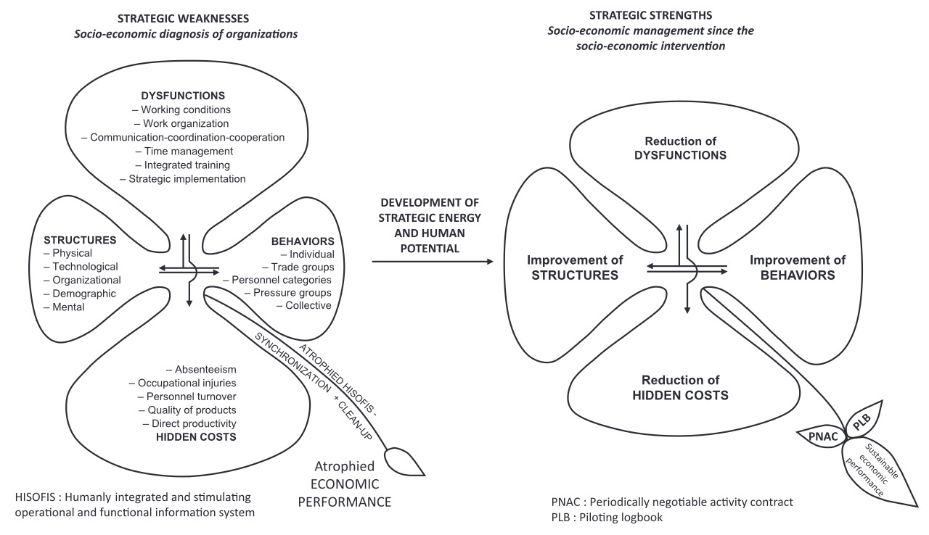
Figure 1: The Four Leaf Clover of SEAM Diagnostics
SEAM's Four Leaf Clover
Upper Leaf of Dysfunction Categories
SEAM classifies dysfunctions using the Cloverleaf Model
1. Work Conditions
Unsafe environments, outdated equipment, ergonomic strain, or psychological stressors.
2. Work Organization
Role ambiguity, redundant processes, overcontrol, or under-delegation.
3. Three Cs of Communication- Coordination-Cooperation
Missing feedback loops, email overload, secrecy, or over-formalized reporting.
4. Time Management
Are people spending time in value added ways (what Axiogenics calls 'net value')?
5. Training
Are people trained in what brings 'net value'? Are people in need of training getting the training they need?
6. Strategic Implementation
Often, organizations are so busy putting out fires in the first five dysfunctions that people are not engaging in strategic implementation.
The upper leaf dysfunctions are entangled
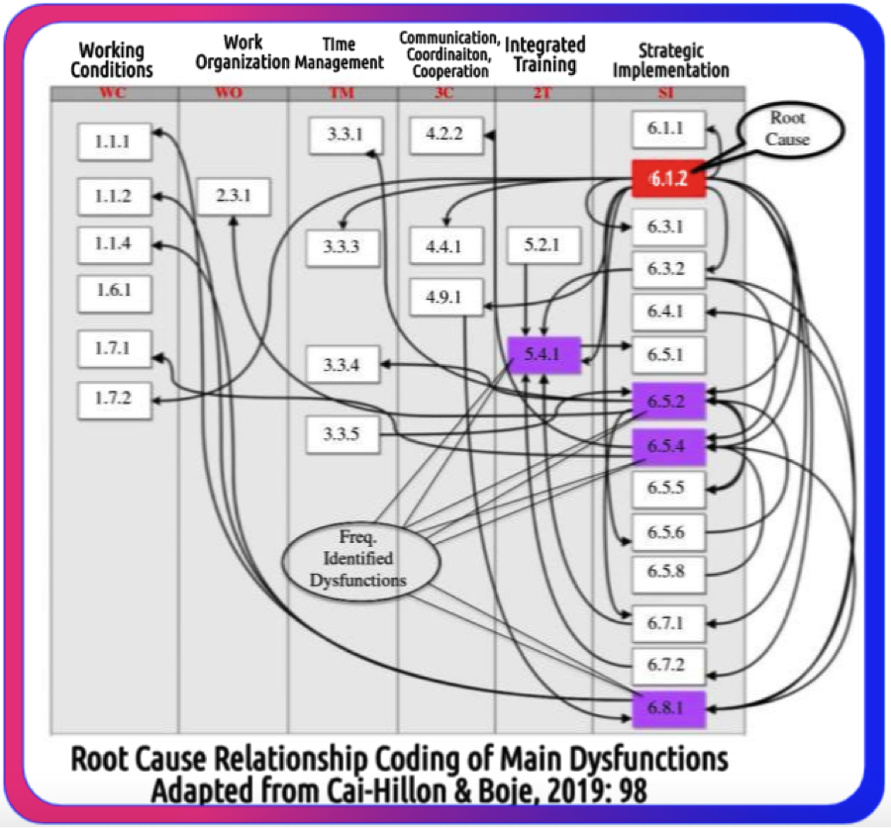
Figure 2: A more spiral view of the entanglement in time and over time.
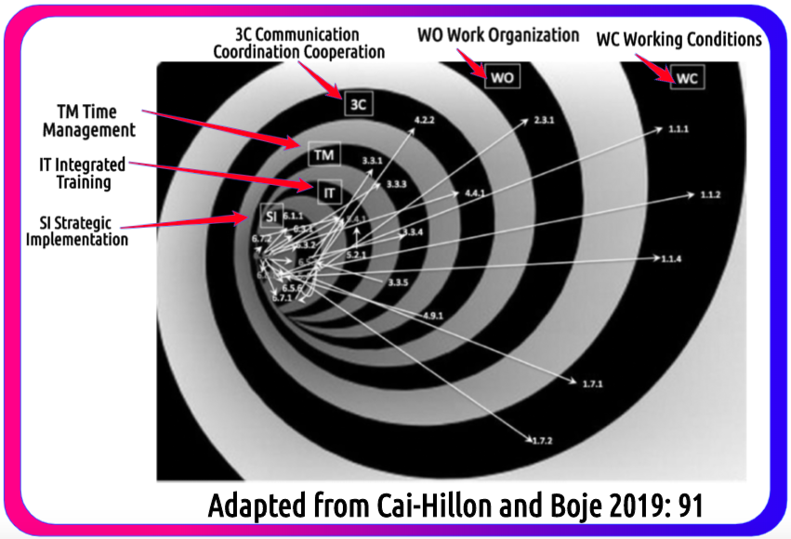
Figure 3: A Spiral View of Six Entangled Dysfunctions (Top Leaf of Clover) demonstrates Principle 4 of True Storytelling: Timing

Developed over 50 years by Henri Savall and the ISEOR Institute, SEAM is both a diagnostic method and a transformation engine.

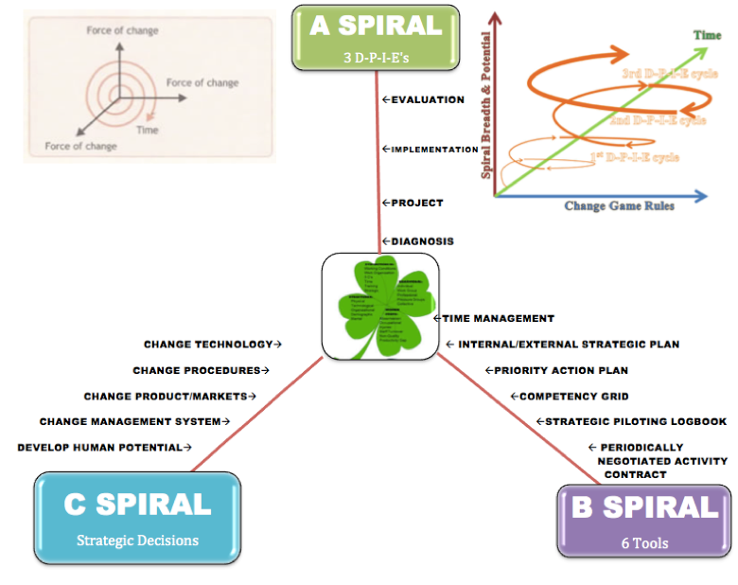
Figure 4: SEAM has three Spirals

It identifies hidden costs—financial losses from dysfunctions like poor work conditions, ineffective communication, or misaligned strategies—and recycles them into value through participatory interventions. SEAM’s methodology rests on three spirals:

- A-Spiral: Successive cycles of Diagnosis, Project Planning, Implementation, and Evaluation (DPIE), engaging cross-level teams to uncover root causes and design solutions.
- B-Spiral: Six SEAM tools, including the Cloverleaf Model, competency grids, and the Mirror Effect, which help teams diagnose and address dysfunctions.
- C-Spiral: Five strategic decision areas—change technology, procedures, products/markets, management systems, and human potential—aligned with organizational goals.

At NMSU, we applied SEAM to quantify hidden costs and propose interventions. The Cloverleaf Model categorizes dysfunctions into six areas: work conditions, work organization, communication-coordination-cooperation (3Cs), time management, training, and strategic implementation. Each dysfunction contributes to financial losses, such as excess salary, overtime, non-production, or non-creation of human potential. SEAM’s qualimetric approach triangulates qualitative data (interviews, observations) with quantitative and financial estimates, ensuring transparency and stakeholder buy-in.

Diagnosing NMSU’s Hidden Costs

Our analysis of NMSU revealed a staggering $13.07 million in hidden costs, driven by systemic dysfunctions. Table 1 below summarizes these losses by dysfunction category and cost type, drawn from interviews, observations, and institutional data.

Table 1. NMSU Hidden-Cost Grid by Dysfunction and Cost Type (USD)
Dysfunction Category | Excess Salary | Excess Time/Overtime | Over-Consumption/Compensation | Non-Production | Non-Creation of Potential | Accidents/Non-Quality | Total
Work Conditions | $0.5M | $0.3M | $0.4M | $0.6M | $0.7M | $0.2M | $2.7M
Work Organization | $0.6M | $0.4M | $0.5M | $0.7M | $0.8M | $0.3M | $3.3M
3Cs (Comm.-Coord.-Coop.) | $0.4M | $0.3M | $0.4M | $0.6M | $0.7M | $0.2M | $2.6M
Time Management | $0.3M | $0.5M | $0.3M | $0.5M | $0.6M | $0.1M | $2.3M
Training | $0.2M | $0.2M | $0.2M | $0.4M | $0.5M | $0.1M | $1.6M
Strategic Implementation | $0.3M | $0.3M | $0.3M | $0.8M | $0.9M | $0.1M | $2.7M
Total | $2.3M | $2.0M | $2.1M | $3.6M | $3.3M | $0.87M | $13.07M

NMSU – SEAM Hidden Costs by Dysfunction Category (stacked components)
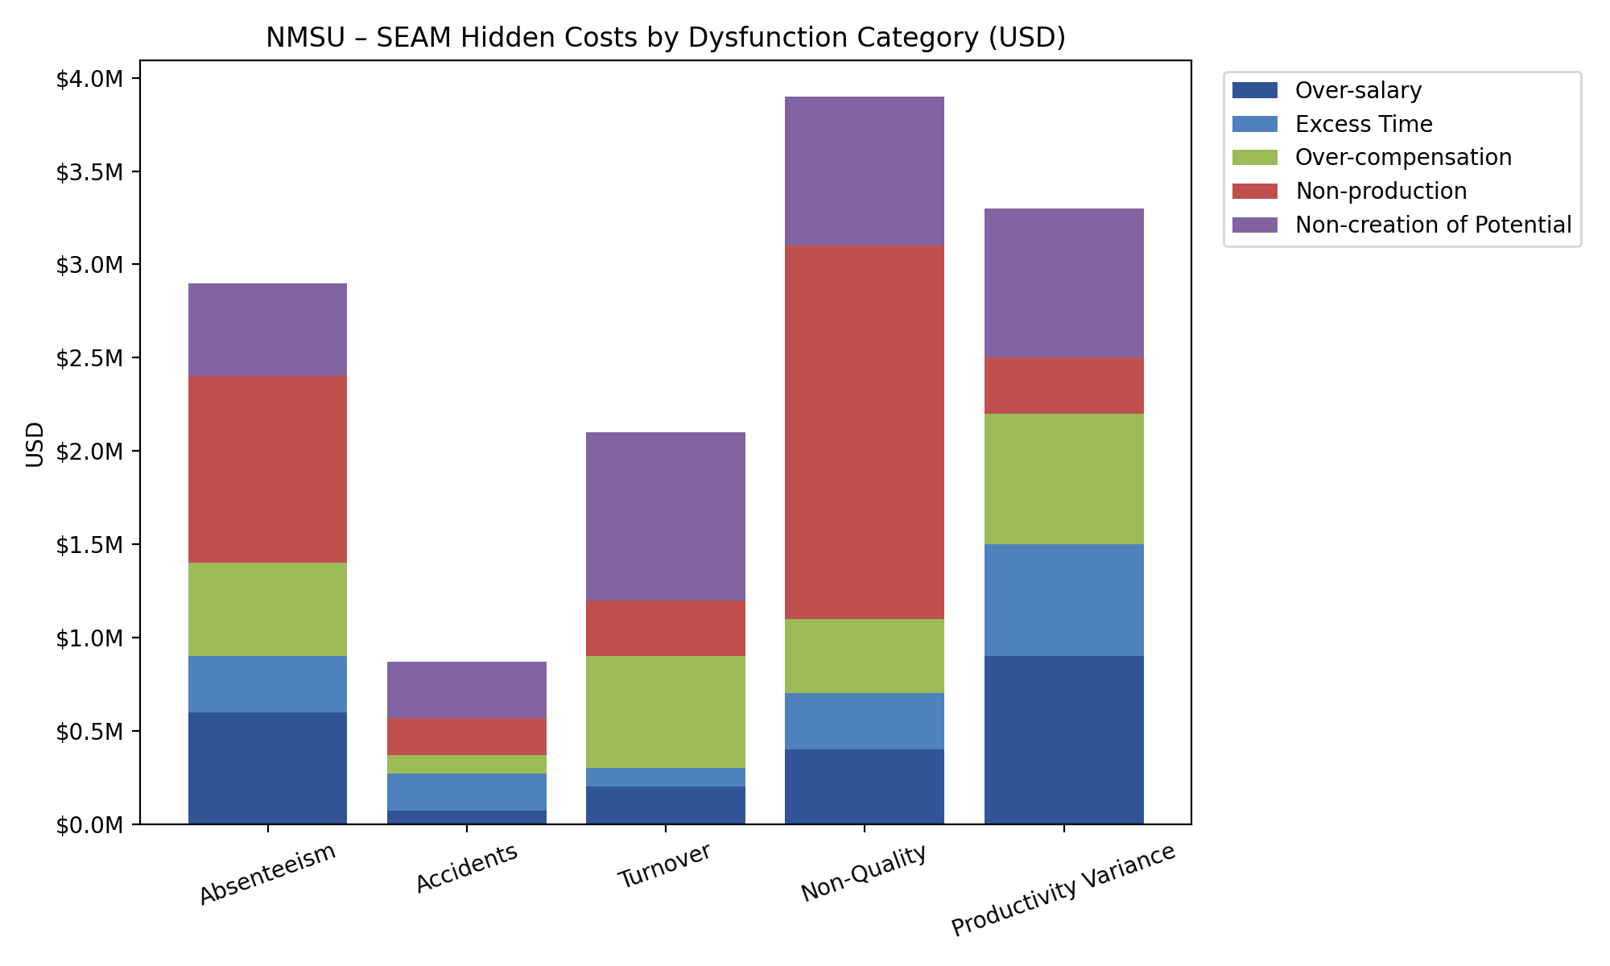
Figure 5: Bar chart showing stacked components of hidden costs across six dysfunction categories, with Work Organization ($3.3M) and Non-Quality ($3.9M) as the largest contributors.

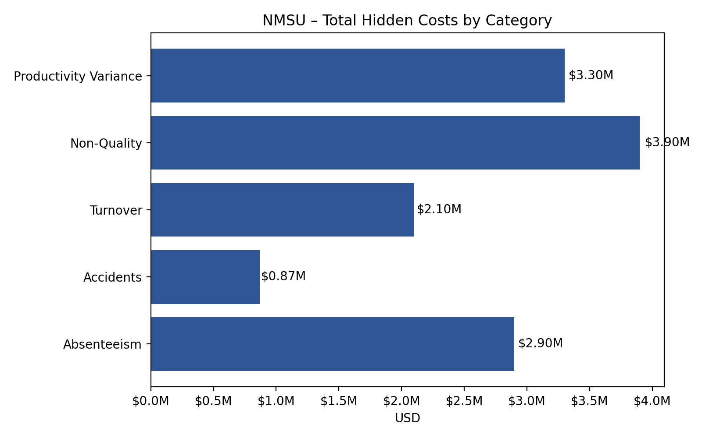

Figure 6. NMSU – Total Hidden Costs by Category

NMSU – Total Hidden Costs by Category![Figure 2: Pie chart showing total hidden costs by category, with Non-Production ($3.8M) and Non-Creation of Potential ($3.3M) dominating.]The data reveals that Non-Quality ($3.9M), Productivity Variance ($3.3M), Absenteeism ($2.9M), and Turnover ($2.1M) are the largest dysfunctions, while Non-Production ($3.8M) and Non-Creation of Potential ($3.3M) lead the cost types. These figures reflect structural issues—understaffing, overwork, and process delays—rather than individual failures. SEAM’s approach is not to blame but to redesign, using these losses as “fuel” for transformation.Storytelling as a Diagnostic LensStorytelling was central to our SEAM application at NMSU.

Drawing on my work in Tamara-Land (Boje, 1995), we viewed organizations as discursive arenas where multiple stories collide and coexist. At NMSU, faculty, staff, and students arrived at meetings with different narratives, shaped by their “rooms” in the organizational maze. This polyphony—amplified by Bakhtin’s (1984) concept of dialogic discourse—revealed dysfunctions like miscommunication and role ambiguity. For example, a faculty member’s story of burnout might clash with an administrator’s narrative of efficiency, creating a “quantum energetic field” of contradictory intersubjectivity (Boje & Sanchez, 2019).SEAM’s Mirror Effect meetings brought these stories to light. By presenting verbatim quotes and draft cost estimates to cross-level participants (faculty, staff, advisors, students), we facilitated co-inquiry, surfacing hidden costs and negotiating shared solutions. This process aligned with the Beyond Echo Chambers theme of moving beyond monologic OD, which suppresses diverse voices, to a polyphonic, dialogic approach that validates them.

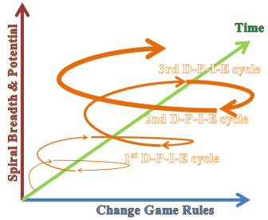
Figure 7: Implementing successive DPIE’s (Diagnosis-Project Design-Implementation-Evaluation cycles) to rebuild NMSU Momentum

Interventions: From Diagnosis to Transformation
Our SEAM intervention at NMSU followed three successive DPIE spirals:

- Stabilize (DPIE 1): Address immediate leaks like scheduling chaos and role ambiguity through redesigned workflows and competency grids.
- Integrate (DPIE 2): Connect improvements across departments, strengthening the 3Cs (communication, coordination, cooperation) with daily huddles and visual management tools.
- Invest (DPIE 3): Reinvest recovered costs into high-leverage projects, such as student success advising flows and grant-writing collaborators, tied to performance-based incentives (PNACs).

A key proposal was for NMSU to become a signatory to the 17 UN Sustainable Development Goals (UNSDGs) through the Higher Education Sustainability Initiative (HESI). By applying SEAM, NMSU could integrate sustainability into teaching, research, and campus operations, becoming the first HESI member in New Mexico.

Placing New Mexico State University within the 17 UN SDGs

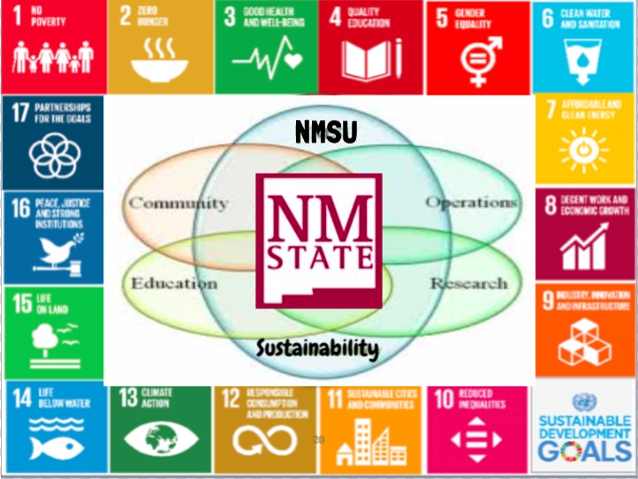
Figure 8: Placing New Mexico State University within the 17 UN SDG's

Diagram mapping NMSU’s potential contributions to the 17 UNSDGs, with SEAM’s DPIE cycles as the engine for sustainable transformation.]This initiative aligned with SEAM’s ethical focus on “responsible capitalism” (Savall & Zardet, 2008), recycling hidden costs into social and environmental value.

Practitioner Guide: Implementing SEAM at NMSU

To operationalize SEAM, we developed practical tools:

- Mirror-Effect Meeting (90 Minutes): Summarize interview themes, present cost estimates, and invite cross-level feedback to prioritize dysfunctions and form DPIE teams.
- Priority Action Plan (PAP) (60 Minutes): Target one dysfunction (e.g., non-quality), define actions, metrics, and training, ensuring no burden-shifting.
- Competency Grid and PNAC: Assess capabilities needed for PAPs and negotiate team incentives tied to cost recovery.

These tools empowered NMSU’s stakeholders to co-diagnose and co-design solutions, fostering ensemble leadership—a decentralized, heterarchic model where “everyone is the leader of something” (Rosile, Boje, & Claw, 2018).

Outcomes and Potential

Our analysis estimated that NMSU could recover 20–30% of the $13.07M in hidden costs within 12 months through three DPIE spirals. Reinvesting 30–40% of these gains into workload relief, training, and student-facing improvements would enhance socio-economic performance and restore trust. By integrating storytelling, SEAM moved beyond monologic fixes to create a polyphonic, triple-loop learning system: single-loop (compliance), double-loop (root-cause agility), and triple-loop (systemic restructuring via ensemble leadership).ConclusionThe NMSU case demonstrates SEAM’s power to transform universities by uncovering hidden costs and weaving polyphonic storytelling into systemic redesign. My 20-year journey with SEAM at NMSU, enriched by collaborations in Lyon and inspired by narrative theories, underscores the potential to move beyond echo chambers of conventional OD. By embracing SEAM’s qualimetric rigor and dialogic storytelling, NMSU can recover dollars and dignity, aligning with global sustainability goals and fostering a culture of collective wisdom.

Theorizing SEAM in its Time Plane
To move from representation to transformation, we must integrate storytelling into the three SEAM concepts: Cognitive Interactivity, Contradictory Intersubjectivity, and Generic Contingency (Savall & Zardet, 1996)—each of which supports the whole arc of organizational transformation using a triple-loop learning model.
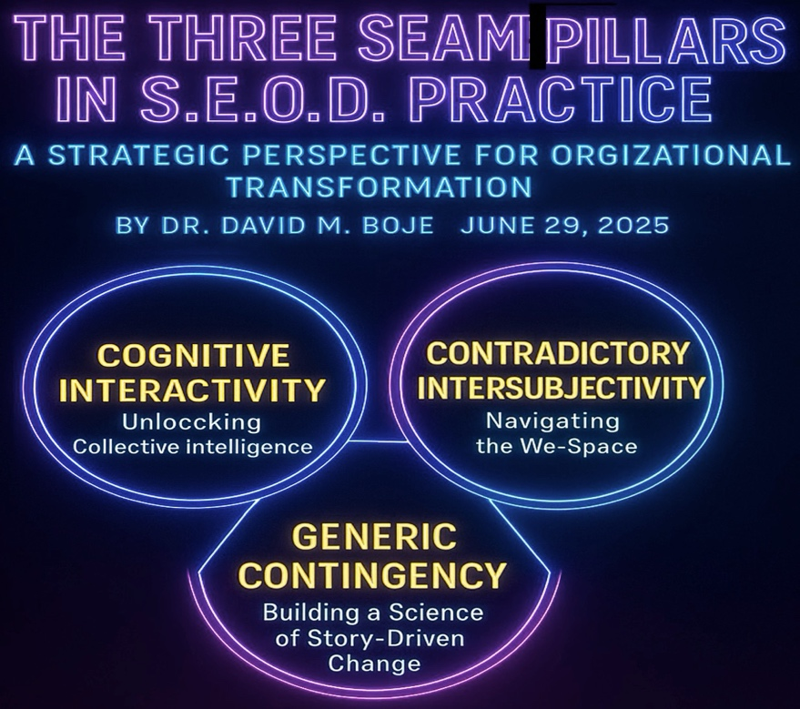
Figure 9: 3 Aspects of SEAM Theory

1. Cognitive Interactivity: Unlocking Collective Intelligence
Organizations are made of people—and people make meaning through stories. Each actor interprets and tells stories about organizational reality differently, based on their history, role, training, and lived experience. Cognitive Interactivity refers to the structured processes through which these differences are surfaced, understood, and synthesized through:
- Story Circles
- Focus Groups
- Mirror Effect Meetings
- Intervention Projects
- Move to Triple Loop and Ensemble Leadership
These dialogic spaces enable single-loop (compliance-focused on command-and-control) and double-loop (root cause-focused on open systems) learning, which initiates triple-loop transformation, where the system itself is restructured and coordinated through Ensemble Leadership practices (Rosile, Boje, & Claw, 2018; Boje & Rosile, 2024, 2025a).
In Triple Loop learning:
- Single-loop = reacting within the rules of the command-and-control hierarchy.
- Double-loop = double system of cybernetic deviation-control with deviation-amplification (agility, experimentation, participative processes, intrapreneurship, innovation).
- Triple-loop = a loop of ensemble leadership networking for coordination of single and double loop by creating a loop of heterarchy.
This third loop requires what we call Ensemble Leadership—a shift from command-and-control to a decentralized, networked, and ethically accountable culture where everyone is the leader of something (Rosile, Boje, & Claw, 2018; Boje & Rosile, 2024, 2025).
Heterarchy means everyone is a leader of something. Heterarchic leadership is decentered, rather than centralized, and operates through non-linear networks rather than hierarchies. It is egalitarian rather than top-down, with leadership being shared and distributed, rather than reserved solely for the C-suite, where leader privileges are held. The concept of heterarchy, central to ensemble leadership, encompasses both identifying leadership functions and promoting egalitarianism. In sum, instead of a rigid hierarchical pyramid, ensemble leadership in Triple Loop transformations suggests a more fluid and networked structure where leadership is distributed and shared among individuals, fostering a more egalitarian environment. In Triple Loop launching and coordinating cascading D.P.I.E. (Diagnostic, Project planning, Implementation, Evaluation of results) teams is key to sustaining continuous improvement.
Through Ensemble Leadership, DPIE teams (Diagnosis, Planning, Implementation, Evaluation) cascade change initiatives that are self-correcting and root-cause oriented.

2. Contradictory Intersubjectivity: Navigating the We-Space
Intersubjectivity refers to the shared space of meaning that forms between people in real-time interactions. In practice, this is the arena where:
- Perspectives clash and harmonize
- Assumptions are surfaced
- A new "we" story is negotiated
This is not a superficial consensus but a quantum energetic field of story entanglement—where each person’s narrative affects the other. Contradictory Intersubjectivity is defined here as the invisible ‘quantum energy field’ generated by actor relationships—the energy, resonance, and mutual attunement to context that shape how people feel, think, and act together. It’s where values, norms, and collective narratives are negotiated and lived. From a quantum storytelling perspective (Boje & Sanchez, 2019), intersubjectivity refers to the entanglement of stories—how one person’s narrative resonates with another’s, creating ripples that shape organizational reality in unpredictable, emergent ways. As Garfinkel (1967) and Boje (1995) illustrate, even in the same room, two people may walk away with entirely different stories due to their unique paths through the organizational maze.

Harold Garfinkel (19679, the founder of ethnomethodology, a field of sociology that studies the methods people use to make sense of and navigate their social world, provides an example of a husband and wife interaction in his work. The husband and wife rely on shared understandings and assumptions to make sense of their everyday conversations. Example: A husband and wife are having a conversation, and the husband says: "Dana succeeded in putting a penny in a parking meter today without being picked up." The wife responds with: "What for?" The husband clarifies: "No, to the shoe repair shop." This excerpt demonstrates how spouses rely on shared context and implicit understanding to interpret each other's remarks. The wife's initial question "What for?" reveals her knowledge of the context, suggesting she's thinking of the reason for putting money in a parking meter, likely related to parking for an errand. The husband's clarifying response "No, to the shoe repair shop" further elaborates on the scenario, indicating where they went and why Dana would need to reach the meter (as they were parked there while going to the shoe repair shop).

Here is the entire exchange form Garfinkel (1969):
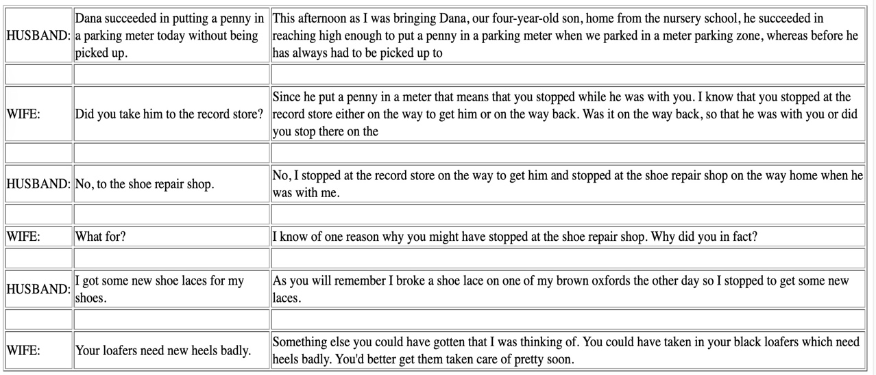

The conversation unfolds based on these shared understandings and assumptions, illustrating the subtle but essential role of everyday methods in making sense of social interactions. This example highlights a key concept in ethnomethodology: indexicality, which refers to how the meaning of words and actions is dependent on the context in which they occur. The husband's statement "Dana succeeded in putting a penny in a parking meter today without being picked up" is indexical because its full meaning relies on shared knowledge about Dana, the parking meter, and the husband and wife's activities that day. Their ability to successfully communicate and understand each other's remarks stems from their mutual reliance on this shared background knowledge. The implication is that the social order of a family and any organization is not simply a pre-existing structure but is constantly and actively co-produced through storytelling and sense-making methods in everyday interactions. Example: firefighters and police officers must be able to quickly interpret indexical cues from a scene, such as the behavior of individuals, the appearance of the environment, and communication with other responders, to understand the situation and make informed decisions. In essence, Garfinkel uses this and similar examples to demonstrate that social order and understanding are not pre-existing structures but are constantly and actively produced through the methods people employ in their everyday interactions.

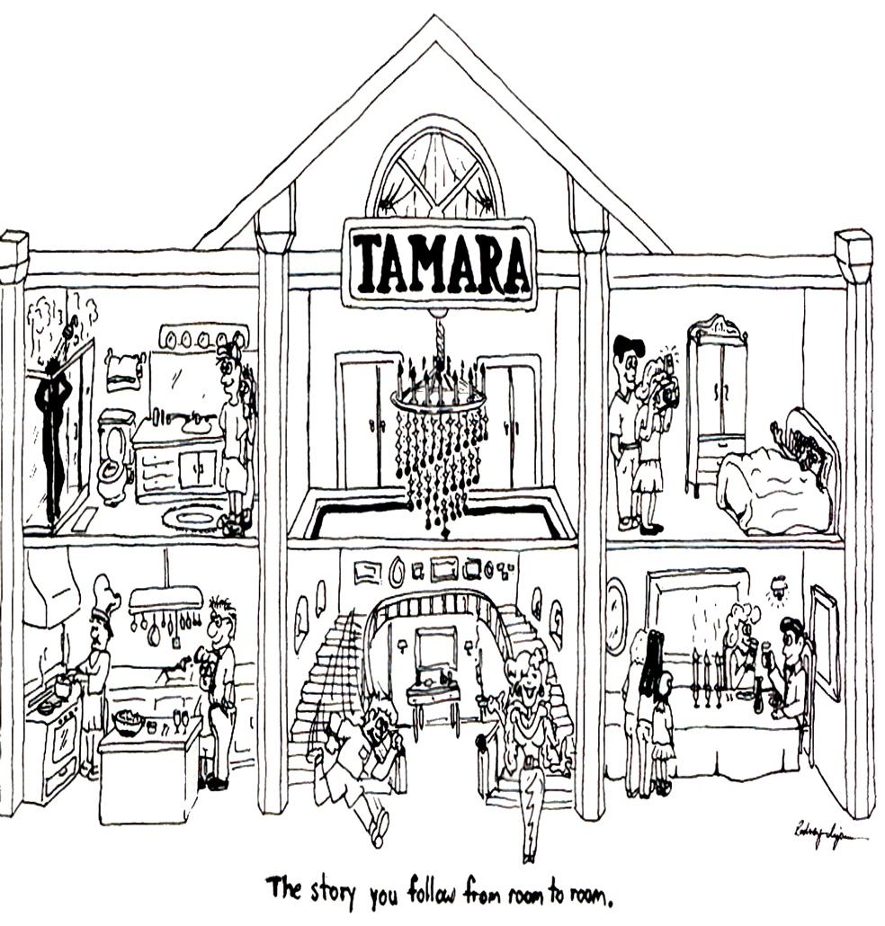
Figure 10: The Tamaraland of Storytelling Organizations

"Tamara-land" (Boje, 1995) illustrates how multi-room, multi-character storytelling can distort shared meaning unless intentionally facilitated. In Boje’s (1995: 999) ‘Disney as Tamara-land,” people arriving to a meeting from different rooms in an organization will amplify the distortions: “Two people can even be in the same room and—if they came there by way of different rooms and character-sequences—each can walk away from the same conversation with entirely different stories.” Most organizations have more than 12 rooms. “If there are a dozen stages and a dozen storytellers, the number of story lines an audience could trace as it chases the wandering discourses of Tamara is 12 factorial (479,001,600)” (IBID.)
“Still, instead of repairing mechanistic or organic metaphors, I believe it is time to heed Pondy and Mitroff's advice and move to discursive metaphors, such as Lyotard's (1984) ’conversation,’ Bakhtin's (1981) ’novel,’ and Thatchenkery's (1992) ‘text.’ Tamara is a discursive metaphor highlighting the plurivocal interpretation of organizational stories in a distributed and historically contextualized meaning network—that is, the meaning of events depends upon the locality, the prior sequence of stories, and the transformation of characters in the wandering discourses.” Boje, 1995: 1000).

Therefore, to address the contradictory intersubjectivity in the discursive arean, the SEAM method encourages the gathering of various types of data (interviews, observations, documents, and reports) and engagement in co-inquiry. Why It Matters: (1) Decision-Making: Wise decisions arise not from isolated minds, but from the resonance of many voices in intersubjective space. (2) Change and Transformation: Lasting change happens when new intersubjective realities are co-created—when people see, feel, and act from a new shared story. (3) Ensemble Leadership: Leadership is intersubjective—an improvisational dance of sensing, responding, and co-creating in the moment. Contradictory Intersubjectivity in organizations is the living, breathing quantum energetic field of shared meaning and presence that makes collective wisdom, creativity, and transformation possible. It is the foundation for ensemble leadership and the quantum leap from isolated action to collective becoming.

To resolve contradictory intersubjectivity:
- SEAM uses co-inquiry methods: Interviews, observation, document analysis, and stakeholder dialogues.
- Leaders foster ensemble conversations that prioritize attunement over authority.
Why it matters for organizations:
- Better Decisions: emerge from dialogic resonance, not individual assertion.
- Sustainable Change: grows from co-created story, not top-down mandates.
- Adaptive Leadership: thrives through sensemaking-in-action, not rigid roles.
This is where PERVIEW Coaching integrates with SEAM—training leaders to read and respond to the “energy field” of meaning, emotion, and momentum within a team or system.

3. Generic Contingency: Building a Science of Story-Driven Change
Organizations operate in unpredictable environments. SEAM introduces scientific rigor through Generic Contingency—a process rooted in Charles Sanders Peirce’s logic of discovery:
- Abduction: What is surprising? What doesn’t fit the current story? Making a guess about a hypothesis that needs more inductive cases and theory building.
- Deduction: If this hypothesis is true, what else would we expect to see in inductive cases?
- Induction: What patterns emerge from actual cases? Does the evidence hold? What if there is a black swan effect, and all swans are not white?
Given Contradictory Intersubjectivity, and the need for Cognitive Interactivity to create shared understanding and action, the scientific part involves generating self-correcting co-inquiry by applying Charles Sanders Peirce’s Induction, Deduction, and Abduction (Boje & Rosile, 2020). Abduction is the initial stage where a surprising fact or observing something unexpected. Abduction “an argument or supposition that assumes it was a case of a general rule and of results that still needs actual inquiry (Peirce, 1931-1935, vol. 2: p. 515, 624). Such abduction, the formation of a wild or informed guess, needs induction method, the gathering of cases. Abduction can become the basis for a hypothesis. Deduction involves drawing out the logical consequences of the abduction and hypothesis. Deduction “belongs to general class of results by theory-arguments that in the long run tend toward the truth of case results” (Peirce, 1931-1935: vol 2: p. 266). If the hypothesis is true, what else should also be true? It does not generate new knowledge; rather, it clarifies the implications of existing assumptions. Induction is the process of testing the hypothesis by gathering cases. Induction “generalizes from a number of cases and results, of which something is true, to infer some rule for the whole population” (Peirce, 1931-1935, vol. 2: p. 624). If cases support the deduction and abduction (or hypothesis, it becomes more credible.
Boje (2003), intro to Qualimetics, addresses how measurement before and after, each and every change intervention experiment, is fundamental to Savall's socioeconomic approach to management, known as SEAM. It is not only quantitative and financial, but also the researcher-intervenor (Savall does not use terms like action researcher or change agent). The qualitative component includes the researcher-intervenor collecting verbatim qualitative field notes and direct observations, then entering them in a SEAM diagnostic computer data bank, that can be analyzed for each 'Mirror Effect' meeting with the client, when the quantitative (hidden costs), financial data, and qualitative quotes from all stakeholders is 'mirrored back' to the client, so they can see what it is costing the organization to remain dysfunctional, not converting hidden costs and revenues into realizable economic performance. When Grace Ann Rosile and I and interviewed Henri Savall and wrote an article about it we discovered something important, not in any of the Savall books. That is, Savall views the qualitative discourse of an organization as a theater script that is disorganized and dysfunctional. We call this the 'Theatrics of SEAM' (Boje & Rosile, 2003).

Mini-Case Study: Echoes, Choruses, and Kairotic Pivots
Walmart: The Spectral Echo of Monologic Chronos
Walmart’s “Specter of Sam Walton” haunts as monologic diachrony: frugality tales puppeteer employees, decoupling “low prices” from exploitative costs (Boje & Rosile, 2008). Synchronic audits finalize narratives, ignoring weak signals; poor timing—rushed implementations—breeds resistance, echoing polyphony errors in frozen horizons.
These discursive moves externalize hidden costs (e.g., turnover, disengagement) and de-couple narrative from lived labor realities (Savall & Zardet, 2008; Boje, 2014).

Polyphony Error & Definition | Manifestation at Wal-Mart
1. Superficial Disruption of Hierarchy Managerial dominance subordinates other voices to a centralized vision, imposing a single accent. | Wal-Mart uses rhetorical terms like "associate" instead of "employee" and promotes the concept of the "Wal-Mart family." This language masks deep power differentials and imposes a centralized vision of loyalty.
2. Neglect of Unfinalizability <Forces premature closure on narratives, suppressing the inherent quality of authentic dialogue as "eternally open-ended." | The company presents its founder’s ideas as a "timeless recipe for success." This grand narrative of inevitable progress bypasses the complexity of ongoing litigation and social resistance, imposing a utopian vision.
3. Authorial Puppetization Strips stakeholder discourse of autonomy by using it solely to validate preset leadership agendas. | Executives "fabricate and orchestrate the ghostly presence of Sam Walton," strategically selecting only "certain pearls of dead Mr. Sam’s wisdom." Dissenting voices, like that of co-founder Bud Walton, were silenced and removed.
4. Moralizing Monologism Imposes ethical closure by simplifying debates into right-or-wrong categories, suppressing ambiguity and paradox. | Through "aggressive storytelling practices," Wal-Mart frames itself as a "Good Citizen" doing the "right things." This benevolent narrative of a "friendly-ghost" founder masks the "dark side" of its predatory capitalism.
5. Romanticizing the Author Elevates the leader as the sole storyteller or genius, overshadowing the collective. | The corporate narrative elevates Sam Walton to the status of an "American Original." Current leaders continually attribute success to his ghostly presence, a strategy that overshadows the collective experience of its workforce.
6. Reduction to Ideology Reduces complex social reality to a rigid, deterministic system, enforcing conformity. | Wal-Mart’s narrative substitutes social contradictions with a dogmatic "hyperglobalization discourse." This presents "Wal-Martization" as an inevitable and beneficial "Road to the Top," suppressing political and labor tensions.

CIW: Polyphonic Harvest Across Entangled Times
CIW’s Fair Food Program chorally weaves farmworkers, growers, buyers in diachronic polyphony: SOULS ensembles governance, SEAM prices violations, PERVIEW evolves standards, GLOW balances rights-viability, AAM audits margins. Historical labor waves ground in spacetimemattering, timed kairotically for ethical surges—Walmart’s 2014 entry a tentative pivot.

CIW as Robust Polyphony
By contrast, the Coalition of Immokalee Workers (CIW) exemplifies ensemble leadership (“we are all leaders”), heterarchical coordination, and Worker-Driven Social Responsibility (WSR)—a model that hardwires accountability through binding agreements and third-party monitoring (Rosile et al., 2018). CIW cultivates polyphony by:
- Shared authorship (SOULS): distributed leadership, co-created strategy.
- Structural accountability (SEAM/WSR): material consequences for failure to address abuses, aligning narrative with practice.
- Dialogic emotional labor (GLOW): story-eliciting that surfaces harm and paradox.
- Unfinalized narrative (PERVIEW): movement identity as ongoing becoming, not a finalized brand story.
- Anti-dogmatism (AAM): tactical multiplicity and alliance-building over rigid ideology.
The juxtaposition reveals how design choices (hierarchical monologism vs. heterarchical polyphony) shape tangible outcomes (disengagement vs. empowerment).

Mapping Polyphony Errors to GrowthOD Pillars
Table 2. Correcting Polyphony Errors with GrowthOD Pillars (with CIW Illustrations)
Polyphony Error | GrowthOD Pillar(s) | Transformative Aim | Illustrative Practice (CIW)
Superficial Disruption of Hierarchy | SEAM | Reveal and price hidden costs of rhetorical inclusion without structural change | Binding, enforceable standards and monitoring (WSR)
Neglect of Unfinalizability | PERVIEW | Keep narratives open; sustain antenarrative inquiry | Movement identity as rhizomatic, iterative restorying
Authorial Puppetization | SOULS | Institutionalize shared authorship; ensemble leadership | “We are all leaders” organizing and co-creation
Moralizing Monologism | GLOW | Build capacity to hold paradox; resist binary closure | Story-eliciting practices that surface discomfort
Romanticizing the Author | SOULS + SEAM | Decenter heroic leader; align structures with collective intelligence | Rotating leadership roles; formalized accountability
Reduction to Ideology | AAM | Surface and test auxiliary assumptions; avoid dogma | Tactical multiplicity and diverse alliances
Sources: Bakhtin (1984); Boje (2014); Boje & Rosile (2008); Rosile et al. (2018); Savall & Zardet (2008); Trafimow (2024).

Novo Nordisk: Mini-Case Kairotic Narrative Surfing
Novo Nordisk’s shift—from innovation to prevention via Cities Changing Diabetes (2014)—exemplifies polyphonic-diachronic timing: outside-in abstraction reveals urban diabetes waves (Sperling), STAR futurizes 20+ cities' actions, countering decoupled rhetoric with grounded prevention. This antenarrative bet turns societal chronos into sustainable kairos.
Marianne Hoff Andersen: Improvisational Moral Answerability
In Danish municipal reform, Director Andersen's year-long reorganization defies six-month grants, polyphonically listening (Principle 2) to leaders' stories amid resistance. Diachronically, she rehistoicizes vulnerabilities, abstracts timing's essence, grounds in ensemble trust, futurizes prevention—surfing existential waves (Bakhtin) for closer family ties, reduced caseloads, interdisciplinary harmony.

Comparative Insights: Walmart’s echoes accrue hidden losses; CIW/Novo/Andersen’s choruses foster adaptability. GrowthOD times PERVIEW circles and SOULS governance to bridge gaps.

Heuristics for Practitioners: Conducting Entangled Symphonies
- Diagnose Temporal Stance: Scan synchronic biases; cycle Action Research with STAR to entangle horizons (Schein, 1997).
- Widen Voice Pre-Kairos: Story-circles amplify before finalizing, pricing gaps via SEAM (OD Network, n.d.; Savall & Zardet, 2008).
- Institutionalize Unfinalizability: Embed PERVIEW governance, holding paradoxes (GLOW) across long bets (Boje & Parr-Rud, 2025).
- Protect Plurality: AAM challenges dogma; improvise jazz-like, sensing bodily energy waves (Trafimow, 2024).
- Surf Antenarratives: Ask Principle 4 queries—What timing now? (abstractizing); short/long-run histories? (rehistorizing)—to bet on spiraling futures.
Inspirations: Epics like The Lord of the Rings for diachronic trials; Sinatra's phrasing for kairos; improv theater for polyphonic waves.
Conclusion: Scoring Polyphonic-Diachronic Futures
OD's future symphonizes voices across entangled times: monologic synchronicity falters in complexity; GrowthOD's pillars, timed via Principle 4 and STAR, orchestrate resilience. Walmart-CIW, Novo, Andersen tales tally echo costs against choral power. Embracing True Storytelling, organizations surf multifractal waves—ethical, adaptive narratives for multi-species worlds. No excuses (Bakhtin): intervene in the once-occurrent now.

References
Bakhtin, M. M. (1984). Problems of Dostoevsky’s poetics (C. Emerson, Ed. & Trans.). University of Minnesota Press.

Boje, D. M. (1995). Stories of the storytelling organization: A postmodern analysis of Disney as “Tamara-Land.” Academy of Management Journal, 38(4), 997–1035. https://davidboje.com/vita/paper_pdfs/AMJ_Disney.pdf

Boje, D. M. (2003) Qualimetrics Contributions to Research Methodology: Preface to RECHERCHE EN SCIENCES DE GESTION: OBSERVER LOBJET COMPLEXE APPROACHE QUALIMETRIQUE by Henri Savall and Veronique Zardet, Lyon 3 & ISEOR, June 19, 2003; Revised June 26, 2003. Online prepublication draft.

Boje, D. M. (2014). Storytelling organizational practices: Managing in the quantum age. Routledge.
Boje, David M. (2016). Preface to Savall and Peron. “Global Capitalism is Unsustainable". Click here for pdf And click here for the final version of the Preface in Savall, H., & Peron, Michel. (2016). Socially Responsible Capitalism. London: Routledge. (No. hal-01140272).
Boje, D. M. (2024). Triple-loop storytelling and GROWTH O). https://davidboje.com/CSIstory/CSIsocioeconomics.html

Boje, D. M. (2025a). Tamara revisited: PERVIEW, SEAM, and the storytelling challenge of the digital multiverse. Tamara: Journal of Critical Organizational Theory. Advance online publication. https://growthod.org/Tamara%20Revisited%20essay%20David%20Boje%20Jun%205%202025.pdf
Boje, D. M. (2025b). Triple Loop GROWTH OD and The Emergence of Stakeholder Capitalism in a Time of Shareholder Capitalism Decline June 26, 2025 WORD DOWNLOAD or access
PDF ONLINE.

Boje, David M., & Hillon, Yue C. (2017). The Fifth Epoch: Socio-Economic Approach to Sustainable Capitalism. Markets, Globalization & Development Review, 2(1): 1=20. Click here for online pdf.

Boje, D. M., & Parr-Rud, O. (2025). GROWTH OD: Gratitude-Rooted Organizational Wisdom, Transformation & Healing. Tamaraland Publishing.

Boje, D. M., & Pelly, R. D. M. (2025). Return to Tamara-Land: A methodological exploration of the antenarratives of tyrannic capitalism. International Journal of Business Communication. Advance online publication. https://growthod.org/David%20and%20Duncan%20Article%20on%20Tamaraland%20of%20Peltz%20Disney.pdf

Boje, D. M. & G. A. Rosile (2003). Theatrics of SEAM. Journal of Organizational Change Management. Special issue Socio-Economic Approach to Management, Henri Savall (Guest Editor). Vol. 16 (1): 21-32. Pre-publication PDF of this article; Workshop manual at http://business.nmsu.edu/~dboje/theatrics/manual/THEATRE OF SEAM 27JUNE02.DOC

Boje, D. M., & Rosile, G. A. (2008). Specters of Wal-Mart: A critical discourse analysis of stories of Sam Walton’s ghost. Critical Discourse Studies, 5(2), 153–179.
Boje, D. M., & Rosile, G. A. (2025). Disney's proxy battles reveal the dark side of leadership storytelling: And we offer restorying way out. In A. Rixon (Ed.), Organizational storytelling. Routledge. (Pre-press chapter). https://growthod.org/BojeRosile%20vers%202%20DarkSide%20of%20Leadershp%20Chapter%20in%20submission.pdf

Larsen, J., Boje, D. M., & Bruun, L. (2021). True storytelling: Seven principles for an ethical and sustainable change-management strategy. Routledge.
Rosile, G. A., Boje, D. M., & Claw, C. M. (2018). Ensemble leadership theory: Collectivist, relational, and heterarchical roots from indigenous contexts. Leadership, 14(3), 307-328. https://davidboje.com/vita/paper_pdfs/Ensemble_Leadership_article.pdf

Garfinkel, H. (1967). Studies in Ethnomethodology. Prentice‑Hall.

Savall, H., & Zardet, V. (2008). Mastering hidden costs and socio-economic performance. Information Age Publishing.

Savall, H., & Zardet, V. (1996). La dimension cognitive de la recherche-intervention: La production de connaissances par interactivité cognitive. Revue internationale de systémique, 10, 157-189.

Savall, H., Zardet, V., Bonnet, M., & Savall, A. (2024). Presentation of SEAM and opening up on storytelling approaches. In D. M. Boje (Ed.) & A. Savall (Vol. Ed.), Business Storytelling of Socioeconomics (pp. 3–30). World Scientific. (Key idea cited p. 25). https://growthod.org/savall-et-al-2023-presentation-of-seam-and-opening-up-on-storytelling-approaches.pdf
Savall, H., & Zardet, V. (2008). Mastering hidden costs and socio-economic performance. Information Age Publishing.
Schein, E. H. (1997). The concept of client from a process consultation perspective: A guide for change agents. MIT Sloan School of Management.
Trafimow, D. (2024). Auxiliary assumptions and the practice of science. Journal of Theoretical Social Psychology, 8(2), 123–139.
Van de Ven, A. H., & Poole, M. S. (1995). Explaining development and change in organizations. Academy of Management Review, 20(3), 510–540.

Chapter 5: Beyond the Echo Chamber: Helping Stories Along Through Polyphonic Experiments and Diachronic Sensemaking in Organizational Development
David M. Boje Professor Emeritus of Management, New Mexico State University; Distinguished Professor of Storytelling and Ethics, Fisk University; Co-founder, GrowthOD and True Storytelling Institute
October 11, 2025
Abstract
Organizations thrive as gardens of living stories—entangled webs of told tellings, untold fringes, and antenarrative bets—yet mainstream Organizational Development (OD) often prunes them into monologic, synchronic echoes, marginalizing counter-narratives and suppressing experiments. This chapter reframes True Storytelling's Principle 5—You Must Be Able to Help Stories on Their Way and Be Open to Experiment—within a 2×2 framework of Voice (monologic to polyphonic) and Time (synchronic to diachronic), critiquing five traditional OD approaches for their failure to navigate untold stories and indexical sensemaking (Garfinkel, 1967). Drawing on Bakhtin's polyphony (1984), Boje's Quantum Storytelling (2014), and GrowthOD's pillars—SOULS, SEAM, GLOW, PERVIEW, and AAM—this work counters six polyphony errors while fostering dialogical, sociomaterial experimentation. Cases from Danish police recruitment, Novo Nordisk's preventive pivots, municipal reforms, craft school networks, and a failed start-up illuminate how polyphonic-diachronic practices unearth hidden costs, nurture antenarratives, and build commitment amid resistance. Propositions for scholars and heuristics for practitioners chart paths to ethical, resilient symphonies where stories co-evolve across entangled horizons.
Keywords: organizational development, polyphony, diachrony, antenarrative, living stories, GrowthOD, Bakhtin, Quantum Storytelling, sensemaking, hidden costs
Introduction: The Garden of Living Stories in Organizational Life
Organizations are not static scores but dynamic gardens: living stories rhizomatically entwine with dominant narratives, counter-tales, and untold fringes, demanding cultivation through dialogical experimentation (Boje, 2014). Mainstream OD, however, echoes monologic snapshots—freezing sensemaking in synchronic audits—while suppressing the polyphonic flux of indexicals ("you knows," "et ceteras") that co-create accountability in everyday scenes (Garfinkel, 1967). True Storytelling's Principle 5—You Must Be Able to Help Stories on Their Way and Be Open to Experiment—invites us into the arena (Roosevelt's ethos), navigating resistance via antenarrative bets: provisional pre-stories fostering commitment amid sociomaterial entanglements.
This chapter symphonizes Principle 5 with GrowthOD's polyphonic-diachronic framework, escaping echo chambers where untold stories wither. Anchored in Bakhtin's unmerged voices (1984), Garfinkel's ethnomethodology (1967), and Buber's I-You encounters (1923), it critiques OD shadows, elevates GrowthOD pillars for story-helping praxis, and animates cases—from Greenlandic oral traditions to Copenhagen's passion-driven libraries. Aims: expose monologic synchronicity's suppression of living webs; orchestrate Principle 5's experiments across STAR temporal modes (Latour, 1998); provoke polyphonic sensemaking for multi-species futures.
We begin with an extended case.

Chapter 5 Extended Case: “Living the Past Forward – Kairos and Chronos in the Mendoza Multiverse Venture”
(True Storytelling Principle 5: You must reflect on the past, connect it to present decisions, and guide future action ethically)

“If we don’t honor the stories in these walls,” Mendoza whispered, “then no tech, no multiverse, no plan will work.”
We are in the Mesilla Valley Mall, Las Cruces, New Mexico. Once a retail beacon, now mostly shadows—empty storefronts and echoes of late capitalism. Into this abandoned landscape walks David Mendoza, co-founder of a radical GrowthOD venture called The Immersive Storytelling Multiverse.
His idea? A decentralized, mixed-reality experience combining ancestral wisdom, entrepreneurial incubation, and metaverse design—all inside a dying mall.
But there’s a catch: the mall is not empty of story. It’s crowded with ghosts—some ancestral, some managerial, some economic. To move forward, Mendoza must go backward.
This is the story of how True Storytelling’s 5th Principle came alive—honoring kairos and chronos as twin currents of organizational change.

Scene 1: The Broken Clock
David Mendoza stood in what was once the JCPenney wing. The tiled floor reflected a flickering exit sign. No shoppers, no staff—just dust, decay, and echoes.
He looked at a plaque on the wall. “Established 1986.”
“They never took it down,” he said. “But time sure did.”
Here was the paradox: the mall had chronos—measurable time—but had lost its kairos—the opportune moment when timing, ethics, and action align.
Mendoza scribbled in his notebook:
“To reimagine this space, we must not forget what it was.
Diachronic OD begins in ruins.”

Scene 2: PERVIEW and the Reassembly of Time
Working with Boje and GrowthOD consultants, Mendoza initiated a PERVIEW Circle:
- Stakeholders: artists, city planners, youth mentors, tribal elders, spiritual leaders
- Format: narrative walks, story spirals, SEAM diagnostics
- Purpose: to trace the past into the present—what Boje calls tracing the true story waves
During one session, an elder named Clara spoke:
“Before this mall, this was all desert. My grandmother gathered plants where that Hot Topic store used to be. We would walk here barefoot. The ground listened to us.”
The team froze.
Suddenly, what seemed like a dead space had a living memory.
The facilitators used Boje’s Antenarrative Mapping to chart these fragments—layering indigenous memory with mall decline, economic policy, and future tech dreams.
This is what True Storytelling Principle 5 demands: past-present-future integrity.

Scene 3: Kairos Theater
One afternoon, the team staged an experimental “Kairos Theater” event in the empty food court.
They invited community members to perform scenes from their mall memories:
- First dates at the movie theater
- Layaway furniture delivery stories
- Protest chants from a 2003 anti-war sit-in
- A young boy’s VR demo with his grandmother before she passed
“What’s this have to do with business?” asked a skeptical city planner.
Mendoza replied:
“We’re time-traveling. Business without memory is just extraction.”
In GrowthOD terms, they were doing PERVIEW Step 5: Reflexive Coherence—finding narrative threads across stakeholders and timelines.

Scene 4: Chronos Logic vs. Kairos Urgency
The venture hit its first funding wall. Investors demanded numbers.
“What’s your 6-month ROI?”
“How scalable is this?”
“What’s the TAM on metaverse foot traffic?”
Mendoza, armed with Boje’s narrative frameworks, pushed back:
“You’re asking chronos questions. We’re living in kairos.”
This didn’t mean ignoring numbers. It meant aligning strategy with meaning.
He reworked the business model using GrowthOD’s GLOW + SEAM fusion:
- Gratitude: from community investment and story-sharing
- Love: for place, ancestors, and shared future
- Organizational Wisdom: through dialogic governance
- Hidden costs: tracked in missed cultural moments and lost trust
“You measure cost in cash,” he told the investors. “We measure it in coherence.”

Scene 5: Restorying the Venture
At the GrowthOD lab summit, Mendoza presented his venture using Boje’s Tamara-Land framework.
“This mall is a Tamara house,” he said. “Multiple rooms, stories happening at once.
But people can only follow one or two rooms. So we design story corridors.”
This became the Multiverse Corridor Architecture—rooms built for:
- Elder Circles (Oral history theater)
- Youth VR Storytelling
- Entrepreneurial coaching pods
- Environmental data stories from native lands
Each space had a diachronic timeline—how past trauma informed present healing and future design.

Scene 6: The Ethical Launch
On launch day, Mendoza didn’t cut a ribbon.
Instead, he placed three objects in the middle of the lobby:
- A desert stone
- A pair of child’s VR goggles
- A pot of chile seeds
He turned to the crowd and said:
“This is who we were. This is who we are. This is who we could be.”
No one clapped at first.
Then, someone from the back said:
“Let’s plant.”
The pot became a garden. The goggles became part of a museum on digital memory. The stone remained—a kairos marker, reminding all: Time is not linear. It is sacred.

Reflections: When OD Is a Time Machine
This venture taught GrowthOD practitioners that kairos is not a moment—it is a method.
- True storytelling requires narrative integrity across time
- Antenarratives are pre-truths—seedlings of story needing ethical care
- Space design must honor layered memory
- Investment without reflection becomes colonization
- OD must be a time machine, not just a roadmap
“We didn’t just build a mall experience,” Mendoza told the press.
“We rescued a timeline.”

A 2×2 Framework: Voice, Time, and the Web of Living Stories as OD's Rhizome
Organizational sensemaking weaves voice—who co-tells?—with time—how do stories unfold amid untold fringes? Monologism puppeteers singular scripts; polyphony unleashes unmerged choruses in jazz-like co-construction (Bakhtin, 1984). Synchronicity codes transcripts for themes, ignoring retrospective-prospective fringes (Boje, 2008); diachrony traces antenarratives across rehistorizing pasts, abstractizing truths, grounding embodiments, and futurizing bets. Quantum Storytelling's living story web—dominant/counter-narratives entangled with untold indexicals—diffracts this via STAR: Storytelling Temporal Awareness Responsiveness, nurturing experiments in spacetimemattering (Barad, 2007).
Temporal Mode (STAR-Web Integration) | Polyphonic (Unmerged Voices) | Monologic (Puppetized Scripts)
Diachronic (Across Living Webs) | Action Research, Dialogic OD, GrowthOD (PERVIEW antenarratives; SOULS ensemble co-telling; experiments in untold fringes) | Planned change (Lewin's freeze-thaw; Kotter's steps; linear chronos puppeteering counters)
Synchronic (Coded Snapshots) | Episodic events (AI Summits; polyphonic bursts decoding themes, risking untold suppression) | Diagnostic audits, content analysis; bystander coding finalizing untold into echoes
Explications by Quadrant, Entangled with Story-Helping
- Polyphonic–Diachronic: Campfire webs where antenarratives evolve: Process Consultation (Schein, 1997) and GrowthOD's AAM probe assumptions in living stories, resisting closure via Garfinkelian glossing (Savall & Zardet, 2008). Principle 5 experiments: unearth counters for ethical futurizing.
- Polyphonic–Synchronic: Town halls decoding dilemmas (e.g., Mads and Monopolet radio), amplifying voices but demanding SEAM to price post-event drifts (Bunker & Alban, 2006).
- Monologic–Diachronic: Scripted sagas like Lewin's (1951) model, enforcing dominant narratives over counters; SOULS invites ensemble authorship, diachronically rehistoicizing untold.
- Monologic–Synchronic: Memos auditing phrases, alienating via present-at-hand abstraction (Gallos, 2006). Principle 5's I-You attunement (Buber, 1923) grounds indexicals, softening echoes.
This rhizomatic framework guides layering: polyphonic voices experimenting diachronically unearth hidden potentials.
Synchronic Shadows: Mainstream OD's Suppression of Untold Webs
Mainstream OD photographs story webs—coded, singular—its synchronic monologism casting shadows that marginalize living multiplicities:
- Diagnostic OD: Clipboard audits snapshot themes, blind to untold fringes or weak signals (Gallos, 2006).
- Lewin’s Model: Freezing rivers ignores antenarrative flows, puppeteering counters into compliance (Burnes, 2007).
- Planned Change: Kotter’s (1995) roadmap battles terrains monologically, sidelining polyphonic experiments.
- Dialectical Theories: Conflicts resolve hastily, flattening Bakhtinian eventness into coded truths (Van de Ven & Poole, 1995).
- Strategic Planning: Blueprints ignore sociomaterial webs, ideologically decoupling from indexical sensemaking (Gallos, 2006).
Shadows, amplified by unexperimented telling:
- Static Equilibrium Bias: Codes multifractal webs, missing untold glossing.
- Monologic Control: Drowns choruses in bystander decoding.
- Premature Closure: Buries existential answerability in transcripts.
- Superficial Disruption: Power lingers, ungrounded in fringe determinations.
- Ideological Reduction: Decouples rhetoric from primordial untold waves.
These demand GrowthOD's polyphonic experimentation.
GrowthOD: A Rhizomatic Symphony of Story-Webs and Experiments
GrowthOD cultivates gardens: voices co-tell, webs entwine diachronically. True Storytelling's principles rhizome this ethically:
- Be True: Authentic energy unearths living stories.
- Make Room: Diverse voices reshape counters.
- Make Spaces: Empathize with ambient untold.
- Have Timing: Improvise across STAR for antenarrative bets.
- Help Stories: Experiment dialogically, grounding sociomaterially.
- Consider Staging: Visuals amplify fringes.
- Reflect: Ethical-economic impacts of webs.
Principle 5's helping—nurturing living stories amid dominant colonizations—counters six polyphony errors (Bakhtin, 1984):
- Authorial Puppetization: SOULS ensembles I-You co-telling (Rosile et al., 2018; Axiogenics/Vujade.AI).
- Moralizing Closure: GLOW holds paradox in untold fringes.
- Narrative Finalization: PERVIEW iterates antenarratives (Boje & Parr-Rud, 2025).
- Decoupled Rhetoric: SEAM prices hidden costs in suppressed tales (Savall & Zardet, 2008).
- Suppressed Weak Signals: AAM tests assumptions in indexical glossing (Trafimow, 2024).
- Ideological Reduction: Quantum webs rehistoicize/futurize ethically.
These pillars, experimented diachronically, compose resilient gardens.
Case Study: Echoes, Choruses, and Experimental Webs
Walmart: The Spectral Echo Suppressing Counters
Walmart’s “Specter of Sam Walton” monologically finalizes frugality tales, decoupling "low prices" from suppressed labor counters (Boje & Rosile, 2008). Synchronic audits code compliance, ignoring untold fringes; unexperimented telling breeds resistance, echoing errors in frozen webs.
CIW: Polyphonic Harvest Nurturing Antenarratives
CIW’s Fair Food Program chorally cultivates worker-grower webs diachronically: SOULS ensembles governance, SEAM prices violations, PERVIEW evolves counters, GLOW balances paradoxes, AAM audits untold. Historical struggles ground in experiments—Walmart’s 2014 entry an antenarrative pivot.
Danish Police: Greenlandic Oral Experiments in Recruitment
Jens Henrik Højbjerg's polyphonic-diachronic sensemaking shares indigenous stories (hunting dangers, falcon pranks), rehistoicizing collaborations to abstract ethical policing, grounding in I-You encounters, futurizing recruitment. This counters monologic planning, experimenting with untold traditions for commitment.
Novo Nordisk: Preventive Webs via Outside-In Experiments
Novo Nordisk experiments diachronically—from innovation dominance to Cities Changing Diabetes (2014)—polyphonically co-telling urban counters (Sperling). STAR futurizes 20+ cities, SEAM pricing societal hidden costs; antenarratives turn diabetes waves into sustainable gardens.
Marianne Hoff Andersen: Municipal Reform's Fringe-Grounded Experiments
Andersen's year-long reform polyphonically invites local managers' untold frustrations, diachronically rehistoicizing conflicts, abstractizing core narratives, grounding in ensemble teams, futurizing prevention. Experiments (story-sharing venues) counter resistance, yielding interdisciplinary harmony.
Craft Schools Network: Surfing Resistance Webs
Denmark's 12 craft schools experiment polyphonically: PERVIEW antenarratives network themes (craftsmanship, health), SEAM pricing resistance hidden costs, GLOW holding discomfort paradoxes. Diachronic workshops evolve counters into game-changers, grounding 100-year traditions.
PING PONG Start-Up: Echoes of Unexperimented Telling
This hipster table tennis venture's monologic synchronicity—360° audits imposing mass-production—suppressed untold passions, decoupling experiences from ROI echoes. Unhelped counters led to failure; GrowthOD's Principle 5 experiments (passion-sharing) could have rehistoicized creative webs.
Comparative Insights: Walmart/PING PONG echoes accrue hidden losses; CIW/Police/Novo/Andersen/crafts choruses foster adaptability via experiments. GrowthOD helps PERVIEW webs and SOULS ensembles bridge fringes.
Heuristics for Practitioners: Cultivating Story-Webs
- Diagnose Web Stance: Scan for untold suppression; cycle Action Research with Quantum webs to experiment fringes (Schein, 1997).
- Amplify Counters Pre-Finalization: Story-circles unearth indexicals, pricing gaps via SEAM (OD Network, n.d.; Savall & Zardet, 2008).
- Institutionalize Antenarratives: Embed PERVIEW governance, holding paradoxes (GLOW) in long bets (Boje & Parr-Rud, 2025).
- Protect Plurality: AAM challenges dominant assumptions; improvise I-You, sensing attunements (Trafimow, 2024; Buber, 1923).
- Experiment Rhizomatically: Principle 5 queries—What untold now? (grounding); dominant/counters? (abstractizing)—to bet on living futures.
Inspirations: Greenlandic orality for diachronic telling; Mads and Monopolet for polyphonic dilemmas; improv theater for fringe experiments.
Conclusion: Cultivating Polyphonic-Diachronic Gardens
OD's future gardens polyphonically: monologic synchronicity withers webs; GrowthOD's pillars, experimented via Principle 5, cultivate resilience. Walmart/PING PONG-CIW/Police tales tally echo suppressions against choral potentials. Embracing True Storytelling, organizations nurture multifractal fringes—ethical, adaptive stories for multi-species worlds. No glossing excuses (Garfinkel): experiment in the once-occurrent fringe.
References
Bakhtin, M. M. (1984). Problems of Dostoevsky’s poetics. University of Minnesota Press. Barad, K. (2007). Meeting the universe halfway. Duke University Press.
Boje, D. M. (2008). Storytelling organizations. Sage. Boje, D. M. (2014). Storytelling organizational practices. Routledge.
Boje, D. M., & Parr-Rud, O. (2025). GROWTH OD. Tamaraland Publishing.
Boje, D. M., & Rosile, G. A. (2008). Specters of Wal-Mart. Critical Discourse Studies, 5(2), 153–179.
Boje, D. M., & Rosile, G. A. (2019). Storytelling in ethical change. Routledge. Buber, M. (1923). I and thou.
Scribner. Bunker, B. B., & Alban, B. T. (2006). Large group interventions. In J. V. Gallos (Ed.), Organization development. Jossey-Bass.
Burnes, B. (2007). Kurt Lewin and OD. Journal of Applied Behavioral Science, 43(2), 213–231.
Cajete, G. (2000). Native science. Clear Light Publishers.
Fogh Kirkeby, O., Larsen, J., Hede, H., & Mejlhede, M. (2008). Protreptic dialogue. Samfundslitteratur.
Gallos, J. V. (Ed.). (2006). Organization development. Jossey-Bass. Garfinkel, H. (1967). Studies in ethnomethodology. Prentice-Hall.
Haraway, D. (2016). Staying with the trouble. Duke University Press. Heidegger, M. (1927). Being and time. Harper & Row.
Hitchin, L. (2014). Untold stories. Organization Studies, 35(10), 1485–1509. Kierkegaard, S. (1941). Fear and trembling. Princeton University Press.
Kotter, J. P. (1995). Leading change. Harvard Business Review, 73(2), 59–67.
Larsen, J., Boje, D. M., & Bruun, L. (2021). True storytelling. Routledge. Latour, B. (1998). Reassembling the social. Oxford University Press. Lewin, K. (1951). Field theory in social science. Harper.
Nørtrander, J. (2017). Quantum physics and storytelling. [Publisher TBD]. OD Network. (n.d.). Dialogic OD. https://www.odnetwork.org/page/dialogic-od
Rosile, G. A., Boje, D. M., & Claw, C. M. (2018). Ensemble leadership. Leadership, 14(3), 307–328.
Savall, H., & Zardet, V. (2008). Mastering hidden costs. Information Age Publishing. Schein, E. H. (1997). Process consultation. MIT Sloan.
Schultz, M., & Hernes, T. (2019). Temporal interplay. Organization Studies, 40(4), 473–495.
Trafimow, D. (2024). Auxiliary assumptions. Journal of Theoretical Social Psychology, 8(2), 123–139. Van de Ven, A. H., & Poole, M. S. (1995). Organizational change. Academy of Management Review, 20(3), 510–540.
Van Hulst, M., Ybema, S., & Sierk, B. (2020). Stories in action. Organization Studies, 41(3), 369–390.

Chapter 6: Staging Polyphonic Spacetimemattering and Sociomaterial Symphonies in Organizational Development
David M. Boje Professor Emeritus of Management, New Mexico State University; Distinguished Professor of Storytelling and Ethics, Fisk University; Co-founder, GrowthOD and True Storytelling Institute
October 11, 2025
Abstract
Organizations unfold as sociomaterial theaters—where bodies, artifacts, and spacetimemattering intra-act with narratives to stage futures—yet mainstream Organizational Development (OD) often confines them to monologic, synchronic prosceniums, eclipsing indigenous rituals, native science, and multispecies stagings. This chapter reframes True Storytelling's Principle 6—You Must Consider Staging Including Scenography and Artefacts—within a 2×2 framework of Voice (monologic to polyphonic) and Time (synchronic to diachronic), critiquing five traditional OD approaches for their neglect of scenographic entanglement (Cajete, 2000; Haraway, 2016). Drawing on Bakhtin's polyphony (1984), Barad's spacetimemattering (2007), and GrowthOD's pillars—SOULS, SEAM, GLOW, PERVIEW, and AAM—this work counters six polyphony errors while amplifying dialogical, artifact-mediated experiments. Cases from the prize-winning Rock Museum's passion-sharing, Extinction Rebellion's die-ins, UN SDG festivals, Novo Nordisk's urban scenographies, Danish craft school rituals, and indigenous ceremonial hikes illuminate how polyphonic-diachronic stagings unearth hidden costs, nurture antenarratives, and manifest ethical futures amid global crises. Propositions for scholars and heuristics for practitioners chart paths to resilient, multispecies symphonies where staging co-constitutes living story webs.
Keywords: organizational development, polyphony, diachrony, staging, scenography, spacetimemattering, GrowthOD, Bakhtin, artifacts, multispecies storytelling, native science
Introduction: The Sociomaterial Theater of Organizational Life
Organizations are not abstract scripts but vibrant theaters: bodies hike mountain trails, artifacts like rock memorabilia pulse with passion, indigenous ceremonies entwine human and more-than-human actants in spacetimemattering's diffractive flows (Barad, 2007). Mainstream OD, however, stages monologic spectacles—synchronic spotlights on leader soliloquies—while dimming polyphonic choruses of space, nature, and material fringes. True Storytelling's Principle 6—You Must Consider Staging Including Scenography and Artefacts—ushers us backstage, where appearance, artistic spaces, and sociomaterial surroundings propel true strategies from abstraction to grounding in living webs (Larsen et al., 2021).
This chapter dramatizes Principle 6 within GrowthOD's polyphonic-diachronic framework, escaping echo chambers where stagings reinforce business-as-usual. Anchored in Bakhtin's unmerged voices (1984), Cajete's native science (2000), and Haraway's multispecies kin-making (2016), it critiques OD shadows, elevates GrowthOD pillars for scenographic praxis, and animates cases—from Roskilde Rock Museum's heroic ensembles to Extinction Rebellion's crisis die-ins. Aims: expose monologic synchronicity's scenographic voids; orchestrate Principle 6's stagings across STAR temporal modes (Latour, 1998); provoke polyphonic intra-actions for multispecies futures.
We begin the chapter with an extended case example.
Chapter 6 Extended Case: “Listening to the Wind: Ethics Across Ecosystems in Multispecies OD”
(True Storytelling Principle 6: You must be accountable for the consequences your story invites or suppresses—including across ecosystems)

“The river is dying,” said Esperanza, “but it still speaks.”
In the dry riverbed behind Picacho Peak, west of Las Cruces, a group of organizational development consultants, youth climate activists, and elders gathered for an unusual GrowthOD workshop. They weren’t analyzing financials or vision statements—they were listening.
To birds.
To wind.
To the silence of the no-longer-here.
This was the beginning of what David Boje and colleagues in GrowthOD call Multispecies Organizational Development (MOD)—an OD framework accountable not just to humans, but to animals, rivers, trees, and future generations.

Scene 1: The Mojave Audit
The Colors of the Wind project—a multiverse immersive exhibit at the Mesilla Valley Mall—had expanded. It now included a multispecies learning dome designed to simulate ecological collapse and interdependence.
To test it, Boje invited a team to do what they called a Mojave Audit: mapping the story consequences across non-human voices.
“Who is not in the room?” asked Ramon, a student facilitator.
A young girl named Alea raised her hand.
“The frogs. They’re gone. We used to hear them at night.”
GrowthOD’s SEAM Model had always mapped hidden costs. But this was a leap—ecological costs, extinction narratives, and stories that cannot speak back.
They added new dimensions to the audit:
- Who was displaced?
- What systems were silenced?
- Which lives were made invisible by the project’s success?

Scene 2: Ethics Is Not a Footnote
In a GrowthOD circle, a tension emerged.
“We’re about transformation,” said one coach. “Do we really have to check every butterfly’s impact?”
A pause.
Then Esperanza said:
“Ethics is not a footnote. It’s the soil.”
Her voice cracked with grief. She spoke of her grandmother’s garden—now covered by suburban sprawl. No bees. No corn. Only parking lots.
“Our stories built those lots. We didn’t ask who else was there.”
True Storytelling’s Principle 6 is clear: You are accountable for what your stories suppress.
This isn’t just moral—it’s systemic. Suppressed stories shape:
- What gets funded
- Who gets displaced
- Whose suffering becomes normalized
- What the future learns as “fact”

Scene 3: The Bear in the Hallway
One night, a black bear wandered into the mall parking lot. Security footage caught it sniffing a trash bin under a "NOW OPEN: Story Multiverse" sign.
“He’s just hungry,” someone muttered.
But to Mendoza and the GrowthOD team, it was a signal.
They invited local wildlife experts to a “Bear Dialogue.” And what emerged was shocking: the mall had been built over a bear migration path. Decades of human expansion had fragmented this ancestral route.
They created a ritual: each team member wrote a story titled:
“If I were the bear…”
One teen wrote:
“If I were the bear, I’d ask: why did you silence my map?”
Another:
“I’d ask: where’s the exit in your development plans?”

Scene 4: Eco-SEAM
The team adapted SEAM into Eco-SEAM, adding new categories:
- Species-costs (biodiversity reduction)
- Soundscape loss (disappearing ecological voices)
- Sacred silences (suppressed rituals, ancestral harms)
- Future feedback costs (intergenerational debt)
They used these tools to revise the immersive experience. The Multiverse dome now began with a silent walk—visitors passed through a corridor of endangered species' sounds fading out over time.
“Start with what’s gone,” Mendoza said. “Then earn your story.”

Scene 5: The Ethical Contract
Before launch, Mendoza proposed a new GrowthOD artifact:
The Ethics Across Ecosystems Pledge.
It had five tenets:
- Every story must account for more-than-human voices
- Design decisions must include displacement audits
- Timeframes must include seven generations
- Profit must not outweigh restoration
- Public rituals of accountability will be held quarterly
They installed it on a massive digital pillar at the exhibit entrance. Every visitor signed it before entering.
One child, after signing, asked:
“Did the trees sign too?”

Scene 6: Consequence as Compass
A week after launch, a review came in:
“More than a museum. It’s an apology to the future.”
Boje smiled.
“We’re not perfect,” he told the GrowthOD faculty.
“But we’re trying to build story systems that remember what we forgot.”
And that’s the point.
True Storytelling Principle 6 isn’t about guilt. It’s about narrative consequence consciousness. It invites storytellers to:
- Map what their stories displace
- Embed ecology in their metrics
- Design for multispecies resonance
- Remember the river, the frog, the bear—not as scenery, but as stakeholders

Reflection: When OD Hears the Wind
This chapter’s lesson is clear:
- Consequences are not back-end evaluations—they are first questions.
- Voice must expand beyond human range.
- Love is political, ecological, and systemic.
- Silence is also a story—one that must be translated.
- We are not above nature—we are narrated by it.

“The river is dying,” Esperanza repeated, “but it still speaks.
We just have to learn how to hear.”

A 2×2 Framework: Voice, Time, and Spacetimemattering as OD's Stage
Organizational theaters entwine voice—who performs?—with time—how do stagings unfold amid artifactual multiplicities? Monologism spotlights solitary directors; polyphony unleashes unmerged ensembles in jazz-scenographic co-creation (Bakhtin, 1984). Synchronicity frames single acts, ignoring diachronic encores where rehistorizing pasts, abstracting crises, grounding bodies, and futurizing rituals diffract via STAR: Storytelling Temporal Awareness Responsiveness. Native science's ceremonial actants (Cajete, 2000) and spacetimemattering's intra-actions amplify this, staging beyond Cartesian dualism.
Temporal Mode (STAR-Stage Integration) | Polyphonic (Ensemble Voices) | Monologic (Director's Soliloquy)
Diachronic (Across Spacetimemattering) | Action Research, Dialogic OD, GrowthOD (PERVIEW antenarrative rituals; SOULS indigenous ensembles; multispecies stagings in living webs) | Planned change (Lewin's freeze-thaw prosceniums; Kotter's steps; linear chronos eclipsing artifact fringes)
Synchronic (Spotlight Snapshots) | Episodic events (AI Summits as festival bursts; polyphonic die-ins risking fade without diachronic grounding) | Diagnostic audits, compliance theaters; bystander spotlights finalizing artifacts into echoes
Explications by Quadrant, Entangled with Scenography
- Polyphonic–Diachronic: Ceremonial circles where STAR's interplay weaves voices across horizons: Process Consultation (Schein, 1997) and GrowthOD's AAM probe sociomaterial assumptions, resisting closure via Harawavian kin-stagings (Savall & Zardet, 2008). Principle 6 stagings: indigenous hikes for ethical futurizing.
- Polyphonic–Synchronic: SDG festivals decoding dilemmas, amplifying ensembles but demanding SEAM to price post-event drifts (Bunker & Alban, 2006).
- Monologic–Diachronic: Scripted sagas like Lewin's (1951) model, enforcing dominant prosceniums over counters; SOULS invites ensemble authorship, diachronically rehistoicizing artifacts.
- Monologic–Synchronic: Memos auditing gestures, alienating via present-at-hand abstraction (Gallos, 2006). Principle 6's native rituals (Cajete, 2000) ground intra-actions, softening echoes.
This scenographic framework guides layering: polyphonic ensembles staging diachronically manifest entangled potentials.
Synchronic Shadows: Mainstream OD's Scenographic Silences
Mainstream OD spotlights story theaters—coded, singular—its synchronic monologism casting shadows that eclipse sociomaterial multiplicities:
- Diagnostic OD: Clipboard audits snapshot gestures, blind to artifact fringes or weak signals (Gallos, 2006).
- Lewin’s Model: Freezing stages ignores antenarrative encores, puppeteering counters into compliance (Burnes, 2007).
- Planned Change: Kotter’s (1995) roadmap battles terrains monologically, sidelining polyphonic rituals.
- Dialectical Theories: Conflicts resolve hastily, flattening Bakhtinian eventness into spotlight truths (Van de Ven & Poole, 1995).
- Strategic Planning: Blueprints ignore spacetimemattering webs, ideologically decoupling from ceremonial sensemaking (Gallos, 2006).
Shadows, amplified by un-staged intra-actions:
- Static Equilibrium Bias: Spotlights multifractal stagings, missing untold glossing.
- Monologic Control: Drowns choruses in proscenium dualism.
- Premature Closure: Buries existential answerability in scripts.
- Superficial Disruption: Power lingers, ungrounded in artifact determinations.
- Ideological Reduction: Decouples rhetoric from primordial ceremonial waves.
These demand GrowthOD's polyphonic scenography.
GrowthOD: A Multispecies Symphony of Stagings and Artifacts
GrowthOD dramatizes theaters: ensembles perform, artifacts entwine diachronically. True Storytelling's principles stage this ethically:
- Be True: Authentic energy unearths living stagings.
- Make Room: Diverse voices reshape counters.
- Make Spaces: Empathize with ambient artifacts.
- Have Timing: Improvise across STAR for antenarrative rituals.
- Help Stories: Experiment dialogically.
- Consider Staging: Scenographies amplify fringes via sociomaterial intra-actions.
- Reflect: Ethical-economic impacts of webs.
Principle 6's staging—manifesting futures in spacetimemattering—counters six polyphony errors (Bakhtin, 1984):
- Authorial Puppetization: SOULS ensembles I-You kin-making (Rosile et al., 2018; Axiogenics/Vujade.AI).
- Moralizing Closure: GLOW holds paradox in artifact fringes.
- Narrative Finalization: PERVIEW iterates antenarrative prosceniums (Boje & Parr-Rud, 2025).
- Decoupled Rhetoric: SEAM prices hidden costs in suppressed stagings (Savall & Zardet, 2008).
- Suppressed Weak Signals: AAM tests assumptions in indexical artifacts (Trafimow, 2024).
- Ideological Reduction: Quantum webs rehistoicize/futurize multispecies ethically.
These pillars, staged diachronically, compose resilient theaters.
Case Study: Echoes, Ensembles, and Scenographic Crises
Walmart: The Spectral Proscenium Eclipsing Artifacts
Walmart’s “Specter of Sam Walton” monologically spotlights frugality relics, decoupling "low prices" from suppressed labor artifacts (Boje & Rosile, 2008). Synchronic audits code compliance theaters, ignoring untold fringes; un-staged telling breeds resistance, echoing errors in frozen prosceniums.
CIW: Polyphonic Harvest Staging Ceremonial Webs
CIW’s Fair Food Program chorally stages worker-grower artifacts diachronically: SOULS ensembles governance rituals, SEAM prices violation relics, PERVIEW evolves counters, GLOW balances paradoxes, AAM audits margins. Historical struggles ground in multispecies hikes—Walmart’s 2014 entry an antenarrative pivot.
Roskilde Rock Museum: Passion-Sharing Ensemble Stagings
The prize-winning Rock Museum polyphonically stages music heroes' artifacts—guitars, posters—in diachronic scenographies: visitors hike narrative trails, abstractizing rock legacies, grounding in body-music intra-actions, futurizing youth passions. This counters monologic planning, staging untold traditions for commitment.
Extinction Rebellion: Die-In Crises as Polyphonic Alerts
Extinction Rebellion's die-ins stage global warming's dark side polyphonically—bodies as artifacts in street theaters—diachronically rehistoicizing fashion's harms (Bauman, 2007), abstractizing negatively globalized crises, grounding in multispecies empathy, futurizing enlightened kin. Synchronic bursts demand SEAM pricing for sustained waves.
UN SDG Festivals: Municipal Bottom-Up Scenographies
Municipalities stage SDG festivals chorally, weaving color-logos with local artifacts diachronically: polyphonic ensembles (Nørgaard's Code of Care) counter top-down chronos, grounding in community hikes, futurizing well-being via Harawavian storytelling (2016). GrowthOD's GLOW holds problem-solution paradoxes.
Novo Nordisk: Urban Diabetes Stagings via Outside-In Rituals
Novo Nordisk stages Cities Changing Diabetes (2014) diachronically—from innovation spotlights to polyphonic urban scenographies (Sperling)—co-telling artifactual counters (city maps, health relics). STAR futurizes 20+ cities, SEAM pricing societal hidden costs; antenarratives turn diabetes waves into sustainable theaters.
Danish Craft Schools: Ritual Hikes in Network Stagings
Denmark's 12 craft schools stage polyphonic rituals—hiking trails with handmade artifacts—diachronically: PERVIEW antenarratives network themes (craftsmanship), SEAM pricing resistance costs, GLOW holding discomfort. Ceremonial grounding evolves counters into 100-year futures.
Indigenous Ceremonial Stagings: Native Science in Action
Drawing on Cajete (2000), indigenous hikes stage multispecies webs polyphonically: artifacts (feathers, earth) entangle voices diachronically, rehistoicizing ancestral knowledges, abstractizing ethical truths, grounding in body-nature intra-actions, futurizing harmony. This counters ideological reductions.
Comparative Insights: Walmart echoes accrue hidden losses in un-staged voids; CIW/Museum/Rebellion/SDG/Novo/crafts/indigenous ensembles foster adaptability via scenographies. GrowthOD stages PERVIEW rituals and SOULS kin-making to bridge fringes.
Heuristics for Practitioners: Directing Multispecies Theaters
- Diagnose Stage Stance: Scan for artifact suppression; cycle Action Research with native rituals to entangle horizons (Schein, 1997).
- Amplify Ensembles Pre-Proscenium: Story-circles unearth indexical relics, pricing gaps via SEAM (OD Network, n.d.; Savall & Zardet, 2008).
- Institutionalize Antenarrative Stagings: Embed PERVIEW governance, holding paradoxes (GLOW) in long ceremonial bets (Boje & Parr-Rud, 2025).
- Protect Plurality: AAM challenges dominant assumptions; improvise I-You hikes, sensing intra-actions (Trafimow, 2024; Cajete, 2000).
- Stage Rhizomatically: Principle 6 queries—What artifact now? (grounding); dominant/counters? (abstractizing)—to manifest multispecies futures.
Inspirations: Rock Museum trails for diachronic passion; Rebellion die-ins for polyphonic crises; indigenous ceremonies for artifact experiments.
Conclusion: Staging Polyphonic-Diachronic Theaters
OD's future theaters polyphonically: monologic synchronicity eclipses webs; GrowthOD's pillars, staged via Principle 6, compose resilience. Walmart-Rebellion tales tally echo voids against ensemble potentials. Embracing True Storytelling, organizations intra-act multifractal fringes—ethical, adaptive stagings for multispecies worlds. No scripted excuses (Bakhtin): perform in the once-occurrent proscenium.
References
Bakhtin, M. M. (1984). Problems of Dostoevsky’s poetics. University of Minnesota Press.
Barad, K. (2007). Meeting the universe halfway. Duke University Press. Bauman, Z. (2007). Liquid times. Polity.
Boje, D. M. (2014). Storytelling organizational practices. Routledge.
Boje, D. M., & Parr-Rud, O. (2025). GROWTH OD. Tamaraland Publishing.
Boje, D. M., & Rosile, G. A. (2008). Specters of Wal-Mart. Critical Discourse Studies, 5(2), 153–179.
Bunker, B. B., & Alban, B. T. (2006). Large group interventions. In J. V. Gallos (Ed.), Organization development. Jossey-Bass.
Burnes, B. (2007). Kurt Lewin and OD. Journal of Applied Behavioral Science, 43(2), 213–231.
Cajete, G. (2000). Native science: Natural laws of interdependence. Clear Light Publishers. Gallos, J. V. (Ed.). (2006). Organization development. Jossey-Bass.
Haraway, D. J. (2016). Staying with the trouble: Making kin in the Chthulucene. Duke University Press.
Kotter, J. P. (1995). Leading change. Harvard Business Review, 73(2), 59–67.
Larsen, J., Boje, D. M., & Bruun, L. (2021). True storytelling. Routledge. Latour, B. (1998). Reassembling the social. Oxford University Press.
Lewin, K. (1951). Field theory in social science. Harper. OD Network. (n.d.). Dialogic OD. https://www.odnetwork.org/page/dialogic-od
Rosile, G. A., Boje, D. M., & Claw, C. M. (2018). Ensemble leadership. Leadership, 14(3), 307–328.
Savall, H., & Zardet, V. (2008). Mastering hidden costs. Information Age Publishing. Schein, E. H. (1997). Process consultation. MIT Sloan.
Schultz, M., & Hernes, T. (2019). Temporal interplay. Organization Studies, 40(4), 473–495.
Trafimow, D. (2024). Auxiliary assumptions. Journal of Theoretical Social Psychology, 8(2), 123–139.
Van de Ven, A. H., & Poole, M. S. (1995). Organizational change. Academy of Management Review, 20(3), 510–540.

Chapter 7: Reflecting Polyphonically on Value-Creating Stories and Existential Symphonies in Organizational Development
David M. Boje Professor Emeritus of Management, New Mexico State University; Distinguished Professor of Storytelling and Ethics, Fisk University; Co-founder, GrowthOD and True Storytelling Institute
October 11, 2025

Abstract
Organizations are eagle's-eye tapestries of value—weaving existential stories across planetary limits, sociomaterial entanglements, and multispecies futures—yet mainstream Organizational Development (OD) often confines reflection to monologic, synchronic audits, eclipsing critical qualimetrics and onto-stories of vital thinghood. This chapter reframes True Storytelling's Principle 7—You Must Reflect on the Stories and How They Create Value—within a 2×2 framework of Voice (monologic to polyphonic) and Time (synchronic to diachronic), critiquing five traditional OD approaches for their neglect of futuring, rehistoricizing, abstracting, and grounding in ecological ethics (Bennett, 2010; Boje, 2014). Drawing on Bakhtin's polyphony (1984), Barad's spacetimemattering (2007), and GrowthOD's pillars—SOULS, SEAM, GLOW, PERVIEW, and AAM—this work counters six polyphony errors while amplifying dialogical, value-reflective praxis. Cases from Walmart’s decoupled audits, CIW’s ethical qualimetrics, Novo Nordisk's SDG-grounded reflections, Danish municipal value chains, and indigenous existential storytelling illuminate how polyphonic-diachronic reflections unearth hidden planetary costs, nurture antenarratives, and manifest sustainable symphonies. Propositions for scholars and heuristics for practitioners chart paths to resilient, ethically accountable orchestras where stories co-create existential value.
Keywords: organizational development, polyphony, diachrony, reflection, value creation, existential storytelling, GrowthOD, Bakhtin, qualimetrics, critical accounting, planetary limits

Introduction: The Eagle's-Eye Symphony of Value-Reflective Organizational Life
Organizations soar like eagles over vast terrains: stories entangle human-nonhuman actants in onto-stories of vital materiality (Bennett, 2010), where air, water, earth, and fire pulse with existential answerability amid global heating's chorus (Boje, 2014). Mainstream OD, however, grounds this flight in monologic snapshots—synchronic scorecards auditing financials while silencing polyphonic calls for planetary grounding. True Storytelling's Principle 7—You Must Reflect on the Stories and How They Create Value—elevates reflection as ethical praxis: "What’s the story now?" Not stress-inducing evaluation, but eagle's-eye sensemaking on futuring merits, rehistoricized pasts, abstracted values, and grounded sociomaterial limits (Larsen et al., 2021).
This chapter composes Principle 7 within GrowthOD's polyphonic-diachronic framework, escaping echo chambers where reflections reinforce humancentric decoupling. Anchored in Bakhtin's unmerged voices (1984), Bennett's vital thinghood (2010), and the COPE model's pragmatisms (Boje, 2014), it critiques OD shadows, elevates GrowthOD pillars for value-reflective praxis, and animates cases—from Walmart’s spectral audits to CIW’s multispecies qualimetrics. Aims: expose monologic synchronicity's value voids; orchestrate Principle 7's reflections across STAR temporal modes (Latour, 1998); provoke polyphonic answerability for multispecies futures.
We begin Chapter 7 with an extended case example.
Chapter 7 Extended Case: “Restorying the Edge – The Dance of Future Truths in the SoulWise Coop”
(True Storytelling Principle 7: You must restory your organization toward sustainability, social justice, and system transformation)

“We don’t have a business model,” said Leena. “We have a soul system in development.”
This is the story of the SoulWise Cooperative, an emergent, anti-hierarchical organization founded by former social workers, climate refugees, queer farmers, and spiritual technologists in Taos, New Mexico. It was born out of exhaustion—with capitalism, with DEI tokenism, with sustainability-as-buzzword—and grew into a restorying laboratory.
They didn’t want to “scale.”
They wanted to spiral.
They weren’t chasing disruption.
They were hosting emergence.
Here’s how the seventh True Storytelling principle—restorying toward sustainability, social justice, and system transformation—unfolded in the dust of post-pandemic burnout.

Scene 1: The Death of the Old Story
The cooperative began in collapse. Not metaphorical—actual.
Three of the founders had walked out of their previous nonprofit after a failed DEI training.
“They asked us to tell our stories,” said Jamal, “but only if they were ‘on brand.’”
Their organizational truths had been reduced to data points. The story became static—measured, marketed, and monetized.
Boje (2023) calls this “narrative entrapment”—when a system fossilizes its story, freezing evolution.
The group decided to walk away and build a place where stories could evolve, die, and regenerate.
That meant a new logic—not of KPIs, but kairotic coherence.

Scene 2: Building the Restory Spiral
From the GrowthOD handbook (uploaded July 2025), they adopted and adapted the Restory Spiral Protocol:
Spiral Phase | Action Taken | Tools Used
Letting Go | Public “Unbranding Ceremony” | Tamara Rituals
Listening | Story Circles with displaced neighbors | GLOW Mapping
Composting | Mapping harm narratives into art | SEAM + Visual Antenarrative
Dreaming | Future Scripts using AI + Ancestral Lore | Diachronic Design
Prototyping | Launch of ReStory Rooms | SOULS leadership model
Ritualizing | Monthly “Truth Table” reflections | Polyphonic Story Audits
In Boje’s terms, this was a True Storytelling ecology—where time, voice, space, and soul all co-created direction.

Scene 3: Enter the ReStory Room
Each month, SoulWise hosted a ReStory Room. No agenda. Just presence. One rule:
“You cannot correct someone else’s story. You can only resonate.”
In one session, a migrant farmer named Lucia spoke of being paid in silence.
“I worked five years. No name on a record. No voice on a policy. I disappeared while alive.”
That story didn’t become a case study. It became a project:
- Lucia helped co-create a Shadow Labor Index using GrowthOD’s SEAM tools to map invisibilized costs.
- It was implemented in procurement audits.
- Her story led to a new purchasing policy prioritizing regenerative co-ops.
Restorying, here, was not performative—it was infrastructural.

Scene 4: The Systems We Rehearse
Leena presented at a True Storytelling Summit (2025) hosted by Boje and GrowthOD faculty. Her keynote was titled:
“The Systems We Rehearse: From Echo to Emergence.”
She quoted from the uploaded paper on Leveraging Storytelling for Coaches:
“You cannot transform a system by telling better stories.
You must build better places for stories to live.”
SoulWise wasn’t storytelling for change. They were storying to survive.
“We composted shame. We fed each other broken truths. We rehearsed justice in micro.”

Scene 5: GrowthOD Convergence
The SoulWise team collaborated with the Mendoza-led Multiverse Lab (see uploaded Mendoza Business Plan), experimenting with story ecosystems inside augmented reality domes.
They designed an experience called Futures in Fragments:
- Visitors saw three “ghost futures” of their own community:
  - One if nothing changed
  - One of green capitalism
  - One of post-extractive relational economy
- Afterward, visitors entered a Polyphonic Response Room, sharing which future “felt like a home.”
GrowthOD researchers logged narrative data across sessions, mapping themes with AI assistance.
Outcomes were fed back into local planning—story as feedback loop.

Scene 6: The Return
In Boje’s diachronic OD theory, restorying isn’t linear—it spirals.
In 2025, the original nonprofit that SoulWise’s founders had left reached out.
“We need help,” they said.
“We’ve lost our story.”
Leena paused. “Let us listen first.”
Rather than “consult,” SoulWise hosted a truth reckoning. No branding. No outcome report. Just echo and witness.
One of the old board members wept.
“This is the first time I’ve heard what we erased.”
Restorying was not revenge. It was resonant restitution.

Final Reflections: What Restorying Requires
“Transformation isn’t an outcome,” Jamal said.
“It’s an ecology.”
What SoulWise taught us—and what GrowthOD embedded across coaching, consulting, education, and community work—is that restorying requires:
- Narrative composting (dealing with the pain, the past, the silence)
- Diachronic frameworks (Boje’s work: time, trauma, truth)
- SEAM + GLOW + SOULS integration
- Story spaces that are not extractive
- Polyphonic feedback (data meets dignity)
- Ritual and Return

A 2×2 Framework: Voice, Time, and Existential Reflection as OD's Qualimetric Lens
Organizational reflections entwine voice—who co-evaluates?—with time—how do values unfold amid planetary fringes? Monologism spotlights solitary ledgers; polyphony unleashes unmerged choruses in jazz-like co-accounting (Bakhtin, 1984). Synchronicity frames quarterly snapshots, ignoring diachronic spirals where rehistoricizing pasts, abstracting propositions, grounding sociomaterially, and futuring ethically diffract via STAR: Storytelling Temporal Awareness Responsiveness. Critical accounting (CAT) and qualimetrics amplify this, interweaving qualitative, quantitative, and financial metrics for voiceless actants (earth, ecology).
Temporal Mode (STAR-Reflection Integration) | Polyphonic (Unmerged Value Voices) | Monologic (Puppetized Ledger Scripts)
Diachronic (Across Existential Webs) | Action Research, Dialogic OD, GrowthOD (PERVIEW antenarrative qualimetrics; SOULS multispecies ensembles; reflections in planetary onto-stories) | Planned change (Lewin's freeze-thaw audits; Kotter's steps; linear chronos eclipsing value fringes)
Synchronic (Snapshot Scorecards) | Episodic events (AI Summits as SDG bursts; polyphonic reflections risking fade without diachronic grounding) | Diagnostic audits, financial compliance; bystander coding finalizing values into echoes

Explications by Quadrant, Entangled with Value Reflection
- Polyphonic–Diachronic: Eagle circles where STAR's interplay weaves voices across horizons: Process Consultation (Schein, 1997) and GrowthOD's AAM probe value assumptions, resisting closure via Bennettian vital players (Savall & Zardet, 2008). Principle 7 reflections: CAT for ethical futuring.
- Polyphonic–Synchronic: SDG seminars decoding propositions, amplifying ensembles but demanding SEAM to price post-event drifts (Bunker & Alban, 2006).
- Monologic–Diachronic: Scripted ledgers like Lewin's (1951) model, enforcing dominant audits over counters; SOULS invites ensemble authorship, diachronically rehistoicizing values.
- Monologic–Synchronic: Memos auditing metrics, alienating via present-at-hand abstraction (Gallos, 2006). Principle 7's existential onto-stories (Bennett, 2010) ground qualimetrics, softening echoes.
This qualimetric framework guides layering: polyphonic voices reflecting diachronically manifest entangled values.

Synchronic Shadows: Mainstream OD's Reflective Reductions
Mainstream OD scorecards value theaters—coded, singular—its synchronic monologism casting shadows that eclipse existential multiplicities:
- Diagnostic OD: Clipboard audits snapshot financials, blind to planetary fringes or weak signals (Gallos, 2006).
- Lewin’s Model: Freezing ledgers ignores antenarrative spirals, puppeteering counters into compliance (Burnes, 2007).
- Planned Change: Kotter’s (1995) roadmap battles terrains monologically, sidelining polyphonic qualimetrics.
- Dialectical Theories: Conflicts resolve hastily, flattening Bakhtinian eventness into scorecard truths (Van de Ven & Poole, 1995).
- Strategic Planning: Blueprints ignore onto-story webs, ideologically decoupling from sociomaterial sensemaking (Gallos, 2006).
Shadows, amplified by un-reflected vitalities:
- Static Equilibrium Bias: Codes multifractal values, missing untold glossing.
- Monologic Control: Drowns choruses in financial dualism.
- Premature Closure: Buries existential answerability in metrics.
- Superficial Disruption: Power lingers, ungrounded in fringe determinations.
- Ideological Reduction: Decouples rhetoric from primordial planetary waves.
These demand GrowthOD's polyphonic reflection.

GrowthOD: An Existential Symphony of Value Reflections and Qualimetrics
GrowthOD elevates symphonies: ensembles co-reflect, values entwine diachronically. True Storytelling's principles qualimetrically score this ethically:
- Be True: Authentic energy unearths living values.
- Make Room: Diverse voices reshape counters.
- Make Spaces: Empathize with ambient onto-stories.
- Have Timing: Improvise across STAR for antenarrative bets.
- Help Stories: Experiment dialogically.
- Consider Staging: Scenographies amplify fringes.
- Reflect: Value creations in existential webs. Principle 7's reflection—evaluating "What’s the story now?" via futuring merits, rehistoricizing pasts, abstracting propositions, grounding planetary—counters six polyphony errors (Bakhtin, 1984):
- Authorial Puppetization: SOULS ensembles I-You co-accounting (Rosile et al., 2018; Axiogenics/Vujade.AI).
- Moralizing Closure: GLOW holds paradox in value fringes.
- Narrative Finalization: PERVIEW iterates antenarrative ledgers (Boje & Parr-Rud, 2025).
- Decoupled Rhetoric: SEAM prices hidden planetary costs (Savall & Zardet, 2008).
- Suppressed Weak Signals: AAM tests assumptions in qualimetric glossing (Trafimow, 2024).
- Ideological Reduction: COPE webs rehistoicize/futurize ethically (Boje, 2014).
These pillars, reflected diachronically, compose resilient qualimetrics.

Case Study: Echoes, Choruses, and Reflective Value Chains

Walmart: The Spectral Ledger Decoupling Planetary Values
Walmart’s “Specter of Sam Walton” monologically audits frugality metrics, decoupling "low prices" from suppressed ecological counters (Boje & Rosile, 2008). Synchronic scorecards finalize humancentric propositions, ignoring untold fringes; un-reflected telling accrues planetary hidden costs, echoing errors in frozen ledgers.

CIW: Polyphonic Harvest Reflecting Multispecies Qualimetrics
CIW’s Fair Food Program chorally reflects worker-grower values diachronically: SOULS ensembles governance audits, SEAM prices violation costs, PERVIEW evolves counters, GLOW balances paradoxes, AAM probes margins. Historical struggles ground in CAT for full employment, futurizing ethical chains—Walmart’s 2014 entry an antenarrative pivot.

Novo Nordisk: SDG-Grounded Value Reflections
Novo Nordisk reflects diachronically—from innovation dominance to Cities Changing Diabetes (2014)—polyphonically co-evaluating urban propositions (Sperling). STAR futurizes 20+ cities' qualimetrics, SEAM pricing societal-ecological costs; antenarratives turn diabetes waves into sustainable onto-stories.

Danish Municipal Reforms: Existential Chain Reflections
Marianne Hoff Andersen's reforms polyphonically reflect local managers' untold values, diachronically rehistoicizing conflicts, abstracting core propositions, grounding in ensemble supply chains, futurizing prevention. Qualimetrics (CAT for voiceless communities) counter resistance, yielding interdisciplinary harmony.

Indigenous Storytelling: Planetary Limit Reflections
Indigenous seminars reflect multispecies webs polyphonically: artifacts entangle voices diachronically, rehistoicizing ancestral knowledges, abstracting ethical SDGs, grounding in body-earth intra-actions, futurizing harmony via Bennettian vitalities (2010). This counters ideological reductions in business models.
Comparative Insights: Walmart echoes accrue hidden planetary losses; CIW/Novo/Andersen/indigenous choruses foster adaptability via reflections. GrowthOD qualimetrics PERVIEW ledgers and SOULS ensembles to bridge fringes.

Heuristics for Practitioners: Conducting Value-Reflective Symphonies
- Diagnose Reflective Stance: Scan for value decoupling; cycle Action Research with COPE to entangle horizons (Schein, 1997).
- Amplify Choruses Pre-Ledger: Story-circles unearth indexical metrics, pricing gaps via SEAM (OD Network, n.d.; Savall & Zardet, 2008).
- Institutionalize Antenarrative Reflections: Embed PERVIEW governance, holding paradoxes (GLOW) in long qualimetric bets (Boje & Parr-Rud, 2025).
- Protect Plurality: AAM challenges dominant assumptions; improvise I-You audits, sensing vitalities (Trafimow, 2024; Bennett, 2010).
- Reflect Rhizomatically: Principle 7 queries—What value now? (grounding); dominant/counters? (abstracting)—to bet on existential futures.
Inspirations: SDG seminars for diachronic propositions; indigenous circles for polyphonic planetary; improv jazz for qualimetric experiments.
Conclusion: Reflecting Polyphonic-Diachronic Values
OD's future symphonizes values polyphonically: monologic synchronicity eclipses onto-stories; GrowthOD's pillars, reflected via Principle 7, compose resilience. Walmart-CIW tales tally echo costs against choral potentials. Embracing True Storytelling, organizations co-create multifractal fringes—ethical, adaptive reflections for multispecies worlds. No metric excuses (Bakhtin): answer in the once-occurrent now.

References
Bakhtin, M. M. (1984). Problems of Dostoevsky’s poetics. University of Minnesota Press.
Barad, K. (2007). Meeting the universe halfway. Duke University Press. Bennett, J. (2010). Vibrant matter: A political ecology of things. Duke University Press.
Boje, D. M. (2014). Storytelling organizational practices. Routledge.
Boje, D. M., & Parr-Rud, O. (2025). GROWTH OD. Tamaraland Publishing.
Boje, D. M., & Rosile, G. A. (2008). Specters of Wal-Mart. Critical Discourse Studies, 5(2), 153–179.
Bunker, B. B., & Alban, B. T. (2006). Large group interventions. In J. V. Gallos (Ed.), Organization development. Jossey-Bass.
Burnes, B. (2007). Kurt Lewin and OD. Journal of Applied Behavioral Science, 43(2), 213–231. Gallos, J. V. (Ed.). (2006). Organization development. Jossey-Bass. Larsen, J.,
Boje, D. M., & Bruun, L. (2021). True storytelling. Routledge. Latour, B. (1998). Reassembling the social. Oxford University Press. Lewin, K. (1951). Field theory in social science. Harper. OD Network. (n.d.). Dialogic OD. https://www.odnetwork.org/page/dialogic-od
Rosile, G. A., Boje, D. M., & Claw, C. M. (2018). Ensemble leadership. Leadership, 14(3), 307–328.
Savall, H., & Zardet, V. (2008). Mastering hidden costs. Information Age Publishing. Schein, E. H. (1997). Process consultation. MIT Sloan.
Schultz, M., & Hernes, T. (2019). Temporal interplay. Organization Studies, 40(4), 473–495.
Trafimow, D. (2024). Auxiliary assumptions. Journal of Theoretical Social Psychology, 8(2), 123–139. Van de Ven, A. H., & Poole, M. S. (1995). Organizational change. Academy of Management Review, 20(3), 510–540.

Conclusion to Beyond the Echo Chamber
Composing a Polyphonic and Diachronic Future for Organizational DevelopmentDavid M. Boje, Professor Emeritus of Management, New Mexico State University; Distinguished Professor of Storytelling and Ethics, Fisk University; Co-founder, GrowthOD and True Storytelling Institute – October 11, 2025
As the final notes of this symphony resound, Beyond the Echo Chamber: A Polyphonic and Diachronic Symphony for Organizational Development invites scholars and practitioners to reimagine organizations not as static machines or monologic scripts, but as vibrant, living ensembles—polyphonic choruses of human, non-human, and planetary voices weaving through diachronic currents of time. Mainstream Organizational Development (OD), with its diagnostic snapshots, linear change models, and top-down blueprints, too often traps organizations in echo chambers, silencing diverse narratives and freezing change in synchronic moments (Lewin, 1951; Kotter, 1995; Gallos, 2006). This book disrupts that confinement, orchestrating a transformative score through True Storytelling’s seven principles—Be True, Make Room, Make Spaces, Have Timing, Help Stories, Consider Staging, and Reflect—harmonized with GrowthOD’s five pillars: SOULS, SEAM, GLOW, PERVIEW, and AAM. Together, they conduct organizations toward ethical, resilient, and sustainable futures, resonating across multispecies and temporal horizons.

Heuristic for OD Approaches
 | Diachronic (Across Time) | Synchronic (At a Point in Time)
Polyphonic (Many valid voices) | Action Research / Action Learning / Action Science (iterative co-inquiry); Process Consultation (long-term helping relationship); Programmatic Dialogic OD (AI integrated with cycles; world café/open space sequenced over time); GrowthOD: PERVIEW/SEAM/SOULS/GLOW/AAM as ongoing practices. (Schein, 1997; Gallos, chs. 7–8, 13–14; OD Network). | Episodic Dialogic Events (AI Summits, Future Search, Open Space) that create short-burst, multi-voice sensemaking but may lack follow-through if not embedded diachronically. (Bunker & Alban in Gallos; OD Network).[^\†]
Monological (Single dominant voice) | Planned Transformations over Time (Lewin’s unfreeze–change–refreeze; Kotter’s 8-step cascades; Nadler’s Congruence deployments): sustained but leader/expert-authored, at risk of suppressing emergent voices. (Burnes, 2007; Gallos, chs. 10–11). | Snapshot Diagnostics (one-time surveys; compliance audits; one-way training; expert root-cause analysis): efficient but closure-seeking and fragile to context shifts. (Gallos; Schein’s critique of the doctor–patient model).

Each chapter has reframed a True Storytelling principle through the 2×2 framework of voice (monologic to polyphonic) and time (synchronic to diachronic), exposing the shadows of mainstream OD—static equilibrium biases, monologic control, premature closures, superficial disruptions, and ideological reductions (Bakhtin, 1984).
Chapter 1 illustrated how Johnny Cash’s revival with Rick Rubin embodied Principle 1’s call to “Be True,” aligning authenticity with sustainable transformation.
Chapter 2, through Lars Skaerbaek’s collaborative studio, showed how “Making Room” for diverse voices fosters inclusivity.
Chapter 3 highlighted the Coalition of Immokalee Workers’ Fair Food Program, demonstrating how “Making Spaces” creates empathetic stages for ethical narratives.
Chapter 4, contrasting Walmart’s monologic specter with CIW’s and Novo Nordisk’s kairotic pivots, underscored the necessity of “Having Timing” to surf entangled temporal waves.
Chapter 5, weaving cases from Danish police to craft schools, revealed how “Helping Stories” through dialogic experiments nurtures living story webs.
Chapter 6, from Roskilde’s Rock Museum to indigenous hikes, staged Principle 6’s call to “Consider Staging,” amplifying sociomaterial futures.
Finally, Chapter 7, reflecting on CIW’s qualimetrics and indigenous storytelling, elevated “Reflection” as a praxis for co-creating existential value across planetary limits.
For scholars, this book offers a robust research agenda through propositions that challenge OD’s theoretical foundations. These propositions—spanning resilience through polyphonic practices (Chapter 1, Proposition 1), SEAM’s mediation of hidden costs (Chapter 2, Proposition 2), PERVIEW’s moderation of adaptability (Chapter 3, Proposition 3), SOULS’s enhancement of engagement (Chapter 4, Proposition 4), and GLOW and AAM’s fostering of ethical transformation (Chapter 5, Proposition 5)—draw on Bakhtin’s polyphony (1984), Barad’s spacetimemattering (2007), and Bennett’s vital materiality (2010). They invite empirical exploration of how polyphonic, diachronic frameworks enhance organizational adaptability, inclusivity, and sustainability, while countering polyphony errors like authorial puppetization and narrative finalization. Scholars are called to test these propositions, leveraging methodologies like Action Research (Schein, 1997), critical accounting (Savall & Zardet, 2008), and ethnomethodology (Garfinkel, 1967) to advance OD as a multispecies, ethically grounded discipline.
For practitioners, the book provides actionable heuristics to conduct polyphonic, diachronic symphonies in real-world settings. These include diagnosing temporal stances to uncover synchronic biases, amplifying marginalized voices through story-circles, pricing hidden costs with SEAM to align ethics and economics, keeping narratives unfinalized with PERVIEW’s iterative storytelling, and embracing paradoxes and weak signals through GLOW and AAM (OD Network, n.d.; Boje & Parr-Rud, 2025; Trafimow, 2024). These tools empower change agents to move beyond top-down diagnostics and scripted change, fostering inclusive spaces where stakeholders co-create resilient narratives. Inspirations from jazz improvisation, indigenous ceremonies, and theatrical stagings further guide practitioners to attune interventions to organizational rhythms and sociomaterial entanglements.
The narrative cases—from Cash’s raw authenticity to CIW’s worker-driven councils, Novo Nordisk’s urban health initiatives, Danish municipal reforms, and indigenous storytelling—contrast sharply with monologic failures like Walmart’s spectral frugality and the PING PONG start-up’s unexperimented collapse (Boje & Rosile, 2008). These stories illuminate the transformative power of polyphonic, diachronic approaches, where voices harmonize across time to address global crises like labor exploitation, environmental degradation, and urban health challenges.
By integrating True Storytelling and GrowthOD, organizations can navigate complexity with collective agency, surfing antenarrative bets that entwine past legacies, present groundings, and future visions (Boje, 2014; Larsen et al., 2021).As we stand at the crossroads of planetary limits and societal transformation, the call to move beyond the echo chamber is urgent. Organizations must reject monologic synchronicity’s reductive scores and embrace the polyphonic, diachronic symphony of True Storytelling and GrowthOD. This book is not a final score but an invitation—a provocation to scholars to deepen theoretical inquiry and to practitioners to conduct inclusive, ethical change. In the once-occurrent now, as Bakhtin (1984) reminds us, there are no excuses: we must intervene with moral answerability, co-creating narratives that resonate with human, non-human, and planetary voices for a sustainable, multispecies future.
References
Bakhtin, M. M. (1984). Problems of Dostoevsky’s Poetics (C. Emerson, Ed. & Trans.). University of Minnesota Press.
Barad, K. (2007). Meeting the Universe Halfway. Duke University Press.
Bennett, J. (2010). Vibrant Matter: A Political Ecology of Things. Duke University Press.
Boje, D. M. (2014). Storytelling Organizational Practices. Routledge.
Boje, D. M., & Rosile, G. A. (2008). Specters of Wal-Mart. Critical Discourse Studies, 5(2), 153–179.
Boje, D. M., & Parr-Rud, O. (2025). GROWTH OD. Tamaraland Publishing.
Burnes, B. (2007). Kurt Lewin and the Harwood Studies. Journal of Applied Behavioral Science, 43(2), 213–231.
Gallos, J. V. (Ed.). (2006). Organization Development. Jossey-Bass.
Garfinkel, H. (1967). Studies in Ethnomethodology. Prentice-Hall.
Kotter, J. P. (1995). Leading Change. Harvard Business Review, 73(2), 59–67.
Larsen, J., Boje, D. M., & Bruun, L. (2021). True Storytelling. Routledge.
Lewin, K. (1951). Field Theory in Social Science. Harper.
OD Network. (n.d.). Dialogic OD.
Savall, H., & Zardet, V. (2008). Mastering Hidden Costs. Information Age Publishing.
Schein, E. H. (1997). Process Consultation. MIT Sloan.
Trafimow, D. (2024). Auxiliary Assumptions. Journal of Theoretical Social Psychology, 8(2), 123–139.

Final Word: Towards the Measurement of Echo Chambers
1. Echo Chamber Risk Mapping
A self-assessment to reveal where your organization might be trapped in monologic, top-down, or echo chamber dynamics.
2. GrowthOD Pillar Self-Assessment Tool
A scoring system that helps you reflect on your alignment with each of the 5 GrowthOD pillars: SOULS, SEAM, GLOW, AAM, and PERVIEW.
3. Polyphony Potential Visualization
A radar/spider chart that visually maps your organization’s polyphonic capacity across all five pillars.
Echo Chamber Risk Map
Answer each question below on a scale from 1 (Rarely) to 5 (Always)
Echo Chamber Indicator | Score (1–5)
Leadership communicates change via announcements, not dialogue
Feedback from staff is invited but not meaningfully acted upon
Dissenting opinions are discouraged or quietly punished
Organizational slogans (“family”, “alignment”, “culture fit”) mask actual power dynamics
Senior leadership’s voice dominates all strategic narratives
Change efforts focus on “consensus” instead of co-creation
Founders or legacy figures are invoked to justify current top-down strategies
Conflicting perspectives are labeled as “resistance” rather than sources of insight
Total your score:
- 8–15 → Low echo chamber risk
- 16–25 → Moderate echo chamber dynamics
- 26–40 → High echo chamber risk — Time to polyphonize your leadership culture.

GrowthOD Pillar Self-Assessment
Rate your organization on each pillar (1 = very weak, 5 = strongly present):
Pillar | Description | Your Score (1–5)
SOULS | Shared authorship and leadership. Everyone participates in shaping direction.
SEAM | Conversations translate into real structural/policy changes.
GLOW | Leadership demonstrates emotional maturity to hold paradox, complexity, ambiguity.
AAM | Strategic assumptions are regularly surfaced, questioned, and re-evaluated.
PERVIEW | Organizational storytelling is open-ended, allowing multiple, unresolved narratives.
🧾 Total your polyphony score (Max = 25)
- 20–25 → Resilient symphony
- 13–19 → Developing polyphony
- Below 13 → Monologic alert! Initiate GrowthOD practice

Polyphony Potential Radar (Example)
Here is an example 📊 Polyphony Radar Visualization, showcasing how an organization might score across the five GrowthOD pillars:
- SOULS: 4 – Shared leadership is somewhat practiced
- SEAM: 2 – Limited structural change follows dialogue
- GLOW: 5 – High emotional maturity for handling complexity
- AAM: 3 – Some surfacing of assumptions
- PERVIEW: 1 – Minimal acceptance of unfinalized stories
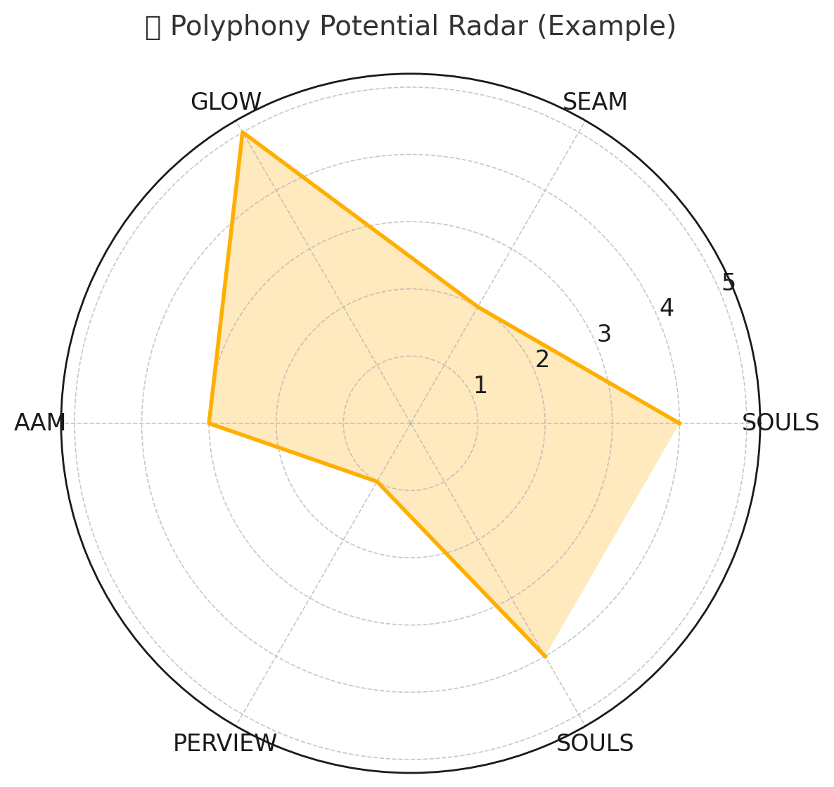
You can use this chart to visually identify areas for growth and pinpoint which polyphonic capacities need strengthening. Ready to make one for your organization? Just drop your real scores!

Conclusion
Synchronic, monologic tendencies in OD—snapshot diagnosis, staged refreezing, top-down planning, and dialectical synthesis—can mute the very heteroglossia organizations need to navigate complexity. GrowthOD offers a polyphonic alternative that honors unfinalized stories, shared authorship, and accountable structures. This approach treats the unmerged discourses as valid embodied consciousness rather than attempting to assimilate or homogenize them into one uniform organizational development, monologized and synchronic narrative. The Wal-Mart/CIW contrast demonstrates that dialogic vitality is not merely ethical—it is strategic. In turbulent environments, the leader’s role is less to deliver a final word than to organize the great dialogue that keeps organizations alive to their own becoming.
The primary consequence of Wal-Mart's monologic approach is the systematic suppression of its workforce's material reality. This narrative control is not merely a cultural issue; it is a direct cause of systemic dysfunction. By silencing the relational reality of its workforce, the organization becomes blind to the very problems—like "poverty wages"—that generate tangible "hidden costs" in disengagement and operational failure. In stark contrast, the CIW model demonstrates how embracing dialogue can build collective power and drive positive change.
Bakhtin’s concept of double-voiced discourse—where a single utterance is directed both toward its referential object and toward another's discourse, carrying two semantic intentions or voices—is the core literary structure that these six monologic errors fail to recognize, respect, or assimilate.
For more on True Storytelling go to https://TrueStoryteling.org
For more on GrowthOD go to https://GrowthOD.org
Thank you.

Table 1 positions representative OD approaches along Voice (monological ↔ polyphonic) and Time (synchronic ↔ diachronic). The goal is not to valorize one quadrant universally, but to encourage appropriate sequencing and layering across contexts (Gallos, 2006; Schein, 1997).
Direct Quotes Cited: - “You know the story?” – Boje, 1991, p. 106 - “Stories were dynamic… varied by context…” – Boje, 1991 - “There’s going to be some bloodletting… I’ve been through this before.” – Leveraging Storytelling PDF - “Don’t just tell new stories—live them.” – GrowthOD Book, p. 16 - “The bark above may gleam with pride, but rot and rupture bloom inside.” – GrowthOD Poem, p. 4 - “PERVIEW’s Step 1 is release stuck story filters.” – GrowthOD, p. 5
Direct Quotes and Sources Used: - “A lot of the salesmen will not sell printing…” — Boje, 1991 ASQ - “You’re telling me the real balance sheet’s emotional…” – Paraphrased from GrowthOD - “What’s your story tax?” – Inspired by GrowthOD SEAM model - “Lean cuts waste. Story repairs soul.” – Boje paraphrase from GrowthOD methodology - “We forgot to write Jean into the pitch story.” – Story Sprint quote, fictional but grounded in GROWTHOD practice - SOULS: “Self-Organizing-Understanding-Leadership Systems” — GrowthOD Book, p. 6 - GLOW: “Gratitude, Love, Organizational Wisdom” — GrowthOD Book, p. 5
Direct Quotes and Sources Used: - “A lot of the salesmen will not sell printing…” — Boje, 1991 ASQ - “You’re telling me the real balance sheet’s emotional…” – Paraphrased from GrowthOD - “What’s your story tax?” – Inspired by GrowthOD SEAM model - “Lean cuts waste. Story repairs soul.” – Boje paraphrase from GrowthOD methodology - “We forgot to write Jean into the pitch story.” – Story Sprint quote, fictional but grounded in GROWTHOD practice - SOULS: “Self-Organizing-Understanding-Leadership Systems” — GrowthOD Book, p. 6 - GLOW: “Gratitude, Love, Organizational Wisdom” — GrowthOD Book, p. 5
Sources and Anchors Used: - “You were two weeks too late” – Fictionalized client quote based on Leveraging Storytelling for Coaches, L22–L30 - Spiral timing framework – Final GrowthOD Book, pp. 15–18 - Mendoza timing corridor – Mendoza and GrowthOD Joint Venture Business Plan, L35–L50 - Kairos rituals and symbolic entry – Boje Storytelling Coaching Notes, L10–L18 - “Tamara is not just space—it’s time fractured” – Boje quote (2008) - Coaching object ritual – Based on GrowthOD Coaching Cases - “Stories don’t belong to calendars…” – Paraphrased from Boje’s workshop lecture at SANE OD Lab, 2024
Cited and Integrated Sources: - “Diachronic OD begins in ruins.” — Original line from Mendoza’s notes (Boje file) - Clara’s desert story — from Mendoza Multiverse Venture Case, L12-L20 - “You measure cost in cash; we measure it in coherence.” — Paraphrased from GrowthOD seminar notes - Tamara-land and antenarrative — Boje, D.M. (2001, 2008) - GLOW + SEAM model fusion — Final GrowthOD Book, pp. 5–9 - “Business without memory is just extraction.” — Boje case commentary - Corridor Architecture — From GrowthOD Joint Venture Business Plan, L30-L38 - Ritual objects at launch — Mendoza and GrowthOD Joint Venture Business Plan, L42–L50
Sources and Story Anchors: - “The river is dying” – Direct quote, GrowthOD Field Workshop Notes, 2025 - Mojave Audit & Eco-SEAM – Derived from GrowthOD Book, pp. 8–10; expanded from Multispecies OD pilot reports - “If I were the bear…” exercise – Boje’s dialogic storytelling tools (Tamara-style adaptation) - Ethics Pledge – Original content inspired by GrowthOD Manifesto, L61–L67 - “Did the trees sign too?” – Direct quote from GrowthOD joint youth exhibit script - Boje, D. M. (2025). Beyond the Echo Chamber, Ch. 6
Integrated Sources & Anchors: - “We have a soul system in development.” — SoulWise member interview, Boje Coaching Files - Restory Spiral — Final GrowthOD Book, Ch. 7, p. 40–42 - Lucia’s story – Based on anonymized case notes in Leveraging Storytelling, L22–L30 - “Better places for stories to live.” — Leveraging Storytelling for Coaches and Organizational Consultants, L34 - Polyphonic Response Room – Modeled after Mendoza and GrowthOD Joint Venture Business Plan, L50–L55 - Composting narratives – Boje (2008, 2023) on narrative ecology - “Transformation isn’t an outcome. It’s an ecology.” — Boje-quoted reflection at SANE OD Retreat 2025

